Andrew Chen 2026 03 04
Report for Processing Lab
Follow the Colab file “HSI Lab 4 – Processing.ipynb” and record your process and results in this document.
* For each step, provide sufficient explanation of the process of reaching the final result or plot
* For each plot to report, include proper axis labels and units. For each numerical result to report, include proper units
- Load raw data and calculate metabolic rate of each user
What I did: Using mL/min units for VO2 and VCO2, I calculated metabolic rate using the formula: metabolic_rate = 1440 * (3.9 * vo2 / 1000 + 1.1 * vco2 / 1000) kcal/day
Reference: https://doi.org/10.1113/jphysiol.1949.sp004363

- Select appropriate parameters
Continuous parameter selected: Weight
Categorical parameter selected: Sex

- Analysis of continuous parameter
What I did: Created a scatter plot with x axis representing weight in kg and y axis representing metabolic rate in kcal/day.
Plot:
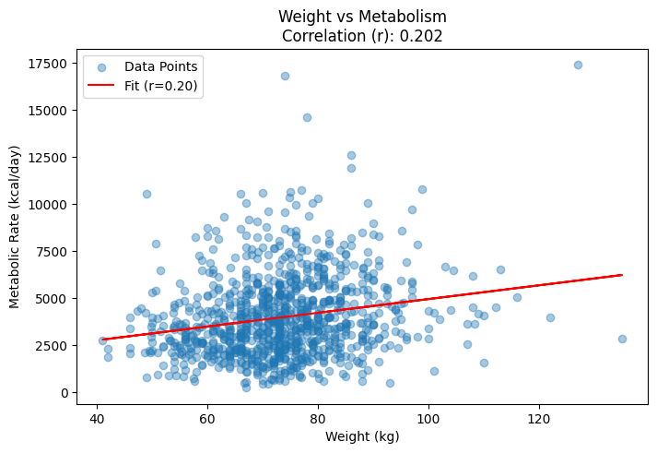

- Analysis of categorical parameter
What I did: Split metabolic rates into two categories based on sex, and plotted two boxplots.
Plot:
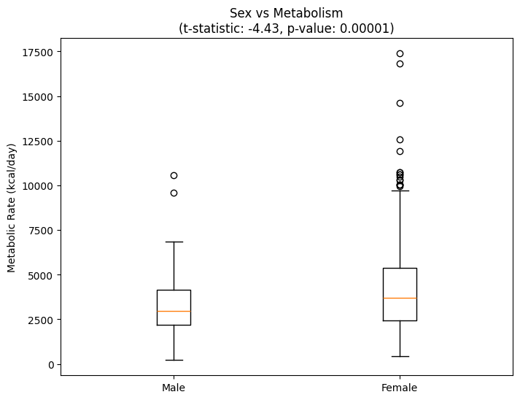

- Discussion: Continuous parameter
Comment on the results of your statistical test and provide reasonable explanation to why (or why not)
Based on the pearson correlation test results of r = 0.202, we can conclude that there is a weak correlation between weight and metabolism.

- Discussion: Categorical parameter
Comment on the differences between two types of spectrograms, as well as the traits shown in the spectrograms that are indicative of the sound
Based on the t-test results of a t-statistic of -4.43 and a p-value of 0.00001, we can conclude that there is strong evidence that rejects the null hypothesis, the hypothesis that sex doesn’t affect metabolic rate.

- Link to Colab file: [Make sure to grant file access to “anyone with the link” to make sure TAs have access to the code]
https://drive.google.com/file/d/1kjzlMgW3MywNqMZweLHbOkJSVn6S7sR0/view?usp=sharing

