Andrew Chen 2026 02 23
Report for Food Sounds Lab
Follow the Colab file “HSI Lab 3 – food sounds.ipynb” and record your process and results in this document.
* For each step, provide sufficient explanation of the process of reaching the final result or plot
* For each plot to report, include proper axis labels and units. For each numerical result to report, include proper units
- Load raw audio
What I did: Used librosa.load()
Plot: 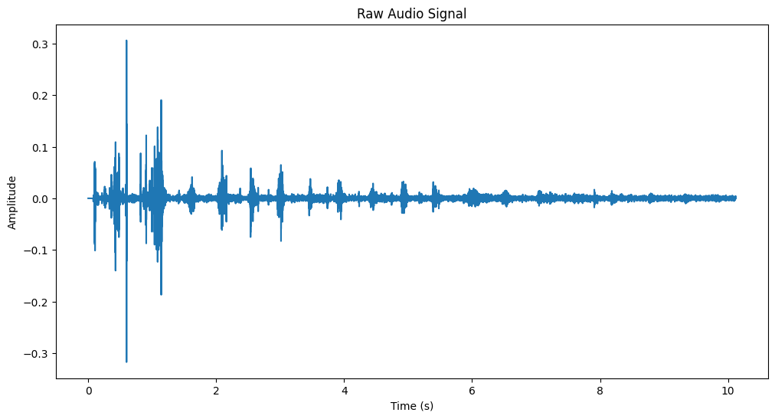

- Apply band-pass filter
What I did: [Please describe the parameter selection reasoning and/or tuning process] Used 20-2000 Hz bandpass. I started with 20000, but the curve looked strange, dropping the upper limit to 2000 made results better.
Plot: 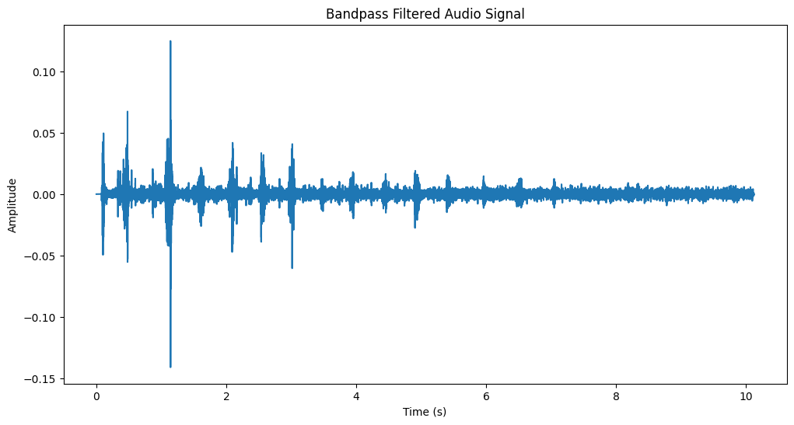

- Convert data to spectrogram
What I did: Used spectrogram() and took log of y-values before plotting.
Plot: 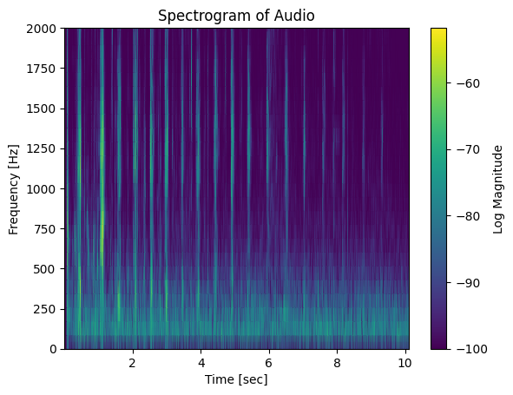

- Convert data to Mel-spectrogram
What I did: used librosa.feature.melspectrogram to get power values, then converted to dB.
Plot: 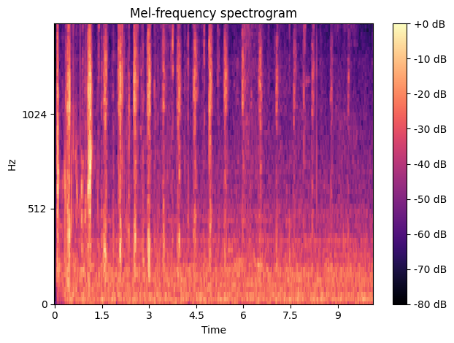

- Discussion: Spectrograms
Comment on the differences between two types of spectrograms, as well as the traits shown in the spectrograms that are indicative of the sound
In the mel-spectrogram, there’s more energy / amplitude in the higher frequencies relative to the lower frequencies. You can see consistent lines of sound in both plots, likely due to the cyclical sound of chewing.

- Alternative Scenario Processing
[The following plots are required: filtered data plot, spectrogram, Mel-spectrogram]
What I did: Exact same functions and parameters as the previous audio file.
Plots: 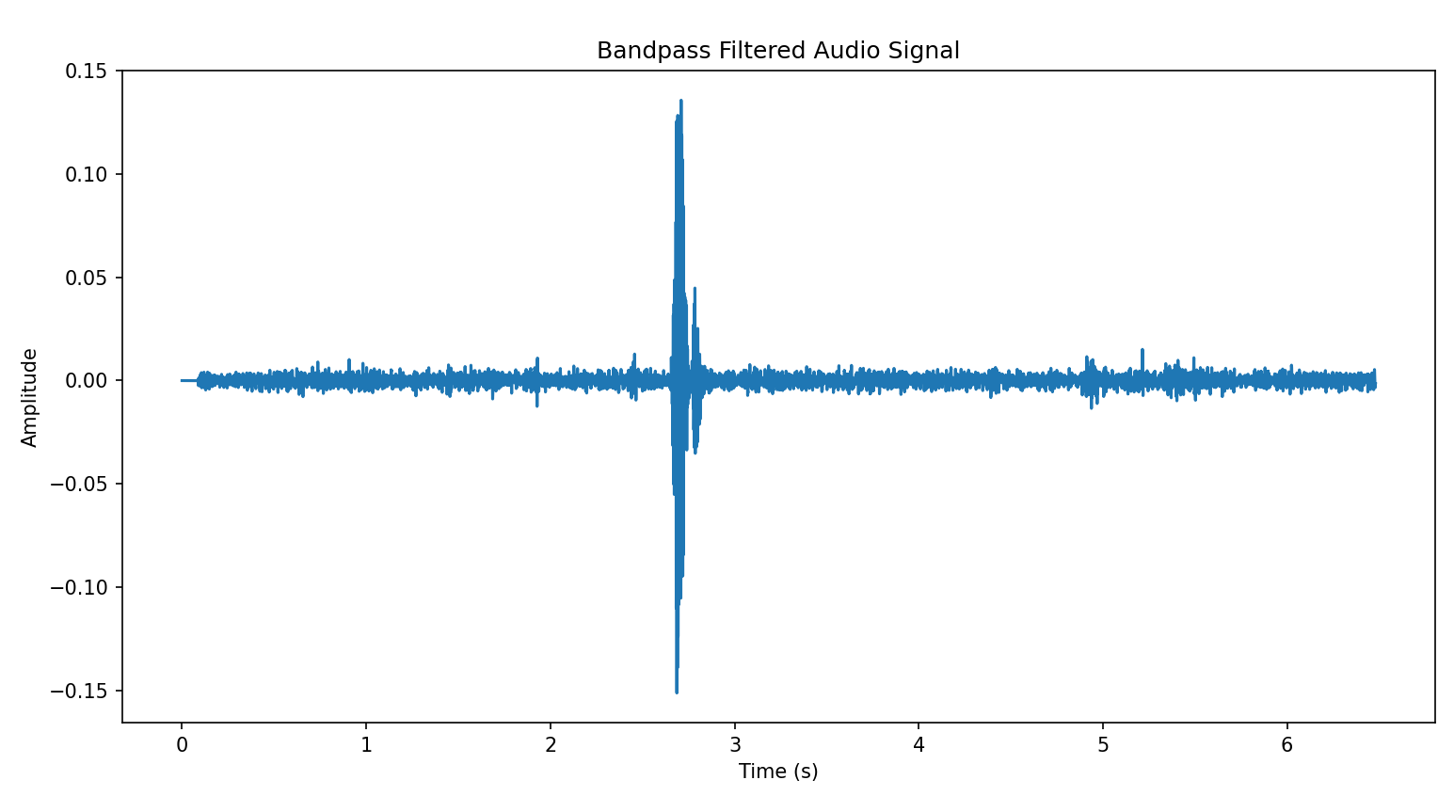 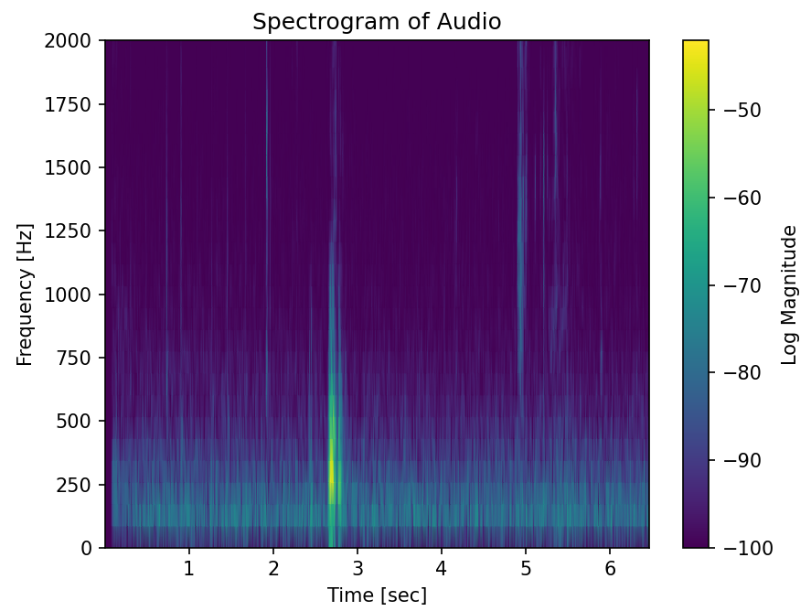 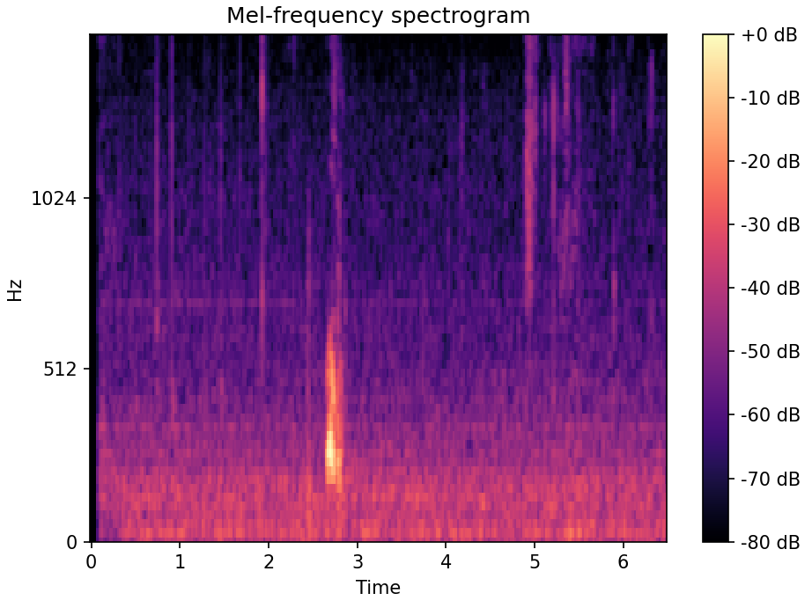

- Discussion: Different audio
Comment on the differences between two different data
In chips.wav, the signal is much more cyclical and repetitive, whereas for drink.wav, there’s one large spike when the participant swallows, and then mostly noise.

- Process & identify unknown audio
[The following plots & results are required: filtered data plot, spectrogram, Mel-spectrogram, identification of the audio]
What I did: Exact same functions and parameters as the previous audio file.
Plots: 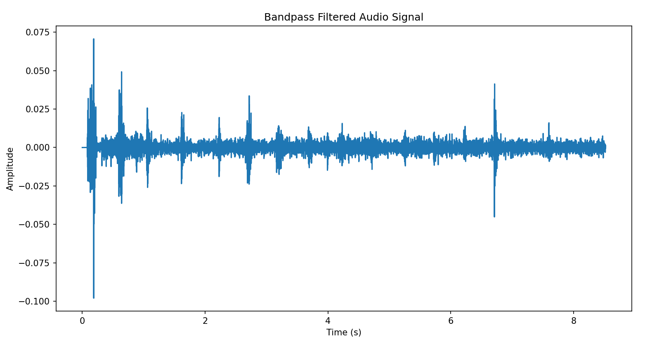 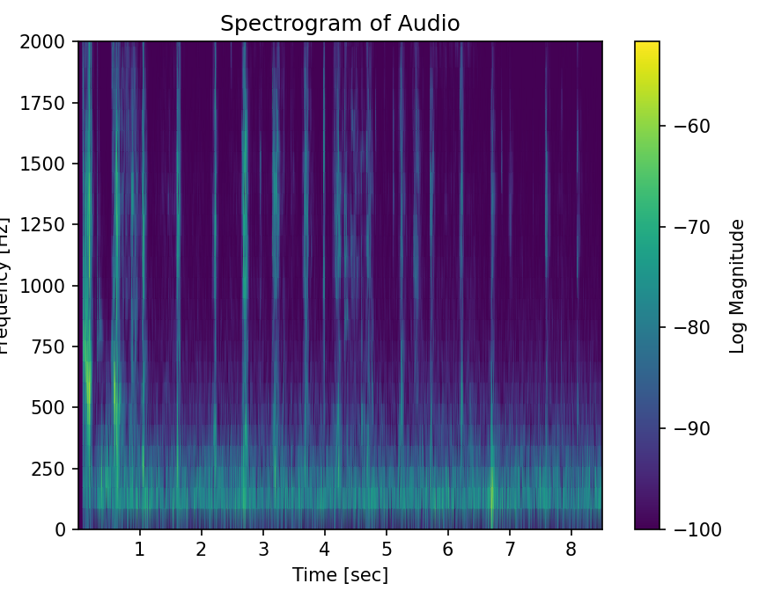 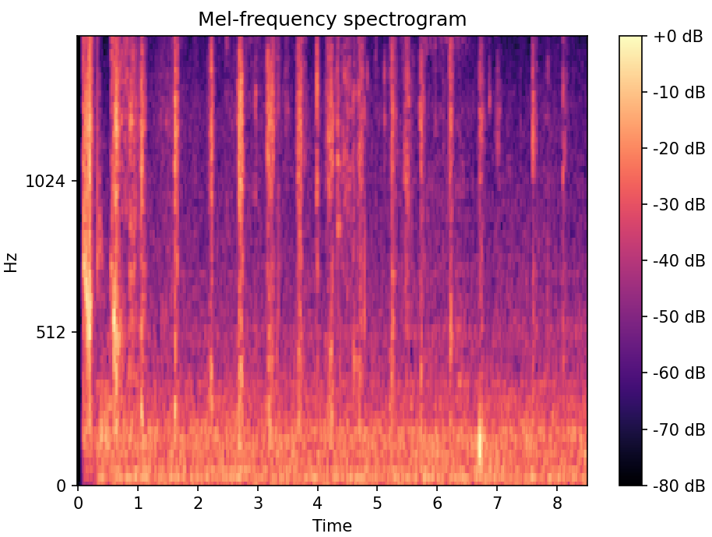
Result: Eating chips, as evidenced by the consistent sound bursts, likely due to repetitive chewing.

- (Extra Credit) Personal Audio Processing
[The following plots & results are required: filtered data plot, spectrogram, Mel-spectrogram, identification of the audio]
What I did: Same processing as all the others. This is a recording of me eating an orange. Note there’re less consistent chewing sounds since the orange is soft.
Results & Plots: 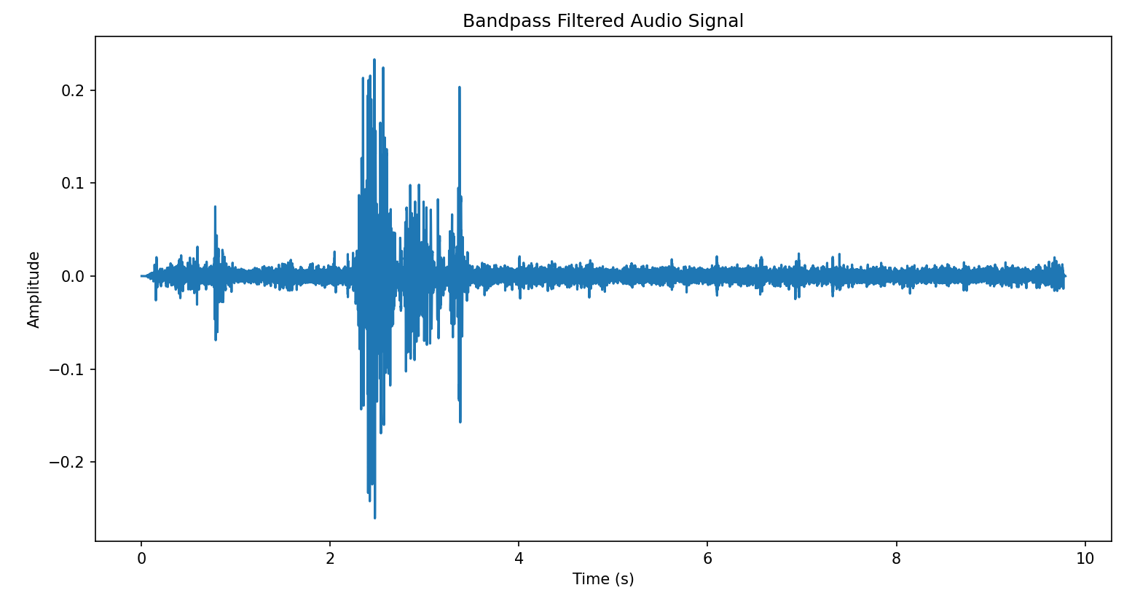 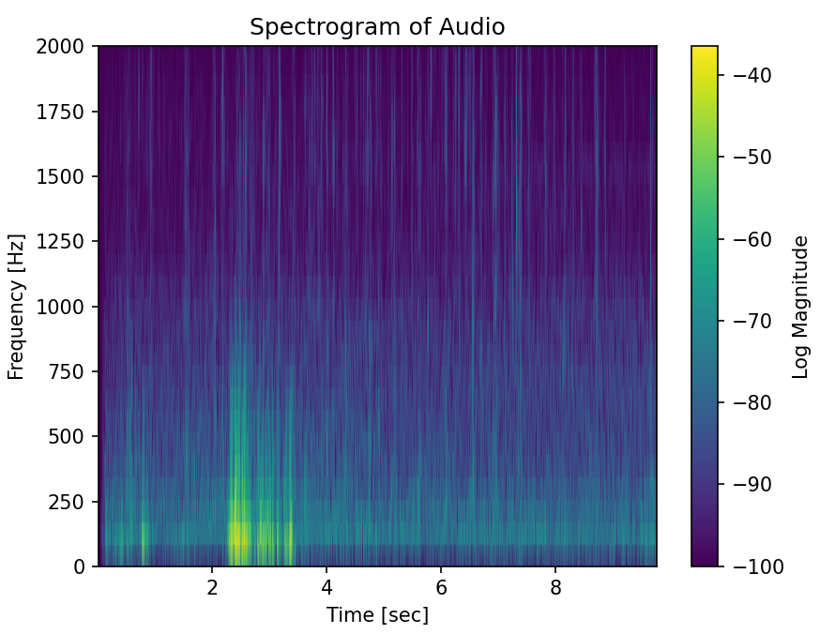 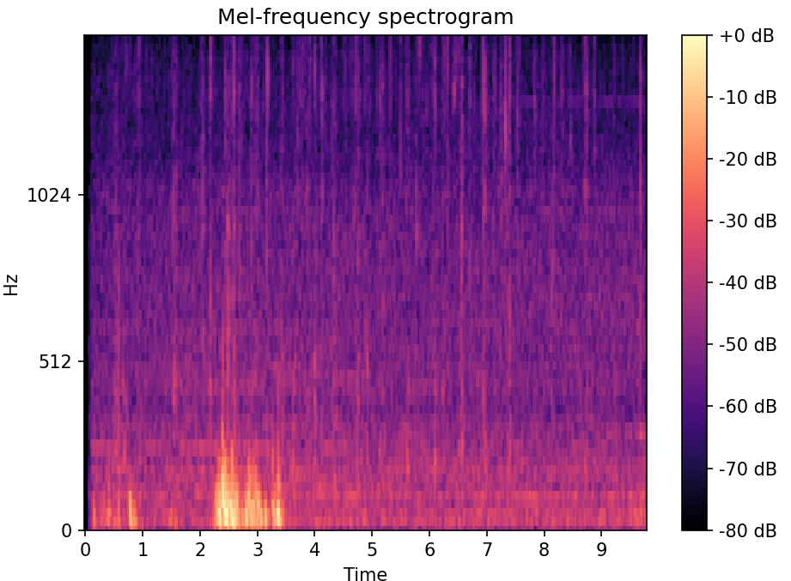

- Link to Colab file: [Make sure to grant file access to “anyone with the link” to make sure TAs have access to the code]

https://drive.google.com/file/d/13RF5kVu0lBdr_0rkyu9czbCeAQRmBPCz/view?usp=sharing

