Andrew Chen 2026 03 10
Report for Urine Slides Lab
Follow the Colab file “HSI Lab 5 – urine slides.ipynb” and record your process and results in this document.
* For each step, provide sufficient explanation of the process of reaching the final result or plot
* For each plot to report, include proper axis labels and units. For each numerical result to report, include proper units
- Load raw figures
What I did: used pyplot to plot all 3 images
Plot: 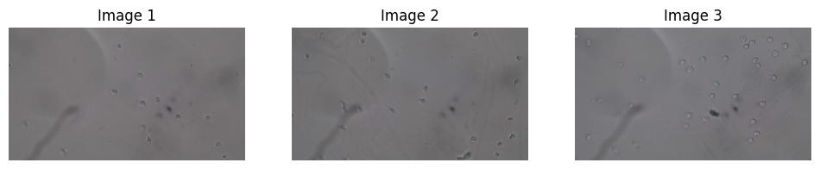

- Count RBCs with Hough Circle
What I did: tuned the blur and hough parameters until I captured all RBCs in Image 1.
Fine tuned parameters:
dp=1.2,
minDist=40,
param1=50,
param2=5,
minRadius=15,
maxRadius=15

Plot: 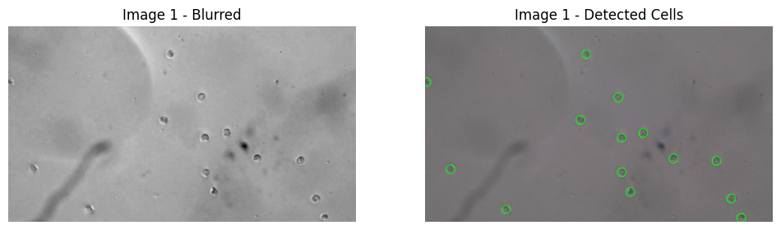

- Count RBCs with Canny
What I did: tuned the canny, dilate, and erode parameters, and then min and max area of detected circles.
Fine tuned parameters:
Canny: 40, 50
Kernel Size: 3, 3
Dilate: 2
Erode: 1
Min: 280
Max: 1000
Plot: 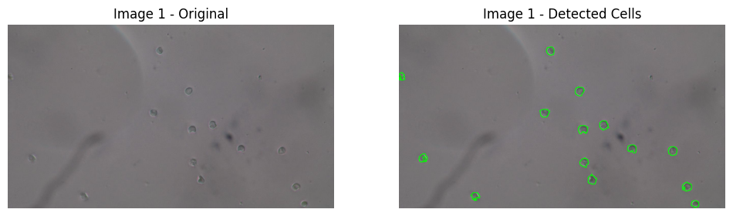

- Count RBCs from another image with Hough Circle
What I did: reran my hough function on a new image
Plot: 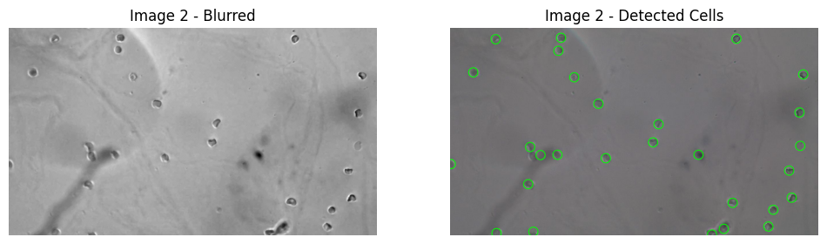
Evaluation metrics:
Accuracy: 0.96
Precision: 0.96
Recall: 1.00

- Count RBCs from another image with Canny
What I did: reran my canny function on a new image
Plot: 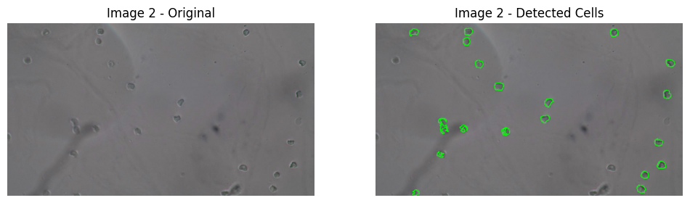
Evaluation metrics:
Accuracy: 0.74
Precision: 1.00
Recall: 0.74

- (Extra Credit) Build your own model
What I did:
Plot:
Evaluation metrics:

- Link to Colab file: [Make sure to grant file access to “anyone with the link” to make sure TAs have access to the code]
https://drive.google.com/file/d/1-jL1zYFXvMf53W6OGeUfP3tWC8xcgwKc/view?usp=sharing

