《小学英语》（鄂教版）课题实验模块一听说检测题
- 单词选择：请根据图片提示读出正确的单词
1.  morning miss name
2. 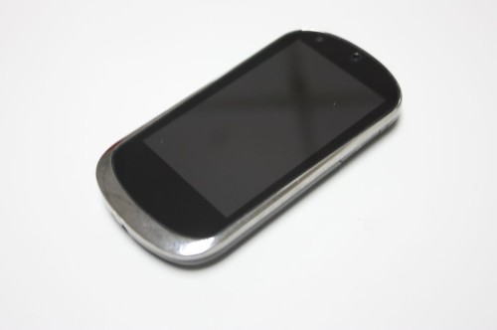 card book phone
3. 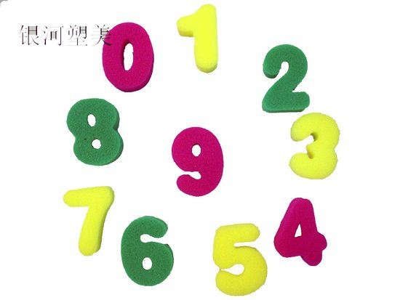 number zero what
4.  I hello your
5.  nine six eight
6.  zero three seven
二、句子跟读：请跟读你所听到的句子（试卷上没有英语，录音时应当是：下面请听第一题， …， Beep! 学生跟读。）
1. Hello!
2. I’m Li Yan.
3. Good morning
4. Good afternoon, Miss Chen.
5. What’s your name?
6. This is my phone book.
7. What’s your phone number?
8. It’s 55545868.
三、看图说话：请根据图片和语音提示，读出正确的句子
1. 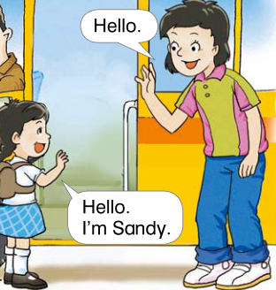 Hello! I’m Sandy This is Sandy需要去掉对话框
2.  This is my phone book. What’s your name?
3.  Good morning! Good afternoon!
4.  It’s one one nine. It’s one one zero.
5.  What’s your phone number? Hello! This is 12315
四、回答问题：根据你听到的句子，读出正确的应答语（题目不必印刷出来，只看见选项。）
1. Good afternoon, Tony!
Good morning. Yes, I’m Tony Good afternoon!
2. What’s your name?
Wu Wei. Hello! Wu Wei This is Wu Wei.
3. What’s your phone number?
This is my phone number It’s 88021413 Hello! 12345
4. Good morning, I’m Li Yan.
Good morning, I’m Sandy Yes, Li Yan Very good.
5. Hello! I’m Miss Chen
Hello! I’m Ken Good morning, Miss Chen Yes, Miss Chen

