Vault
Graphical secure file storage and management

A1 – Planning
Scenario: A person needs to store sensitive / private files in an encrypted manner on their device while still being able to easily access them. The client also wishes that data can be quickly cleared in the case of an emergency.

Goals
- Encrypt and decrypt files provided by the user
- Create path tree of the folder within a database including file information
- Temporarily extract encrypted content into a temporary file for reading and writing
- Allow user to open files with other applications
- GUI and CLI for managing files
- Clean temporary files on exit

B – Design

Algorithm structure

Flowchart
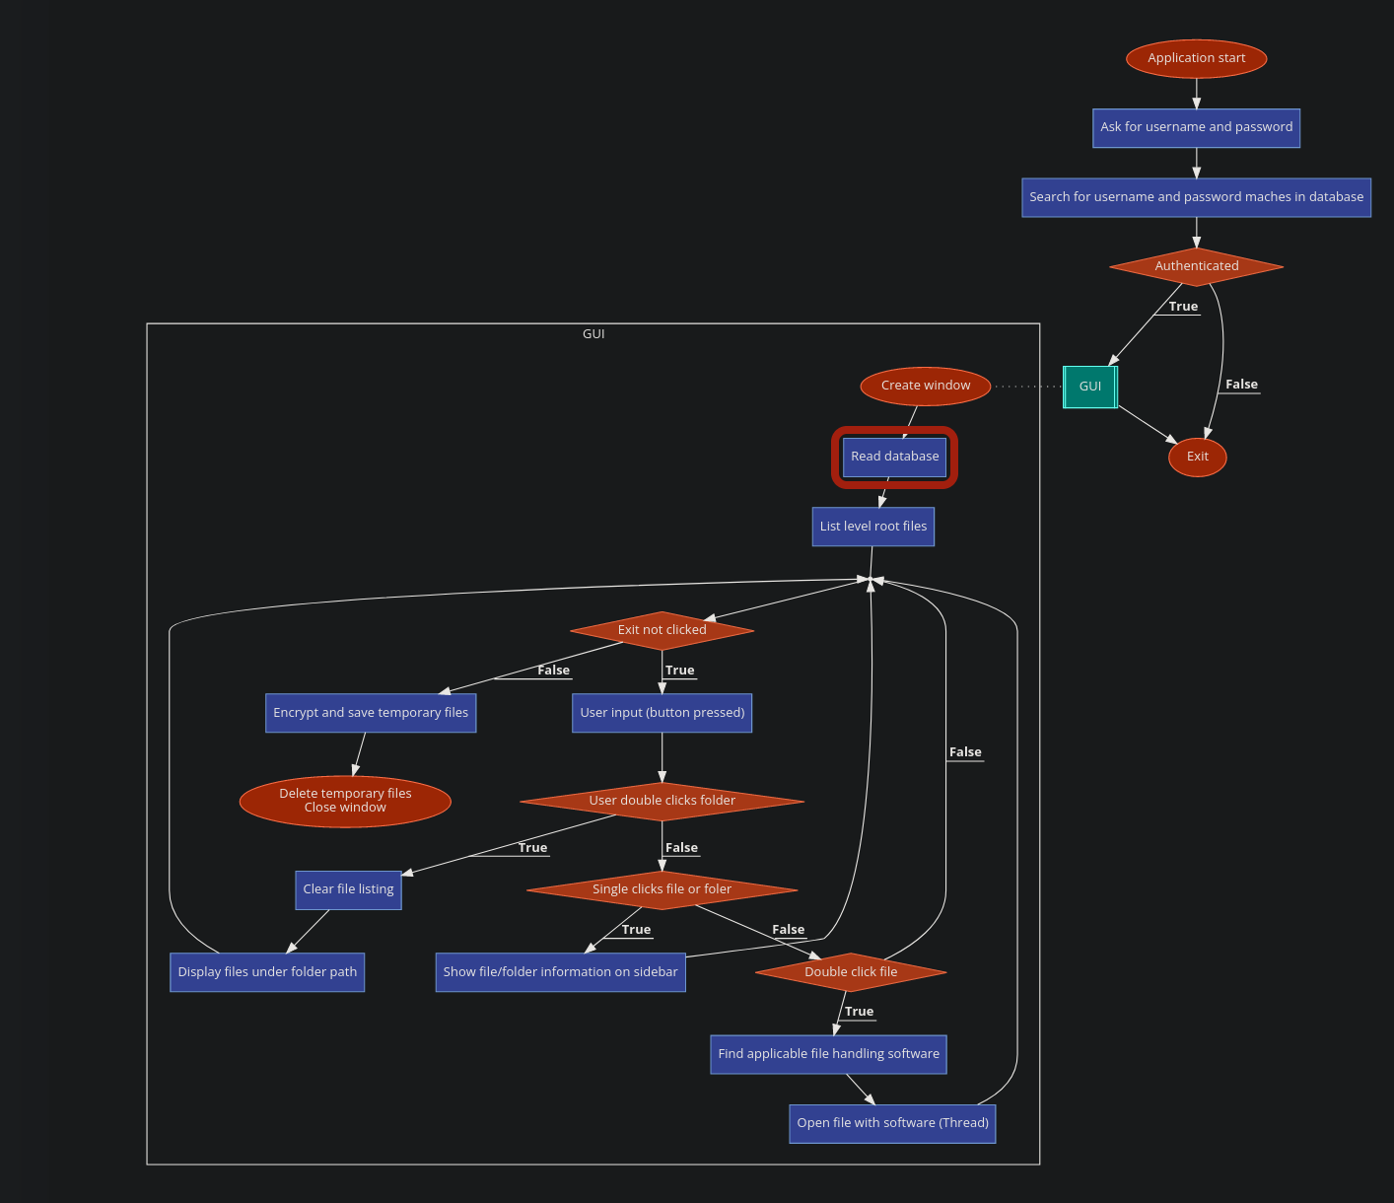

Modular Organization – Object Oriented Programming
- modules – Folder
  - vault_manager.py – File
    - encDir – Class
      - Description:
        - Manages the reading and writing of files into a compressed archive
      - Methods:
        - getData(self, arcname) – Reads the section data of the archive with the specified arcname
        - add(self, data, arcname) – Writes the data input into archive with name as arcname
        - ls(self) – Used for debug purposes: Outputs the arcnames stored within the archive.
        - rm(self, arcname) – Deletes data with name as arcname
        - clear(self) – Deletes all data within the archive
    - fileDB – Class
      - Description:
        - Manages the database which links arcnames in the archive to the supposed output name when temporarily extracted.
      - Methods:
        - dbConnect(self) – Utility used by other methods: Returns connection and cursor
        - add(self, filename, arcname, type, directory) – Adds an entry to the database with the given parameters
        - rm(self, filename, directory, type) – Deletes an entry from the database with the given parameters
        - ls(self, directory) – Returns the file entries from the database
        - clear(self) – Deletes all data from the database
    - fileManager – Class
      - Description:
        - Extends encDir and fileDB – Unifies methods to simplify interaction
        - Encrypts and decrypts data being written into and read from the archive
      - Additional methods
        - encrypt(self, plaintext) – Encrypts the given input
        - decrypt(self, ciphertext) – Decrypts the given input
        - open(self, filename) – Gets data from archive, decrypts it, and opens it with the default handler

Data Structures
Name | Location | Purpose | Type
dirPath | EncDir – self | Stores the relative path of the main archive | Constant
tmpPath | Universal | Stores the directory where files are temporarily extracted | Constant
arcname | Universal | Name of file in archive (MD5 of normal filename) | Variable
filename | Universal | Unobfuscated name of file | Variable
data | EncDir – self | Raw data read or written to/from the archive | Variable
dbPath | FileDB – self | Stores the relative path of the database containing file entries | Constant
uploadDir | FileManager – self | Stores the relative path of where files should be added from | Constant
zipCur | FileManager – self | EncDir Object | Object
dbCur | FileManager – self | FileDB Object | Object
password | FileManager – self | Stores the password which data should be encrypted based off of | Variable
plaintext | FileManager – Instance | Stores unencrypted data | Variable
ciphertext | FileManager – Instance | Stores encrypted data | Variable
pwdhash | Cli.py – Main | Stores the hash of the correct password | Constant

Requirements

Third-party Modules
zipfile: Reading, writing, and unpacking from zip files
sqlite3: Database management
PyGTK: Graphical User Interface
hashlib: Hashing library
cryptocode: Encryption and decryption library
os and shutil: Built in utilities

Handling Errors
- All actions with possible crashes is run with ‘try’ and ‘except’
- Non-existant paths are escaped with if statements
- Data types are forcefully converted with str() and int()
- Iteration and selection are relative: len() and ‘in’ are used to prevent overflow
- Else statements are used in every conditional statement to guard against stupidity

Testing
Name | Description
IO equivalence | Are the data added to vault and data extracted equal?
Password check | Does the hash from derived from user entry equal stored hash file
CLI vs GUI | Does the command line interface have the effect as the graphical user interface
Invalid input | Enter invalid path, filename, or command. Checks for error checking functionality.

C – Documentation of Functionality
Usage is extremely simple:

GUI

Authentication
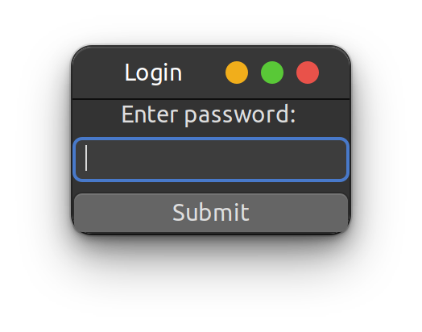
Description:
Enter password. If password has not been set, a new password will be set.
Explanation:
The user enters a password. The password is then hashed using the MD5 algorithm. The hash is then compared to the stored hash in a file in ‘src/auth’. If the auth file does not exist, a new file is created and the hash is stored. If the hash matches that of the file, the program proceeds to the next window.

Menu
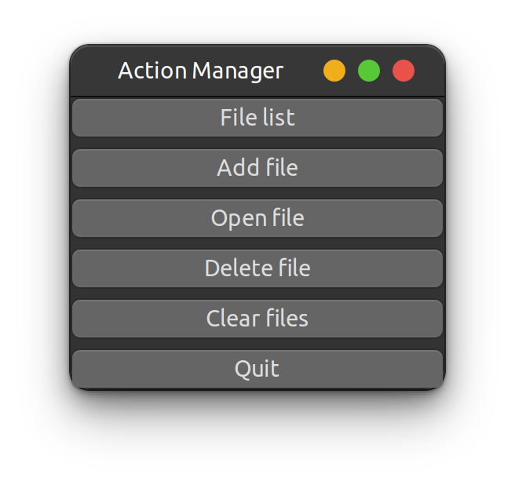
Description:
The menu provides a list of methods that the user can use to manipulate the file vault
Explanation:
Each of the buttons are linked to an action function which starts the new GTK window specified

