Sumobot Build Instructions

1. Follow the Zumo Chassis instructions to build your chassis.

Tips:

Use electric tape to hold the battery terminal in place.

It is a good idea to solder the motor and terminal wire connections.

1. Attach the Arduino to the top of the chassis.

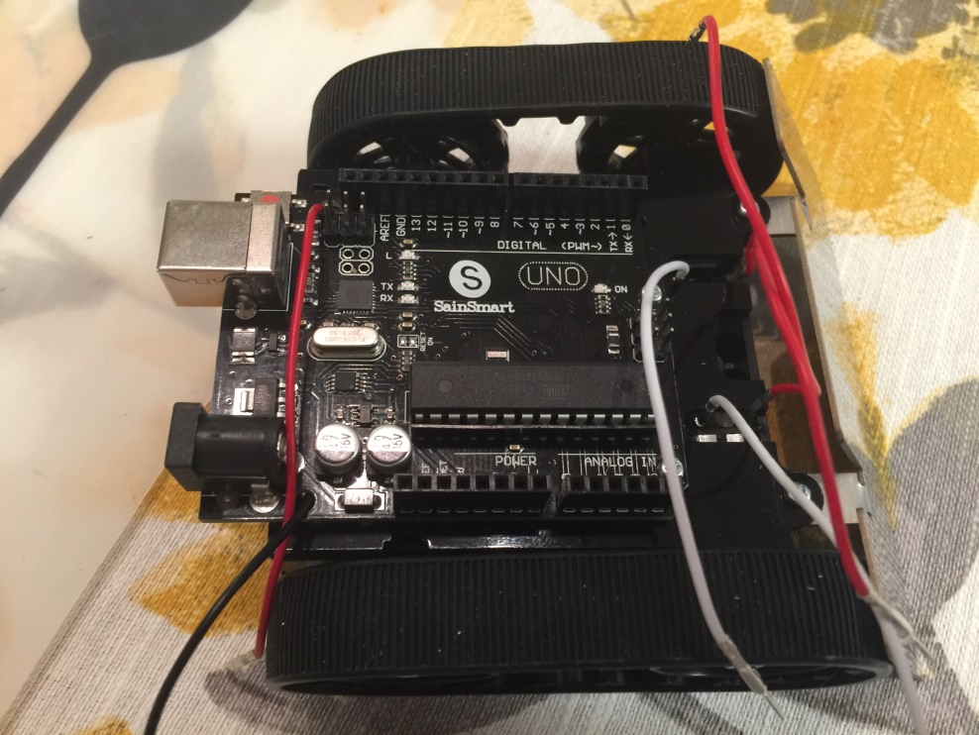

1. Insert the Motor Shield into the Arduino and attach wires.

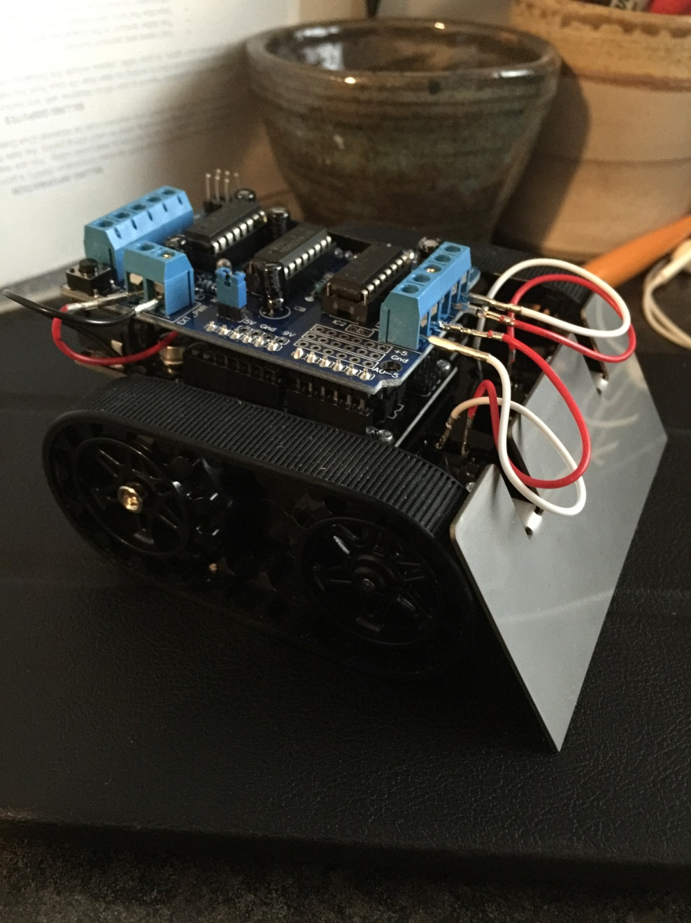

1. Insert 4 AA batteries and put battery cover on.
2. For testing, place bot on top of something so treads do not touch the ground.
3. Attach USB cable to laptop. Your bot is now ready to run the sumobot control software.
   1. $ cd code
   2. $ npm install
   3. $ node sumobot.js
4. If you want to do some additional making, you can use the provided servo and 3D printed parts to add something to help your bot in battle.
5. On battle day you will be provided with a much longer cable. Good luck!