**Introduction/ Business Problem**

The data science project emphasizes on the problem and the stakeholders related to the problem. It creates a result which eventually benefits the particular set of stakeholders in order to ease the life. Coming up with the business problem and how effective it would be if the problem gets solves plays a vital role while choosing the problem area.

-Considering the scenario where the tourists are in a new city where the surroundings are unknown, even with having the facilities like guide and hotels, one comes under the situation where they need to find out food places on their own at times.

-The problem here could be, how easy it is to find different type of cuisines in the particular city and that too near by to the tourist places. If we can get to know the types of restaurants with the ambience and reviews of the users for the same, then one can easily decide on the part where it is confusing for tourists as they are unknown to different cuisines.

-Adding to that, distance is one more problem area, if a tourist can find a particular type of restaurant within the vicinity, then time and money both could be saved.

Defining the questions: What is the availability of different cuisines in New york city, and around the distance from the particular locations.

**Data**  
  
As far as the data for the project, the problem specifies that the visitors should be able to find the restaurants with different cuisines. The data that would be used here to come up with the locations and resulting data frame would be the forsqaure API data.

-Here, the main reason behind using forsquare API location data would be as we need to find out the restaurants with different cuisines.

-Forsquare offers the most integrated and essential solution, in terms of the location data using API.

- For Example,

If I want to pull the API call for the Cuisine type =”Mexican” with the location near by to a particular hotel , we can get the data with the particular types, names, reviews etc.

By using the location API call with the venues we will be able to get the restaurants with different cuisines and we will be abel to convert it into dataframe and we can do the analysis on the same.

**Methodology**

Considering the data which is used in the project to drag out the results, I have used to pull the data from the link.

-After pull, the data has been modified, with cleaning and removing the regressive data.

-Once cleaning is done, presentation comes into picture.

-presentation of the data is the most vital part of the data science project.

- The data has been converted into a data frame using pandas by which we can know that exact columns and data we will be processing.

-In the end the FORSQUARE API has been used to get the venues, locations, distance, tips, etc.

**Results**

**-**the refined data

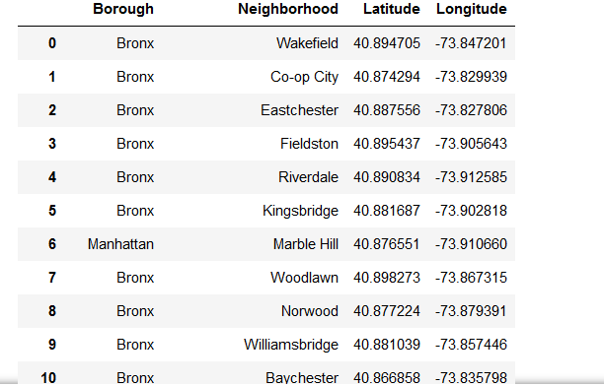

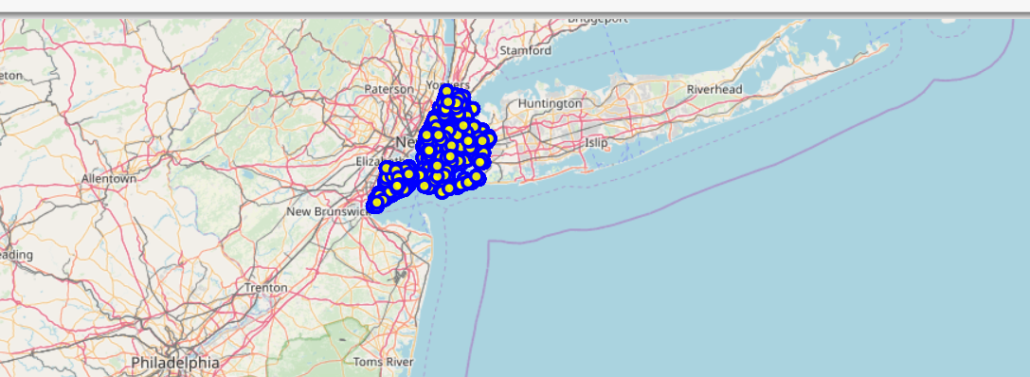

**-**actual results after API calls

