PROMBLEM TWO:

How to run this application (impolemented as springBoot Service):

1. Unzip TaxRestAPI.zip project your local machine and import into Eclipse or preferred IDE as Maven project
2. Right click > Maven > Update Project
3. Right click > Run As > Spring Boot App
4. Use Chrome Poster or Postman and input INPUTs as shown below on end point

<http://localhost:9596/api/tax/calculate> (note that the port is predefined in the application.property file)

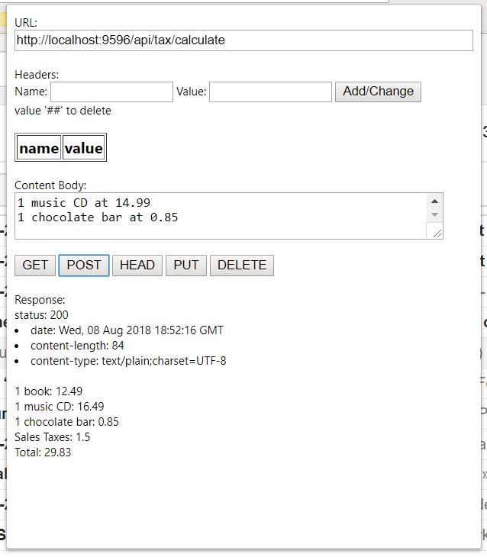

INPUT1

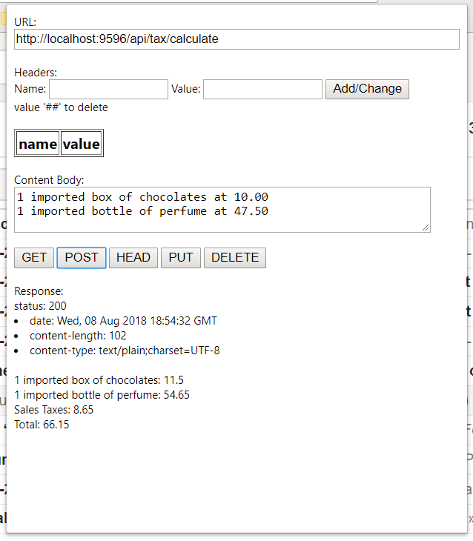

INPUT2

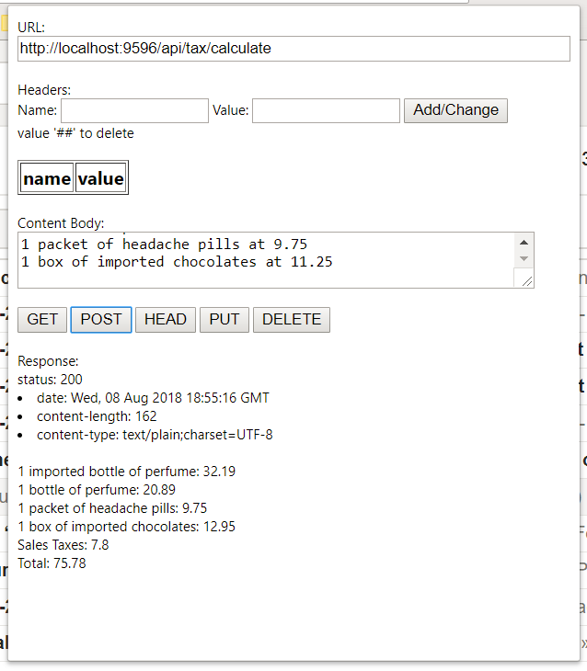

INPUT3