**David Rogan**

**ITAI 2372**

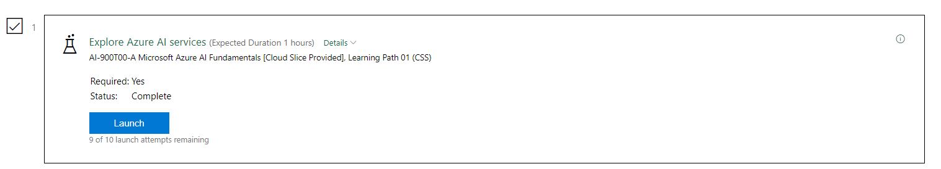

**Reflective Journal: Explore Azure AI Services**

**Introduction**

This reflective journal documents my experience exploring Azure AI Content Safety through the Content Safety Studio. The primary objective was to gain an understanding of how Azure AI services are provisioned and utilized, with a focus on the Content Safety feature. This reflection highlights key insights, analyses, and implications derived from the activity.

**Description of Experience**

**Background Information:**  
Azure AI Content Safety is designed to identify and moderate harmful text and image content using advanced AI models. It assigns severity scores to categories such as violent, sexual, or hateful content, providing a tool for organizations to ensure safe and responsible content management.

**Specific Details:**  
The exercise involved navigating the Content Safety Studio, creating a single-service Content Safety resource in the Azure Portal, and associating the resource with the studio. Key tasks included role assignment through Access Control (IAM), testing moderation of text content, and exploring endpoints and keys for application integration. These steps demonstrated the integration of AI in addressing content safety challenges.

**Personal Reflection**

**Thoughts and Feelings:**  
At the outset, I felt intrigued yet slightly apprehensive, given the complexity of AI systems. As I progressed, I was impressed by the accessibility of the Content Safety Studio and how it streamlined interactions with advanced AI functionalities. This approachability fostered confidence and a deeper appreciation for the potential of AI in content moderation.

**Analysis and Interpretation:**  
This activity provided a tangible understanding of AI's role in moderating harmful content. Running tests on sample text content revealed the practical application of machine learning models in categorizing and flagging unsafe material. The exercise illustrated how AI-powered systems align with human judgments while offering scalability and efficiency.

**Connections to Theoretical Knowledge:**  
The exercise reinforced theoretical concepts from AI and machine learning, such as training and inference. It bridged the gap between academic learning and real-world implementation by demonstrating how Access Control (IAM) supports secure resource management, linking technical implementation to theoretical security frameworks.

**Critical Thinking:**  
The intuitive design of the Content Safety Studio enhanced the experience. However, configuring resources through the Azure Portal presented minor challenges, particularly in navigating permissions and roles. A comprehensive onboarding guide could further improve the user experience and mitigate initial setup difficulties.

**Discussion of Improvements and Learning**

**Personal Growth:**  
This exercise fostered a deeper understanding of how AI can address critical societal issues, such as moderating unsafe content on digital platforms. It also enhanced my confidence in using Azure services and managing resources effectively.

**Skills Developed:**  
Key skills gained include provisioning AI services, interpreting severity scores from AI models, and managing role-based access through IAM. These competencies are invaluable for future projects involving AI integration.

**Future Application:**  
The insights from this exercise have significant implications for future endeavors. I envision applying these skills in scenarios such as content moderation for social platforms, integrating AI into application workflows, and ensuring responsible AI use in professional settings.

**Conclusion**

**Summary:**  
This exploration of Azure AI Content Safety provided a practical understanding of provisioning AI services and leveraging them for content moderation. The experience emphasized the importance of resource management, secure access control, and the interpretability of AI-generated results.

**Final Thoughts:**  
This exercise reinforced the transformative potential of AI in addressing real-world challenges, highlighting its scalability and adaptability. It also underscored the need for ethical considerations in AI deployment. Moving forward, I aim to deepen my expertise in Azure AI services and apply these tools to drive innovation responsibly.

**References**

1. Microsoft Azure. (n.d.). *Content Safety Studio*. Retrieved from <https://contentsafety.cognitive.azure.com>
2. Microsoft Azure. (n.d.). *Azure Portal*. Retrieved from <https://portal.azure.com>