**David Rogan**

**ITAI 2372**

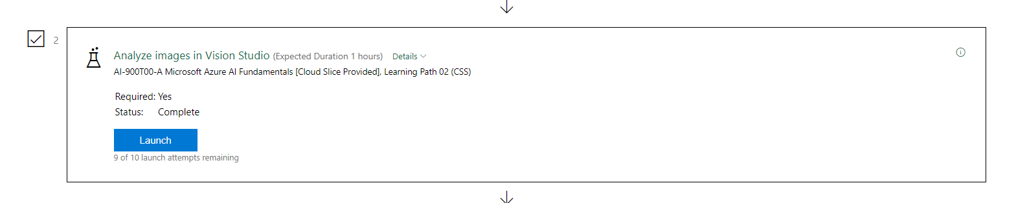

**Reflective Journal: Analyzing Images in Azure AI Vision Studio**

**Introduction**

This reflective journal documents my experience with Azure AI Vision Studio, focusing on its capabilities to analyze and extract insights from images. The goal of this exercise was to explore the practical use of AI for understanding visual content, particularly through captioning, tagging, and object detection. This reflection examines the process, key learnings, and implications of utilizing these tools in a hypothetical retail scenario.

**Description of Experience**

**Background Information:**  
Azure AI Vision provides a comprehensive suite of tools for analyzing image content and context. In this exercise, Vision Studio was used to evaluate how AI can extract meaningful information from images to enhance retail operations, such as identifying customer needs or assisting employees in a "smart store" setting.

**Specific Details:**  
The exercise involved provisioning an Azure AI services multi-service resource in the Azure Portal and connecting it to Vision Studio. Various image analysis features were explored:

* **Captioning:** Generating descriptive text for an image.
* **Dense Captioning:** Providing multiple captions with bounding boxes for detected objects.
* **Tagging:** Identifying objects, actions, and attributes with confidence scores.
* **Object Detection:** Highlighting objects in an image and dynamically adjusting a threshold for confidence scores.

The images analyzed were representative of a retail store scenario, with examples including a parent photographing a child, a shopper with a basket, and a person using a shopping cart.

**Personal Reflection**

**Thoughts and Feelings:**  
I found the exercise both engaging and insightful, as it provided a real-world context for using AI in retail. The intuitive interface of Vision Studio enhanced the learning process, while the sophistication of the AI-generated outputs impressed me. However, I initially felt overwhelmed by the breadth of capabilities offered by Vision Studio.

**Analysis and Interpretation:**  
This activity demonstrated the utility of AI in interpreting visual data. The captioning features underscored the ability of AI to generate human-readable descriptions, while tagging and object detection highlighted its precision in identifying actions and objects. For instance, the Dense Captioning feature not only provided textual descriptions but also visualized bounding boxes, effectively bridging textual and spatial understanding.

**Connections to Theoretical Knowledge:**  
The exercise aligned with theoretical concepts of computer vision, such as convolutional neural networks (CNNs) and object recognition. It also reinforced the importance of confidence scores in AI decision-making, emphasizing probabilistic reasoning in image analysis.

**Critical Thinking:**  
While the tools were user-friendly, the dependence on pre-trained models limited flexibility for highly specific use cases. Additionally, managing confidence thresholds required a balance between accuracy and inclusivity, prompting questions about the trade-offs in AI-driven decision-making.

**Discussion of Improvements and Learning**

**Personal Growth:**  
This experience enhanced my understanding of AI's potential in revolutionizing industries like retail. It also built my confidence in navigating Azure's ecosystem and using Vision Studio effectively.

**Skills Developed:**  
I gained practical skills in provisioning and configuring Azure AI resources, using Vision Studio's features, and interpreting outputs such as tags, captions, and bounding boxes.

**Future Application:**  
These skills have broad applicability in developing AI-powered applications, particularly in retail, security, and content management. The ability to fine-tune thresholds and analyze confidence scores equips me to optimize AI tools for specific needs.

**Conclusion**

**Summary:**  
The exercise showcased the transformative capabilities of Azure AI Vision Studio in analyzing image content. It illustrated how captioning, tagging, and object detection could provide actionable insights in real-world scenarios, such as a smart store environment.

**Final Thoughts:**  
This experience reaffirmed the value of AI in enhancing decision-making and operational efficiency. As AI continues to evolve, I aim to explore its broader applications while considering ethical implications and the need for domain-specific customization.

**References**

1. Microsoft Azure. (n.d.). *Vision Studio*. Retrieved from <https://portal.vision.cognitive.azure.com>
2. Microsoft Azure. (n.d.). *Azure Portal*. Retrieved from <https://portal.azure.com>