**David Rogan**

**ITAI 2372**

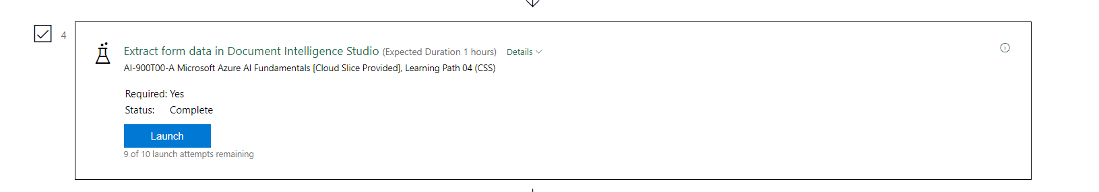

**Reflective Journal: Extracting Form Data in Document Intelligence Studio**

**Introduction**

This reflective journal documents my experience exploring Azure AI Document Intelligence Studio, particularly its prebuilt model for extracting structured data from unstructured forms and documents. The exercise demonstrated how the service enhances optical character recognition (OCR) by identifying and organizing key-value pairs and table information from receipts. This reflection highlights key insights, learning outcomes, and applications of Document Intelligence in real-world scenarios.

**Description of Experience**

**Background Information:**  
Azure AI Document Intelligence, formerly known as Azure Form Recognizer, builds on OCR by capturing the structure and context of extracted text. It converts unstructured text into meaningful data, enabling efficient storage, analysis, and processing. This functionality is invaluable for automating data entry and document management tasks.

**Specific Details:**  
In this exercise, I created a Document Intelligence resource in Azure Portal and connected it to the Document Intelligence Studio. Using the prebuilt receipt model, I analyzed a sample receipt from the fictitious Northwind Traders retail company. The analysis returned structured data fields, including:

* Merchant’s name, address, and phone number.
* Transaction date and time.
* Itemized list with subtotal, tax, and total amounts.

Confidence scores for each field highlighted the accuracy of the extraction.

**Personal Reflection**

**Thoughts and Feelings:**  
At the start, I was intrigued by the promise of transforming unstructured text into structured data. The ease of setting up the resource and running analyses exceeded my expectations. Observing the tool’s ability to extract detailed fields with high accuracy left me impressed and optimistic about its practical applications.

**Analysis and Interpretation:**  
This activity demonstrated how Document Intelligence bridges the gap between raw OCR output and actionable data. For example, the receipt analysis showcased the model’s capability to identify key fields with precision, highlighting its potential for automating processes in finance, retail, and logistics.

**Connections to Theoretical Knowledge:**  
The exercise reinforced theoretical concepts of natural language processing (NLP) and machine learning, specifically the importance of structured data in improving automation workflows. It also highlighted the integration of domain-specific prebuilt models, demonstrating how AI can tailor generic OCR capabilities to specialized use cases.

**Critical Thinking:**  
While the tool delivered excellent results, its reliance on prebuilt models may limit flexibility for niche applications. Additionally, the analysis revealed that certain confidence scores were lower for fields with less clarity, underscoring the need for robust model training and potential post-processing validation.

**Discussion of Improvements and Learning**

**Personal Growth:**  
This exercise deepened my appreciation for AI-powered automation in document processing. It also increased my confidence in using Azure AI services to simplify complex workflows, such as extracting transactional data from receipts.

**Skills Developed:**  
I acquired practical skills in:

* Provisioning and configuring Azure AI resources.
* Using prebuilt models to extract structured data.
* Interpreting confidence scores for quality assurance.

**Future Application:**  
These skills can be applied to real-world scenarios such as invoice processing, inventory management, and data entry automation. The ability to customize models further extends the applicability of Document Intelligence to industry-specific tasks.

**Conclusion**

**Summary:**  
This exercise demonstrated the capabilities of Azure AI Document Intelligence in extracting structured data from forms and documents. The prebuilt receipt model effectively showcased how unstructured text could be transformed into meaningful data fields, simplifying data processing.

**Final Thoughts:**  
The exercise reinforced the transformative potential of AI in document management and automation. Moving forward, I plan to explore custom models to address specific use cases and expand my understanding of Azure AI’s broader capabilities.

**References**

1. Microsoft Azure. (n.d.). *Document Intelligence Studio*. Retrieved from <https://formrecognizer.appliedai.azure.com/studio>
2. Microsoft Azure. (n.d.). *Azure Portal*. Retrieved from <https://portal.azure.com>