Game Design Document

Fill up the Following document

1. Write the title of your project.

Swing World

1. What is the goal of the game?

For the monkey to eat the golden banana

1. Write a brief story of your game?

A monkey is very hungry and his favorite food is fruits. He has to swing around the jungle to find fruits and eat them. He also has to avoid the veggies.

1. Which are the playing characters of this game?

* Playing characters are the ones which respond to the user based on the input from the user
* Cars, monkeys, dinos, wizards etc, are the playing characters in the game.

|  |  |  |
| --- | --- | --- |
| Number | Character Name | What can this character do? |
| 1 | The monkey | Swing on trees and eat the veggies |
| 2 |  |  |
| 3 |  |  |
| 4 |  |  |
| 5 |  |  |
| 6 |  |  |
| 7 |  |  |
| 8 |  |  |

1. Which are the Non Playing Characters of this game?

* Non Playing characters are the ones which don't have an action or a behaviour when the user interacts with the game.
* Hurdles, stones, bananas, coins, etc are non playing characters in the game.

|  |  |  |
| --- | --- | --- |
| Number | Character Name | What can this character do? |
| 1 | broccoli | Kill the monkey |
| 2 |  |  |
| 3 |  |  |
| 4 |  |  |
| 5 |  |  |
| 6 |  |  |
| 7 |  |  |
| 8 |  |  |

Draw your imagination of this game. What does this game look like?

* Draw the game either on your computer or on paper,
* Add images of scenes of the game to show each of the playing and non-playing characters at least once.

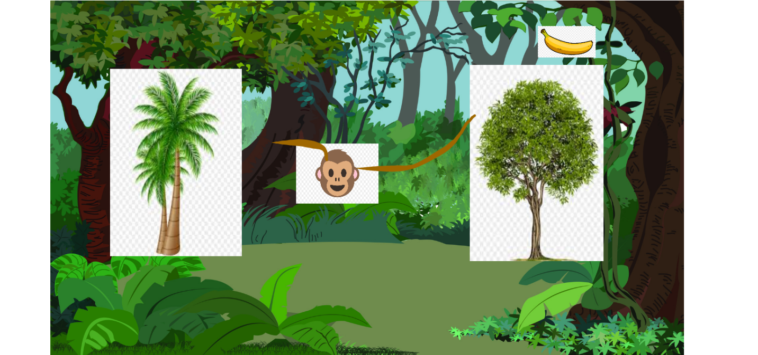

How do you plan to make your game engaging?

I plan to make adaptivity and make the game a little bit faster as it goes on.