

Communications Department

30, Janadhipathi Mawatha, Colombo 01, Sri Lanka. Tel : 2477424, 2477423, 2477311

Fax: 2346257, 2477739

E-mail: [dcommunications@cbsl.lk,](mailto:dcommunications@cbsl.lk) [communications@cbsl.lk](mailto:communications@cbsl.lk) Web: [www.cbsl.gov.lk](http://www.cbsl.gov.lk/)

Press Release

Issued By

Date

Economic Research Department 26-04-2016

**The Annual Report of the Central Bank of Sri Lanka for the Year 2015**

# The sixty sixth Annual Report of the Monetary Board of the Central Bank of Sri Lanka was presented to His Excellency the President Maithripala Sirisena and the Prime Minister, Hon. Ranil Wickremasinghe, while in terms of Section 35 of the Monetary Law Act No. 58 of 1949, it was also submitted to Hon. Ravi Karunanayake, the Minister of Finance by Mr. Arjuna Mahendran, the Governor of the Central Bank of Sri Lanka.

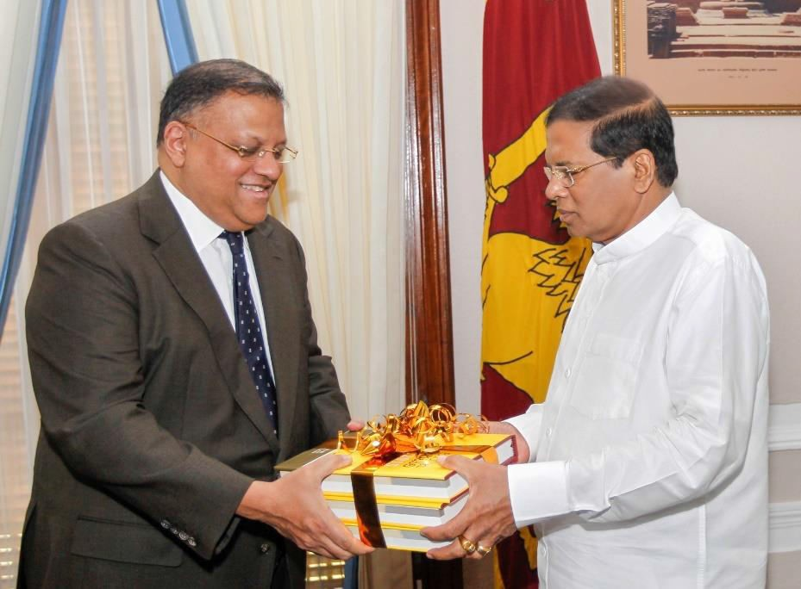

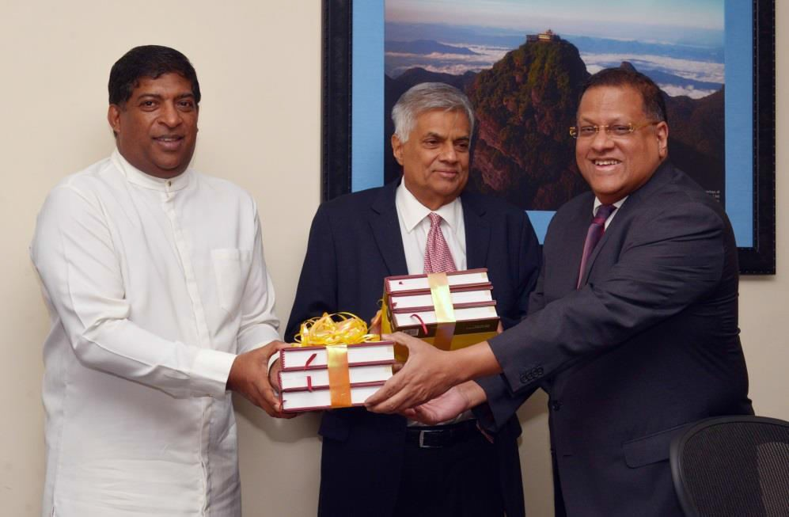

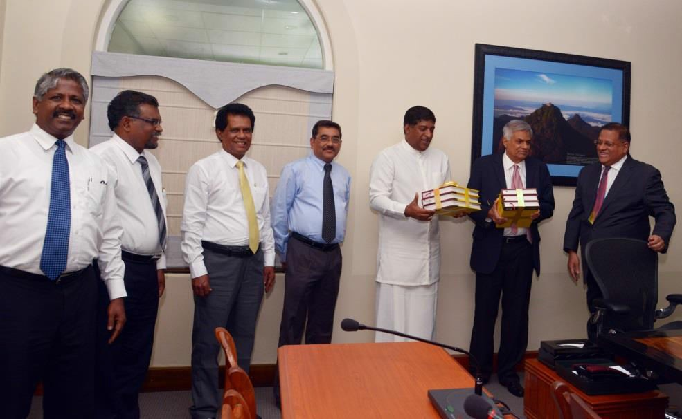

**[Mr. Arjuna Mahendran, the Governor of the Central Bank of Sri Lanka presenting the Annual Report 2015 to His Excellency the President Maithripala Sirisena, Hon. Ranil Wickremasinghe, Prime Minister and Minister of National Policy and Economic Affairs, and Hon. Ravi Karunanayake, the Minister of Finance. Dr. P. Nandalal Weerasinghe and Mr. S. Lankathilake, Deputy Governors of the Central Bank, Mr. K. D. Ranasinghe Assistant Governor of the Central Bank, and Mr. K.M. Mahinda Siriwardana, Director of Economic Research of the Central Bank are also in the photos.]**

# An overview of the Sri Lankan economy in 2015 as reflected in the Annual Report is given below:

**Real economic growth in Sri Lanka in 2015 registered 4.8 per cent, compared with 4.9 per cent in 2014.1** A slowdown in the growth of demand in Sri Lanka’s traditional export markets impacted the growth of the export sector while a strengthening US economy prompted short term capital outflows. The impact of these developments was offset to some extent by lower international commodity prices. Nevertheless, domestic consumption rebounded as incomes

grew, particularly among public sector workers. Agriculture and services related activities grew by 5.5 per cent and 5.3 per cent, respectively, while industry related activities grew by 3.0 per cent during 2015. Inflation, as measured by the year-on-year change in the Colombo Consumers’ Price Index (CCPI), was in negative territory during July-September 2015, mainly due to subdued commodity prices. This was the first time that inflation turned negative since March 1995. However, by end 2015, year-on-year headline inflation was recorded at 2.8 per cent, compared to 2.1 per cent at the end of 2014. Correspondingly, core inflation, which switches out energy and selected food items from the CCPI basket, grew from 0.8 per cent, on a year-on-year basis in February 2015, to reach 4.5 per cent at the end of the year. This was driven primarily by the enhanced growth of bank credit as well as higher wages afforded to government workers and employees in other sectors of the economy. Meanwhile, despite substantial gains from the lower oil prices and continued positive trends in the tourism sector, slowing down of net foreign exchange inflows, including worker remittances, and capital outflows, generated an overall deficit in the balance of payments (BOP). Efforts to reverse the downward trend in government tax and non-tax revenues were moderately successful, but overruns on the expenditure side of the government budget meant that the budget deficit grew to 7.4 per cent of Gross Domestic Product (GDP), as against the targeted deficit of 4.4 per cent. Central government debt grew to 76.0 per cent of GDP by the end of 2015. The new coalition government formed after the Presidential election in January 2015 focused on implementing the 100-day programme before the general election that was held in August 2015. The policy responses to volatile global economic conditions took time to evolve after the general election held in August 2015. In order to address the adverse implications of growing demand pressures on price and financial stability and help

1 In July 2015, the Department of Census and Statistics (DCS) changed the base year for national accounts statistics to 2010 from 2002, while adopting the United Nation’s System of National Accounts (SNA) 2008 standard. The improved compilation procedure captures the changes in the economic structure of Sri Lanka over the past decade and introduces new economic activities to the national accounts system. The rebased GDP estimates had varying effects on macroeconomic indicators. The analysis of the state of the Sri Lankan economy in 2015 provided in the CBSL Annual Report is based on new GDP estimates, which are provisional.

cushion pressure on the BOP, the Central Bank took early corrective action by imparting greater flexibility in the management of the exchange rate, enforcing the new macroprudential regulation of loan to value (LTV) ratio as a selective demand management instrument and tightening monetary policy through an upward adjustment of the Statutory Reserve Requirement (SRR) and also later increasing the Central Bank’s policy interest rates. A renewed focus on export led economic growth and the buttressing of collection of government revenue to contain the overhang of government debt are the key drivers of the government’s medium term economic strategy, and structural reforms proposed by the government towards this end are expected to be endorsed by the International Monetary Fund (IMF) as well.

**All three sectors of the economy contributed to real economic growth in 2015.** Services activities, which account for 56.6 per cent of GDP, grew by 5.3 per cent, buttressed by the growth in financial services (15.8 per cent), real estate activities (9.6 per cent), transport activities (5.5 per cent) and wholesale and retail trade (4.7 per cent). Despite the minor slowdown in construction (-0.9 per cent) and mining and quarrying (-0.9 per cent) activities, industry activities, which account for 26.2 per cent of GDP, grew by 3.0 per cent, mainly supported by the growth in manufacturing activities (4.7 per cent). Agriculture activities, which account for 7.9 per cent of GDP, expanded by 5.5 per cent, mainly due to the significant growth in growing of rice (23.3 per cent) and vegetables (24.9 per cent), amidst the contraction in fishing (-2.7 per cent), growing of rubber (-10.1 per cent) and growing of tea (-2.6 per cent). As per the expenditure approach, the growth in real GDP in 2015 was largely driven by an increase in consumption demand, while investment activities made a modest contribution. Domestic savings declined to 22.6 per cent of GDP in 2015, from 24.0 per cent of GDP in 2014. This, together with the deterioration of net primary income from the rest of the world, along with a reduction in earnings on investment and increased outflows, dampened national savings in 2015, although remittances increased marginally, in rupee terms. Accordingly, national savings declined to 27.8 per cent of GDP in 2015 from 29.5 per cent of GDP in the previous year. Meanwhile, as the decline in investments as a percentage of GDP was higher than the decline in national savings as a percentage of GDP, the savings-investment gap narrowed during 2015.

**The unemployment rate increased to 4.6 per cent during 2015, compared to 4.3 per cent recorded in 2014, amidst a marginal increase in labour force participation, particularly by females**. The female unemployment rate increased from 6.5 per cent to 7.6 per cent, while the

male unemployment rate declined from 3.1 per cent to 3.0 per cent in 2015, compared to 2014. The increase in unemployment among youth and those with GCE A/L and higher qualifications was notable. The labour force participation rate increased to 53.8 per cent in 2015, from 53.3 per cent in 2014, with increased participation of rural sector females in the labour force. Labour productivity increased during 2015, with positive contributions from all three sectors of the economy. Meanwhile, a sharp decline of 12.4 per cent was observed in the total number of departures for foreign employment, which could partly be attributed to escalated geo-political tensions and the slowdown of economic activity in the Middle East. This had an impact on the unemployment rate as well as the labour force participation rate.

**Inflation, based on CCPI (2006/07=100), remained below mid-single digit levels, supported by the downward adjustment of prices of several key consumer items, favourable supply side developments in the domestic and international markets, and well contained inflation expectations.** Headline inflation, as measured by the year-on-year change of CCPI, declined sharply from 3.2 per cent in January 2015 to 0.6 per cent in February 2015, with the price revisions introduced in the Interim Budget for 2015. Year-on-year Inflation remained below 1 per cent thereafter until September 2015, while recording negative inflation during July- September 2015. Inflation picked up in the fourth quarter of 2015, and recorded 2.8 per cent by end 2015. Annual average headline inflation declined from 3.3 per cent in 2014 to 0.9 per cent in 2015. Signalling the gradual buildup of demand pressures in the economy, CCPI based year-on- year core inflation increased to 4.5 per cent by end 2015 from 3.2 per cent at end 2014, although core inflation in terms of the annual average declined from 3.5 per cent in 2014 to 3.1 per cent in 2015. Meanwhile, in 2015, the DCS introduced the National Consumer Price Index (NCPI, 2013=100), which captures price movements of all provinces and changes in consumption patterns based on the findings of the Household Income and Expenditure Survey (HIES, 2012/13). Inflation based on NCPI was at 4.2 per cent on a year-on-year basis and 3.8 per cent on an annual average basis by end 2015. Wage inflation was particularly high in the public sector, as reflected by the change in the public sector wage rate indices, which registered 31.7 per cent in nominal terms and 27.0 per cent in real terms in 2015.

**The performance of Sri Lanka’s external sector reflected the impact of the changing global economic environment as well as a number of developments in the domestic economy.** In spite of the benefit of lower expenditure on fuel imports, the merchandise trade deficit widened

marginally by 1.7 per cent over the previous year, due to the increase in non-oil imports and the slowdown in export earnings. Continued increase in tourist arrivals and higher spending by tourists resulted in a growth in earnings from tourism, which contributed substantially to the improved performance of the services account during the year. The deficit in the primary income account continued to widen in 2015. However, the surpluses in the secondary income and services accounts helped abate a large deficit in the external current account. In absolute terms, the current account deficit expanded marginally in 2015, although as a percentage of GDP, the current account deficit reduced marginally to 2.4 per cent in 2015 from 2.5 per cent in 2014. The modest performance of the current account, together with the decline in inflows to the financial account, in the form of foreign direct investments (FDI) and loans to the government, banking and private sectors and the withdrawal of foreign investments from the government securities market, resulted in the balance of payments (BOP) recording a deficit of US dollars 1,489 million. Along with the deterioration of the BOP, the country’s gross official reserves declined to US dollars 7.3 billion by end 2015 from US dollars 8.2 billion at end 2014. Meanwhile, the rupee, which remained broadly stable during the first eight months of the year, depreciated at a faster pace from early September with the Central Bank’s decision to allow greater flexibility in the determination of the exchange rate, based on market forces. Accordingly, as of end 2015, the rupee had recorded a depreciation of 9.03 per cent against the US dollar.

**Although the Interim Budget for 2015 expected a sharp reduction in the budget deficit during the year, a number of developments challenged fiscal management, hindering the envisaged fiscal consolidation path.** The Interim Budget, which was presented following the Presidential election in January 2015, introduced several fiscal reforms aimed at realising the expected outcomes of the fiscal consolidation process. The government expected to reduce the budget deficit to 4.4 per cent of GDP in 2015 from 5.7 per cent recorded in 2014, while maintaining the central government debt to GDP ratio at 72.0 per cent in 2015, as per the targets outlined in the Medium Term Macro Fiscal Framework 2014-2017 of the Fiscal Management Report for 2015. Nevertheless, the fiscal sector performance deteriorated in 2015, resulting in deviations from the budgetary targets stipulated in the Interim Budget for 2015. The lower than expected collection of government revenue, high level of recurrent expenditure, particularly on salaries and wages, welfare expenditure, and higher than estimated outlay on interest payments, exerted a significant pressure on the overall budget deficit in 2015. Accordingly, the budget deficit increased from 5.7 per cent of GDP in 2014 to 7.4 per cent of GDP in 2015, significantly

overshooting the government’s original target of 4.4 per cent of GDP. The current account deficit, which reflects government dis-savings, increased to 2.2 per cent of GDP in 2015 from

1.2 per cent in the previous year, while the primary deficit, which excludes interest payments from the overall deficit, increased to 2.9 per cent of GDP from 1.5 per cent in 2014. The budget deficit was largely financed by domestic sources, given the slowdown in foreign financing during the year. The central government debt to GDP ratio increased to 76.0 per cent in 2015 from 70.7 per cent in 2014, reflecting the relatively high budget deficit, lower nominal GDP growth and the impact of exchange rate variation. This highlights the need for strong fiscal reforms to reduce the budget deficit and accumulation of debt.

**The Central Bank continued to maintain an accommodative monetary policy stance during the year in an environment of persistently low inflation, but initiated a gradual tightening of monetary policy from end 2015 with a view to preempting excessive demand pressures on inflation, emanating from high credit and money expansion.** Considering the sustained increase in credit flows to the private sector encouraged by the low interest rate environment that was maintained during the past few years, in March 2015, the Central Bank removed the restrictions placed on the access to its Standing Deposit Facility (SDF) under open market operations (OMO) that was in effect since September 2014. Consequent to this measure, to address the excessive volatility of short term interest rates, the Central Bank lowered its key policy interest rates, namely the Standing Deposit Facility Rate (SDFR) and the Standing Lending Facility Rate (SLFR), by 50 basis points to 6.00 per cent and 7.50 per cent, respectively, in April 2015. Nevertheless, as credit and monetary aggregates continued to expand at a faster pace than projected, the Central Bank commenced tightening monetary policy gradually towards end 2015. Accordingly, the SRR applicable on all rupee deposit liabilities of commercial banks was raised by 1.50 percentage points to 7.50 per cent to be effective from the reserve period commencing 16 January 2016, signalling the end of the relaxation cycle of monetary policy. Even prior to the commencement of monetary tightening, several policy measures were introduced in the last quarter of 2015 to contain excessive credit flows to selected sectors. Accordingly, a minimum cash margin requirement was imposed on Letters of Credit (LCs) opened for the importation of motor vehicles, which was replaced later on by a maximum Loan to Value (LTV) ratio, a macro prudential measure, on loans and advances granted for the purpose of purchase or utilisation of motor vehicles. These measures, along with greater flexibility allowed in the determination of the exchange rate and the changes to the tax structure made by

the government, were expected to contain excessive growth of personal loans and advances, while strengthening macroeconomic and financial system stability. Nevertheless, considering the possible aggravation of demand driven inflationary pressures due to continued high monetary expansion, as a preemptive policy measure, the Central Bank raised its SDFR and the SLFR by 50 basis points each, to 6.50 per cent and 8.00 per cent, respectively, effective from the close of business on 19 February 2016.

**Broad money (M2b) growth accelerated during 2015 due to the expansion in credit to both public and private sectors.** M2b increased by 17.8 per cent, year-on-year, by end 2015 compared to a growth of 13.4 per cent at end 2014, while the average broad money growth was

15.2 per cent during the year. As net foreign assets (NFA) of the banking system recorded a contraction during the year, the expansion in broad money was entirely due to the increase in net domestic assets (NDA) in 2015 underpinned by domestic credit expansion. NDA expanded by

26.0 per cent in 2015, driven by increased credit flows to both public and private sectors. Within NDA, net credit to the government (NCG) extended by the banking system increased substantially by Rs. 323.6 billion, exceeding the levels envisaged in the government budget. Meanwhile, the expansion in credit obtained by public corporations from the banking sector moderated marginally to Rs. 76.9 billion in 2015 in comparison to the increase of Rs. 80.9 billion observed in 2014. In response to the continued relaxed monetary policy stance, credit extended to the private sector by the banking system expanded at a high rate. By end 2015, credit to the private sector increased by 25.1 per cent on a year on year basis, compared to the 8.8 per cent growth recorded at end 2014. In absolute terms, credit to the private sector increased by Rs.

691.4 billion during the year compared to the increase of Rs. 223.9 billion in 2014. The acceleration of credit extended to the private sector was driven by persistently low market lending rates as well as the aggressive marketing campaigns by lending institutions to attract borrowers. Market interest rates remained low during 2015 although some upward movement was observed during the latter part of the year.

**In 2015, the financial sector demonstrated its resilience to volatile market conditions emanating from domestic and global uncertainties.** Business operations of the banking sector expanded, supported by increased credit demand against the backdrop of the low interest rate regime, increased profits and internal capital generation, which augmented the cushion available in the sector for absorbing risks arising from any adverse shocks. Asset quality of the banking

sector improved during the year. The finance and leasing companies sector also recorded improved performance as reflected in its increased relative share in terms of total assets of the domestic financial system. The Central Bank continued to take regulatory measures in 2015 to protect depositors’ and investors’ interest in a few liquidity threatened finance companies. The Primary Dealers of government securities showed moderate operating results in spite of rapid business expansion, while the liquidity issues faced by one primary dealer necessitated regulatory intervention to maintain investor confidence and facilitate smooth operations in the government securities market. Contractual savings institutions secured a return close to levels in previous years in spite of low market interest rates. Other non-banking financial institutions also recorded business growth, but with mixed operating performances given their business models and financial market conditions. During the year, domestic financial markets operated with relatively high volatility consequent to monetary and BOP conditions that emanated partly from global developments. Meanwhile, large and retail value national payments systems of the country operated smoothly without any major disruption and stability concerns, while facilitating the growing and changing payment needs of the financial sector and the general public, with improved efficiency and safety.

**The year 2015 highlighted the structural vulnerabilities of the economy that had built up over time, and decisive steps are necessary to correct these vulnerabilities to ensure the country’s progress along a high growth – low inflation path.** Short term fiscal and monetary stimuli are inadequate to support economic growth continuously, and tightening policy spaces and resource constraints point to the fact that such short term stimuli are no longer affordable. Therefore, it is necessary for the country to adopt a proper blend of structural reforms, including fiscal reforms on revenue and expenditure fronts as well as with regard to State Owned Enterprises (SOEs), ensure policy consistency and improve the ease of doing business in order to attract non debt creating capital flows. These reforms must aim at harnessing and synergising the country’s strengths, including its human capital, with greater participation of the private sector.

**It is expected that, with appropriate policies, the economy will return to a high growth path in the medium term.** Addressing the already identified constraints faced by the economy, including low government revenue to GDP ratios and excessive government expenditure, falling exports to GDP ratios and insufficient inflows of FDIs remain key ingredients to achieve sustained economic growth in the medium term. In addition, other structural and emerging

challenges that require the attention of the government include, putting in place more efficient systems to ensure the development of required skills to support the growing demand for high quality human capital; improving public transport to curb the economic loss caused by road traffic congestion; strengthening the national policy on renewable energy development and ensuring energy security; introducing robust market based pricing formulae for energy and public utilities; addressing issues in the agriculture sector, including low productivity, lack of diversification, food insecurity, and inefficiencies in water management; creating enabling socioeconomic infrastructure and lucrative livelihood opportunities amidst constraints on public resources; ensuring the sustainability of the public sector pension scheme while introducing market oriented pension and superannuation schemes that ensure the full coverage of the labour force; facilitating financial deepening through raising the efficiency of financial intermediation, introducing a diverse range of financial products and services, and improving access to formal finance as well as building external and domestic policy buffers to sustain a robust growth trajectory over the medium to long term.