Sri Lanka Institute of Information
Technology


BSc (Hons) in Information Technology
Specializing in Data Science
IT3021 – Data Warehousing and Business Intelligence
Year 3
Assignment 1
Semester 1, 2025

IT23547438
R.M.A.K.Rathnayaka

Table of Contents

1. Data Set Selection
1.1 Introduction
1.2 Dataset Overview
1.3 Source Types and Formats
1.4 Coverage and Realism
1.5 Suitability for Data Warehousing and BI
1.6 Entity–Relationship Diagram of the Source Dataset

2. Source Data Description
2.1 SQL Server Database Source
2.2 CSV File Source

3. Solution Architecture
3.1 Architectural Diagram
3.2 Component Summary

4. Data Warehouse Design & Development
4.1 Dimensional Model Description
4.2 Relational Diagram
4.3 Design Assumptions

5. ETL Development
5.1 SSIS Packages Overview
5.2 Connection Managers
5.3 Package 1
5.4 Package 2

5.5 Package 3
6. Conclusion

Introduction
In today’s data-driven world, businesses generate large volumes of data from various operational processes such as transactions, customer interactions, and service operations. In the food delivery industry, platforms like Foodpanda handle thousands of orders, customer activities, and delivery processes daily. To effectively analyze this data and support strategic decision-making, organizations require robust data warehousing and business intelligence (DWBI) solutions.
This assignment focuses on designing and implementing a complete data warehouse solution for a Food Delivery System based on a Foodpanda-style dataset. The objective is to simulate a real-world business scenario where data is collected from multiple heterogeneous sources, including structured OLTP databases and external flat files. This reflects real enterprise environments where data integration and transformation are critical challenges.
The solution is developed through several stages, including dataset selection, source data preparation, architecture design, dimensional modeling, and ETL implementation using SQL Server Integration Services (SSIS). A star schema is designed to organize the data into fact and dimension tables, enabling efficient analytical queries. Key data warehousing techniques such as Slowly Changing Dimensions (Type 2) for tracking customer history, derived column transformations, and accumulating fact updates for order completion tracking are incorporated into the solution.
The ETL process extracts data from source systems, stages it for transformation, and loads it into the data warehouse while ensuring data quality and consistency. Lookup transformations are used for surrogate key generation, and business logic is applied to calculate derived measures such as transaction processing time.
The final data warehouse provides a structured and scalable foundation for future reporting, OLAP analysis, and dashboard development using tools such as Power BI or SQL Server Analysis Services (SSAS). This project demonstrates how raw transactional data can be transformed into meaningful insights to support business decision-making in a food delivery environment.

Step 1: Data Set Selection

1.1 Introduction
For his assignment, a realistic and custom-designed Food Delivery System dataset inspired by a Foodpanda-style platform was selected as the OLTP dataset. This dataset represents the core operations of a food delivery business, including customer management, restaurant listings, menu items, order processing, and customer feedback.
The dataset was specifically created for this assignment and has not been used in any lab sessions. It follows a normalized OLTP structure and does not contain any predefined fact or dimension tables. Additionally, it does not use any standard sample datasets such as AdventureWorks.
The selected dataset reflects a practical real-world business scenario, making it highly suitable for demonstrating key concepts of data warehousing, ETL processing, and business intelligence. It also enables the integration of multiple data sources, including structured database tables and external flat files, which is a common requirement in enterprise data environments.

1.2 Dataset Overview
The dataset simulates operational data for a food delivery platform over a one-year period (2025–2026). It includes realistic transaction records and maintains proper relationships between entities, ensuring logical consistency and referential integrity.
The dataset was extended to represent continuous business operations such as customer ordering behavior, restaurant activity, and delivery outcomes. This makes it suitable for analytical processing and data warehouse design.
Key Entities:
- Customer
Contains customer demographic and behavioral information such as gender, city, signup date, order frequency, loyalty points, and churn status.
- Restaurant
Stores details about restaurants, including restaurant name and location.
- Dish
Represents menu items offered by restaurants, including dish name, category, and associated restaurant.
- OrderHeader
Captures high-level order information such as customer, order date, payment method, and delivery status.
- OrderDetail
Contains detailed order-level data, including dishes ordered, quantity, and price.
- CustomerRating
Stores customer feedback and ratings given for completed orders.
- CustomerProfileExtra (CSV File)
External flat file containing additional customer attributes such as updated city, loyalty points, and churn status, used to simulate integration of heterogeneous data sources.

1.3 Source Types and Formats
To simulate a realistic enterprise data environment, the dataset was distributed across multiple data sources. This approach reflects real-world scenarios where organizations integrate data from both structured databases and external files.
Source Type | Example Files/Tables Description
SQL  Database | _{FoodpandaSourceDB} Contains normalized OLTP tables such as Customer, Restaurant, Dish, OrderHeader, OrderDetail, and CustomerRating.
CSV File | _{CustomerProfileExtra} Contains additional customer-related attributes such as city updates, loyalty points, and churn status.
The SQL database represents the primary transactional system, while the CSV file simulates an external data source originating from non-relational systems such as third-party services or exported reports.
This multi-source setup demonstrates the ability of SQL Server Integration Services (SSIS) to extract and integrate data from heterogeneous sources. It also highlights the importance of data staging, transformation, and consolidation in building a unified data warehouse.

1.4 Coverage and Realism
The dataset was designed to include sufficient variety and complexity to support key data warehousing and analytical requirements within a food delivery business context.
- Time coverage:
The dataset represents transactional data over a full operational period (2025–2026), enabling time-based analysis of customer behavior and order trends.
- Diverse payment methods:
Includes multiple payment options such as Cash, Card, and Online payments, allowing analysis of customer payment preferences.
- Order lifecycle scenarios:
Covers different delivery outcomes such as delivered, cancelled, and pending orders, supporting operational performance analysis.
- Customer behavior data:
Includes attributes such as order frequency, loyalty points, and churn status, enabling customer segmentation and retention analysis.
- Menu diversity:
Multiple dishes categorized under different food types (e.g., fast food, beverages, meals), linked to various restaurants.
- Multiple items per order:
Each order can contain multiple dishes, supporting detailed transactional and basket analysis.
- Restaurant diversity:
Includes multiple restaurants across different locations, allowing geographic and business performance comparisons.
- Customer feedback data:
Ratings and feedback are captured through the CustomerRating table, enabling quality and satisfaction analysis.
- External data integration:
The CustomerProfileExtra.csv file introduces additional customer attributes from an external source, demonstrating real-world data integration scenarios.

1.5 Suitability for Data Warehousing and BI
The dataset satisfies all major requirements specified in the assignment, ensuring that it is suitable for implementing a complete data warehousing solution:
Requirement | Details
OLTP structure | Normalized database (FoodpandaSourceDB) containing transactional tables such as Customer, Restaurant, Dish, OrderHeader, OrderDetail, and CustomerRating.
Novel scenario | Custom food delivery system inspired by a Foodpanda-style platform, not used in lab work or based on standard datasets.
One year of data | Represents continuous operational data for a full period (2025–2026), enabling time-based analysis.
Multiple source types | Combines SQL Server database tables with an external CSV file (CustomerProfileExtra.csv).
Complex ETL support | Includes Slowly Changing Dimension Type 2 (for DimCustomer), derived columns (e.g., SalesAmount), and accumulating fact updates (order completion tracking).
Warehouse-ready dimensional modeling | Supports a star schema design with one fact table (FactOrders) and multiple dimension tables (DimCustomer, DimRestaurant, DimDish, DimPaymentDelivery, DimDate).

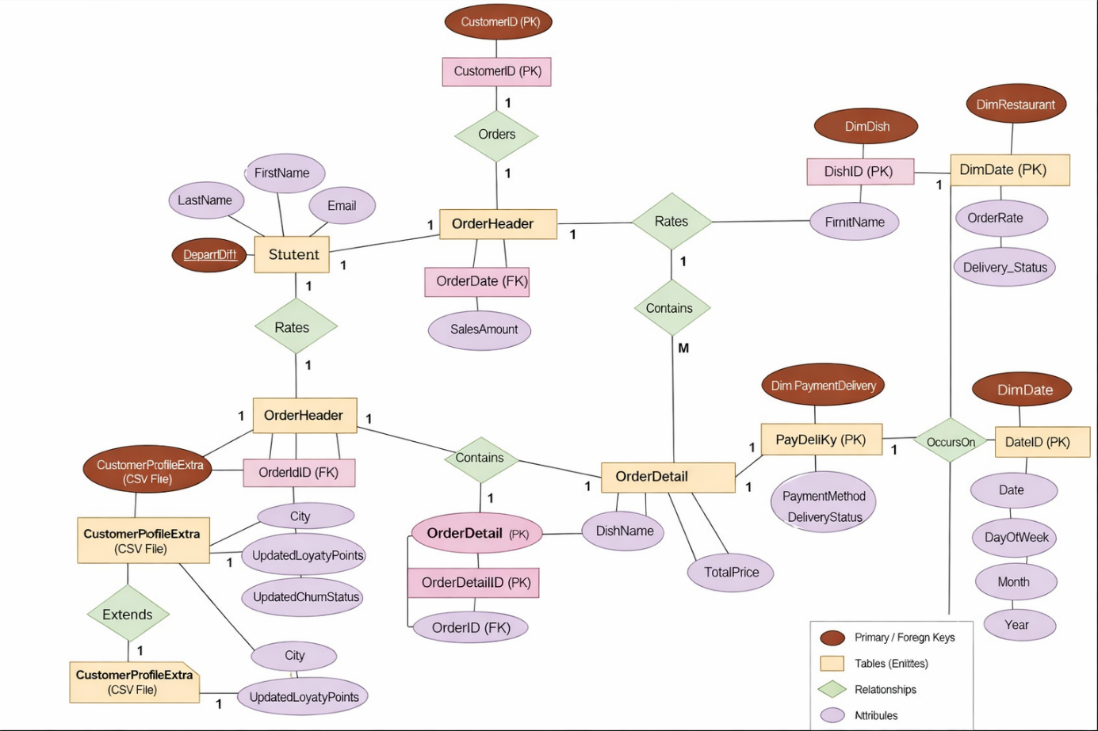
1.6 Entity–Relationship Diagram of the FoodPanda Source Dataset

Step 2: Source Data Description
To simulate a realistic enterprise data warehousing environment, the source data for this project was extracted from two distinct systems: a structured SQL Server database and an external flat file. These heterogeneous sources were selected to demonstrate the ability of the ETL process to handle different data formats while ensuring data integration, consistency, and accuracy.

2.1 SQL Server Database Source
The primary source system is a normalized OLTP-style SQL Server database named FoodpandaSourceDB. This database represents the core transactional operations of a food delivery platform and contains several interrelated tables, including:
- Customer – Contains customer demographic and behavioral information such as gender, city, signup date, order frequency, loyalty points, and churn status.
- Restaurant – Stores details about restaurants, including restaurant name and location.
- Dish – Represents menu items offered by restaurants, including dish name, category, and associated restaurant.
- OrderHeader – Captures high-level order information such as customer ID, order date, payment method, and delivery status.
- OrderDetail – Contains detailed order-level data, including dishes ordered, quantity, and price for each order.
- CustomerRating – Stores customer feedback and ratings for completed orders, enabling quality and satisfaction analysis.
All tables in this source system are fully normalized and maintain referential integrity through well-defined primary and foreign key relationships. Data from these tables was extracted using SQL queries and loaded into staging tables using SSIS data flow tasks.

2.2 Text File Source
In addition to the structured database, an external flat file named CustomerProfileExtra.csv was used to simulate data originating from a non-database system, such as third-party services or exported reports.
This file contains additional customer-related attributes and includes the following fields:
- CustomerID
- City (Updated)
- UpdatedLoyaltyPoints
- UpdatedChurnStatus

The file is formatted as a CSV (Comma-Separated Values) file, allowing easy parsing during the ETL process. It was integrated into the ETL pipeline using a Flat File Connection Manager in SSIS and loaded into a staging table.
This integration demonstrates the flexibility of SSIS in handling heterogeneous data sources and highlights how external data can be merged with internal transactional data to enrich the data warehouse.

Step 3: Solution Architecture
A high-level Data Warehouse (DW) and Business Intelligence (BI) solution architecture was designed to support the integration, transformation, and analysis of food delivery data. The architecture reflects a realistic enterprise BI pipeline, starting from operational data sources and ending with user-facing analytical tools.

3.1 Architectural Diagram
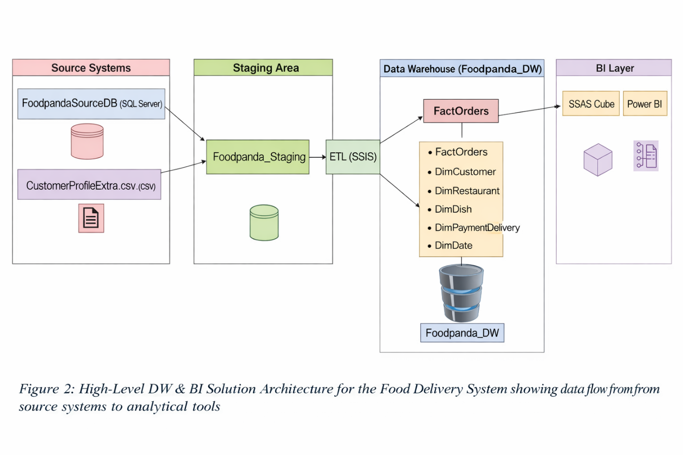
The following diagram illustrates the key components of the DW & BI solution implemented for the University Enrollment System.

3.2 Component Summary
Layer | Component | Description
Source Systems | FoodpandaSourceDB (SQL Server) | The primary OLTP system containing normalized tables such as Customer, Restaurant, Dish, OrderHeader, OrderDetail, and CustomerRating.
 | CustomerProfileExtra.csv | External flat file containing additional customer attributes such as loyalty points and churn status, simulating third-party data integration.
Staging Area | UniversityEnrollment_Staging | A temporary area where data from both sources is loaded, cleansed, and transformed before being moved to the data warehouse.
ETL  Process | SSIS (SQL Server Integration Services) | Extracts data from sources, performs transformations such as SCD Type 2, derived columns (e.g., SalesAmount), and accumulating fact updates, then loads data into the warehouse.
Data  Warehouse Foodpanda_DW |  | A dimensional model implemented using a star schema. It includes one fact table (FactOrders) and multiple dimension tables (DimCustomer, DimRestaurant, DimDish, DimPaymentDelivery, DimDate).

Step 4: Data Warehouse Design & Development
A star schema-based dimensional model was developed for the Food Delivery System. This design provides an analytical foundation for exploring customer ordering behavior, restaurant performance, dish popularity, payment and delivery outcomes, and time-based order trends. The schema includes one central fact table (FactOrders) and multiple related dimension tables, satisfying the assignment requirements.

4.1 Dimensional Model Description
Table | Type | Description
FactOrders | Fact Table | Captures order-level facts for each ordered dish, including quantity, unit price, sales amount, rating, loyalty points, and derived metrics such as transaction processing time.
DimCustomer | Dimension | Contains customer demographics and behavioral attributes. Implements SCD Type 2 logic to track changes in customer city, order frequency, loyalty points, and churn status over time using StartDate, EndDate, and IsCurrent.
DimRestaurant | Dimension | Stores restaurant-related information such as restaurant name and city, enabling reporting by restaurant and location.
DimDish | Dimension | Provides dish-level metadata such as dish name and category, supporting menu analysis and product-level reporting.
DimPaymentDelivery | Dimension | Combines payment method and delivery status into a single dimension for analyzing payment behavior and delivery performance.
DimDate | Dimension | A date reference table that enables analysis by day, week, month, quarter, and year. It supports time-based slicing of order and rating events.

4.2 Relational Diagram
The star schema ER diagram is presented on the next page (Figure 3)

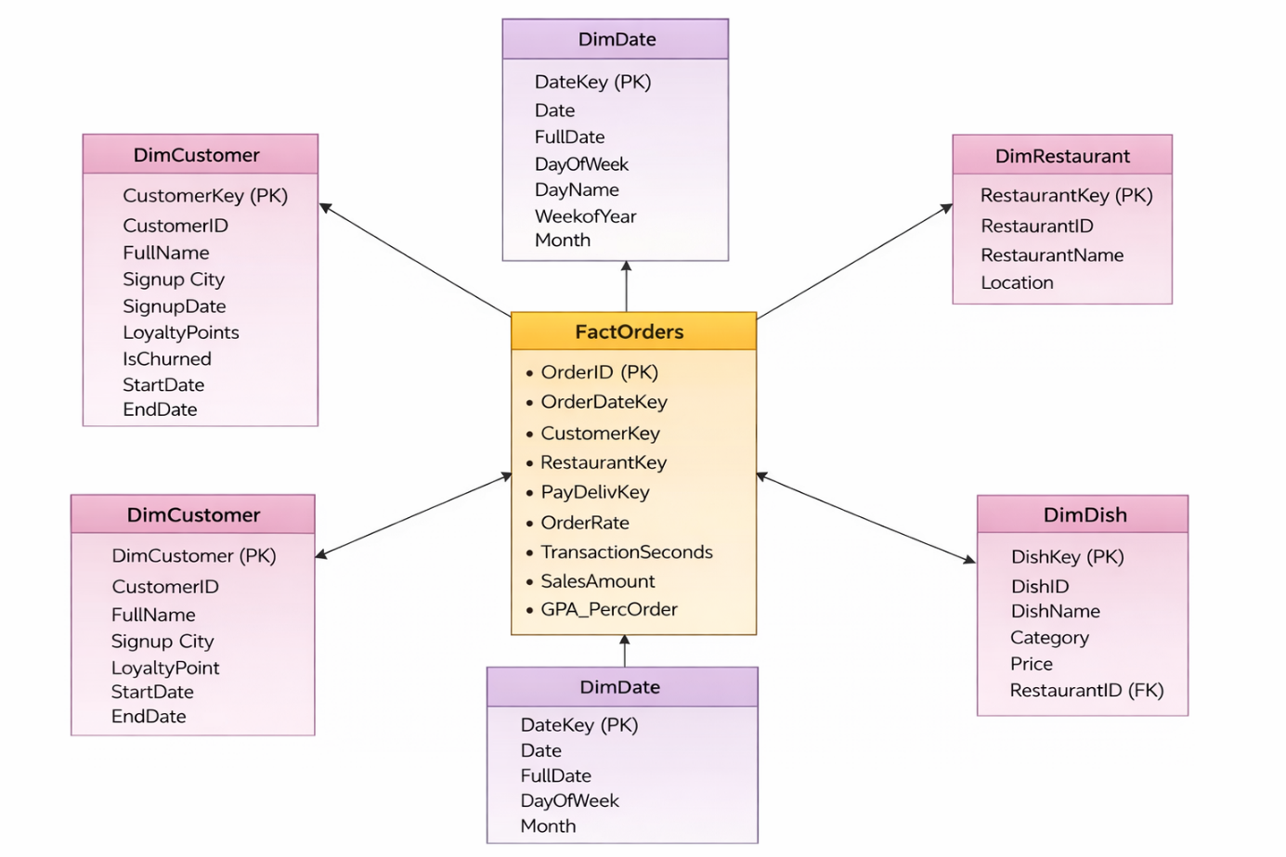

4.3 Design Assumptions
- A star schema was chosen for its simplicity and strong performance in reporting and analytical scenarios.
- The FactOrders table includes one record per ordered dish within an order.
- DimCustomer handles historical customer changes using Slowly Changing Dimension Type 2 logic.
- DimDate is a conformed dimension that supports multiple date roles such as order date and rating date.
- SalesAmount is a derived metric created during ETL as Quantity × UnitPrice.
- txn_process_time_hours is a derived metric calculated after completion-time updates in the accumulating fact process.
- The fact table links to dimension tables using surrogate keys such as CustomerKey, RestaurantKey, and DishKey.
- Reporting hierarchies can be derived through dimensions, such as:
  - Year → Quarter → Month → Day
  - City → Restaurant
  - Category → Dish

Step 5: ETL Development
To populate the data warehouse with clean, consistent, and integrated data, multiple ETL packages were developed using SQL Server Integration Services (SSIS). The ETL process was structured into three main stages:
- Data Extraction to Staging Area
- Transformation and Loading to the Data Warehouse
- Updating Accumulating Fact Table Attributes
Each stage demonstrates key SSIS functionalities such as connection configuration, control flow and data flow design, data transformations, lookup operations, and loading data from multiple heterogeneous sources.

5.1 SSIS Packages Overview
Four SSIS packages were created to organize the ETL workflow logically and modularly:
Package Name Purpose
Foodpanda_Load_Staging.dtsx Extracts data from the OLTP database and CSV file into staging
tables.
Foodpanda_Load_DW.dtsx Transforms and loads data into dimension and fact tables using star
schema design.
_{UpdateFactOrders.dtsx} Updates accumulating fact attributes such as completion time and transaction duration.

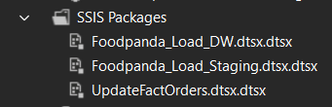

Figure 5.1: SSIS package modules as seen in Solution Explorer.

5.2 Connection Managers
All ETL packages utilize multiple connection types to handle data from both relational databases and external flat files. These connection managers enable seamless integration between heterogeneous data sources within the ETL process.
The following connections were configured:

🔹 SQL Server – OLE DB Connections
- FoodpandaSourceDB (Source OLTP Database)
Contains normalized transactional data such as Customer, Restaurant, Dish, OrderHeader, OrderDetail, and CustomerRating.
- Foodpanda_Staging (Staging Database)
Temporary storage area used to hold extracted data before transformation and loading into the data warehouse.
- Foodpanda_DW (Data Warehouse)
Stores the dimensional model including FactOrders and dimension tables.

🔹 Flat File Connections
- CustomerProfileExtra.csv
External CSV file containing additional customer attributes such as updated loyalty points and churn status.
- FactOrdersCompletion_1000.csv
CSV file used to simulate delayed transaction completion events, providing completion timestamps for updating the accumulating fact table.

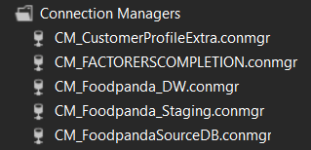

Figure 5.2a–c: Connection Manager panels showing database and flat file sources.

5.3 Package 1: University_Load_Staging.dtsx
This package is responsible for extracting raw data from source systems and loading it into staging tables. The staging layer acts as an intermediate storage area where data is temporarily held before transformation and loading into the data warehouse.
The control flow of this package consists of multiple sequential data flow tasks, each responsible for loading a specific entity into its corresponding staging table.

The following tasks are executed sequentially:
- Truncate Staging Tables
Clears existing data from staging tables to ensure fresh data loading during each ETL execution.
- Load Customer Data
Extracts customer data from the OLTP database and loads it into StgCustomer.
- Load Restaurant Data
Extracts restaurant information and loads it into StgRestaurant.
- Load Dish Data
Loads menu item details into StgDish.
- Load Order Header Data
Loads high-level order information into StgOrderHeader.
- Load Order Detail Data
Loads detailed order-level data into StgOrderDetail.
- Load Customer Rating Data
Loads customer feedback and ratings into StgCustomerRating.
- Load Customer Profile Extra (CSV)
Loads external data from CustomerProfileExtra.csv into StgCustomerProfileExtra.

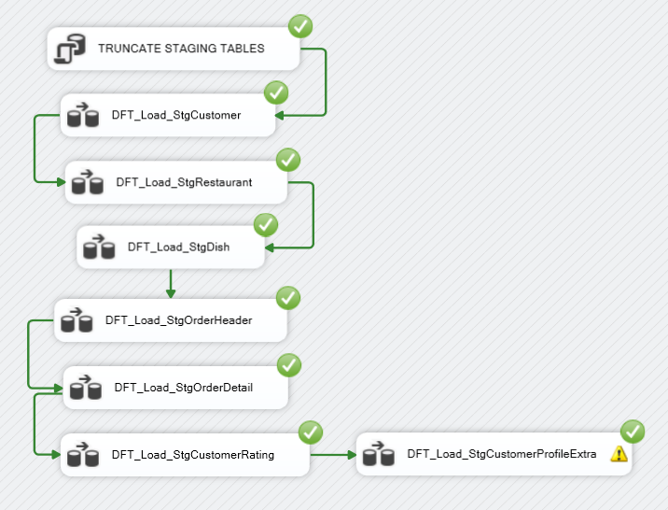
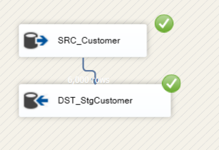
Figure 5.3: Control Flow in Foodpanda_Load_Staging.dtsx showing sequential staging tasks

Figure 5.3a–c: Data flow for loading Customer data from source to StgCustomer

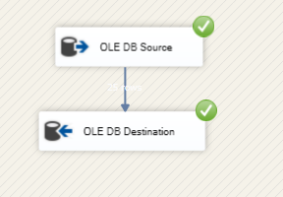

Figure 5.3b: Data flow for loading Restaurant and Dish data into staging tables


Figure 5.3c: Data flow for loading external CSV data into staging table

5.4 Package 2: University_Load_DW.dtsx
This package is responsible for transforming cleaned staging data and loading it into the dimensional model of the data warehouse. It includes loading dimension tables followed by the fact table, ensuring referential integrity using surrogate keys.
The execution order ensures that all dimension tables are populated before loading the fact table.
The tasks are executed in the following sequence:
- Clear Fact Table
- Clear Dimension Tables
- Load DimCustomer (SCD Type 2)
- Load DimRestaurant
- Load DimDish
- Load DimPaymentDelivery
- Load FactOrders
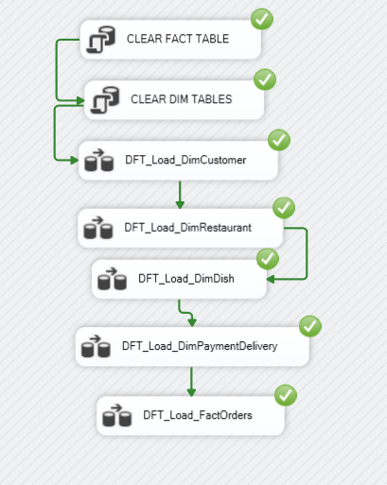
Figure 5.4: Control Flow in Foodpanda_Load_DW.dtsx showing dimension and fact loading sequence

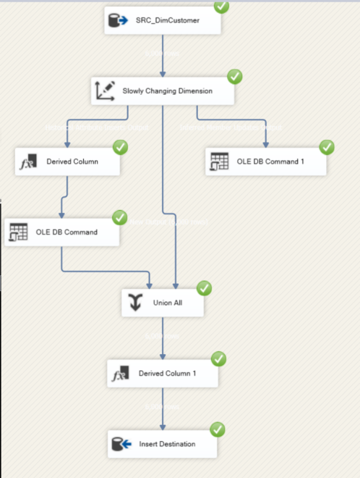

Figure 5.4a: Data Flow for DimCustomer using Slowly Changing Dimension Type 2
Customer data is extracted from the staging table and processed using a Slowly Changing Dimension (Type 2) transformation. This allows tracking historical changes such as city and loyalty points. New records are inserted directly, while updated records expire the old version and create a new current record with updated values.

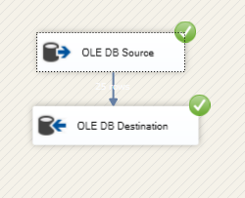
Figure 5.4b: Loading DimRestaurant
Restaurant data is loaded from the staging table into the dimension table using a simple OLE DB Source to Destination flow. Since restaurant data changes infrequently, no complex transformations are required.



Figure 5.4c: Loading DimDish
Dish data is extracted from staging and enriched using a Lookup transformation to retrieve the corresponding RestaurantKey. The transformed data is then loaded into the DimDish table to maintain proper relationships.



Figure 5.4d: Loading DimPaymentDelivery
Payment and delivery information is loaded into the dimension table directly from staging. This dimension contains a small set of static values, so it does not require complex transformations.

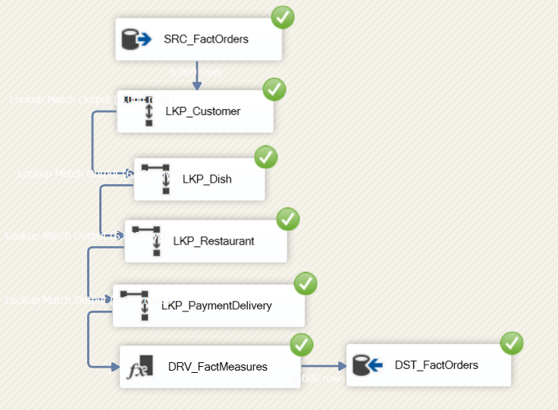

Figure 5.4e: Loading FactOrders
Payment and delivery information is loaded into the dimension table directly from staging. This dimension contains a small set of static values, so it does not require complex transformations.

5.5 Package 3: UpdateFactOrders.dtsx
This package demonstrates the implementation of accumulating snapshot logic by updating the existing FactOrders table using external completion data. It enhances the fact table by adding completion timestamps and calculating transaction duration.
The process includes:
- Truncate Staging Table – Clears previous completion data
- Stage Completion Data – Loads CSV data into staging
- Update FactOrders – Updates completion time and calculates processing duration
This approach ensures the fact table remains analytically enriched while maintaining historical accuracy.
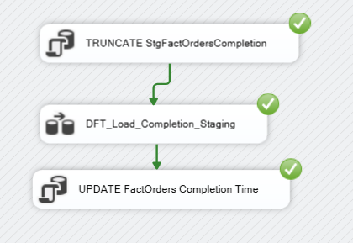
Figure 5.5: Control Flow for UpdateFactOrders.dtsx showing accumulating fact update process

5.5a Staging Completion Data

Completion data is extracted from a CSV file and loaded into the staging table. A Flat File Source reads the data, and a Data Conversion transformation ensures compatibility with database data types before loading into the staging table.
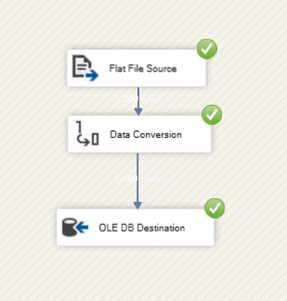
Figure 5.5a Data flow for loading completion data from CSV into staging table

5.5b Updating FactOrders
After staging, an SQL update operation is executed to update the fact table. The completion timestamp is added, and the transaction processing time is calculated using the difference between creation time and completion time. 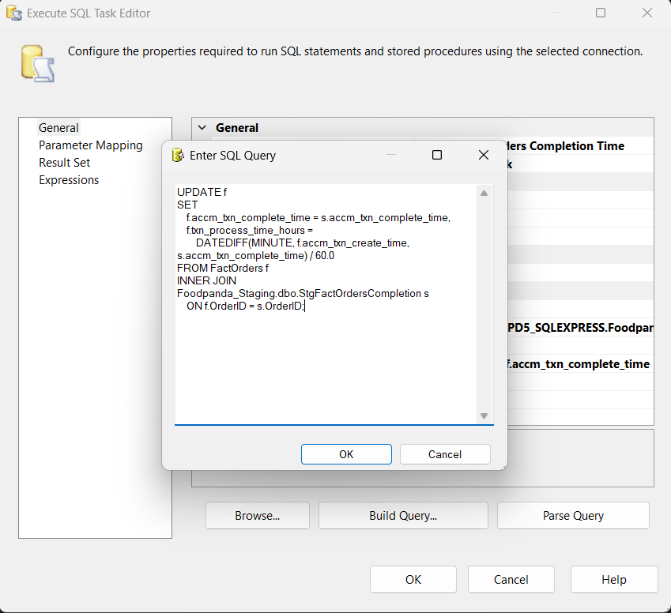
Figure 5.5b: 5.5b – SQL Update

6.0 Conclusion
This assignment successfully demonstrated the design and implementation of a complete data warehouse solution for a Foodpanda-style online food ordering system. The project involved integrating data from a normalized OLTP database and external CSV files, simulating a realistic enterprise data environment with heterogeneous data sources.
The data was extracted, staged, and transformed using SQL Server Integration Services (SSIS), with clearly structured control flows and data flows. A star schema-based dimensional model was implemented, consisting of one central fact table (FactOrders) and multiple dimension tables such as DimCustomer, DimRestaurant, DimDish, DimPaymentDelivery, and DimDate. This design supports efficient and scalable analytical querying.
Key data warehousing concepts were successfully applied, including Slowly Changing Dimensions (Type 2) for tracking customer history, Lookup transformations for surrogate key mapping, Derived Column transformations for calculating business measures, and accumulating snapshot logic for updating transaction completion details.
The modular ETL architecture, implemented using multiple SSIS packages, improved maintainability and ensured a clear separation between staging, warehouse loading, and fact table updates. Additionally, the integration of external CSV data demonstrated the system’s ability to handle real-world data integration challenges.
Although OLAP cube development and reporting are beyond the scope of this assignment, the implemented data warehouse is fully compatible with tools such as SSAS and Power BI for advanced analytics and visualization.
Overall, this project provided valuable hands-on experience in data integration, dimensional modeling, ETL development, and data quality management, reinforcing key concepts in data warehousing and business intelligence.

