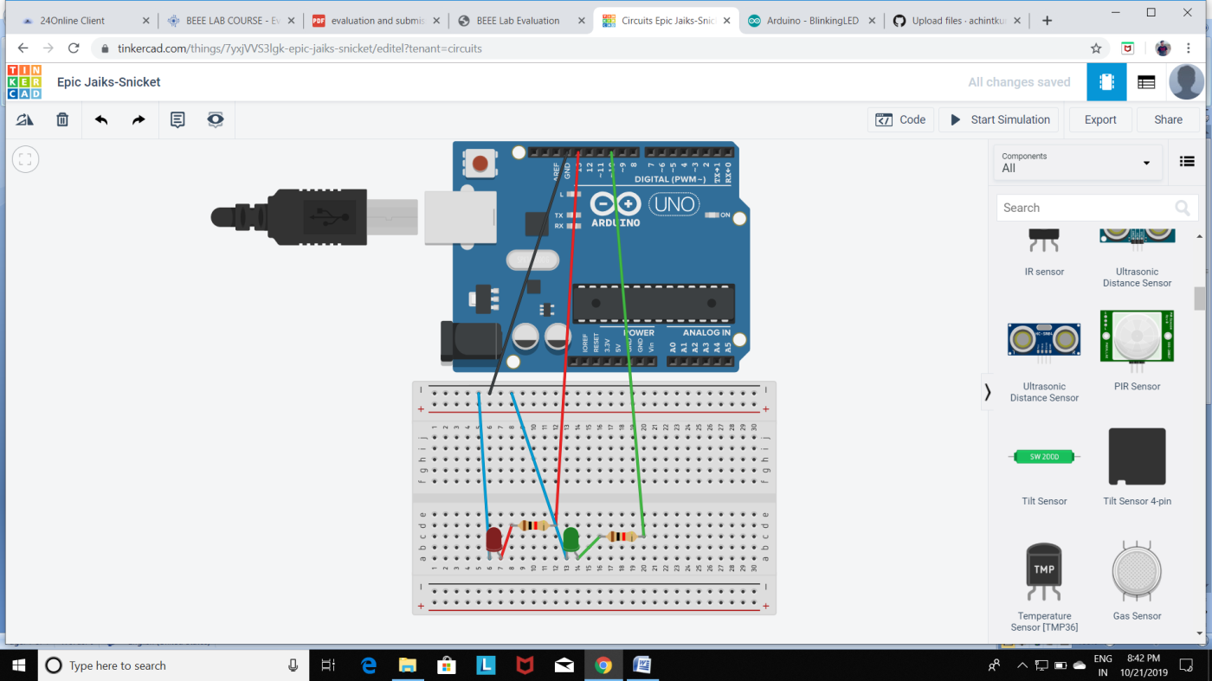

**Aim: . Design a system for LPG gas burners such that, whenever it is turned on, a green LED starts blinking and if it stays on for more than 2000 ms, instead of the green LED, a Red LED starts blinking.**

.

**Observation:**

When the system for LPG gas burner turned on , a green LED gstaets blinking **and if it stays on for more than 2000 ms, instead of the green LED, a Red LED starts blinking**

**Precaution:**

1. Connection must be made carefully with the breadboard and Arduino.
2. Wire should be connected to the pin which is defined in the program.
3. Code should be in case sensitive form.
4. While making connections connection of the breadboard should be kept in mind.

**Learning Outcome:**

1. We get better understanding of Arduino and its components.
2. We get some skills to use various sensor along with Arduino.