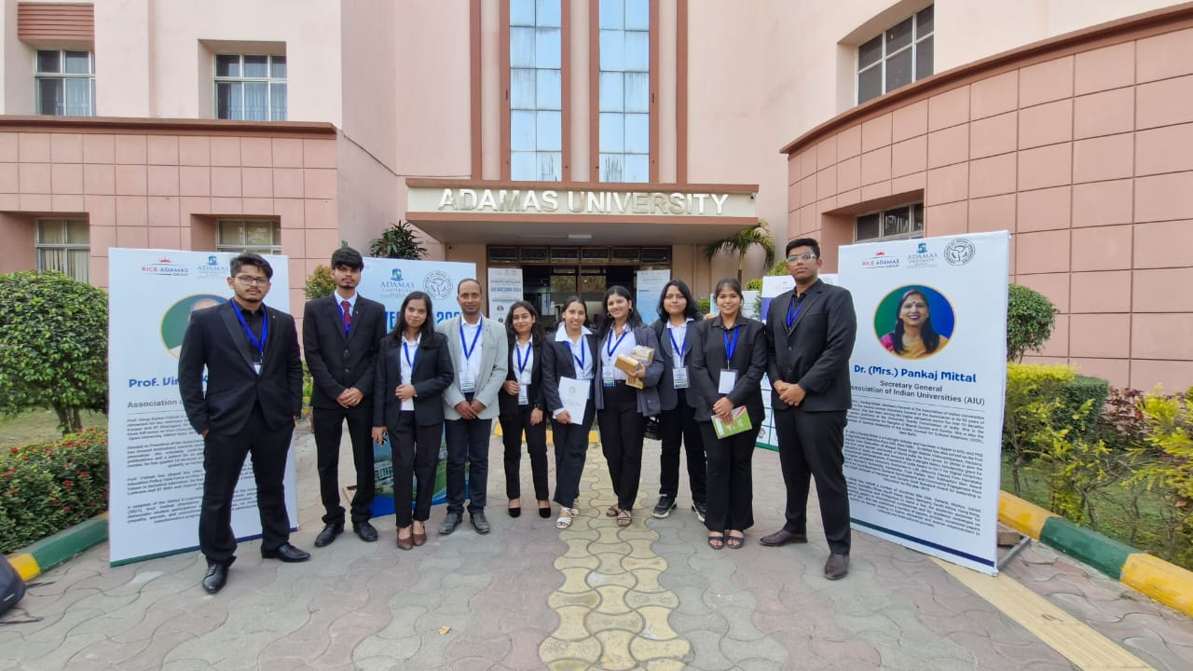

Guided by excellence! KSRC students with their mentor, showcasing the power of teamwork and innovation at AIU Anveshan 2024

**KSRC students shine at AIU Anveshan 2024 – East Zone**

The **AIU ANVESHAN 2024** East Zone event was hosted by **Adamas University, Kolkata** on January 17th and 18th, 2025. This annual convention, organized by the **Association of Indian Universities (AIU)**, serves as a platform for students across India to present and discuss their research projects. The East Zone event brought together participants from universities in India's eastern and central regions.

The convention featured a variety of research presentations, and discussions, fostering academic collaboration and innovation among students and faculty. It allowed young researchers to showcase their work, receive feedback, and engage with peers and experts in their respective fields.

The students of the KIIT Student Research Centre (KSRC) showcased their talent by presenting five innovative projects in the categories of **Engineering and Technology** and **Interdisciplinary Research**.

Among their remarkable achievements, the team comprising **Anchal Batra, Smriti Jha, and Vidhi Vanshita Jha** secured the **3rd position in the Interdisciplinary Research category**, earning accolades for their innovative and impactful work. Their project was guided by their mentor, **Dr. Akhilesh Kumar Dewangan**, whose support and expertise were instrumental in their success.

This outstanding performance has also qualified the team for the **National Round of AIU Anveshan 2024**, which will be held on **March 10th and 11th at Chitkara University, Punjab**.

The success of the KSRC students at AIU ANVESHAN 2024 reflects their dedication to advancing knowledge and contributing to cutting-edge research. Their qualification for the national level is a testament to their hard work and the quality of their projects.

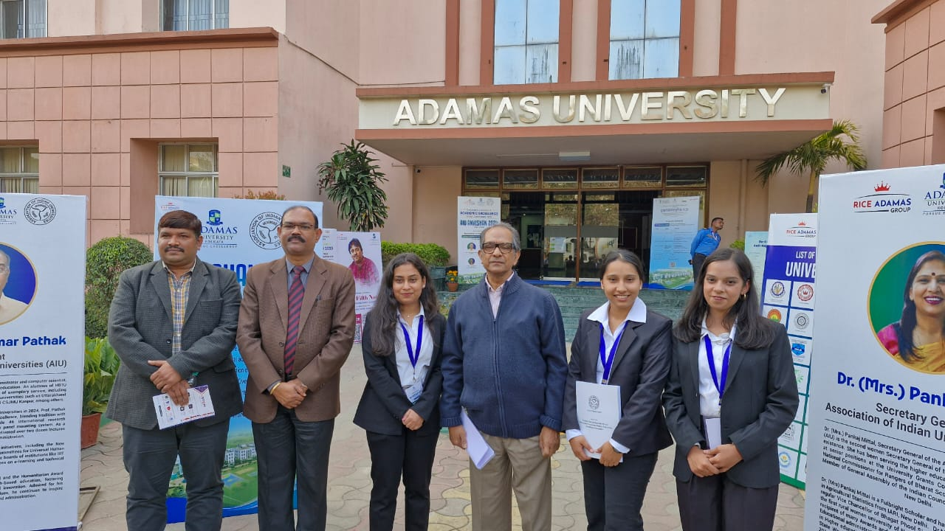

Celebrating success! The winning team poses with dignitaries and organizers after their stellar performance at AIU Anveshan 2024

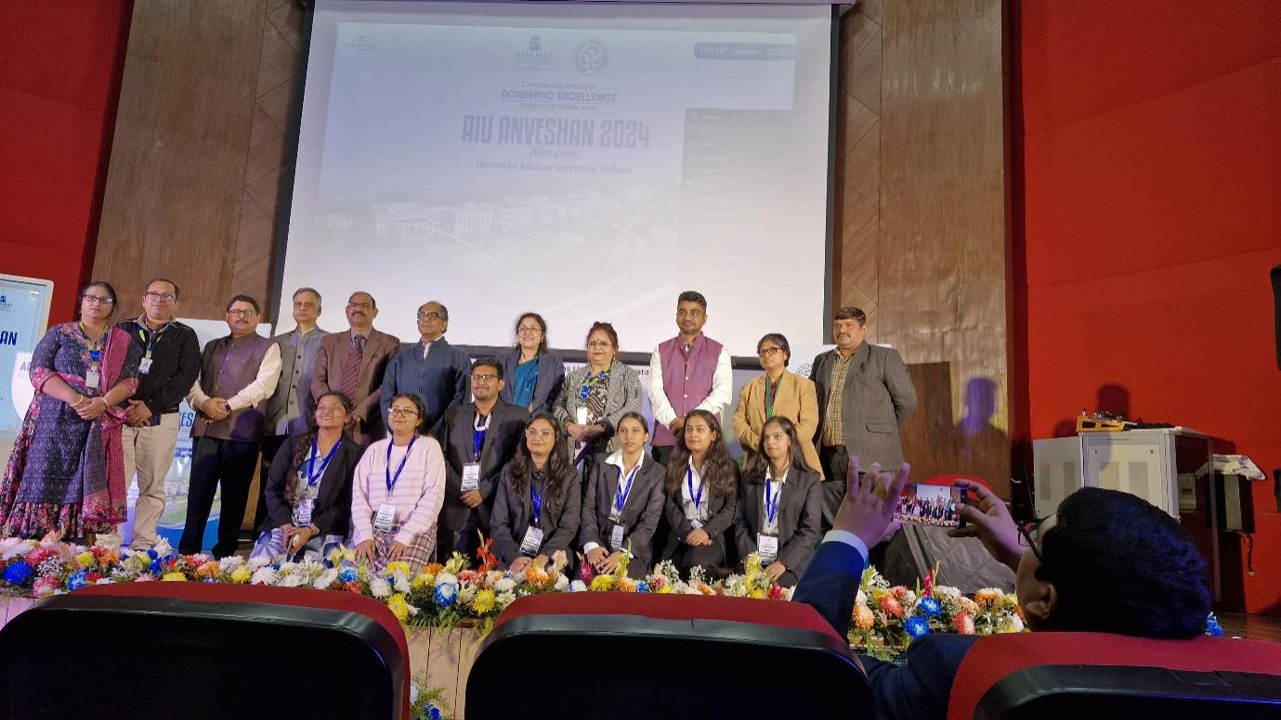

The proud moment! The winning team takes the stage after securing 3rd position in the Interdisciplinary Research category