Lappeenrannan teknillinen yliopisto

School of Business and Management

Sofware Development Skills

<Achmad Yusuf>, <Insert student number here>

LEARNING DIARY, Anytime-course: Software Development Skills: Full-Stack 2021-22 MODULE

**LEARNING DIARY**

**2.7.2022**  
  
I checked the general information and understood the main focus of the course, which is to learn frontend and Backend, create a MEAN fullstack project. I’ve also tried to set up my environment, And I decide Visual studio code editor Due to Atom Code editor will not free anymore until the end of this year 2022. I learned to set up a git repository and did my first commit, everything went smoothly.

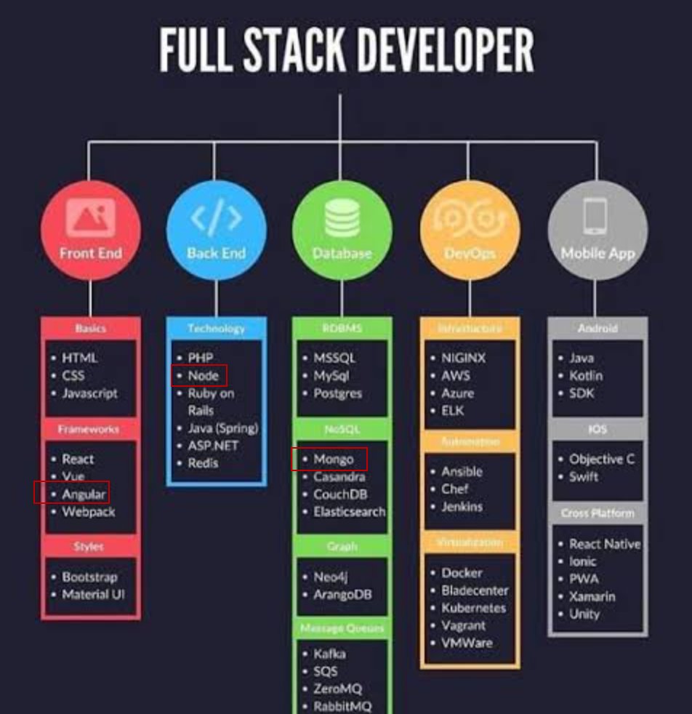

Trying to understand what is MEAN (Monggo Express Angular and Node)

**9.7.2022**

I try to learn FrontEnd /graphical User Interface by Angular. I face problem with navigation bar, before applying css from bootsrap it is working.

by googling I found solution for css, [Getting started · Bootstrap (getbootstrap.com)](https://getbootstrap.com/docs/3.4/getting-started/). copy some script for css and javascript connection via CDN.

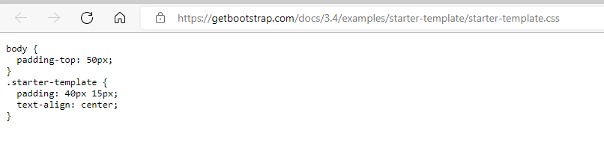

I copy some codes above into style.css therefore navigation bar running well.

the video Tutorial use angular-cli.json, this file for angular 6 below, in this course we install angular 14. when i install node 12, command “ng new workspace” cannot be run therefore I have to install node 14.15.

when doing initiation variable I got error, it seems anguler does not know these variable as shown picture below.

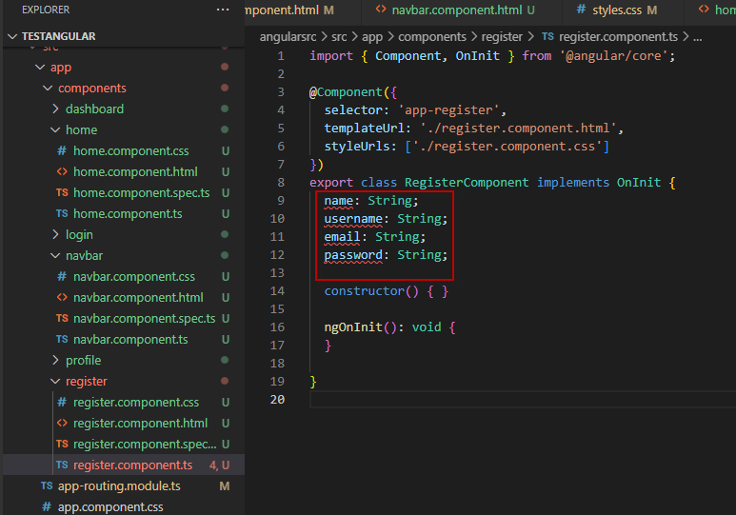

there are some errors on properties

by googling I add these both lines on compiler options  "noImplicitReturns": false,

    "strictPropertyInitialization": false,

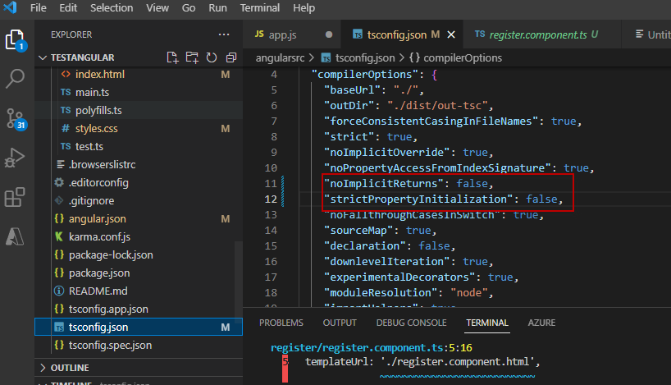

then another error , cannot bind javascript component with ngmodel

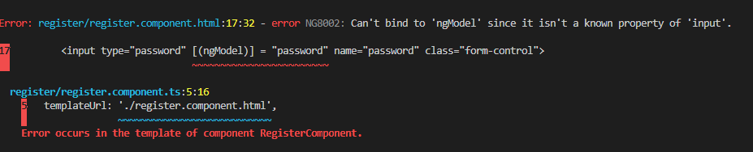

solution from stackoverflow I should import formsmodule

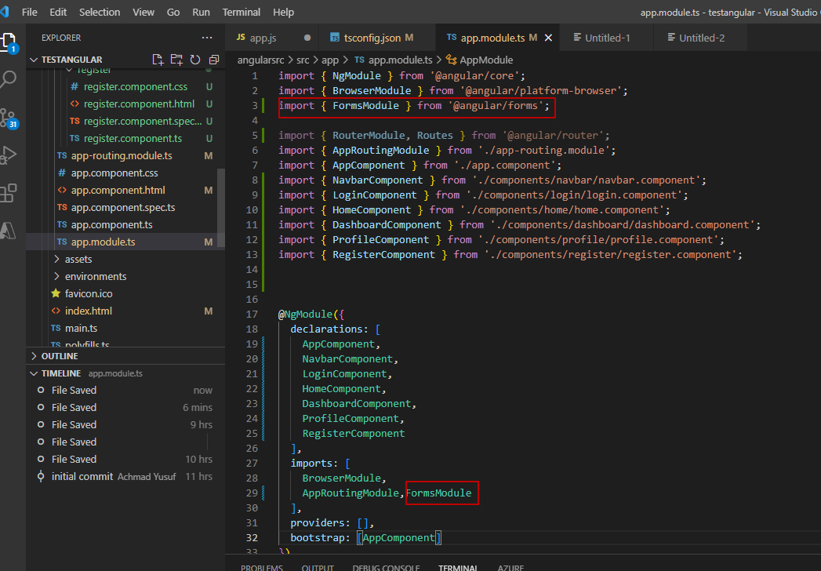

**10.7.2022**

Still Working in Frontend , especially validation value when submit some value to server trought javascript component.when creating validation service I got error as shown picture below

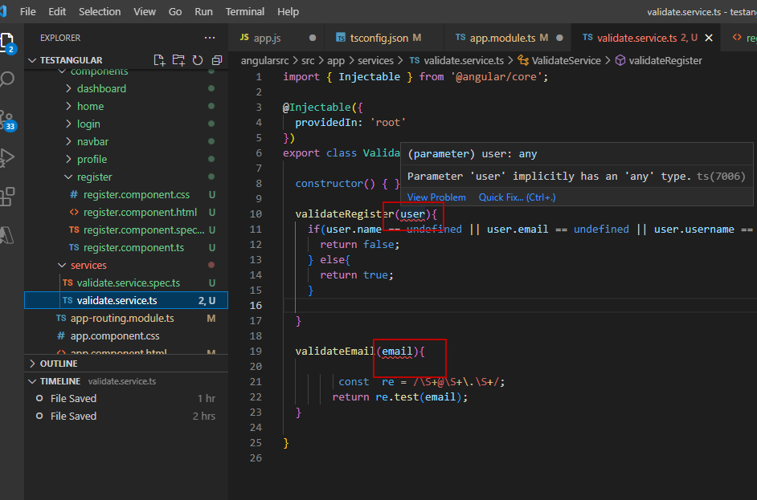

I add "noImplicitAny": false base on googling solution

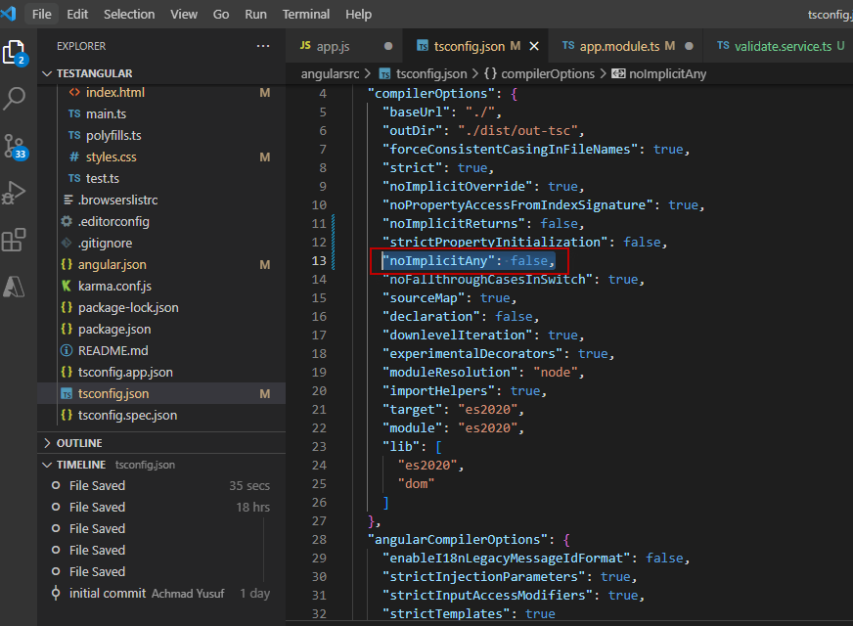

Another error is when use flash message all ui disappear only blank screen

 I edit app.module.ts i change FlashMessagesModule to FlashMessagesModule.forRoot()

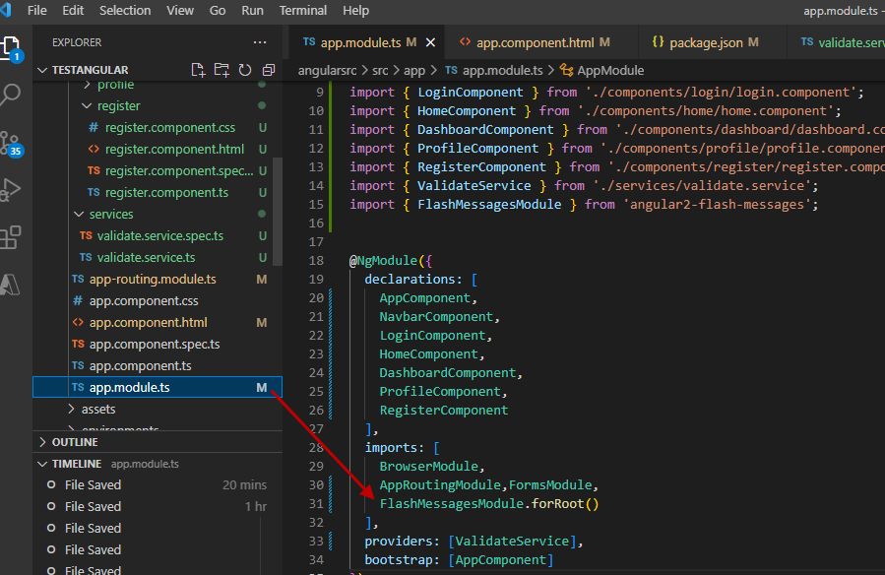

I check app.component.html

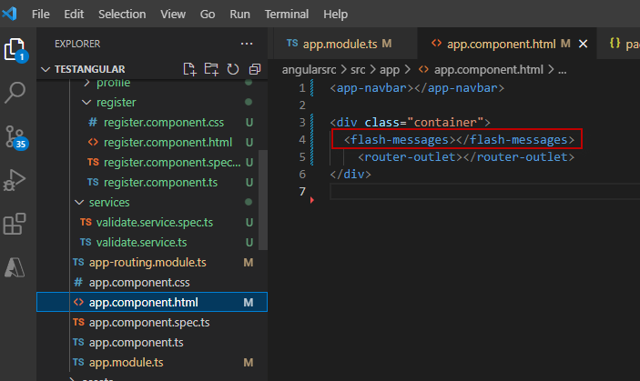

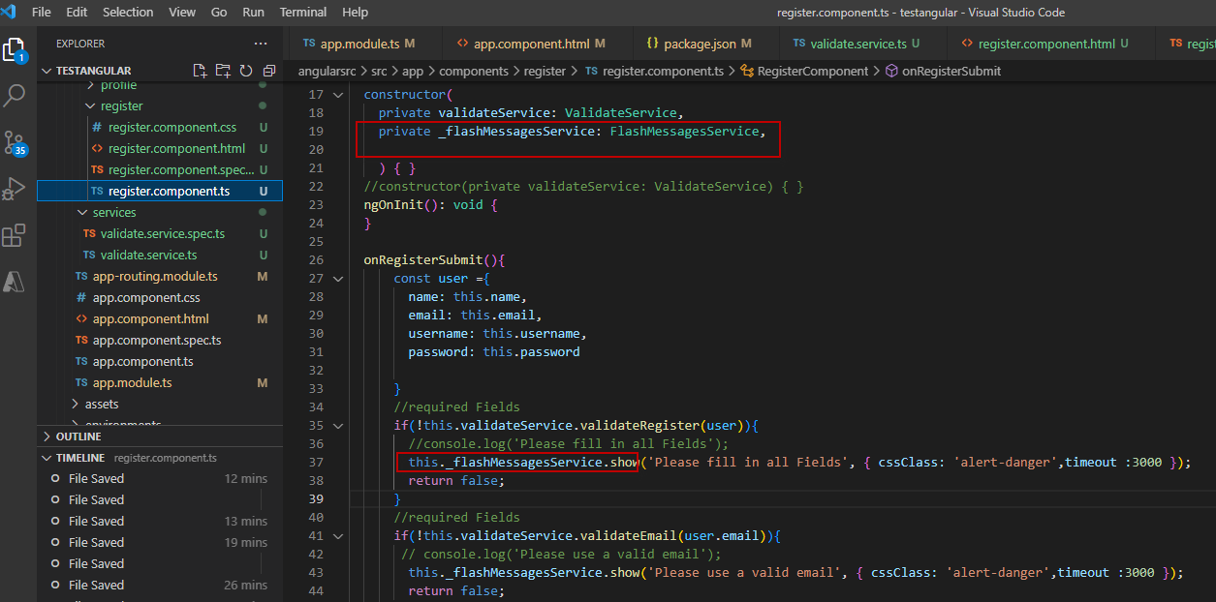

now flash massage shown as picture below

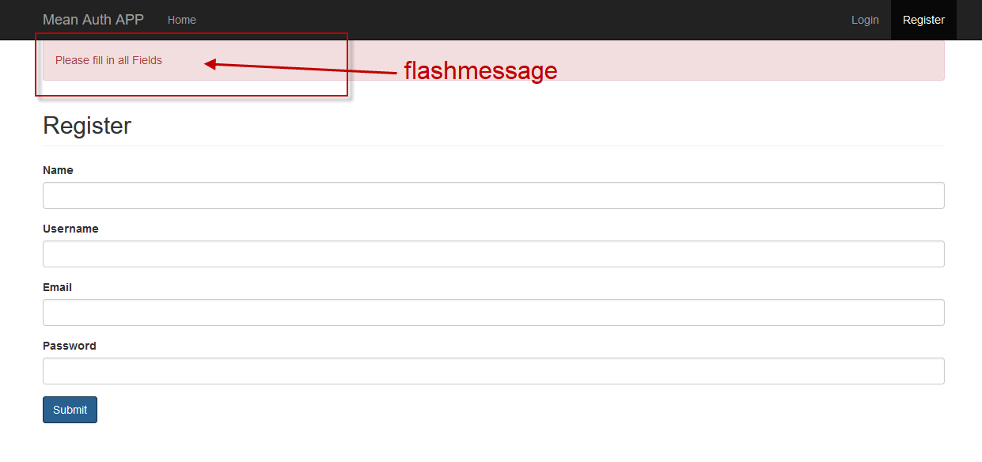

**11.7.2022**

I start learning backend part. create package.json, app.js, and all dependencies file inside node_modules (monggodb, express). compiling by npm start on root directory, in this case thestangular.

when I test authenticate backend on postman I have problem with express session

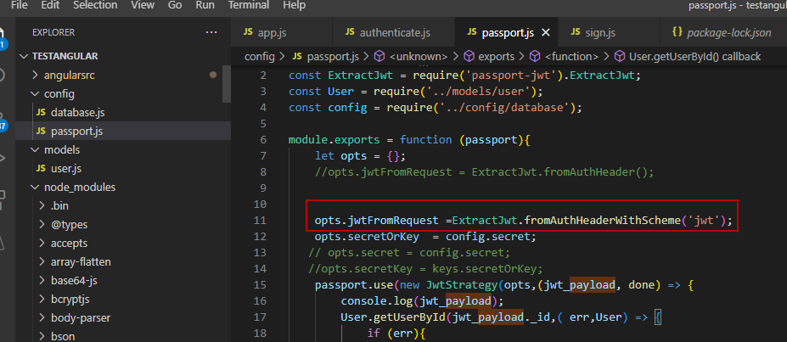

I change

fromAuthHeader();

to be

    opts.jwtFromRequest =ExtractJwt.fromAuthHeaderWithScheme('jwt');

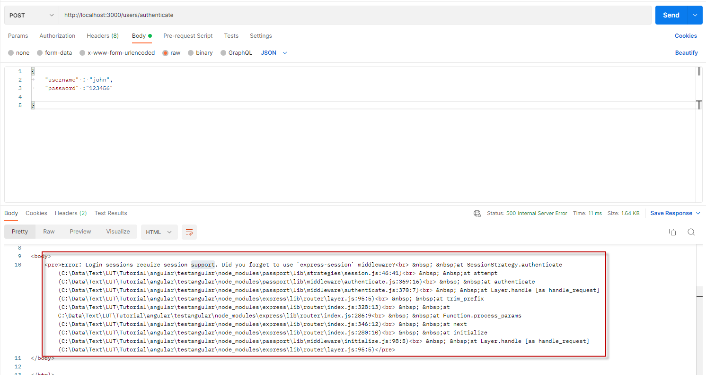

then I fix it by googling , to find session problem

const session = require('express-session')

I add app.use(session({ secret: yoursecret }));

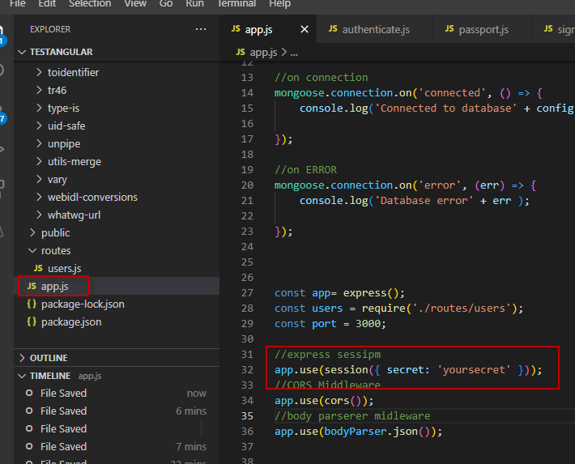

after that another error was coming Error: Expected "payload" to be a plain object.

I change user=>-+ user.toJSON() in routes, user.js

now backend authenticate success

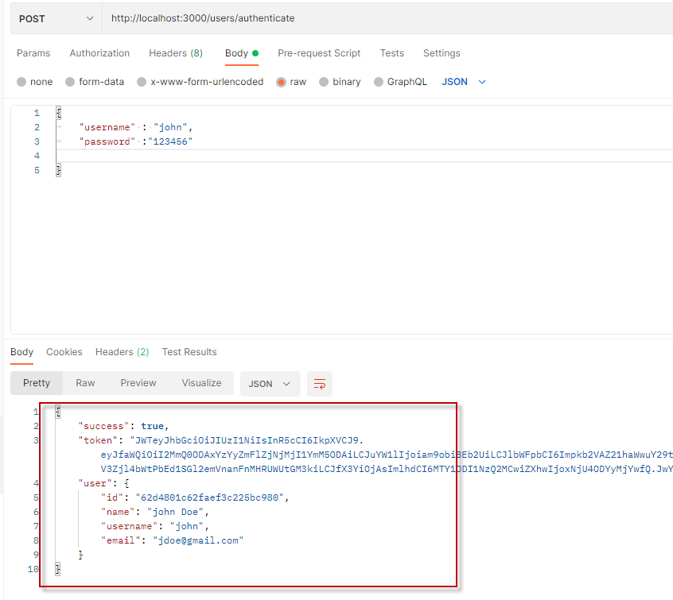

now create backend profile, this is the difficult parts , it seems the token can not be create, I rewind video somany time, I have no solution then I check google

now the token can be create but using different way compare to Video tutorial

I have to change token metod from

//token: 'JWT'+ token,

using bearer token

 token: 'Bearer ' + token,

in users.js(routes folder)

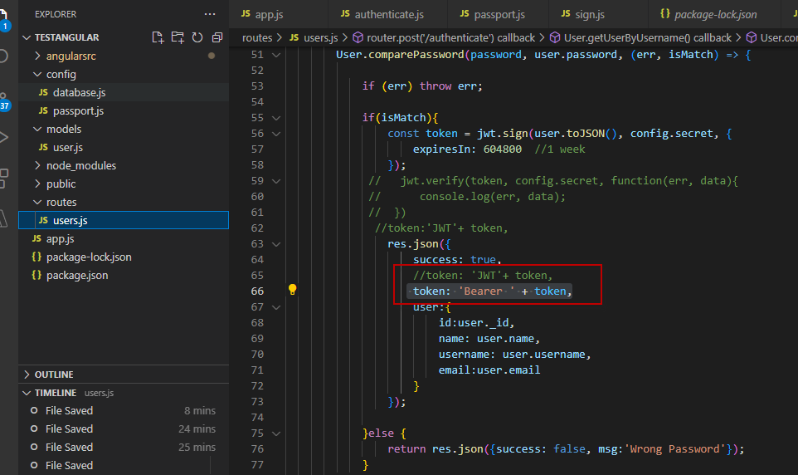

and change passport.js

opts.jwtFromRequest = ExtractJwt.fromAuthHeaderAsBearerToken();

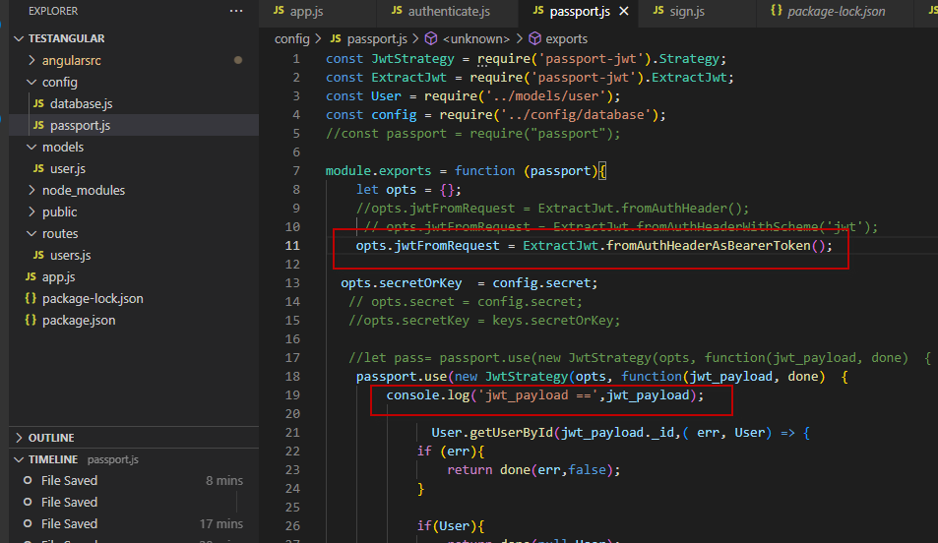

before that I cannot write in consol logine

console.log('jwt_payload ==',jwt_payload);

now it works

I authenticate

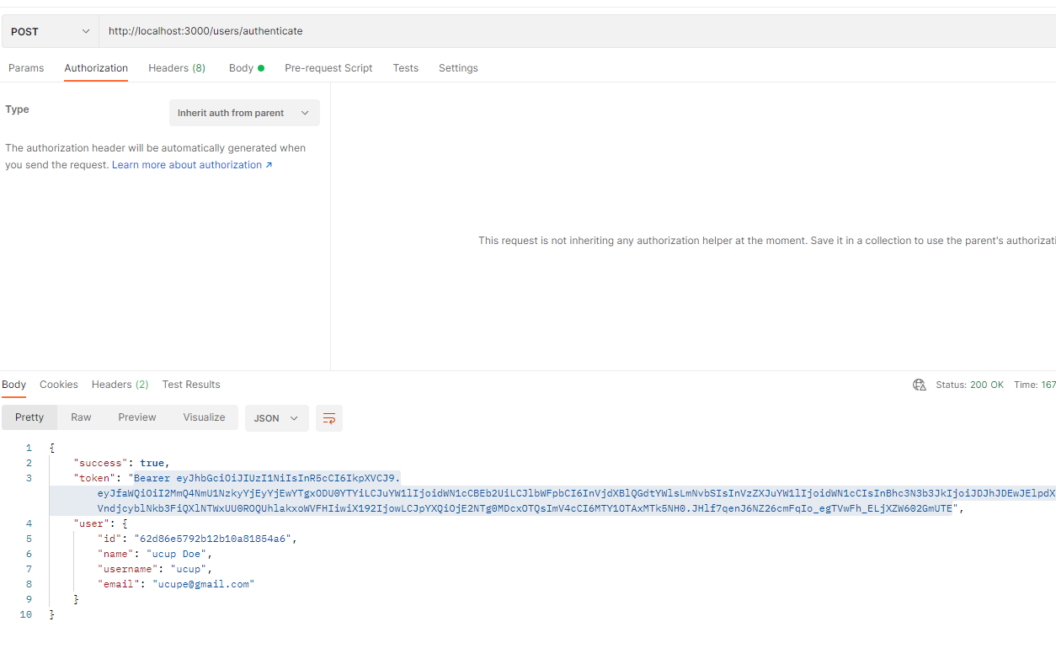

authorization inherit auth from parent

tab header ()

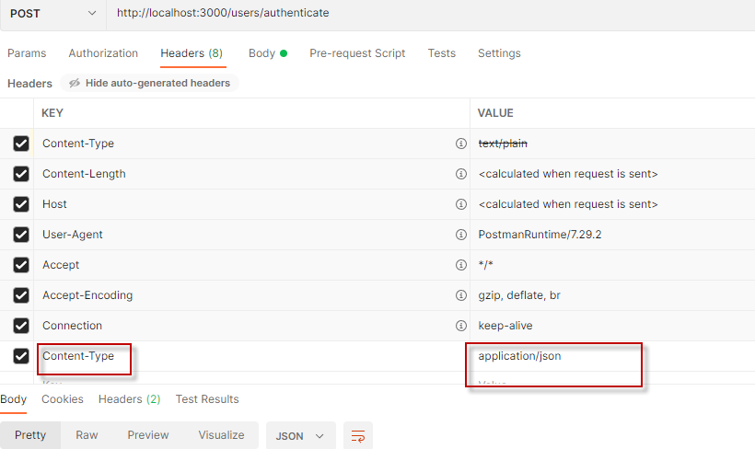

body raw

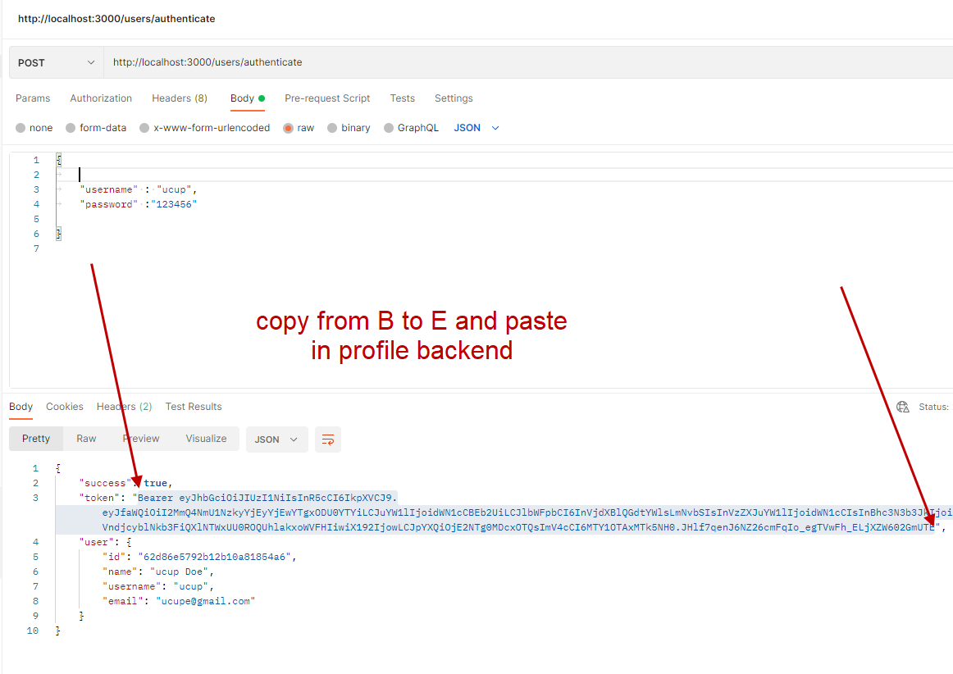

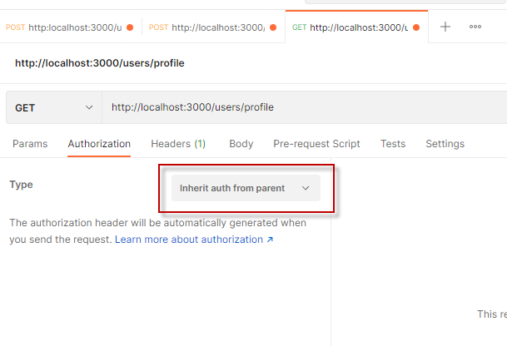

I paste token from authenticate to profile under colom value

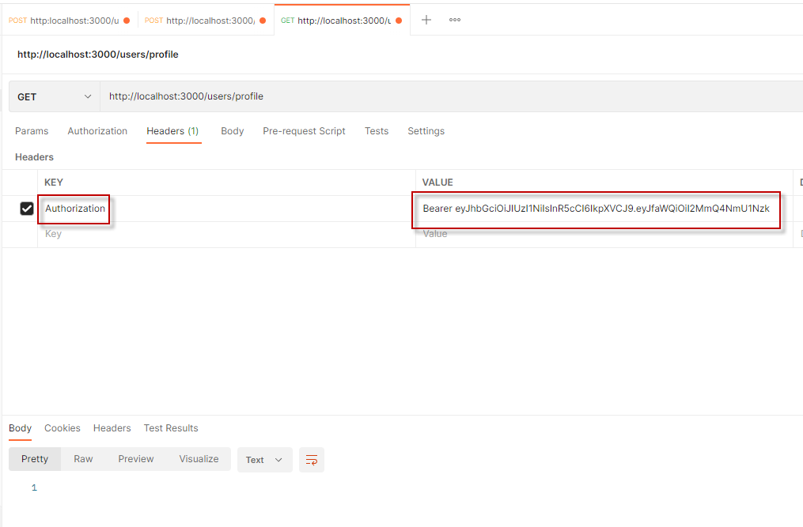

then run atlest in console shown on below picture

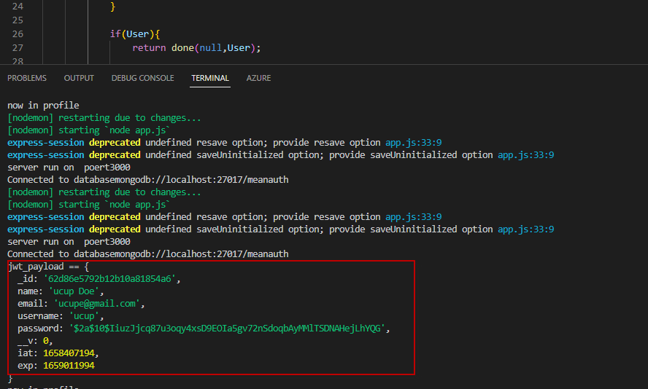

23,07,2022

creating login and logout front end it run well

but when creating profile, access directly to backend via Postman it run well

but when access via Front end always unauthoirized

when compile I got error html does not know object user on *ngIf=user

now I make change on tsconfig.json

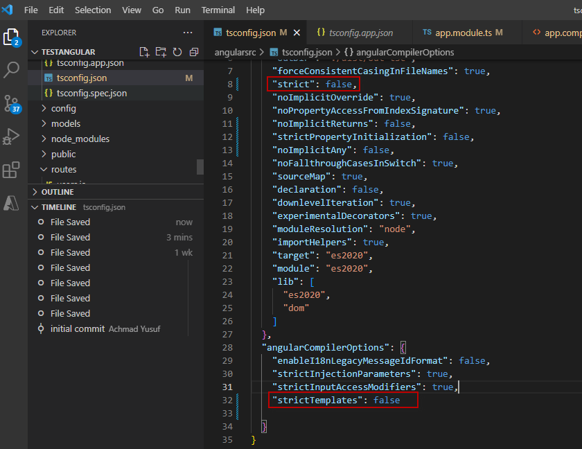

but still struggling with authenticate to get profile

I change 3 lines code become 1 line, it weird how it may work

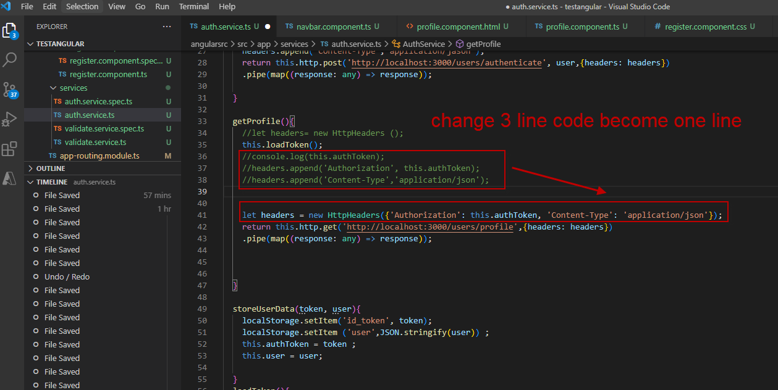

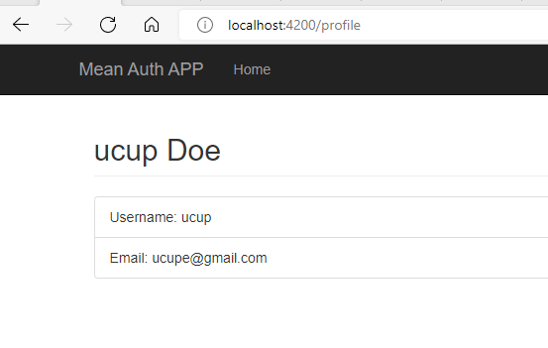

24.7.2022

creating navigation guard

I have problem after installing angular2-jwt

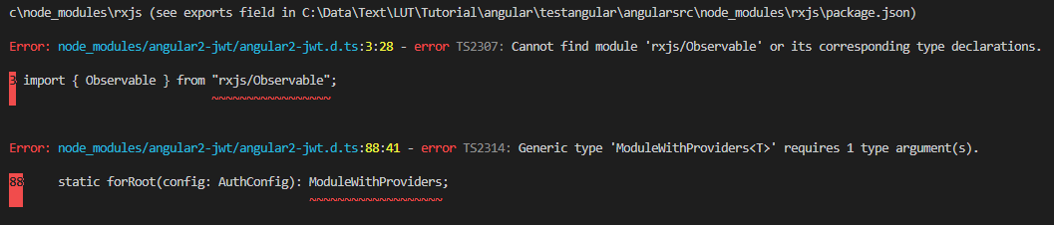

then I googling I found solution in here link

[Token Not Expired Module is not working, Angula...anycodings](https://www.anycodings.com/questions/token-not-expired-module-is-not-working-angular-6)

i uninstall angulat 2

npm uninstall angular2-jwt

npm install @auth0/angular-jwt

npm install rxjs-compat –save

In auth.service.ts:

**import** { **JwtHelperService** } **from** "@auth0/angular-jwt";

loggedin(){

     //return tokenNotExpired();

     return  this.jwtHelper.isTokenExpired(this.authToken);

  }

in navbar.component.html:

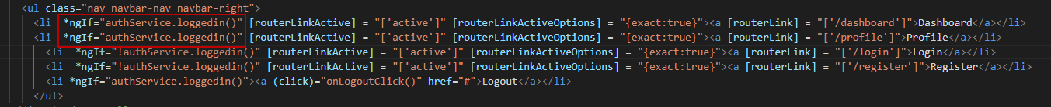

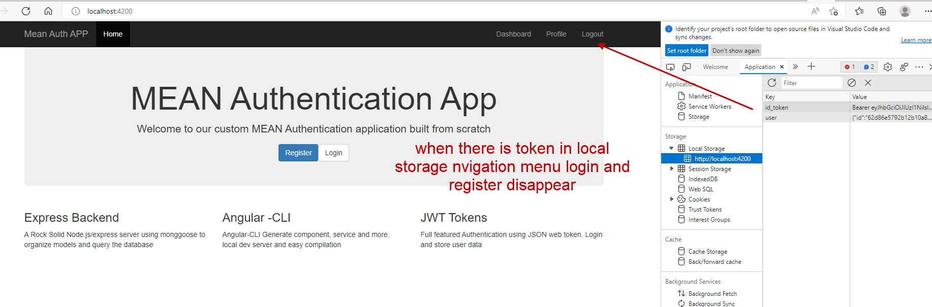

navigation guard work

31.7.2022

now I can create simple crude and using angular table including shorting, filtering, and paging.

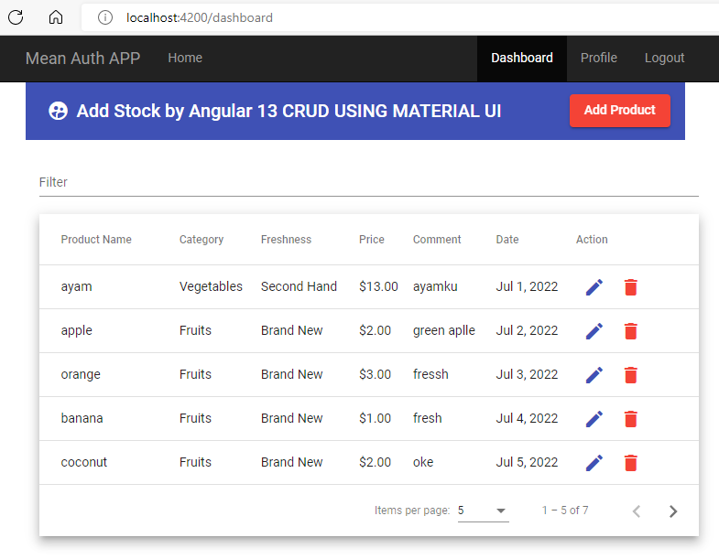

NOTE:

to run backend

nodemon in path C:\Data\Text\LUT\Tutorial\angular

ex

C:\Data\Text\LUT\Tutorial\angular nodemon

to run front end

goto front path

C:\Data\Text\LUT\Tutorial\angular\angularsrc\ng serve