ENTERPRISE NETWORK PT. XYZ

1. Project Overview
This project documentation describes an enterprise network environment supporting server-room infrastructure, office and workshop users, wireless connectivity, CCTV surveillance, and access-control systems. The available source document contains a network topology, VLAN/IP addressing plan, device inventory, and a list of implementation activities.
Project information | Description
Project category | Enterprise Network Infrastructure
Environment | Server room, office areas, workshop areas, wireless network and security systems
Documented technologies | FortiGate firewall; Huawei switching and wireless; Hikvision CCTV/NVR; ZKTeco access control
Main technical areas | VLAN segmentation, routing, DHCP, NAT, firewall policy, wireless configuration and endpoint systems
Available evidence | Topology diagram, VLAN/IP plan, device-role inventory and implementation-scope notes

Role and responsibility
Device configuration, installation, coordination, documentation, and troubleshooting.

Documentation boundary
This portfolio describes the architecture and activities recorded in the available documentation. It does not claim measured availability, throughput, latency, security effectiveness, or successful test outcomes. Activities listed in the source are presented as documented implementation scope, not as independently verified results.

2. Network Architecture
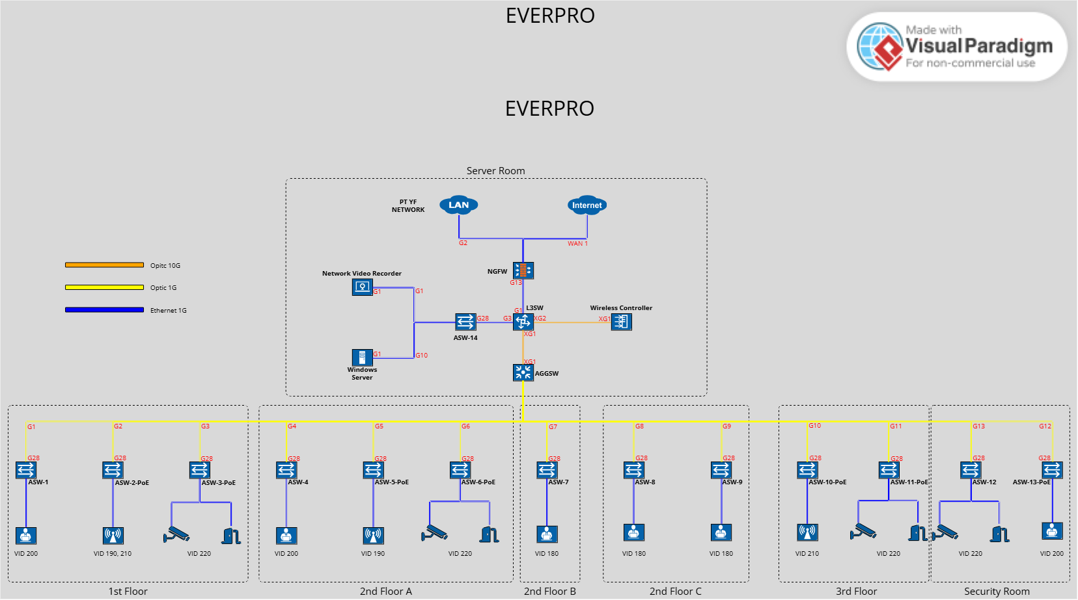
Layer / component | Function represented in the documentation
Edge firewall | External connectivity, routing, source NAT and security policy.
Layer 3 core switch | VLAN gateway interfaces, DHCP pools and routing adjacency with the firewall.
Aggregation switch | Aggregation/distribution connectivity between the core and access layer.
Access switches | Endpoint connectivity and VLAN membership for wired network segments.
Wireless infrastructure | Wireless controller and access points; SSID, radio and channel configuration.
Security systems | CCTV/NVR and RFID-based access-control devices.

3. VLAN & IP Addressing Design
The source documentation identifies VLANs by functional area. Production IP addresses and individual device management addresses have been omitted from this public-facing version.
VLAN ID | Documented segment | Public version
100 | Interconnection | IP details omitted
170 | Management / Server | IP details omitted
180 | Workshop — Wired | IP details omitted
190 | Workshop — Wireless | IP details omitted
200 | Office — Wired | IP details omitted
210 | Office — Wireless | IP details omitted
220 | Access Control / IP Surveillance | IP details omitted
230 / 240 | Reserved | IP details omitted

Design interpretation
- The VLAN plan separates several functional areas, including management/server, wired and wireless users, and security systems.
- This separation provides a basis for organizing broadcast domains and applying access policies. The actual policy behavior is not verified in the available evidence.
- The source identifies VLAN 230 and 240 as reserved; no additional use is inferred.

4. Device Roles
Device category | Vendor / model recorded in source | Documented role
Next-generation firewall | FortiGate 100F | Firewall, routing, NAT and security policy
Layer 3 core switch | Huawei S6720S-S | Core switching and VLAN gateway functions
Aggregation switch | Huawei S5735S-H | Aggregation layer
Access switches | Huawei S5735S-L | Access layer and VLAN port assignment
Wireless controller | Huawei S5735S-L (as listed in source) | Wireless controller role recorded in source
Access points | Huawei AP362 | Wireless access
NVR | Hikvision DS-9664NI-M8 | Video surveillance recording
Access control | ZKTeco InBio Pro Plus | RFID access control
Model names are transcribed from the source document. Confirm product-role/model accuracy before external publication, especially where the source inventory may contain naming or classification errors.

5. Documented Implementation Scope

Firewall configuration
- OSPF connectivity between the firewall and Layer 3 core switch.
- Static route toward an external network identified in the source documentation.
- Source NAT using a public IP pool.
- Security policy configuration.

Core switch configuration
- VLAN creation and VLAN gateway interfaces.
- DHCP address-pool configuration.
- AAA and management-access configuration for device administration.

Aggregation and access switches
- VLAN definitions and port VLAN membership.
- AAA and management-access configuration for device administration.

Wireless controller and Fit AP
- SSID configuration.
- Radio and channel settings.

NVR and CCTV
- IP addressing configuration.
- Camera live-view configuration.

Access control
- IP addressing configuration.
- Entry access-rule configuration.
- RFID card registration.

6. Skills Represented by the Documentation
- Enterprise network topology interpretation and documentation.
- VLAN segmentation and IP addressing-plan documentation.
- Routing concepts involving OSPF and static routes.
- Firewall policy and source NAT concepts.
- Switch management, VLAN membership and DHCP configuration concepts.
- Wireless, CCTV and access-control infrastructure awareness.

7. Publication & Confidentiality Checklist
- Obtain permission before publishing material derived from a company project.
- Keep company identity, production IP addresses, management hostnames and sensitive network paths out of the public version unless explicitly authorized.
- Never publish passwords, PINs, pre-shared keys, private keys, serial numbers, VPN secrets or raw production configuration.
- Review the topology image and every table for residual identifiers before sharing.

