Create Repository

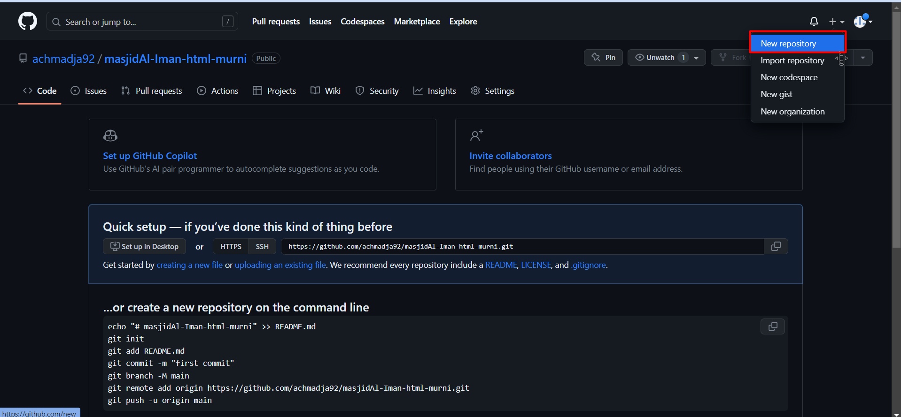

Git init (inside folder project want to use git)

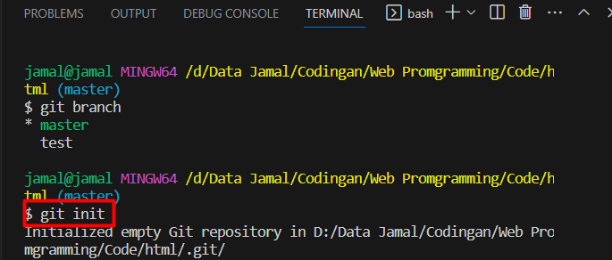

git remote add origin <https://github.com/achmadja92/masjidAl-Iman-html-murni.git> ( origin is remote repository name can rename with anything )

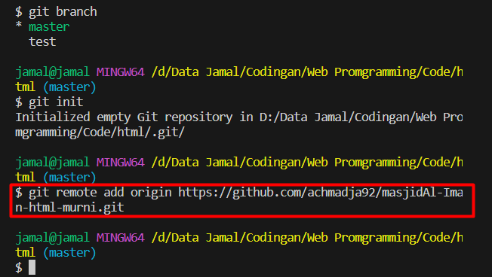

Git add . (add project to git repository)

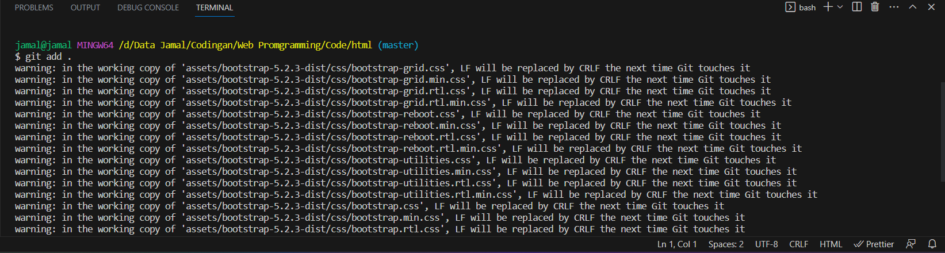

Git commit -m “First Commit” (commit -m -> message “First Command” is command)

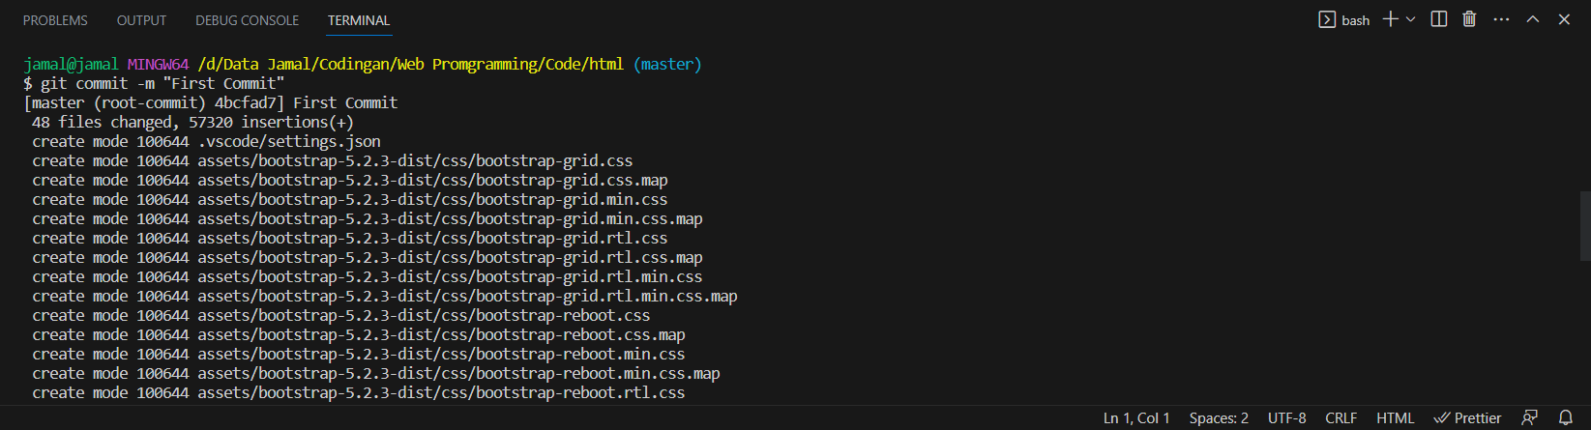

To connect local with github

git config --global user.email "you@example.com"

git config --global user.name "your name"

git push origin master

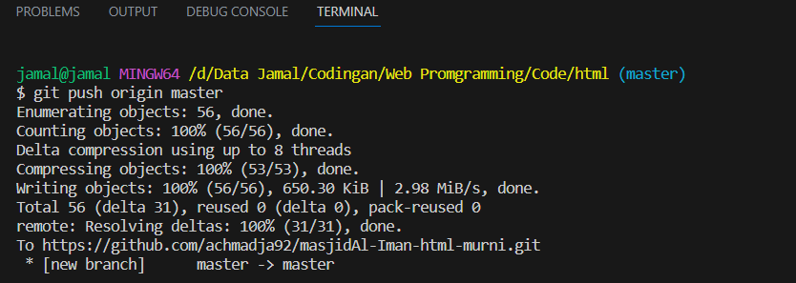

Git branch test (to create new branch)

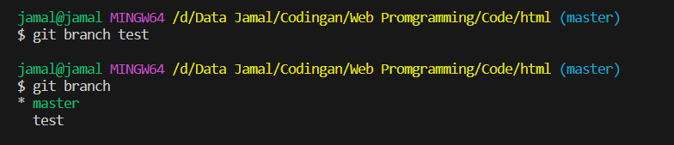

Git checkout test (to switch from branch master to another branch)

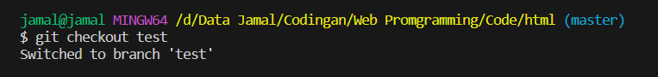

merge another branch to branch master

git branch test (another branch)

git add .

git commit -m “Add comment here”

git push origin test

git branch master (switch to branch master)

git merge test (merge another branch to branch master)

git push origin master