**Flowchart Artikel-1**

Fungsi 1

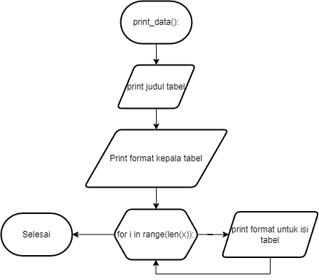

Fungsi 2

Fungsi 3

Program Utama

