Performance of Analysis Bird Pest Control Based on WSN

Achmad Safa Ramadhan
School of Coumputing
Telkom Univeristy
Bandung, Indonesia
achmadsafar@students.telkomuniveristy.ac.id
Maman Abdurrohman
School of Computing
Telkom Univeristy
Bandung, Indonesia
abdurrohman@telkomuniveristy.ac.id
Aji Gautama Putrada
School of Computing
Telkom University
Bandung, Indonesia
ajigps@telkomuniversity.ac.id

Abstract— Indonesia with the majority of livelihoods as rice farmers certainly wants to get good quality and quantity of crops. Farmers are faced with problems that hinder the expected yield of bird pests. Bird pest is one of the problems faced by farmers due to their existence which can cause a decrease in the quality and quantity of birds. The implementation of the Wireless Sensor Network (WSN) in rice fields is an effective solution for monitoring and controlling birds. PIR sensors which are the main sensors in detecting bird pests have a large area that can reach all areas of rice fields and and using buzzers for repelling bird pests. The use of mesh topology is used in building the system so that each sensor can communicate in two directions and know each other about the conditions of each sensor. The results obtained were that detection using sensor pir went well and the use of buzzers to repel bird pests decreased from five days.
Keywords— Bird Pest, PIR Sensor, Wireless Sensor Network, Mesh Topology, Rice Fields

Introduction (Heading 1)

Bachround

Indonesia is a country with abundant natural resources. Indonesia is an agrarian country because livelihoods in agriculture and farming are a lot of fields. Known as an agrarian country, of course, the profession as a farmer becomes the majority's livelihood, especially for rice farmers. The results obtained will certainly be abundant when the rice plants and treated properly. When farmers want to maintain the quality and quantity of the crop there is a problem that is faced when it occurs, namely bird pests. Bird pests attack plants that are heading for rice ready for harvest. Birds will eat directly yellowing rice grains causing direct loss of yield. In addition, birds also cause broken rice panicles. Birds cause serious damage if there is a significant difference in planting time (more than 3 weeks) than the surrounding rice fields. The bird species that most often cause serious losses are sparrows (Lonchura sp.) Which usually attack in groups from tens to thousands of them [1]. For this reason, we need a device that can prevent birds from attacking plants and monitoring the conditions around plants attacked by bird pests.
Several studies on bird pest control existed as in [2] the study was carried out in closed rooms and also objects not flying objects, there was no sort of expulsion from the pests shown in [3]. Expulsion of pests that are shown using noise that can disturb the pest. But the method of expulsion can only be done when the robot is in the place where pests are located, it cannot be done extensively. The same is done in [4] by using certain frequencies to disturb birds. But the research was successfully carried out because the trials were in the room and the birds were silent. Whereas if you want to be implemented in the environment of the paddy field (outdoor), it does not rule out the possibility that disturbing birds with frequency cannot run properly. Therefore building a wireless sensor network can be implemented in the rice field environment in monitoring bird pests and to deal with these bird pests with enough noise using the buzzer

Topic and Problem Limit
The formulation of the problem in this study is how to implement a Wireless Sensor Network in the rice field area to monitor and control bird pests and the performance of the system when placed in a rice field area.
The PIR sensor has an optimal detection distance of around five meters with an area of around seven meters. By using four sensors that work as stations, the area that can be covered by the four PIR sensors is around 12x12m. testing was carried out for 5x4 hours following the activity of active bird pests in the morning and evening. The system will monitor, detect and control bird pests. Nodes needed are five, four nodes as stations and also installed pir sensors, one node as an access point to connect to the internet.

Purpose
The purpose of this final project is to achieve the implementation of wireless sensor networks in rice fields for monitoring and controlling bird pests in the hope of reducing bird pests in the future after the tools are placed and run

RELATED WORKS
In [2], it provides a smart IoT communication system design for detecting rodents. This system is based on low energy consumption and low cost RF microcontroller communication which costs around 1-2 $. A large number of devices connected in real time are deployed to monitor rat pests. The movement of mice and the estimation of traps for periodic dates (weekly, monthly or yearly) in each company or selected area can be monitored remotely by accessing the multimedia platform via cell phone or through a computer. Finally, we measure the bandwidth consumed by Passive Infrared (PIR) sensors.
In [3], it was proposed that wireless robots based on Internet Things (IoT) were designed and implemented to carry out various operations in the field. The proposed wireless robot is equipped with various sensors to measure different environmental parameters. It also includes the Raspberry Pi 2 model B software to run the entire process. The main feature of this smart wireless robot is that it can perform tasks such as sensing humidity, scaring birds and animals, spraying pesticides, moving forward or backward and turning on the electric motor ON / OFF.
In research [4] has developed and designed prototype detectors and bird repellents. This prototype has a motion detection system which is then continued to the repellent which produces a certain frequency, so that the bird will be disturbed. This prototype consists of a PIR sensor as a colpitts type LC detector with a Piezo Ultrasonic sensor as a repeller.
The use of mesh topology in [2] shows that performance in detecting pests is better than using other topologies. Then in [3] in the eviction of pests used loud sounds effective against pests. but cannot monitor the entire area. Expulsion carried out in [4] uses ultrasonic sensors with certain frequencies not yet tested when the bird is moving. So the use of loud sounds like a buzzer can be applied in expelling bird pests.
If the research mentioned by traditional methods of evicting bird pests, it is definitely more effective with traditional evictions such as using the sound of bells by being tied by ropes to the corners of the rice fields. However, this method must be done using human energy and cannot know how much the activity of bird pests in the area. For this reason, the construction of a system that can monitor and control bird pests is needed to find out how the activities of bird pests in the rice field area.

DESIGN SYSTEM

In the system to be built, communication modules are used to communicate between nodes using the ESP8266 module that has been integrated into the NodeMCU. The output of the PIR sensor provides an analog output of 5V voltage level when detecting movement. But NodeMCU has a 3.3V tolerant pin and only requires 3.3V of the sensor as an analog input. To get an output voltage of 3.3v, the 3v pin on the NodeMCU is connected to repeat trigger on 3.3v. For the scheme of the system built can be seen in Fig. 1.

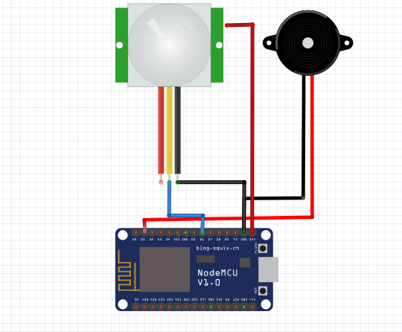
Figure 1. Connection Circuit Each Node

The system was built based on WSN using mesh topology. The way the system works for the first time is that the pir sensor detects movement in the rice field area. When the pir sensor detects a movement from a bird pest, the buzzer will ring and send a message to each node in the area. Nodes that receive messages from nodes that detect movement will ring the buzzer, this will cause a sound that can cover the entire rice field area. This is also done for each node acting as a station.

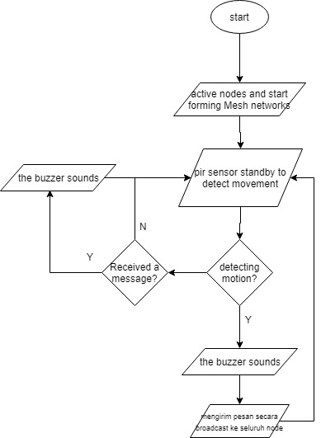

Figure 2. system work flowchart

The library used to build this WSN-based system uses the PainlessMesh library [5]. Painlessmesh uses a concept where each node is connected and forms a network by itself and each node when sending a message, the nodes around it will receive the same as the other nodes as the mesh topology works

EVALUATION

Result
Tests carried out in rice fields in the village area of ​​Gudang Kec. Tanjungsari Kab. Sumedang. The distance of the pir sensor in detecting motion is around five meters. Based on this, laying in the first system testing system is placed with a distance between different nodes, node one and node two are at a distance of 12 meters. Then for node 2 and node 3, the distance is approximately six meters. The distance is placed so that sensor pears can be more effective in detecting bird pests on the entire land and placed on rice. Testing is carried out for 5 days. The first day the system will be placed in the rice fields at nine to eleven o'clock in the morning and three to five o'clock in the afternoon because pest birds do activities only in the morning and evening. The first day the system will be installed without using a buzzer to find out how often the activity of bird pests in the rice field area. Then the second day uses a buzzer to find out the system's ability to repel bird pests and the next day. To find out whether each node in sending a message after detecting it is done successfully, that is by

looking at the message that is entered on one of the nodes. The mesh topology scenario is shown in Fig. 3.

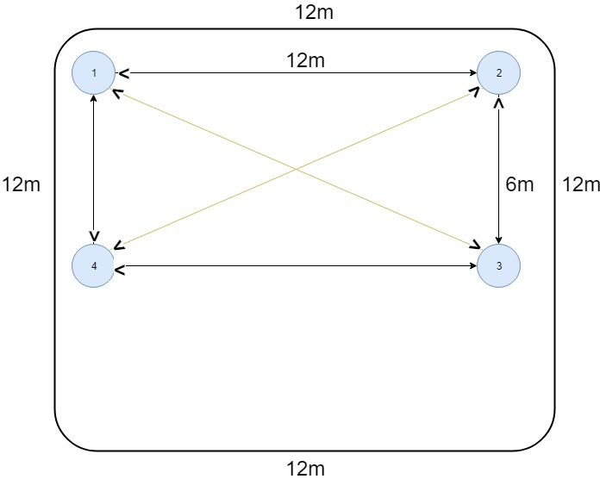
Figure 3. Mesh topology

The first thing to do is to test the ability of the buzzer to repel bird pests. Bird pests will be faced with a buzzer with a certain frequency and a certain distance to find out whether or not a bird pest reacts. This distance is the distance that the pir sensor can reach in detecting motion. The results obtained are as follows:

Table 1. testing buzzer against bird pests
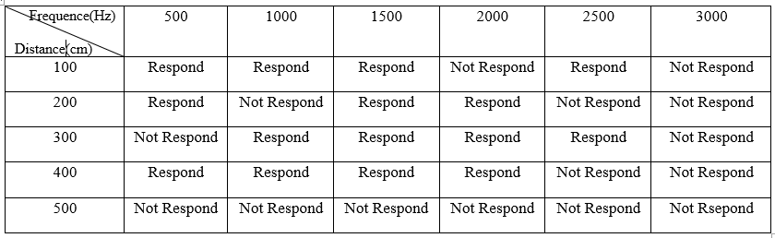

Respond shows that the bird reacts and goes away and Not Respond shows the bird does not go or react. The test results in Table 1 show the frequency of 1500 responses from bird pests most often at a distance of 100-400 cm. Referring to the test, the expulsion in testing in the rice field area uses a buzzer with a frequency of 1500 Hz. After testing of the rice field with the installed system obtained the total of the sensor pears in detecting bird pests is accumulated from the number of detections in the morning and evening in five days. The results obtained are as follows:

Table 2. Detection bird pests at 09.00 to 11.00
Days | Detection | False Positive | False Negative
1 | 27 | 9 | 4
2 | 26 | 6 | 7
3 | 26 | 8 | 5
4 | 20 | 3 | 3
5 | 20 | 5 | 7

Table 3. Detection bird pests at 15.00 to 17.00
Days | Detection | False Positive | False Negative
1 | 41 | 12 | 8
2 | 44 | 15 | 6
3 | 36 | 11 | 6
4 | 31 | 8 | 7
5 | 37 | 16 | 3

Table 4. Total detection of bird pest
Days | Real Detection |  | Total
Days | 09.00-11.00 | 15.00-17.00 | Total
1 | 18 | 29 | 47
2 | 20 | 29 | 49
3 | 18 | 25 | 43
4 | 17 | 23 | 40
5 | 15 | 21 | 36

Positive False shows that the sensor detects movement that is not a bird pest while false negative indicates that the sensor does not detect bird pests even though the bird is in the sensor coverage area. actual detection shows the detection results of only bird pests after being reduced by false positives. Total is the amount of bird pest detection during the morning and evening. Next are the results in Table. 4 then converted into a graph to find out the comparison between the number of detections in the morning and evening. The graph can be seen as follows:

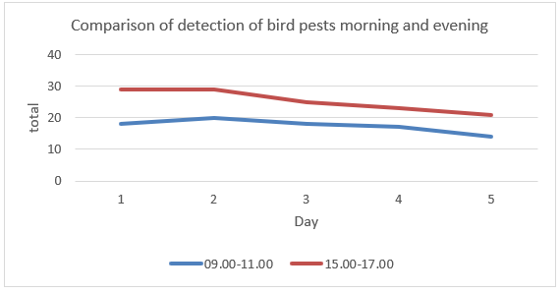
Figure 4. comparison of bird pest activities between morning and evening

Fig. 3 shows a graph of the detection of bird pests for five days in the morning and evening.

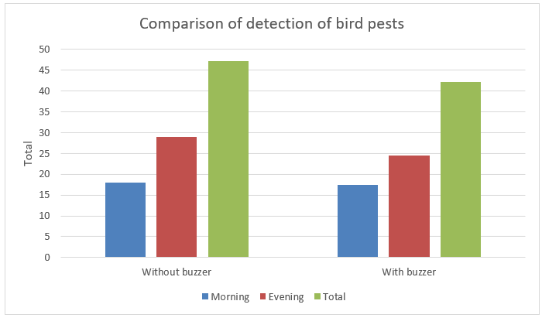
Figure 5. Average Graph of Number of Bird pests without buzzer and with buzzer

Figure 5 shows a comparison of bird pest detection without expulsion with buzzers and bird pest detection using buzzers in the morning, evening and a total of one day. For detection by expulsion, the second to fourth day averaged detection results in the morning, evening and total of one day.

Analysis
In testing the buzzer against bird pests, in table 1 shows the buzzer frequency at 1500Hz has more response than the other frequencies. At this frequency the buzzer sounds are the highest compared to the other frequencies. At a frequency of 500 Hz the sound produced on the buzzer is not stable. then at the frequency of 2000Hz and then the response of the bird pest to the buzzer does not exist. This is because the higher the frequency of eating the sound will be getting weaker.
From the results obtained when the test lasts for five days there are differences in the total buzzer that sounds on the first day to the fifth day. On the first day the intensity of bird pest activity was seen from the number of detections during the system running with a total detection of 47 times. The decline occurred in the tests carried out for four consecutive days to reach a total detection of 36 times. On picture. 4 shows p total detection in the afternoon is greater than the morning. This shows that bird pest activity occurs most often in the afternoon. In Figure 5. Showing a comparison of activities between morning, evening and a total of one day. Seen from the graph, there was a decrease in the activity of bird pests after the buzzer was installed with an average number of detection of 17.5 in the morning, 24.5 in the afternoon and 42 times on one day. To find out how effective the system in evicting bird pests is to calculate the reduction of bird pest detection using the following formula:

After the detection results of bird pests are entered into the formula above, the results obtained are as follows:

Table 5. percentage decrease in the number of bird pests
 | Average number of detection
 | without Buzzer (1 day) | with Buzzer (4 days) | Decreased bird pest
Morning | 18 | 17.5 | 2.7%
Evening | 29 | 24.5 | 15.5%
Total | 47 | 42 | 10.6%

The percentage decrease in the number of bird detections was calculated based on the decline from the first day of detection without using the buzzer with the average detection on four days of testing by evicting using the buzzer in the morning and evening. In the table. 3 It can be seen that the percentage of bird pests decreasing in the morning is around 2.7%, which is much smaller than in the afternoon which reached 15.5%. if calculated in one total day, the percentage of bird pest reduction carried out by the system in one day reaches 10.6%

CONCLUSION AND FUTURE WORKS
The conclusions that can be taken from the results of the test take place are as follows:
- The use of pir sensors in the detection of bird pests is quite effective when used in rice fields.
- The buzzer is effective in removing birds with a frequency of 1500Hz compared to other frequencies
- The use of buzzers to drive out bird pests from the sound produced shows a decrease in total detection on the first day without using the buzzer with a total detection of 47 times until the fifth day with a total detection of 29 times
- The activity of bird pests most often occurs in the afternoon compared to the morning seen from the total number of detection in the morning as much as 88 times then in the afternoon 127 times
- The percentage of the decrease in the morning reaches 2.7% smaller than the percentage in the afternoon which reaches 15.5%
- The percentage of success of the system in removing bird pests for five days is 10.6%.

Suggestions that can be given for the future are as follows:
- The use of nodes should be increased in order to monitor areas with maximum detection rates
- We recommend that you connect to the internet so that the monitoring process can be done anywhere.
- Using sounds that are louder than the buzzer then compare which ones are more effective in driving away bird pests
- Create a new system using traditional systems such as shaking the rope automatically then comparing the results with this system

REFERENCES
[1] “Hama Burung, Musuh Petani Pada Padi,” 2018. [Online]. Available: http://8villages.com/full/petani/article/id/5aa4f43079d065ae381d4cca. [Accessed: 10-Jan-2019].
[2] C. Cambra, S. Sendra, L. Garcia, and J. Lloret, “Low Cost Wireless Sensor Network for Rodents Detection,” Wirel. Mob. Netw. Conf. (WMNC), 2017 10th IFIP, pp. 1–7, 2017.
[3] K. L. Krishna, O. Silver, W. F. Malende, and K. Anuradha, “Internet of Things application for implementation of smart agriculture system,” 2017 Int. Conf. I-SMAC (IoT Soc. Mobile, Anal. Cloud), vol. 25, no. 15, pp. 54–59, 2017.
[4] Y. Siahaan, “Design of Birds Detector and Repellent Using Frequency Based Arduino Uno with Android System,” pp. 238–242, 2017.
[5] “painlessMesh.” [Online]. Available: https://gitlab.com/painlessMesh/painlessMesh. [Accessed: 10-Jan-2019].

