Recommended Navigation Structure
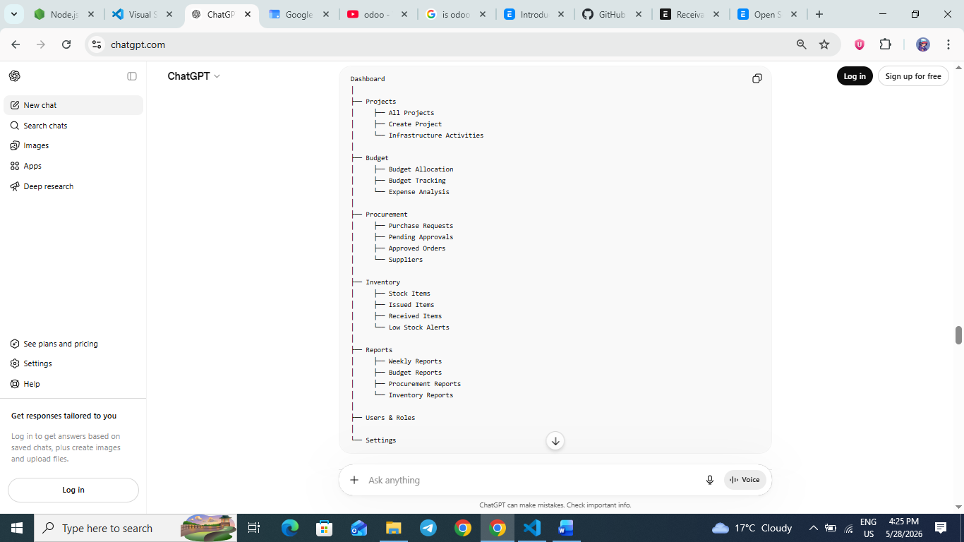

SIMPLE DASHBOARD LAYOUT
Here is a clean and practical UI structure you can implement easily.
- MAIN DASHBOARD
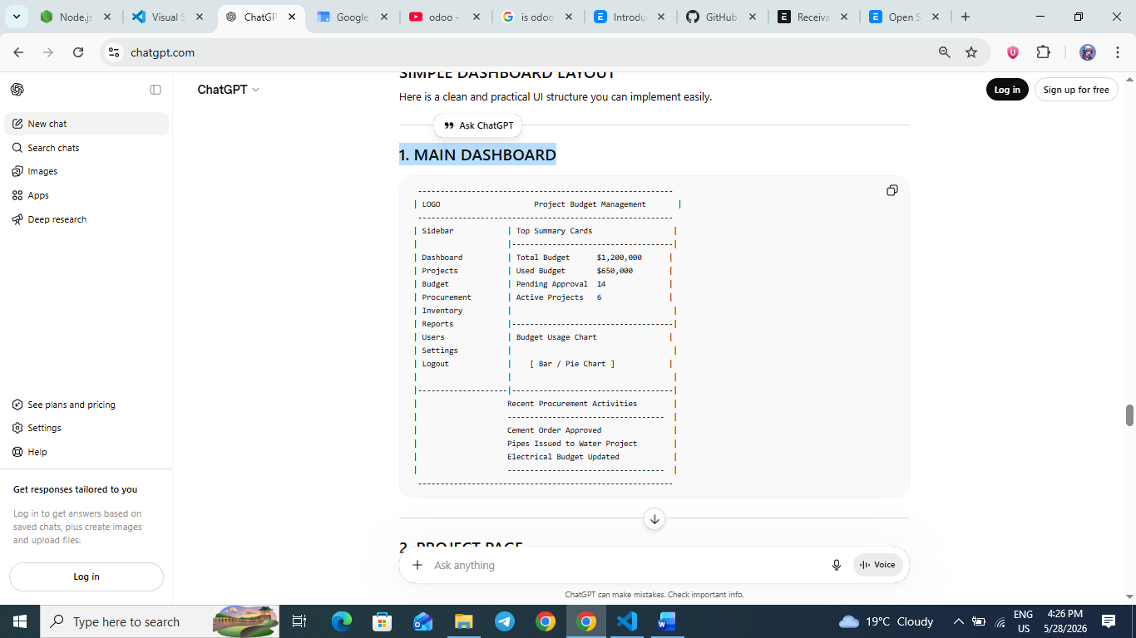

- PROJECT PAGE
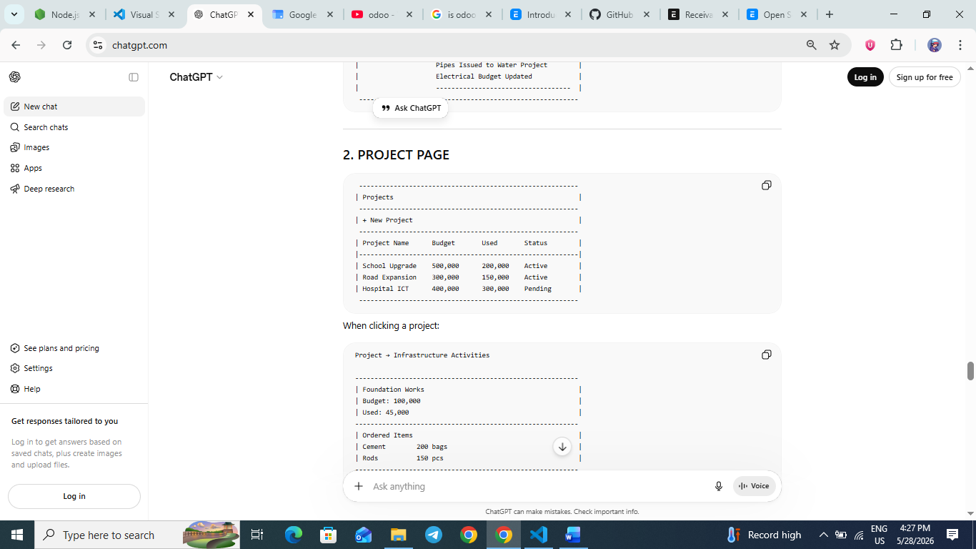
When clicking a project:
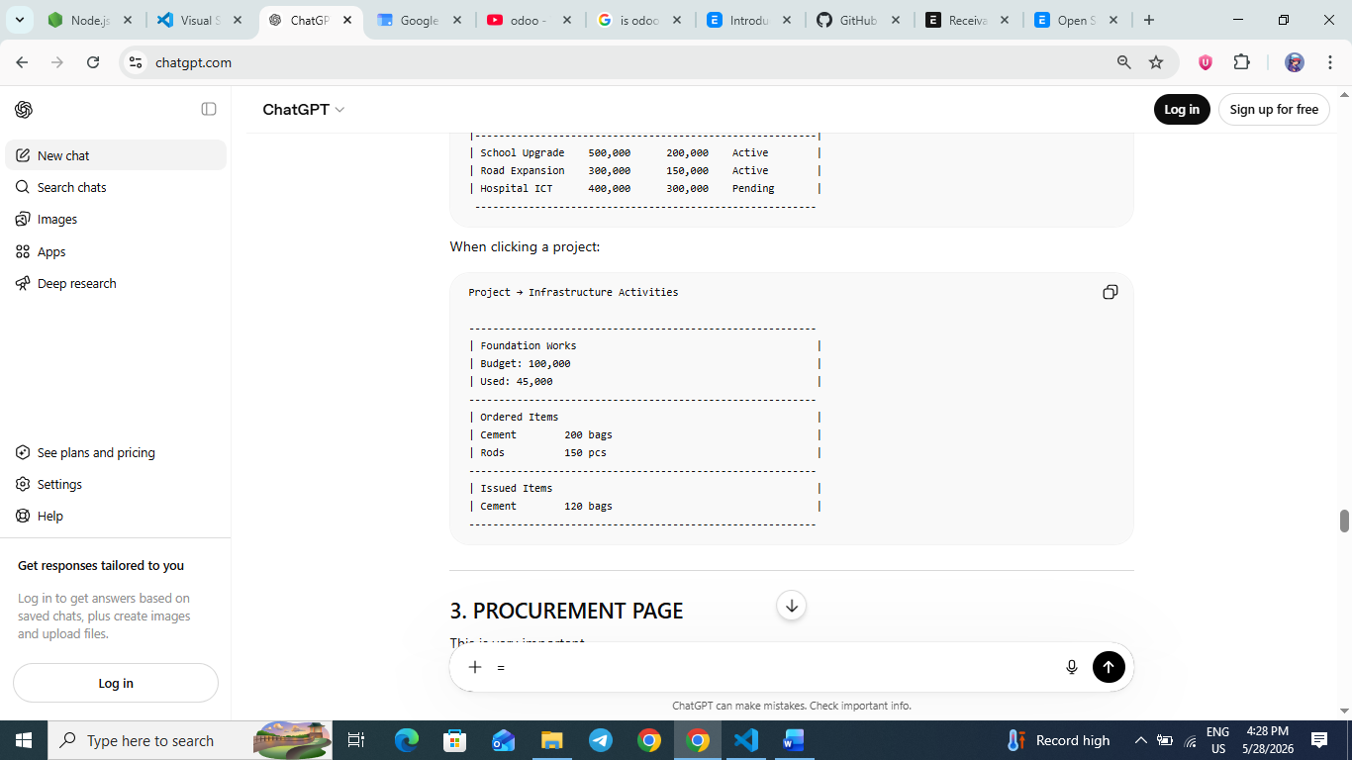
- PROCUREMENT PAGE
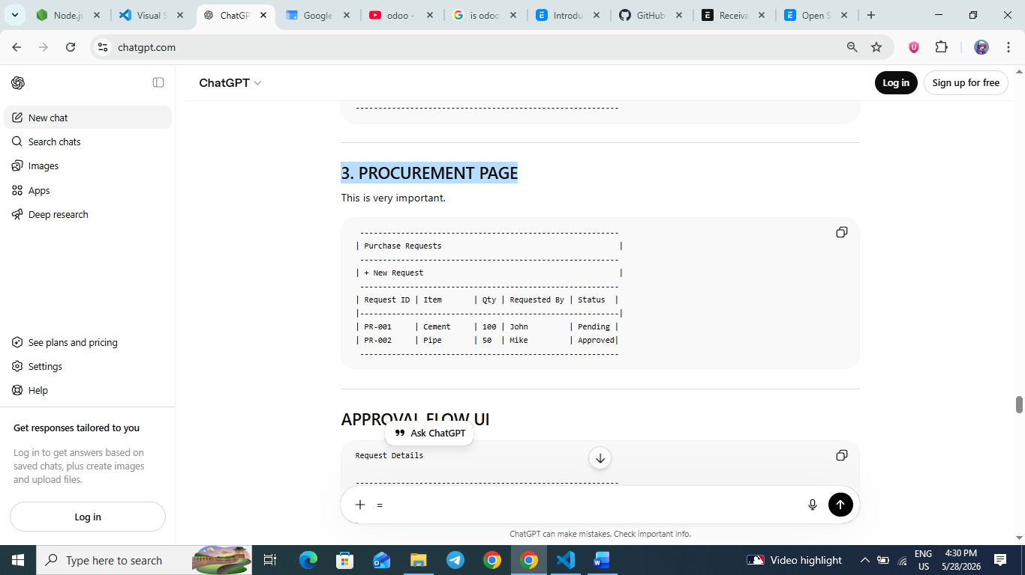
APPROVAL FLOW UI:
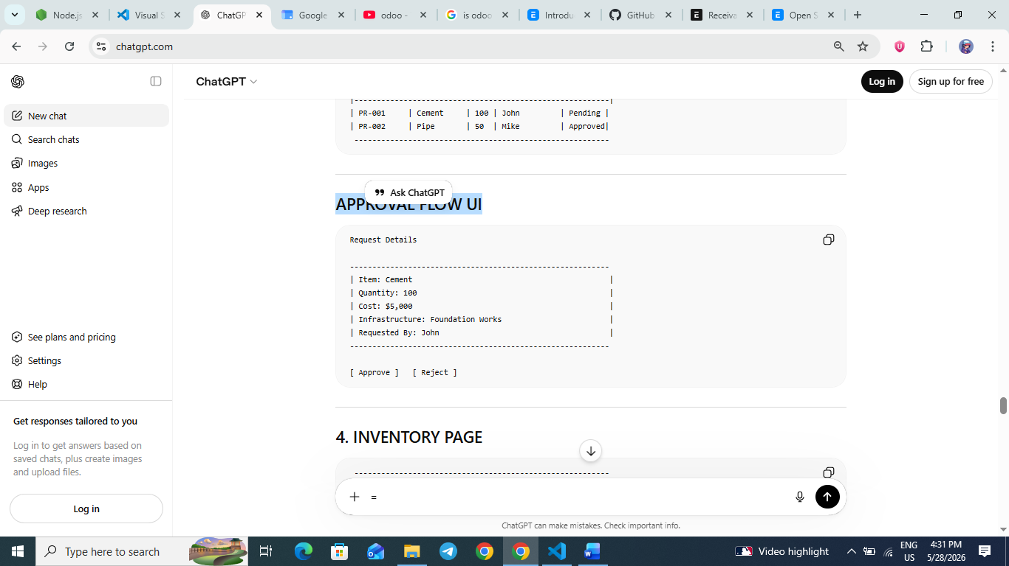
- INVENTORY PAGE
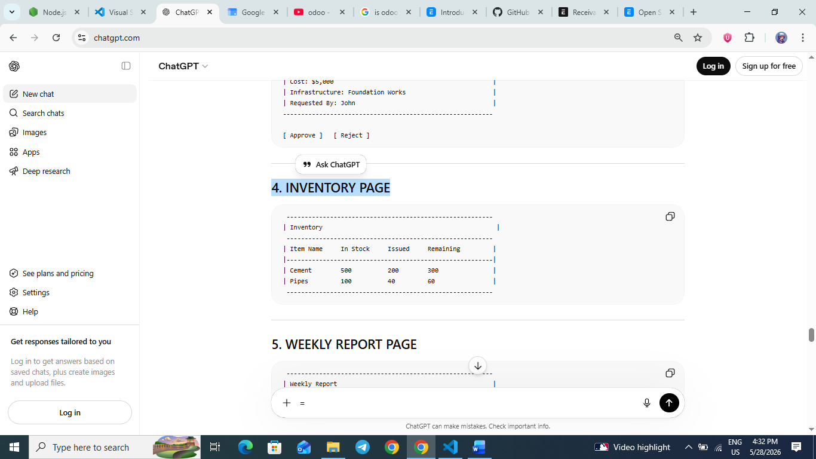
- REPORT PAGE
