AMOL CHOTALIA

B00817019

OS HW3 Report

Graphs made by feeding the data to python.

X Axis is Time in nanoseconds and Y Axis are the

Virtual Addresses.

1. ) Compute and I/O Intensive

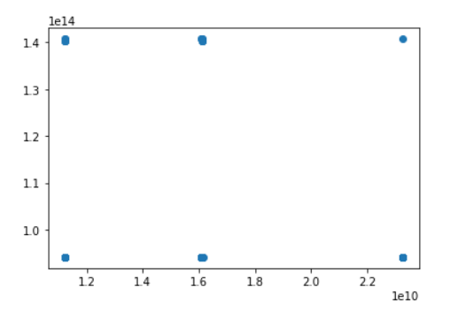

The number of faults for Compute and IO intensive tasks will keep increasing as the time goes on.

1. ) Compute Intensive

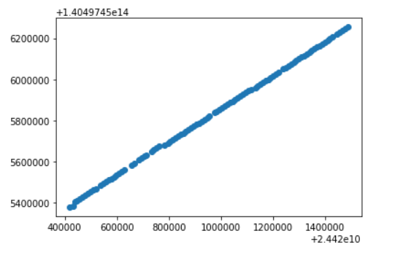

Used the command :

sysbench --test=cpu --cpu-max-prime=20000 run

This helps us to measure the CPU performance.

152 pagefaults were encountered on performing this process.

We see a linear graph made here.

1. ) Network I/O Intensive

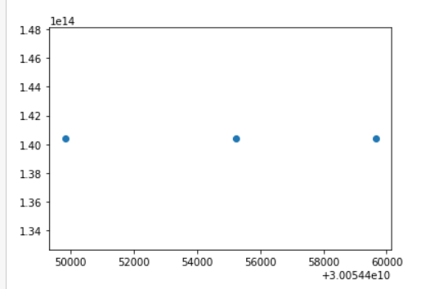

Used the command:

iperf -c bouygues.iperf.fr

Which is us connecting to a predefined iperf server.

Total number of faults were 4.

Conclusions:

The number of pagefaults were the least for Network I/O intensive processes.

Compute Intensive processes show a linear relation between the virtual address and the time.

Whereas the Compute and I/O intensive tasks are a bit scattered and they would also be the most in quantity.