Data Science and Innovation: Artificial Intelligence and Application
Vol. 99, No. 1, July 2024, pp. 1 1x
∼
ISSN: 0000-0000, DOI: 10./.v99.i1.pp1-1x ❒ 1

completion and segmentation of 3D scenes for autonomous cars uses Scpnet method (semantic completion point cloud)

Bogryn Achraf¹
¹Department of Computer Science, University Mohammed V, Rabat, Morocco
²Department of Data Science, University Mohammed V
³Centre National pour la Recherche Scientifique et Technique, Rabat, Morocco

Article Info

Article history:
Received July 18, 2024

Keywords:
AI segmentation and completion Deep learning
3D computer vision Self-driving cars Autonomous vehicles
ABSTRACT

This paper delves into the advancements in 3D scene completion and semantic segmentation for autonomous vehicles, leveraging the innovative SCPNet archi- tecture. SCPNet, a cutting-edge deep learning framework, integrates Multi-Path Blocks (MPBs) and Dense-to-Sparse Knowledge Distillation (DSKD) to enhance the perceptual abilities of autonomous systems. By addressing the challenges posed by the sparse and incomplete 3D data from LiDAR sensors, SCPNet enables precise and detailed 3D scene reconstructions, which are vital for the safe and efficient functioning of autonomous vehicles.

Developing deep neural networks for semantic scene completion (SSC) presents difficulties due to factors like fragmented and sparse input data, diverse object sizes, and inconsistencies in object labels. This research tackles these obstacles using three primary approaches:

- Completion Sub-network Enhancement: A new architecture for the completion sub-network is introduced, utilizing Multi-Path Blocks (MPBs) to capture features at multiple scales and address the limitations of downsampling that leads to feature loss.

- Advanced Knowledge Transfer from Multi-Frame Models: The method of Dense-to-Sparse Knowledge Distillation (DSKD) is developed to convey detailed, relational semantic information from a multi-frame teacher model to a single-frame student model, which significantly improves feature representation.

- Correction of Labels for Improved Model Performance: A novel strategy for label correction is proposed, which uses panoptic segmenta- tion labels to filter out dynamic object artifacts from completion labels, thereby boosting the effectiveness of deep learning models.

Experiments conducted on the SemanticKITTI dataset demonstrate that SCPNet outperforms existing models in semantic scene completion, surpassing S3CNet by 7.2 mIoU, and shows competitive performance in semantic segmentation tasks, highlighting the benefits of knowledge learned in scene completion for segmentation.



Corresponding Author:
Mohd Ali Hassan
Department of Computer Science
Faculty of Science, University Mohammed V
4 Avenue Ibn Batouta BP 1014 RP, RABAT, Morocco Email: contact@um5r.ac.ma

INTRODUCTION
Semantic scene completion (SSC) aims to infer a complete geometric and semantic understanding of a scene from sparse and incomplete observations, making it an essential task in 3D scene understanding. This task is especially challenging in outdoor environments, where the input data is often noisy and the objects within the scene vary significantly in scale. Traditional approaches struggle with these challenges due to their reliance on dense and often imperfect input data, which can lead to suboptimal performance.

Key Challenges in SSC:
  - Sparse and Incomplete Input: Outdoor scenes captured via LiDAR or other sensors often result in sparse point clouds with significant portions of the environment unobserved.
  - Diverse Object Scales: Objects within a scene can range from large structures like buildings to small, detailed elements like traffic signs, requiring models to handle a wide range of spatial resolutions.
  - Dynamic Objects: Moving objects introduce label noise, as their traces across multiple frames can lead to inconsistent labeling, complicating the learning process for SSC models.

Innovations in SCPNet:
- Redesigned Completion Sub-network:
  - The completion sub-network in SCPNet has been overhauled to maintain feature sparsity and avoid the information loss associated with downsampling operations. By employing MPBs with varying convolutional kernel sizes (3x3x3, 5x5x5, and 7x7x7), the network can aggregate features across multiple scales, improving its ability to handle objects of different sizes.

Dense-to-Sparse Knowledge Distillation (DSKD):
  - To mitigate the sparse nature of single-frame point clouds, SCPNet uses a multi-frame teacher- student model. The teacher model, which processes dense multi-frame inputs, transfers relational knowledge to the single-frame student model. This is achieved through the DSKD objective, which ensures the student model learns high-level relational features, significantly enhancing its perfor- mance

Completion Label Rectification:
  - Dynamic objects can leave long traces in completion labels, leading to inaccurate training data. SCPNet uses panoptic segmentation labels to rectify these completion labels, effectively removing the traces of moving objects and resulting in more accurate and reliable labels for training.

FOUNDATIONAL WORK

Progress in Semantic Scene Completion
Early research in scene completion predominantly concentrated on indoor settings, characterized by dense, small-scale, and evenly distributed point cloud data. In contrast, outdoor environments present unique difficulties due to their sparse, expansive, and irregularly distributed point clouds, complicating the develop- ment of effective scene completion algorithms.

Proposed Solutions: Several strategies have been introduced to address these challenges. For exam- ple, LMSCNet combines 2D and 3D convolutions to create a solid base for scene completion. Alternatively, S3CNet performs both 2D and 3D scene completion concurrently and integrates the outcomes through a dy- namic voxel fusion mechanism. Furthermore, JS3C-Net improves completion precision by integrating semantic segmentation features into the model.

SCPNet Overview: SCPNet comprises two models—one as a teacher and the other as a student—both sharing the same architecture. The teacher model handles multi-frame point clouds, whereas the student model focuses on single-frame point clouds. The dense-to-sparse knowledge distillation technique transfers detailed semantic knowledge from the teacher to the student model. Each SCPNet model consists of two sub-networks: one dedicated to completion and the other to segmentation. Initially, the point cloud data is processed through multiple MLP layers to extract features, which are then voxelized and enhanced by the completion sub-network to create denser voxel features. These features are further processed by the segmentation sub-network to pro- duce the final voxel-wise results. The completion sub-network utilizes several multi-path blocks to avoid feature loss from downsampling, while the segmentation sub-network extends the Cylinder3D architecture.

Integration and Improvements: The completion network is closely integrated with the segmentation backbone, improving results through a point-voxel interaction module. Unlike earlier methods, SCPNet avoids feature loss due to downsampling and employs multiple Multi-Path Blocks (MPBs) to gather features at various scales, ensuring high-quality completion for objects of different sizes.

Knowledge Distillation: The concept of knowledge distillation, introduced by G. Hinton and colleagues, in- volves transferring complex knowledge from a larger, more intricate teacher model to a smaller, more efficient student model. Various methods have emerged to facilitate this knowledge transfer, including the use of inter- mediate features, visual attention maps, region-level affinity scores, and similarity measures between different samples. While most of these techniques have been applied to 2D tasks, a few, such as PVKD and SparseKD, extend into the 3D domain. To our knowledge, this study is the first to apply knowledge distillation specifically to semantic scene completion by transferring dense relational semantic knowledge from a multi-frame model to a single-frame model.

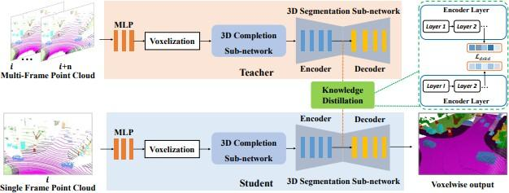
Figure 1. Overview of the SCPNet Framework

METHODOLOGICAL APPROACH
The objective of the semantic scene completion (SSC) task is to infer a comprehensive geometric and semantic representation of a scene from an incomplete and sparse input. Given an input point cloud X ∈ R^{N×3},

where N represents the number of points and each point is defined by its 3D coordinates, the network’s goal is to assign a semantic label to each voxel in a 3D grid.

Formally, the voxel space is defined by dimensions L, W , and H, corresponding to the length, width, and height of the grid, respectively. Each voxel in this space can either be empty or belong to one of C prede- fined classes, where C is the total number of classes. The task is to predict the voxel-wise occupancy and class labels, resulting in an output tensor O R^{L×W×H×C} . Here, O indicates the probability distribution over the classes for each voxel, allowing the network to determine whether a voxel is empty or occupied by a specific object class.
∈

To achieve this, the network processes the input point cloud through multiple stages:

- Point Feature Extraction: Initially, the raw point cloud X is processed by a series of Multi-Layer Perceptrons (MLPs) to extract point features, capturing local geometric details.

- Voxelization: The extracted point features are then voxelized, mapping the 3D points onto a discrete voxel grid, V ∈ R^{L×W×H} .
- Completion Sub-network: The voxelized features are fed into the completion sub-network, which en- hances the voxel features by aggregating multi-scale information using Multi-Path Blocks (MPBs). This step ensures the network can fill in missing parts of the scene and create a dense 3D representation.
- Segmentation Sub-network: Finally, the enhanced voxel features are processed by the segmentation sub-network, which assigns semantic labels to each voxel based on the dense representation produced by the completion sub-network.

By combining these stages, SCPNet effectively infers the complete geometric and semantic layout of the scene, even from sparse and incomplete point cloud data. This enables detailed and accurate scene understanding, crucial for applications like autonomous driving and robotics.

Framework overview
As shown in Figure 1, SCPNet is composed of two main sub-networks: the completion sub-network and the segmentation sub-network. The completion sub-network is carefully crafted with specific principles to boost its effectiveness. Meanwhile, the segmentation sub-network is derived from the Cylinder3D architecture, with slight adjustments to better align it with the completion sub-network.

The completion sub-network focuses on processing the raw voxel features, ensuring the preservation of detail and avoiding lossy downsampling operations. Key design elements include:

    - Multi-Path Blocks (MPBs): These blocks are crucial for aggregating multi-scale features, enabling the network to effectively handle objects of varying sizes.
    - Maintaining Sparsity: By removing convolution biases and batch normalization layers, the sub-network retains the sparse properties of the voxel features, reducing computational overhead and maintaining efficiency.

The segmentation sub-network processes the refined voxel features generated by the completion sub- network to produce the ultimate voxel-wise semantic outputs. Based on the Cylinder3D architecture, this sub-network has been specifically adapted to effectively utilize the dense features provided by the completion sub-network, ensuring highly accurate semantic labeling.

In the subsequent sections, we will delve into the specific design principles that form the foundation of a robust completion sub-network. Additionally, we will explore the knowledge distillation process from the multi-frame model to the single-frame model, highlighting how this transfer of dense, relational semantic knowledge significantly enhances the student model’s learning and performance.

Redesigning the Completion Sub-network
Originally, JS3C-Net first performed semantic segmentation before applying completion on segmenta- tion features, resulting in limitations. These included fewer parameters in the completion sub-network, leading to poor performance, and issues with downsampling and upsampling causing data loss and distortion.

To overcome these problems, the redesigned completion sub-network follows three principles: main- taining sparsity, avoiding downsampling, and aggregating multi-scale features.
It is constructed using Multi-Path Blocks (MPBs) that incorporate 3×3×3, 5×5×5, and 7×7×7 convolution

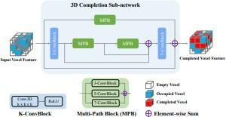
Figure 2. A schematic overview of the designed completion network

blocks (ConvBlock). To preserve sparsity during the completion process, each convolution block operates without convolution bias and omits batch normalization.

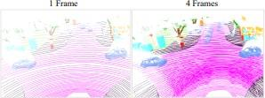
Figure 3. Comparison between multi-frame and single-frame point cloud

The single-frame input is evidently sparser than the multi-frame, making objects harder to identify and significantly increasing the completion difficulty.

Maintaining Sparsity:
  - The completion sub-network uses dense convolution, while the segmentation sub-network employs sparse convolution.
  - Removing convolution bias and BN layers in the completion sub-network helps maintain the sparse property of voxel features, reducing computational costs.

No Downsampling:
  - Eliminating downsampling and upsampling operations retains the original point cloud information, addressing errors in small objects and crowded scenes.
  - The completion sub-network processes raw voxel features directly, benefiting from the segmenta- tion sub-network’s parameters.

Aggregating Multi-Scale Features:
  - The multi-path block design integrates 3×3×3, 5×5×5, and 7×7×7 convolution blocks, with three branches to produce dense completed voxel features.
  - These features are then used by the segmentation sub-network for voxelwise segmentation output.

Knowledge Distillation from Multi-frame Data
Given that single-frame point clouds are naturally sparse and incomplete in outdoor settings, per- forming semantic scene completion directly from such inputs is extremely difficult. A more effective strategy involves building a multi-frame model and then extracting the dense semantic knowledge from this multi-frame network. As shown in Fig. 3, utilizing multi-frame input greatly simplifies the completion task, as the addi- tional frames provide a higher density of points, facilitating easier object identification. The difficulty of the completion process gradually decreases as the number of input point cloud frames increases. Therefore, we create a multi-frame instructor model that processes denser point cloud data, leading to improved completion performance.

To improve the single-frame model, we enable it to extract relational structural knowledge from the multi-frame instructor network. Given that the original voxel features are sparse, we use these sparse features and their indices for the knowledge distillation process. The voxel features and corresponding indices of the teacher and student models are denoted as Ft and Fs , It and Is respectively.respectively,Nm represents the number of non-empty voxel features in the multi-frame input, represents the number of non-empty voxel fea- tures in the multi-frame input,represents the number of non-empty voxel features in the multi-frame input , Ns indicates the number of non-empty voxel features in the single-frame input, and Cf is the number of channels in the voxel features.
Bottom: adjusted completion labels. The proposed label adjustment operation effectively eliminates extended traces of moving objects, enhancing the accuracy of completion labels.

Label Correction for Scene Completion
Generating Completion Labels: As noted by previous research, in outdoor semantic scene comple- tion, ground-truth completion labels are derived by merging the segmentation labels from several consecutive point cloud frames. Specifically, for the t-th frame, the completion labels are created by integrating the segmen- tation labels from this frame with those from subsequent frames adjusted to match the t-th frame’s coordinate system. The alignment is achieved using a transformation matrix that adjusts the coordinates of the following frames to the t-th frame’s system. This procedure can result in extended artifacts for moving objects such as vehicles and pedestrians, as depicted in Figure 5. These extended artifacts can be misleading and impede the training of deep learning models.
Correcting Completion Labels: To address the issue of extended artifacts in completion labels, we utilize panoptic segmentation labels. For each category, we convert the panoptic labels into voxel-based labels. We then determine the boundary for each instance within a category, creating a cubic volume. By combining the cubic volumes for all instances, we refine the original voxel-based completion labels and exclude voxels outside these cubic boundaries. This refinement process is repeated for all categories containing dynamic objects. As shown in Figure 5, this method effectively removes the extended artifacts, resulting in more accurate completion labels.

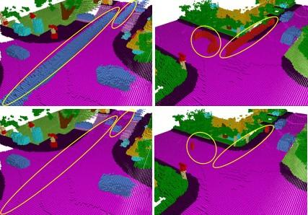
Figure 4. original completion labels with extended traces of dynamic objects such as cars and people

EXPERIMENTAL PROCEDURES
Dataset: In line with the standard procedures of well-known scene completion models, our experi- ments are conducted on the SemanticKITTI LiDAR semantic scene completion benchmark [1]. SemanticKITTI comprises 22 point cloud sequences. Specifically, sequences 00 to 07, 08, and 11 to 21 are allocated for train- ing, validation, and testing, respectively. For both training and evaluation, 19 classes are chosen after merging classes with different moving statuses and omitting those with a minimal number of points.

Implementation Specifications:
Adapting Cylinder3D for Completion Tasks:
For the completion task, Cylinder3D is configured with an output dimension of 256 × 256 × 32. The model undergoes training over 30 epochs with a starting learning rate of 0.0015, using the Adam optimizer. To main- tain training stability, gradient norm clipping is applied with a threshold of 10. The hyperparameters are set to 1 and 3000, respectively. Points outside the voxel-based completion label range are excluded. For the SemanticKITTI dataset, the training process starts with an initial phase on the training set, followed by fine- tuning on both the training and validation sets. Predictions for the test set are then uploaded to the online server.

L = Lce + αLlovasz + βLdskd

RESULTS AND DISCUSSION
Quantitative results The performance of SCPNet and Results on the SemanticKITTI dataset show that SCPNet significantly outperforms other semantic scene completion algorithms in terms of mIoU. SCPNet achieves an mIoU score of 36.7 with a single frame and 47.5 with four frames, outperforming the closest com- peting model, S3CNet, by 7.2 mIoU. SCPNet’s performance is particularly notable for classes such as cars, sidewalks, and vegetation, where performance gaps are significant compared to other methods.

The performance of SCPNet on SemanticKITTI demonstrates the ability of our model to handle com- plex scenes with a wide variety of objects and contexts. Multi-Path Blocks (MPBs) enable efficient capture of multi-scale information, while dense-to-sparse knowledge distillation (DSKD) improves the robustness of single-frame model predictions. Additionally, rectification of completion labels eliminates errors related to dynamic objects, improving the quality of completion predictions.

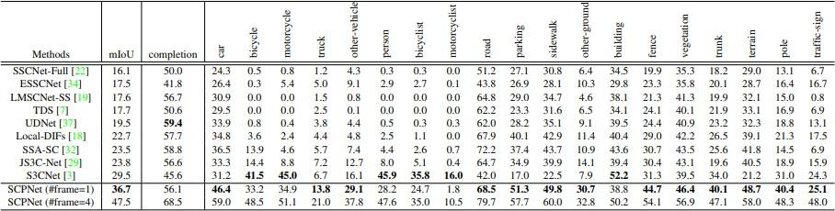
Figure 5. Resultat of completion using dataset semanticKITI

Performance Metrics Comparison
Comparison of performance metrics shows that SCPNet sets a new standard in 3D scene completion and semantic segmentation. In terms of mIoU, SCPNet shows higher scores than previous models such as S3CNet, JS3C-Net, and SSA-SC. SCPNet also achieves better results on accuracy metrics for small objects and in cluttered scenes, thanks to its innovative architecture and knowledge distillation techniques.

The comparative results show that SCPNet offers significant improvements over existing methods, es- pecially for object classes that are difficult to detect and segment. SCPNet performance on SemanticKITTI and SemanticPOSS shows substantial gains in mIoU, demonstrating the effectiveness of our approach in improving the quality of completion and segmentation predictions.

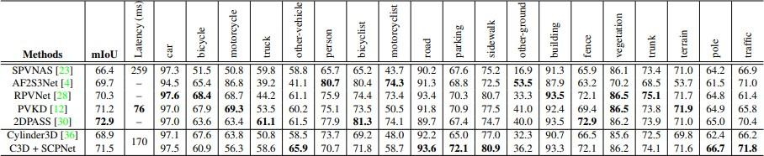
Figure 6. comparison SCPNet with other segmentation models

Visualizing Semantic Completion Results
We present visualizations of semantic completion results obtained with SCPNet on the SemanticKITTI dataset. These visualizations show the accuracy and richness of SCPNet’s predictions, with particular attention to fine details and small objects. The results illustrate how SCPNet manages to complete complex scenes with a wide variety of objects and contexts.

The visualizations clearly show the superiority of SCPNet over existing methods, with more accurate and detailed predictions. Multi-Path Blocks (MPBs) enable efficient capture of multi-scale information, while dense-to-sparse knowledge distillation (DSKD) improves the robustness of single-frame model predictions. Visual results also show the impact of rectifying completion labels, with more accurate predictions for moving objects.

Impact of the Different Components of SCPNet
Ablation studies are carried out to evaluate the impact of different components of SCPNet, such as Multi-Path Blocks, dense-to-sparse knowledge distillation (DSKD) and completion label rectification. The re- sults show that each component contributes significantly to improving the overall performance of SCPNet. For example, the integration of MPBs makes it possible to efficiently capture multi-scale information, while DSKD improves the robustness of single-frame model predictions.

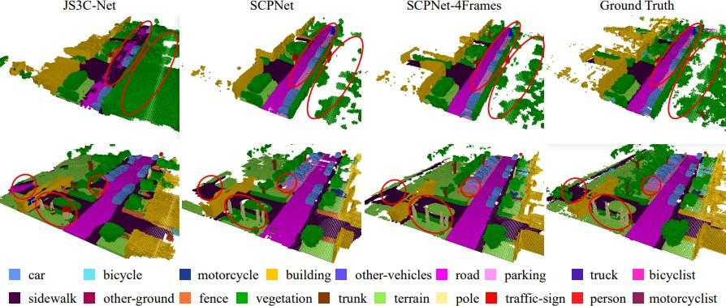
Figure 7. Comparaison visuelle de diffe´rentes me´thodes sur le SemanticKITTI

Ablation studies also show the importance of rectification of completion labels to improve the quality of training data and the performance of deep learning models. By eliminating errors related to dynamic objects, label rectification allows SCPNet to produce more accurate and reliable predictions.
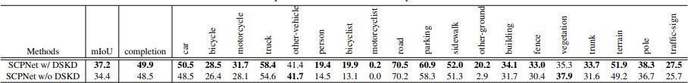
Ability to adapt to changes: This methodology is designed to adjust to changes in requirements dictated by

Figure 8. Impact de la perte DSKD sur les performances customer needs or changes. market changes, which are common in complex projects.

Limitations et Discussions
    - Limites Actuelles de SCPNet
Bien que SCPNet affiche des performances impressionnantes, il existe des limites actuelles qui me´ritent d’eˆtre aborde´es. Par exemple, SCPNet ne´cessite des ressources computationnelles importantes, ce qui peut lim- iter son application pratique dans des environnements a` ressources limite´es. De plus, bien que la rectification des e´tiquettes ame´liore la qualite´ des donne´es d’entraˆınement, elle peut introduire des biais si les e´tiquettes panoptiques utilise´es ne sont pas parfaitement pre´cises.

Une autre limitation de SCPNet est la complexite´ de l’architecture, qui peut rendre difficile l’imple´mentation et le de´ploiement dans des syste`mes de perception en temps re´el. De plus, les exigences en termes de me´moire GPU peuvent eˆtre un obstacle pour certaines applications, en particulier celles qui ne´cessitent une grande e´chelle de traitement des donne´es.

Potentielles Pistes d’Ame´lioration
Des pistes d’ame´lioration potentielles incluent l’optimisation des algorithmes pour des performances en temps re´el, la re´duction des exigences en termes de me´moire GPU, et l’exploration de nouvelles techniques de distillation de connaissances. De plus, l’inte´gration de SCPNet dans des syste`mes de perception en temps re´el pour des applications pratiques, telles que la conduite autonome, repre´sente une direction prometteuse pour les recherches futures.

L’optimisation des algorithmes pour des performances en temps re´el peut inclure des approches telles que la compression des mode`les, l’utilisation de techniques de quantification et de prunning pour re´duire la

taille et la complexite´ des mode`les. De plus, l’exploration de nouvelles techniques de distillation de con- naissances, telles que l’apprentissage par renforcement et les re´seaux adversaires ge´ne´ratifs (GANs), pourrait ame´liorer encore la qualite´ des pre´dictions de SCPNet.

CONCLUSION
SCPNet represents a convergence of significant advances and notable contributions in the field of three-dimensional semantic scene completion and segmentation. By providing a detailed overview of its archi- tecture and functionality, the conclusion highlights how SCPNet overcomes the complex challenges inherent to fragmented data, object size variations, and noise present in labels. It particularly highlights the innovation of its architecture, characterized by specialized subnetworks dedicated to completion and segmentation, as well as by the use of a teacher-student learning model, which facilitates transfer of effective knowledge. Furthermore, the conclusion highlights the significant impact of advanced multi-scale data management mechanisms, such as Multi-Path Blocks (MPBs), in improving the accuracy of 3D reconstructions. By highlighting these ele- ments, the conclusion emphasizes the crucial importance of SCPNet in the development of robust and precise solutions for understanding 3D scenes, the implications of which extend from robotics to autonomous driving and augmented reality. , thus offering revolutionary perspectives for the future of these fields.

REFERENCES
- VR Interactive, ”Nuage de points 3D,” [Online]. Available: https://www.vr-interactive.fr/ nuage-de-points-3d/. [Accessed: 11-Jul-2024].
- S. Tay, ”Segmentation d’images,” [Online]. Available: https://suan-tay.medium.com/ segmentation-dimages-bd59e56ea6bb. [Accessed: 11-Jul-2024].
- Deeply Learning, ”Differences entre classification d’image, localisa- tion, detection, segmentation d’objets,” [Online]. Available: https:
//deeplylearning.fr/cours-theoriques-deep-learning/
differences-entre-classification-dimage-localisation-detection-segmentation-dobjets/
[Accessed: 11-Jul-2024].
- S. Ralla, ”Activation functions: ReLU vs Leaky ReLU,” [Online]. Available: https://medium.com/ @sreeku.ralla/activation-functions-relu-vs-leaky-relu-b8272dc0b1be. [Accessed: 11-Jul-2024].
- Semantic KITTI, ”Semantic KITTI Tasks,” [Online]. Available: http://www.semantic-kitti. org/tasks.html#semseg. [Accessed: 11-Jul-2024].
- Authors, ”Paper Title,” arXiv, 2020. [Online]. Available: https://arxiv.org/pdf/2011. 10033.
- Parkie, ”SCPNet: Semantic Scene Completion on Point Cloud (Paper Re- view),” [Online]. Available: https://medium.com/@parkie0517/ scpnet-semantic-scene-completion-on-point-cloud-paper-review-e33d071c79ac. [Accessed: 11-Jul-2024].
- Authors, ”Paper Title,” arXiv, 2019. [Online]. Available: https://arxiv.org/pdf/1904. 01416.

