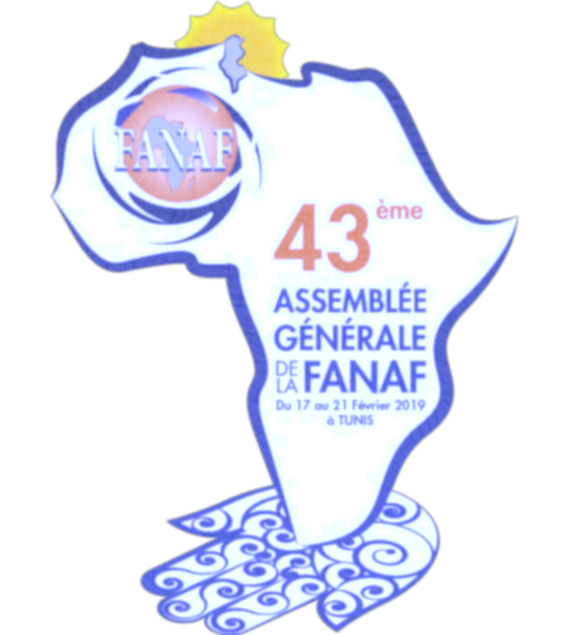***43ème ASSEMBLEE GENERALE DE LA FANAF***

**Salles de réunions & Stands**

|  |  |  |  |  |
| --- | --- | --- | --- | --- |
| Les Stands | Type A | 10m² | 1 Table | 3 chaises |
| **Type B** | 15m² | 1 Table | 4 chaises |
| **Type C** | 20m² | 1 Table | 5 chaises |

|  |  |  |  |  |
| --- | --- | --- | --- | --- |
| Salles  de  Réunion | EL JEM | 62 m² | 2 tables | 6 chaises |
| **DOUGGA** | 60 m² | 3 tables | 8 chaises |
| **AMILCAR** | 45 m² | 3 tables | 8 chaises |
| **UTIQUE** | 60 m² | 3 tables | 8 chaises |
| **ALYSSA** | 88 m² | 4 tables | 10 chaises |
|  | **HANNIBAL** | 88 m² |  |  |
|  | **LEPTIS** | 53 m² |  |  |
|  | **CYRENE** | 53 m² |  |  |
|  | **LIMES** | 53 m² |  |  |

***43ème ASSEMBLEE GENERALE DE LA FANAF***



**Plan du centre d'exposition**

***43ème ASSEMBLEE GENERALE DE LA FANAF***



**Prix des stands & des salles de réunion**

|  |  |  |  |  |  |  |
| --- | --- | --- | --- | --- | --- | --- |
| Les Stands | Type A | 10m² | 3 000 | € | 1 Table | 3 chaises |
| **Type B** | 15m² | 4 000 | € | 1 Table | 4 chaises |
| **Type C** | 20m² | 5 000 | € | 1 Table | 5 chaises |

|  |  |  |  |  |  |  |
| --- | --- | --- | --- | --- | --- | --- |
| Salles  de Réunion | EL JEM | 62 m² |  | € | 2 tables | 6 chaises |
| DOUGGA | 60 m² |  | € | 3 tables | 8 chaises |
| AMILCAR | 45 m² |  | € | 3 tables | 8 chaises |
| UTIQUE | 60 m² |  | € | 3 tables | 8 chaises |
| ALYSSA | 88 m² |  | € | 4 tables | 10 chaises |
|  | HANNIBAL | 88 m² |  | € |  |  |
|  | LEPTIS | 53 m² |  | € |  |  |
|  | CYRENE | 53 m² |  | € |  |  |
|  | LIMES | 53 m² |  | € |  |  |

***43ème ASSEMBLEE GENERALE DE LA FANAF***

**Plan des sa****lles de réunion**