**Delta-X Applications Workshop Instructions**

Table of Contents

Section 1: Introduction 2

Section 2: Tutorials 3

Section 3: QGIS 4

Installing QGIS 4

Section 4: Google Colab 6

Setting up Colab 6

Section 5: Data Access 8

# 

# Section 1: Introduction

This tutorial introduces the ANUGA modeling software for hydrodynamic modeling. The software was developed by Australian National University and Geoscience Australia. You can find more information on source code, development, and community at <https://github.com/GeoscienceAustralia/anuga_core>.

*Copyright 2004 - 2015 Australian National University and Geoscience Australia. All rights reserved*

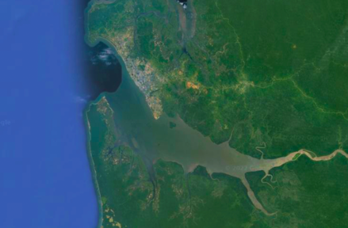

The tutorials will give an overview of building and running **ANUGA** models, using the Komo River Estuary in Gabon as an example. There are 6 tutorials presented as **Python Jupyter Notebooks** and run within **Google Collaboratory**, an online platform. By using **Google Colab**, we reduce the amount of preparation needed for the tutorials and ensure all participants have a working version of Python.

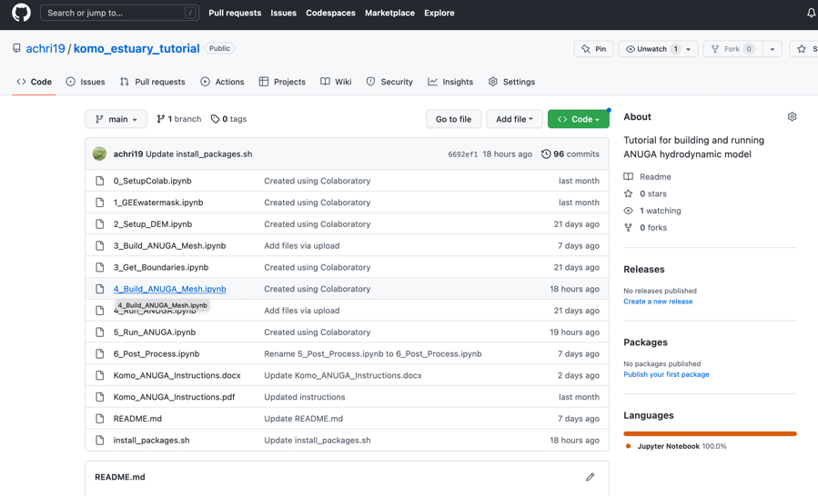These instructions will give a brief overview of using **Google Colab** and installing **QGIS**, an open-source software for visualizing geospatial datasets.

<https://github.com/achri19/komo_estuary_tutorial>

Software:

**QGIS** – Open-source GIS software for visualizing and processing geospatial data

**Python** – Open-source software for installing multiple Python tools

**ANUGA** – Open-source python-based modeling software

**Google Earth Engine** - Cloud-based geospatial analysis platform

Affiliation: Jet Propulsion Laboratory, California Institute of Technology

Acknowledgement: The research was carried out at the Jet Propulsion Laboratory, California Institute of Technology, under a contract with the National Aeronautics and Space Administration (80NM0018D0004)

© 2022 California Institute of Technology. Government sponsorship acknowledged

# Section 2: Tutorials

There are 6 tutorials in the workshop The links to the notebooks for this workshop at this Github page. (<https://github.com/achri19/komo_estuary_tutorial>). All tutorials are designed to run in **Google Colab**, which can be setup using instructions in **Section 4**.

**Tutorial 0: Setup Colab**

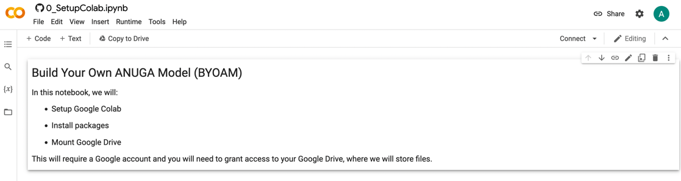Summary: This notebook will walk through the process of installing packages, connecting to your Google Drive, signing up for **Google Earth Engine,** and using **Google Colab** (a free, online platform for running Python Jupyter Notebooks)

**Tutorial 1: GEE Water Masks**

Summary: This notebook will introduce **Google Earth Engine** (via **Python**) and produce water masks for the study area. This is a very time-intensive step so all output files will be provided

**Tutorial 2: Build Digital Elevation Model**

Summary: This notebook will walk through steps to build a DEM for the study area using open-source/publicly available datasets.

**Tutorial 3: Boundary Conditions**

Summary: This notebook will look at options for setting boundary conditions

**Tutorial 4: Mesh Generator**

Summary: This notebook will use the **ANUGA** mesh generator to build a uniform, unstructured mesh for the model domain

**Tutorial 5: Run ANUGA**

Summary: This notebook will run a short **ANUGA** simulation

**Tutorial 6: Post-Processing**

Summary: This notebook will introduce ways to visualize the model output. We will also use **QGIS** to create animations.

# 

# Section 3: QGIS

## 

## Installing QGIS

QGIS is a great tool for processing remote sensing data and especially useful for visualizing data quickly and effectively. It is open-source and can be downloaded here:

<https://qgis.org/en/site/forusers/download.html>

For Windows:

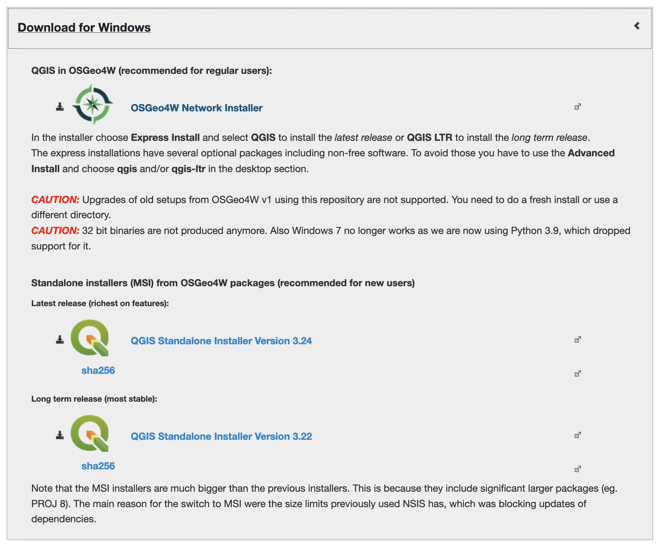

We recommend the standalone installers, specifically Version 3.22

For Mac:

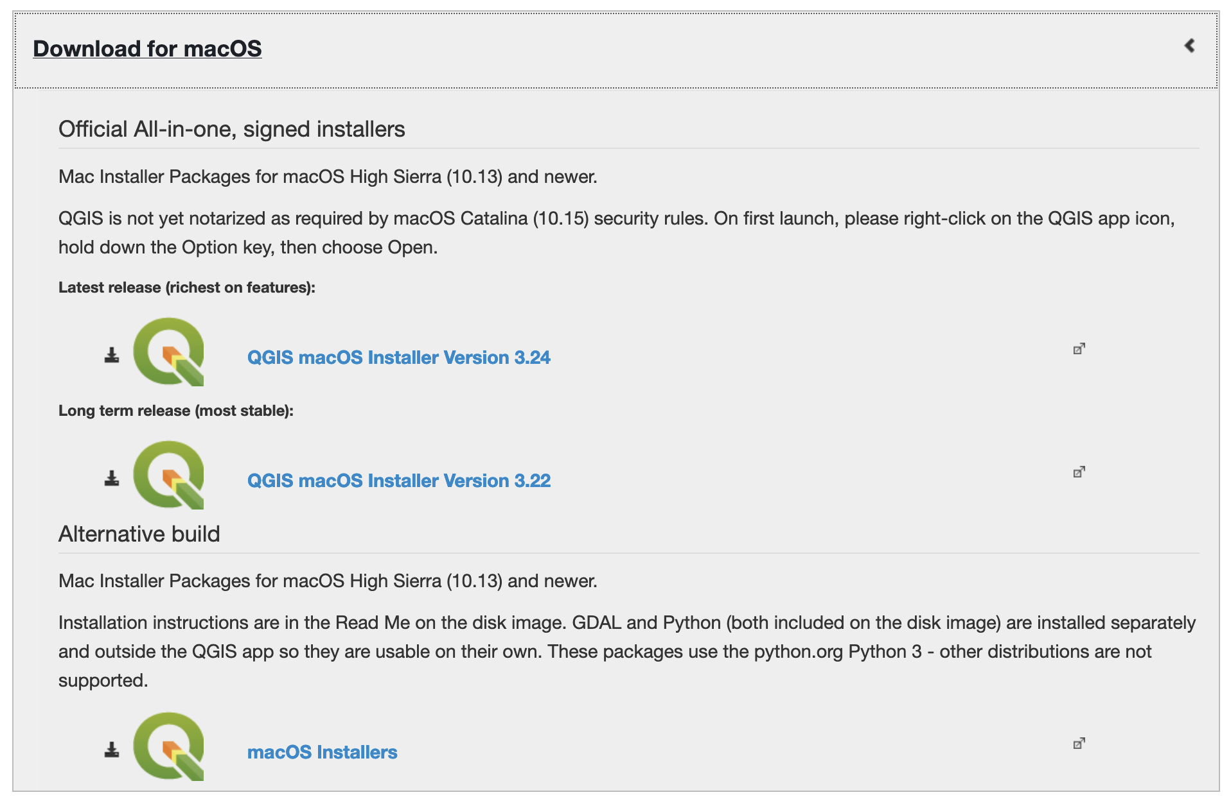

We recommend Version 3.22

For Linux:

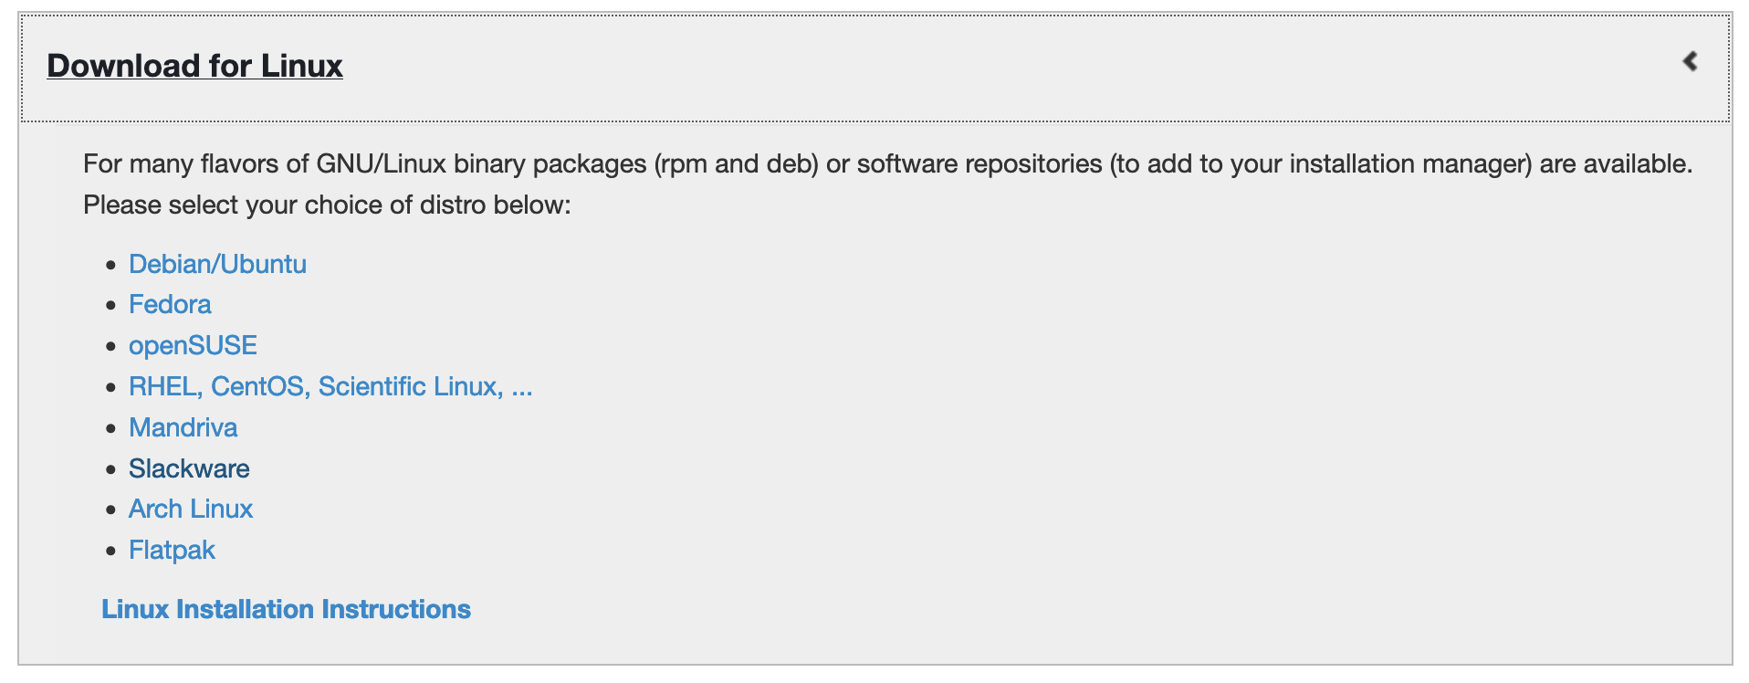

Common issues:

* If you’re using a PC and get error 2503 or 2503, you need to set permissions on C:\\WINDOWS\TEMP to Authenticated users = Full Control
  + More info [here](https://www.urtech.ca/2016/02/solved-how-to-fix-error-2503-2502-on-windows-10-when-installing-software/)

# Section 4: Google Colab

## 

## Setting up Colab

For this tutorial, we will be using **Google Collaboratory**, which allows us to run **Python** **Jupyter Notebooks** online without installing complicated software.

**Google Colab** is similar to **Python** **Jupyter Notebooks**, but is run on the Google cloud and comes with many packages already installed. Therefore, it’s a great way to teach tutorials for this workshop. The only requirement will be allowing **Colab** access to your Google Drive. Unfortunately, **Colab** cannot access the files on your computer, so we will be accessing data through the shared Google Drive.

Please go through the following steps to practice using **Colab**.

1. Go to <https://github.com/achri19/komo_estuary_tutorial> to find the Github site where we are hosting the test notebook.

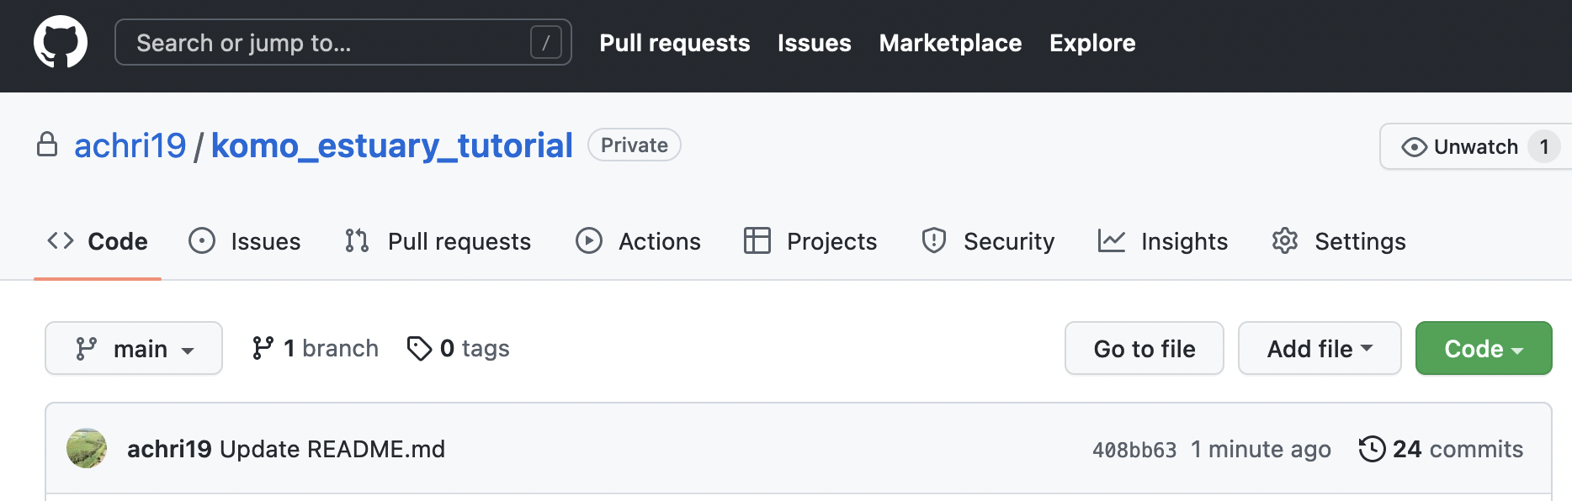

You do not need a Github account to access this repository.

1. Click on the “Open in **Colab**” button within the README section.

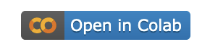

1. This will open a new window and a beautiful test notebook.

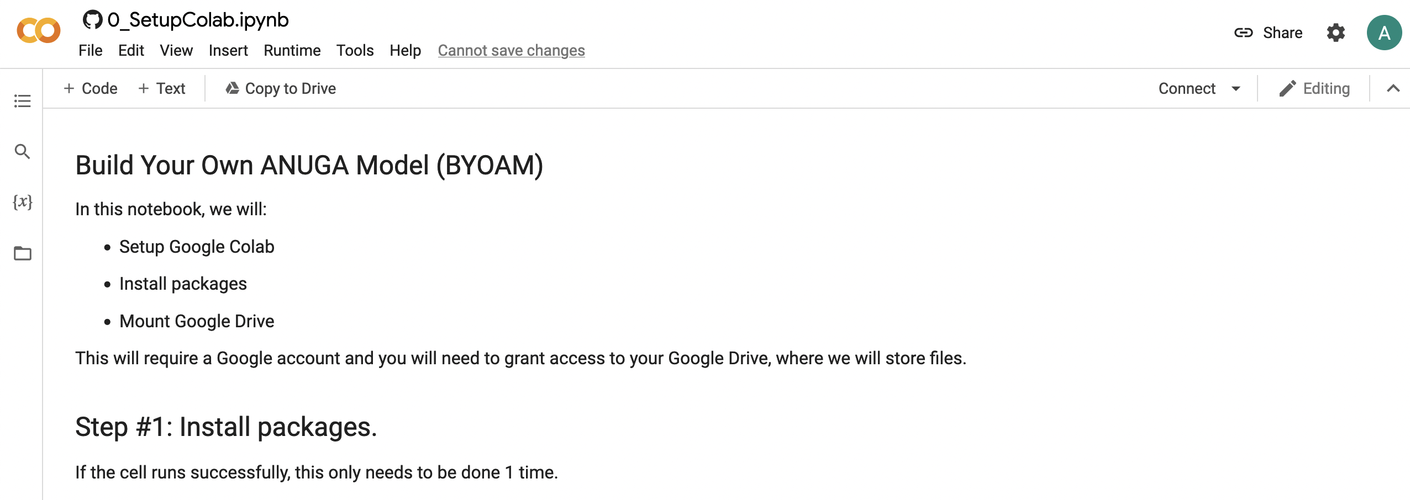

1. Read the instructions and run through each cell (snipet of code separated into boxes)
2. When you hover over the first gray box, you will see a “play” button in the upper left corner. **Click it** to run the first cell. You can also use a command to run this cell, often it’s SHIFT + ENTER or CTRL+ENTER, depending on your system. If you hover over the “play” button, it will tell you what the command is.

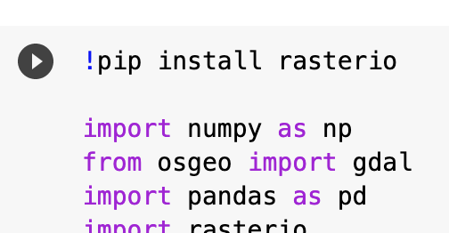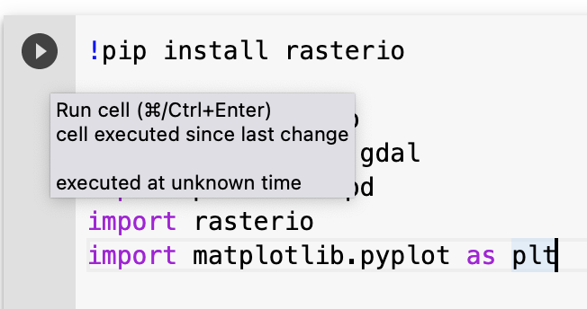

If you run into any problems with this process, please reach out to [alexandra.l.christensen@jpl.nasa.gov](mailto:alexandra.l.christensen@jpl.nasa.gov)

# Section 5: Data Access

All data used in this tutorial are publicly available. Some data are provided in the Google Drive and some are downloaded within the notebooks. Due to the long processing time of some steps, we are providing some pre-processed datasets.

More coming soon…