**Progress Report**

**POC 1- Health/Probe (App Gateway/VMSS)**

***Prerequisites:***

* Spin Window Server 2019 in Azure. Installed .Net Core 3.1, Webdeploy 3.6 and IIS Server (opened port 8172 for remote management).
* Created sample asp.net web app (.net 3.1) and web api (.net 3.1) using Visual Studio 2019
* Added Custom pages healthwebapp and healthapi respectively in sample apps mentioned above respectively.
* Published webapp on default port 80 and web api on port 90 on IIS Server
* Created health.html page in app folder to check window server’s health
* Captured image (Serve as Golden Image) in image gallery to be used for VMSS

***Requirement:***

***Steps completed:***

* Set up APPGateway using two pools for port 80 and 90
* Set VMSS using golden image created in prerequisite steps and app health monitoring and repair for server’ health.
* Setup LogAnalytics, Diagonostics, Insights for all components for monitoring, Analytics and data gathering purposes
* Setup Custom health probes on port 80 and port 90 based on healthwebapp and healthapi pages created above (Response code 200 is success)
* Setup Scale out criteria based on unhealthyHostCount

***Next Steps:***

* Analyze/Monitor Scale out criteria on different conditions.
* Exploring/implementing strategy on removing unhealthy server.
* Implement any other suggestions comes out of discussions
* Explore limitations on custom health/probe from Azure perspective

**Questions/Need Confirmation:**

* What is the strategy on unhealthy node (how long to wait, cool off period etc) before removing it?
* Did CFS currently implement Auto repair on VMSS?

**06/14**

**Routing mechanism**

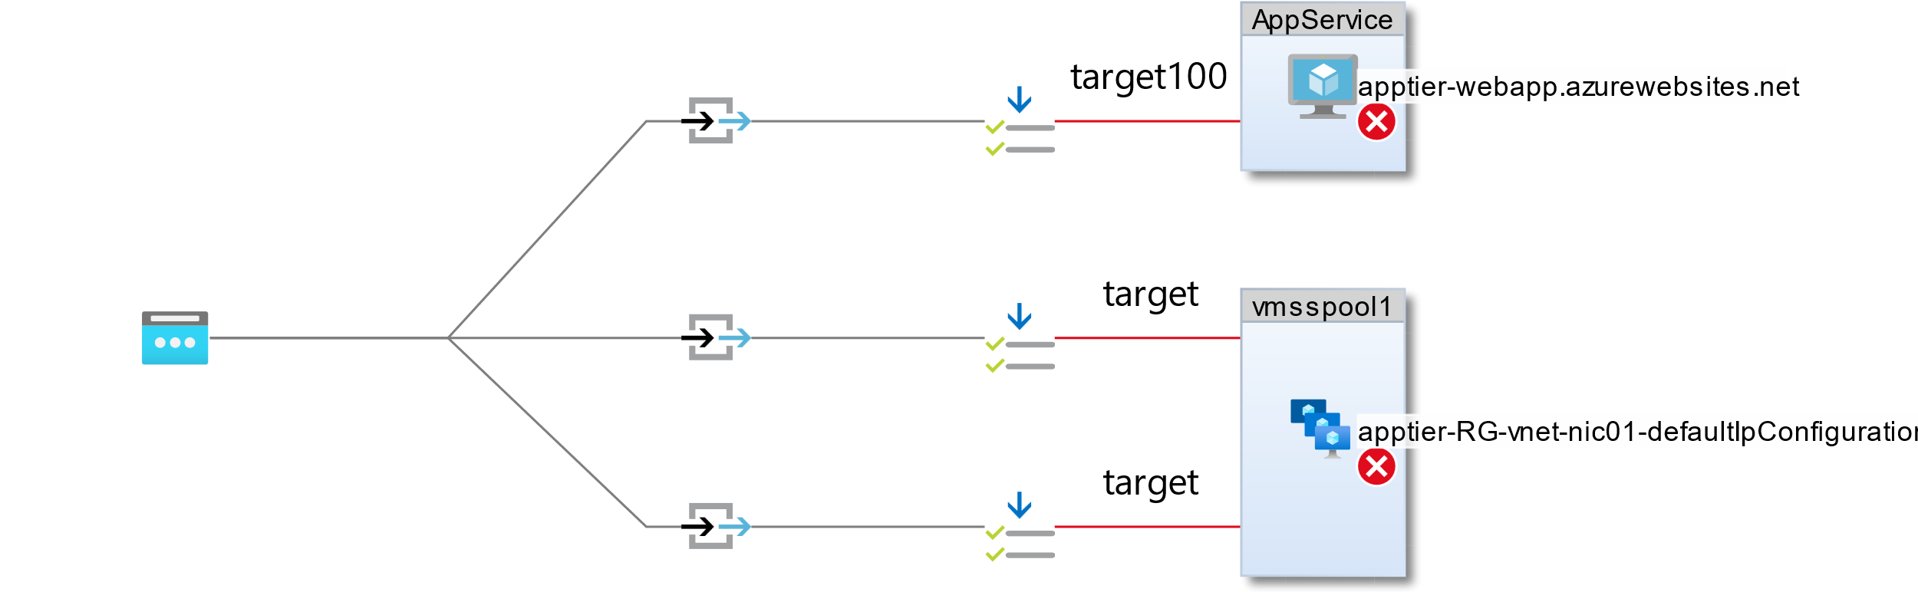

Limit is 40 for Azure WAF (for resources/backend)

[Azure subscription limits and quotas - Azure Resource Manager | Microsoft Docs](https://docs.microsoft.com/en-us/azure/azure-resource-manager/management/azure-subscription-service-limits#application-gateway-limits)

WAF vs WAF v2

[Web application firewall request size limits in Azure Application Gateway - Azure portal | Microsoft Docs](https://docs.microsoft.com/en-us/azure/web-application-firewall/ag/application-gateway-waf-request-size-limits)

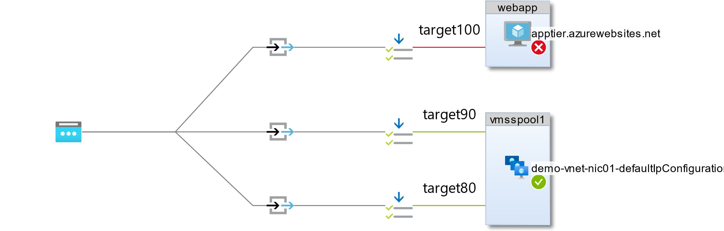

When the application gateway selects the backend pool, it sends the request to one of the healthy backend servers in the pool (y.y.y.y).

The health of the server is determined by a health probe. If the backend pool contains multiple servers,

the application gateway uses **a round-robin algorithm** to route the requests between healthy servers.

This load balances the requests on the servers.

[How an application gateway works | Microsoft Docs](https://docs.microsoft.com/en-us/azure/application-gateway/how-application-gateway-works)

[Hosting multiple sites on Azure Application Gateway | Microsoft Docs](https://docs.microsoft.com/en-us/azure/application-gateway/multiple-site-overview)