Prerequisites

1. Admin Access to Test environments Dev, QA, Staging, Prod

Test env creation in personal azure subscription

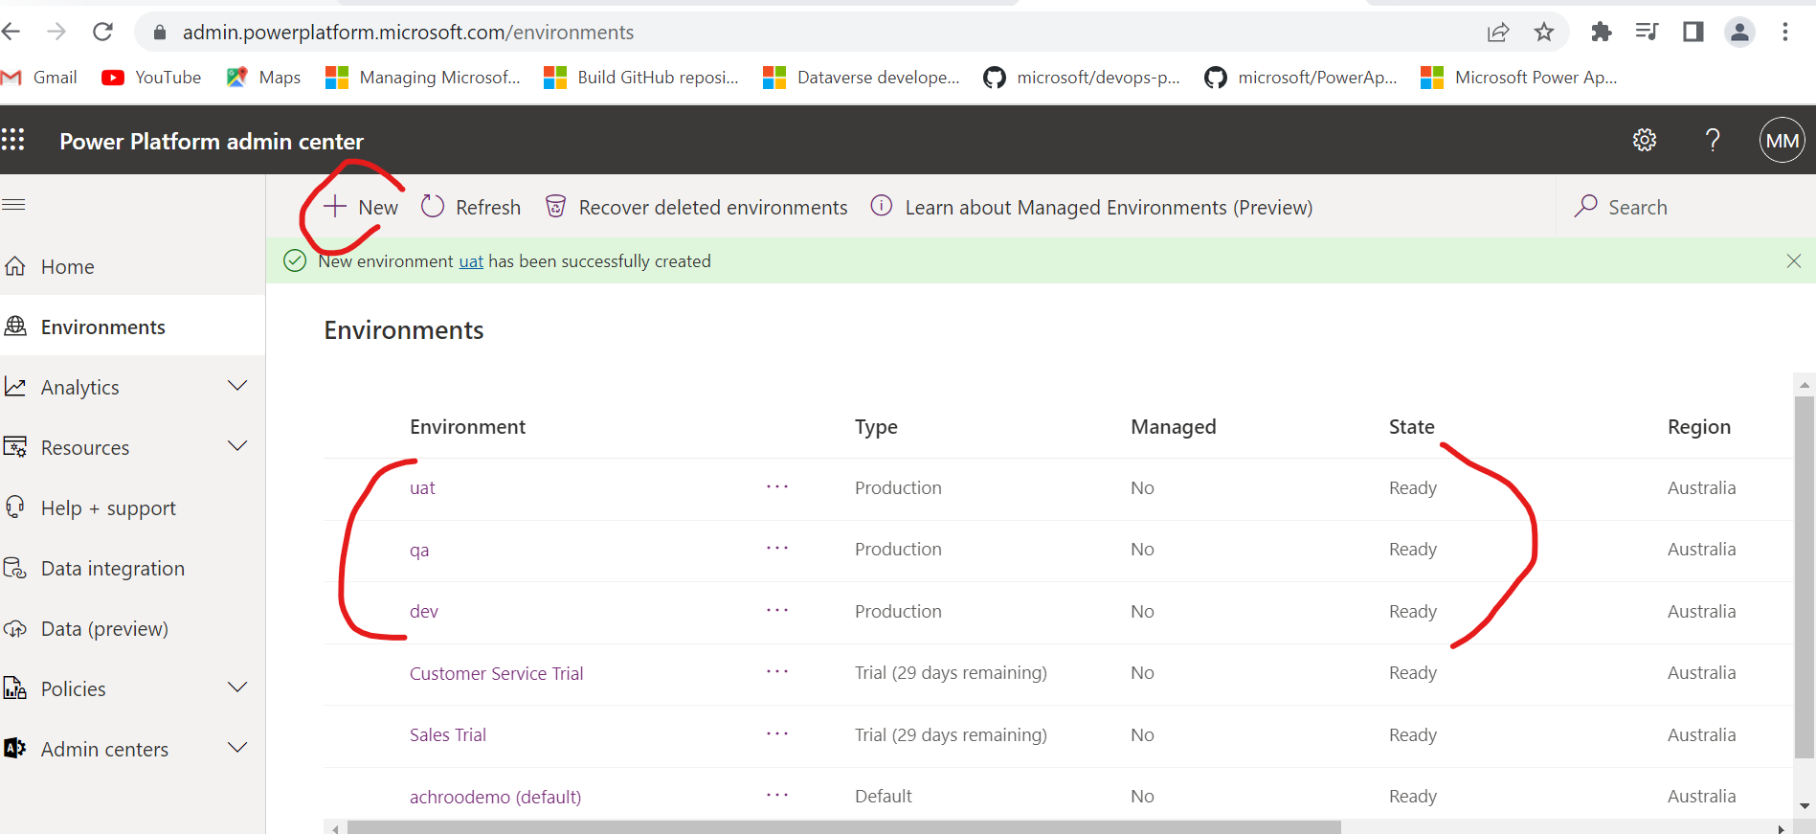

1. In Azure DevOps install Power Platform Build tool extension from marketplace in specific organization
2. Set up new project says alm-powerapps
3. Create default solution in dev environment

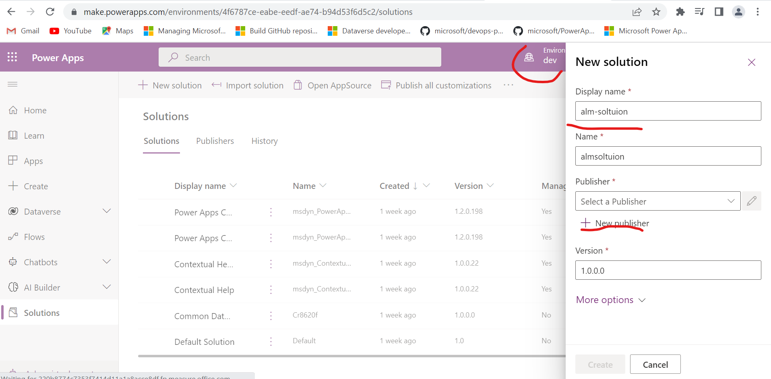

1. Create a new publisher

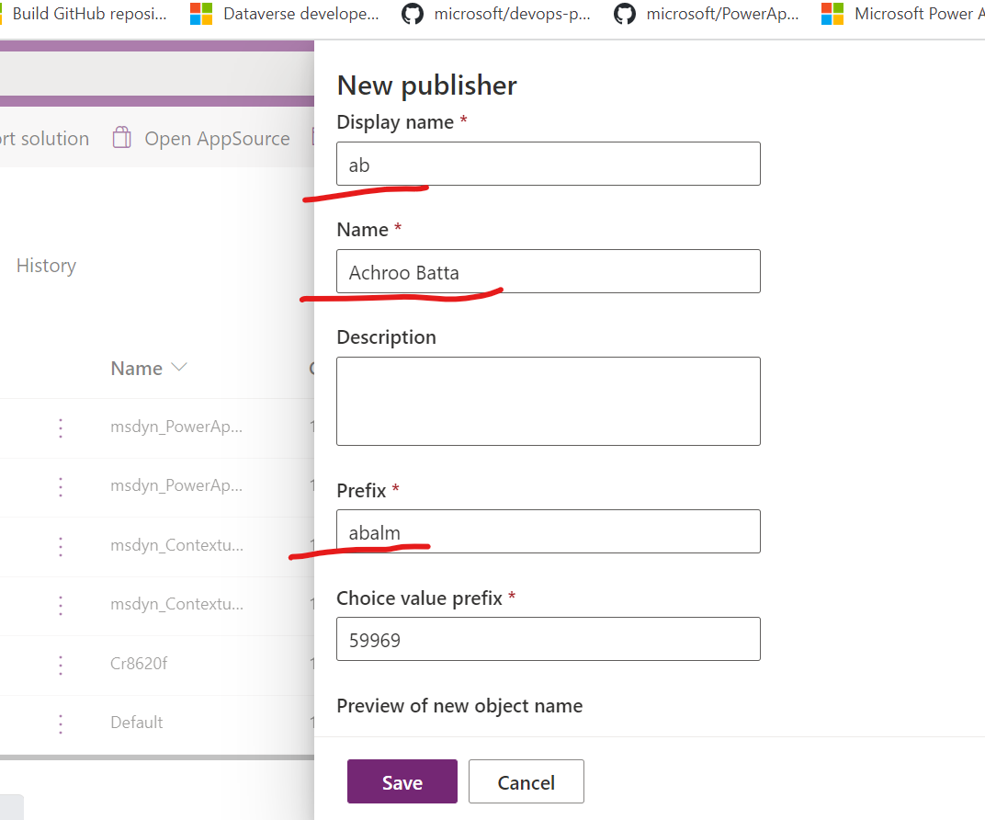

1. 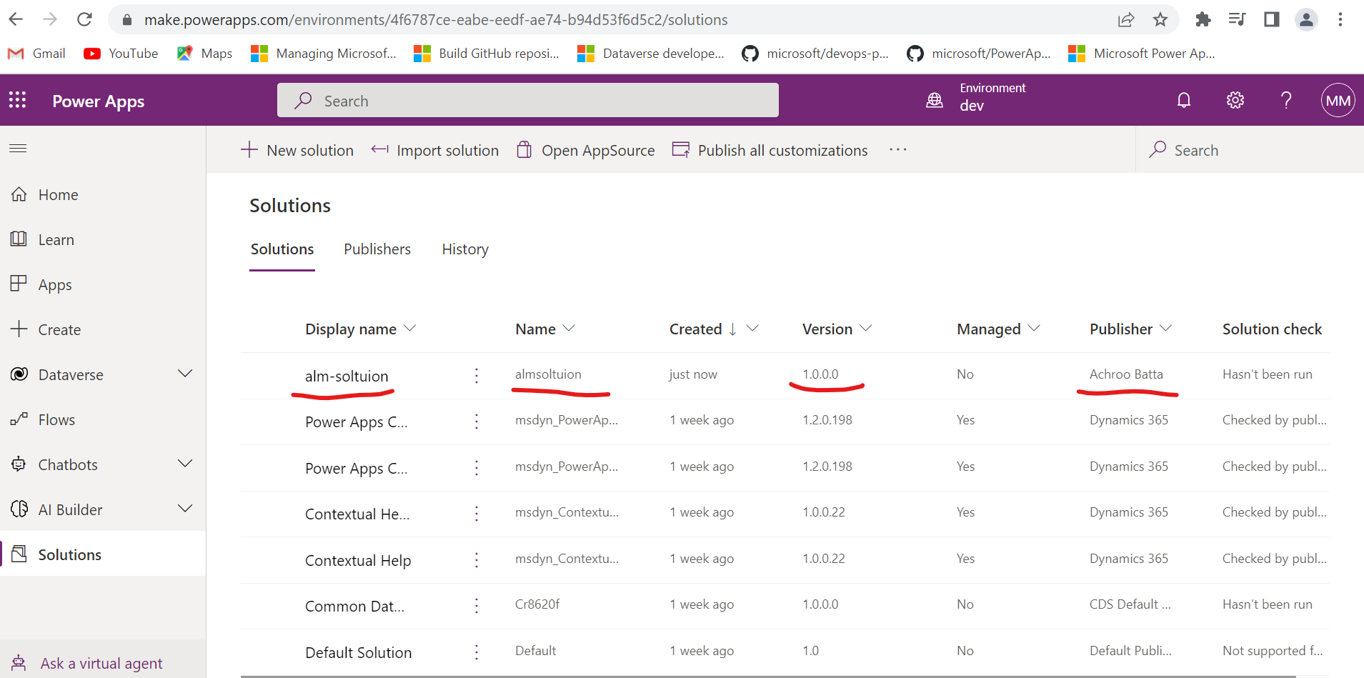

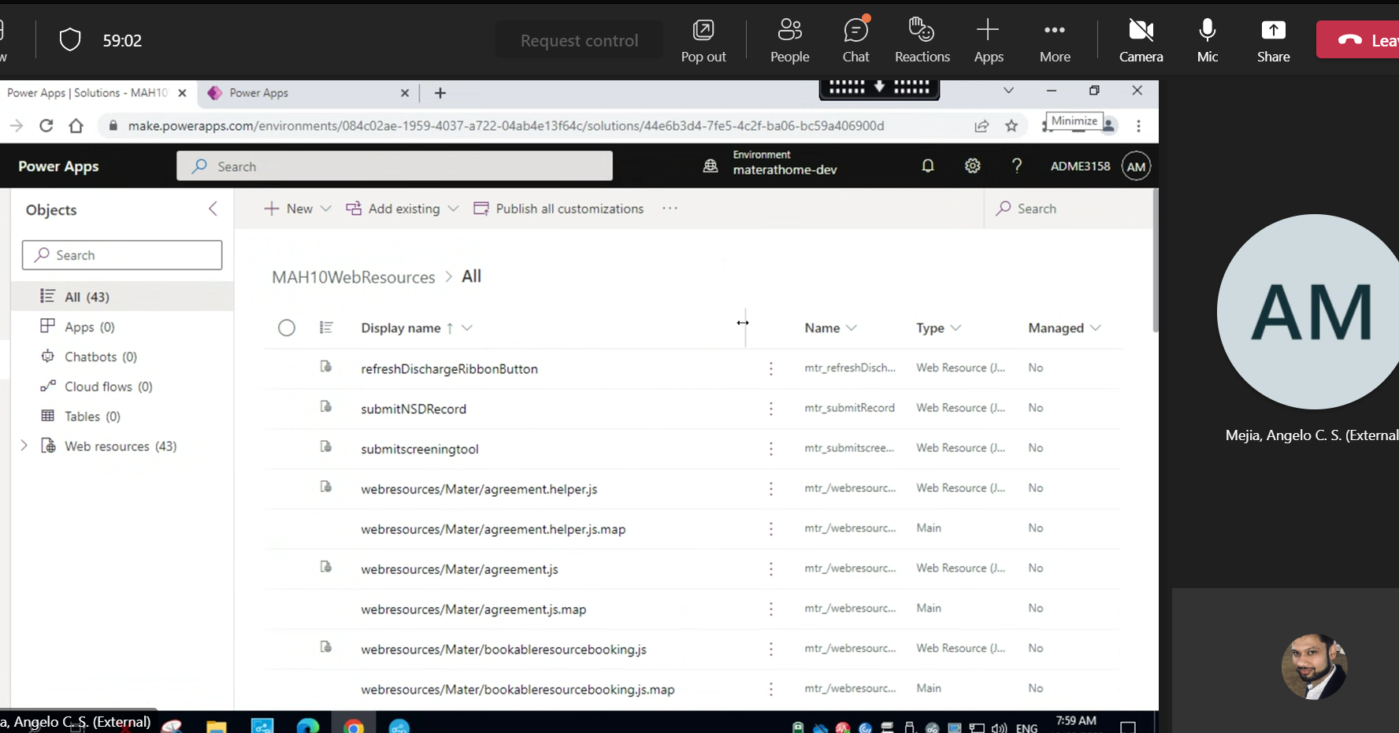

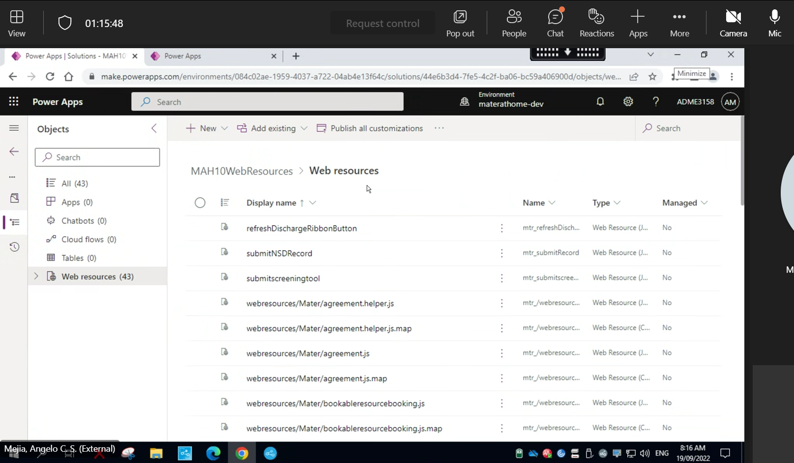

pocdev (unmanaged sol)

10 -- Empty container/folder for webresources

20 -- AC will help to copy the components

poctest (managed sol)

prerequisites: -

1. create 2 environments with full control

2. copy components of 20 from dev to pocdev (manually by AC/Eugenio)

POC Azure pipeline

1. Create AZ AD app registration service principal

2. We need to assign security role (admin) to service principal (app id) for pocdev and poctest

3. Create service principal in service connection in the azure pipeline

2. it will copy webresources into 10 and also build a sol 10 (deployment frontend)

3. it should build unmanaged sol for 20 components

4. make them managed and transport them to poctest

5. AC/Kai/Eugenio will help to validate the deployed sol for pocdev and poctest.

[Mater - Repos (azure.com)](https://dev.azure.com/achrooorg/_git/MaterPOC?path=/src/Dynamics/Web/src/webresources/Mater)

/src/Dynamics/Web/src/webresources/Mater

/src/Dynamics/Deployment/ManagedSolutions

- ${{ if eq(parameters.deploy_frontend, true) }}:

        - job: buildFrontend

          displayName: "Build Frontend"

          steps:

          - template: ../steps/build/dynamics-build-frontend.yaml

          - upload: "$(base_path)/Web/dist"

            artifact: Web

            displayName: "Publish Web Artifact"