**Prerequisites: -**

1. Avanade Managed Team will create two environments (POCDEV and POCTEST) with full control with the help of Anand
2. Avanade Managed Team will copy Power platform components MAH20CustomizingNew from MaterAtHome DEV to POCDEV
3. A Mater Account has been created and access to Azure DevOps has been provided.
4. Access to the GitHub MaterAtHome project has been provided.
5. Access to create a pipeline in Mater Azure DevOps environment and a service principal in Azure AD has been provided.

**Phase1: -**

**POC Azure pipeline:-**

1. Create AZ AD app registration service principal

(refer link: [Use single-tenant server-to-server authentication (Microsoft Dataverse) - Power Apps | Microsoft Learn](https://learn.microsoft.com/en-us/power-apps/developer/data-platform/use-single-tenant-server-server-authentication#azure-application-registration))

1. Assign security role (admin) to service principal (app id) for pocdev and poctest

[(572) Setup Service Principal in a Power Platform Environment for ALM - Part 2 - YouTube](https://www.youtube.com/watch?v=1rahykmdNyA&list=PL6Z-b1l5x5d_dq04pgAQb8BNcYsaUux9O&index=3)

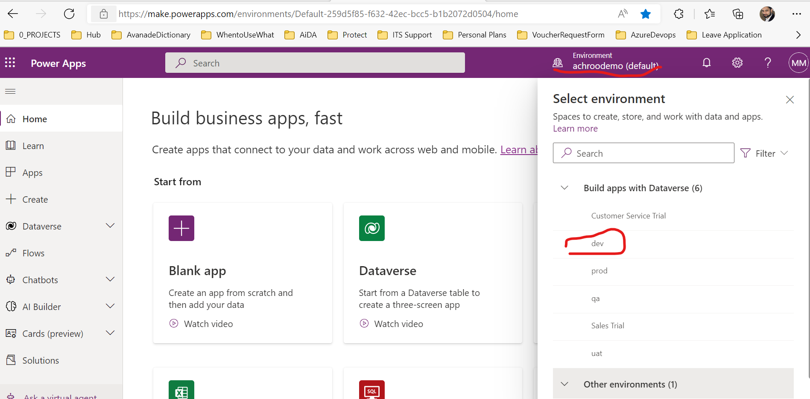

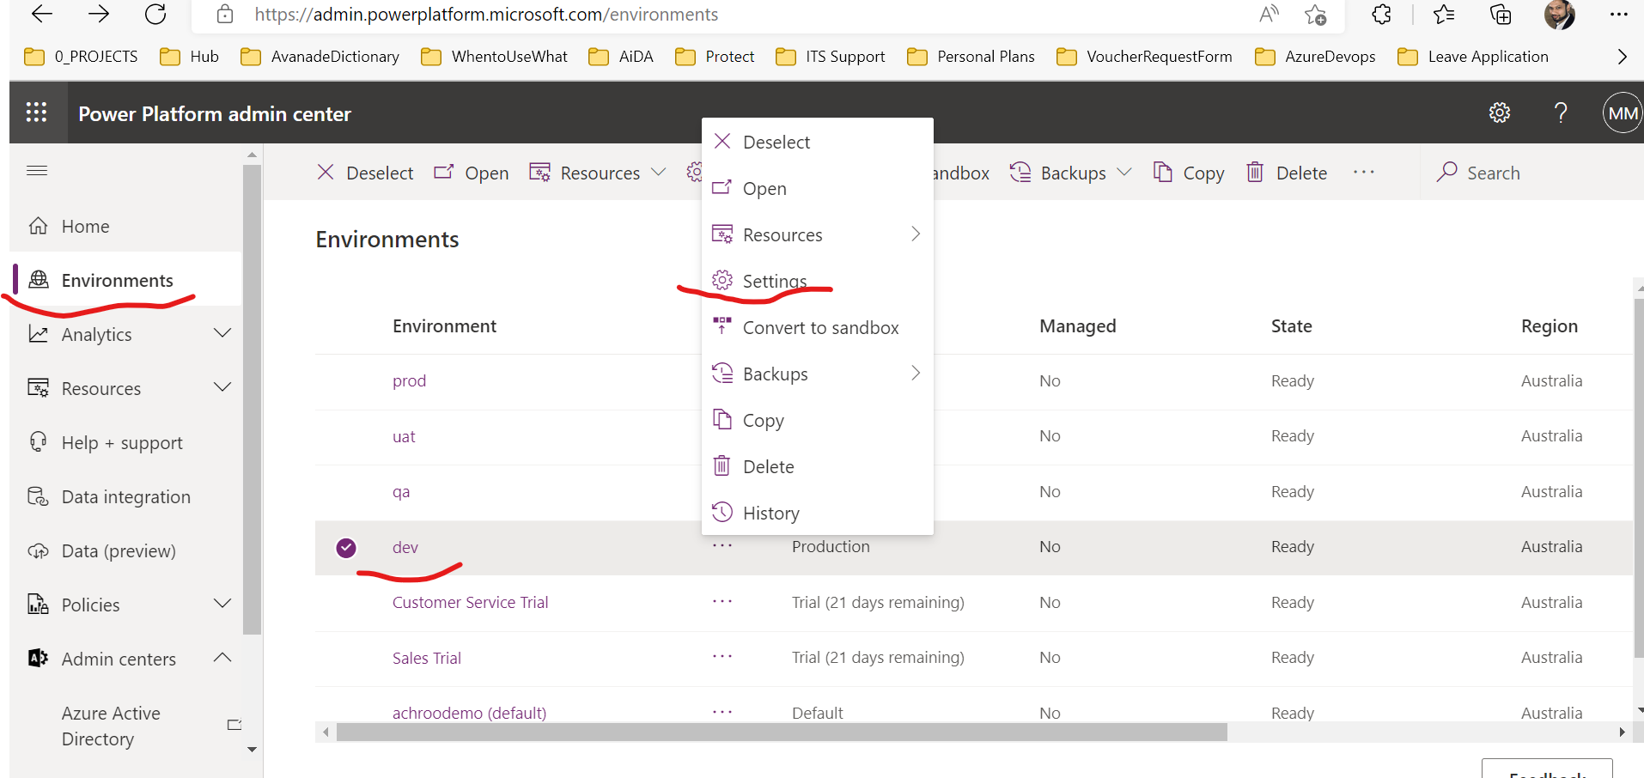

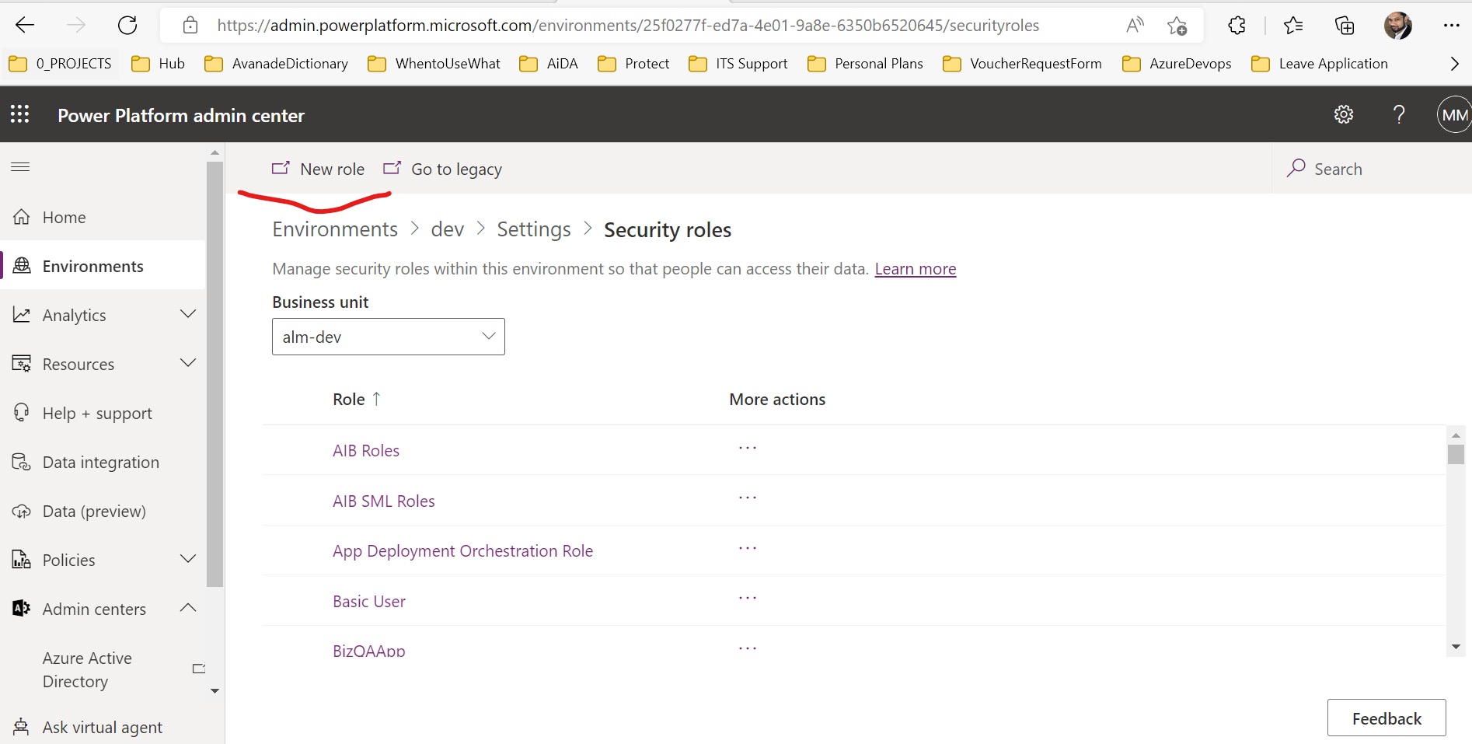

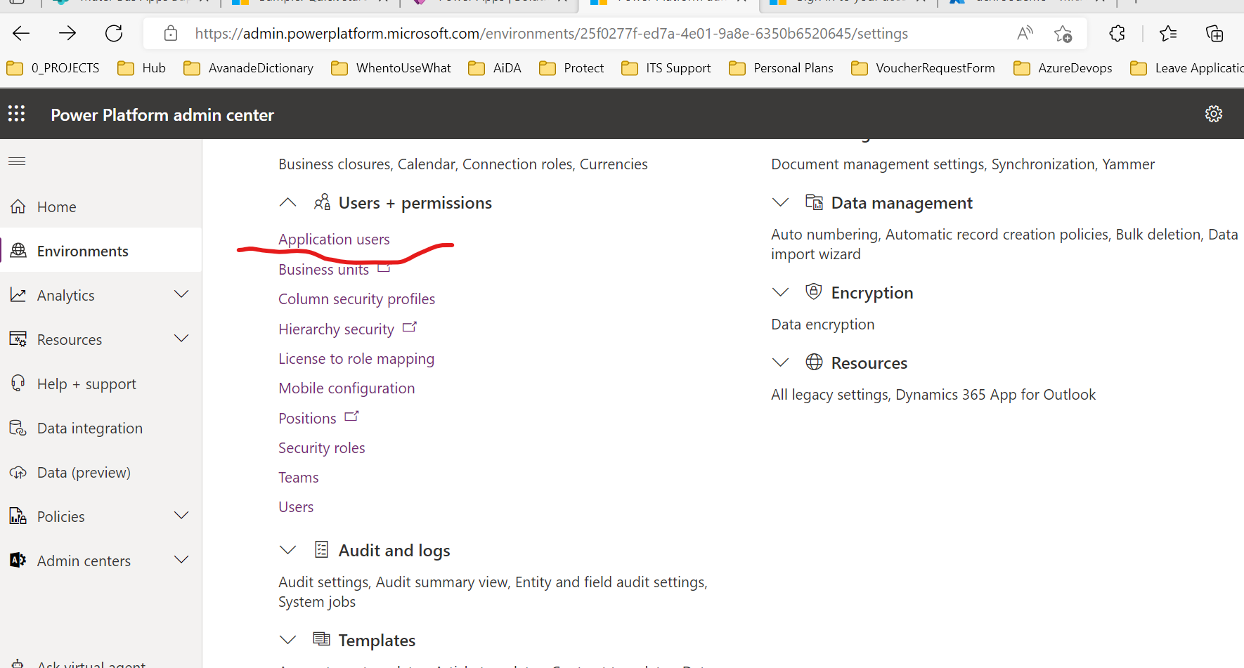

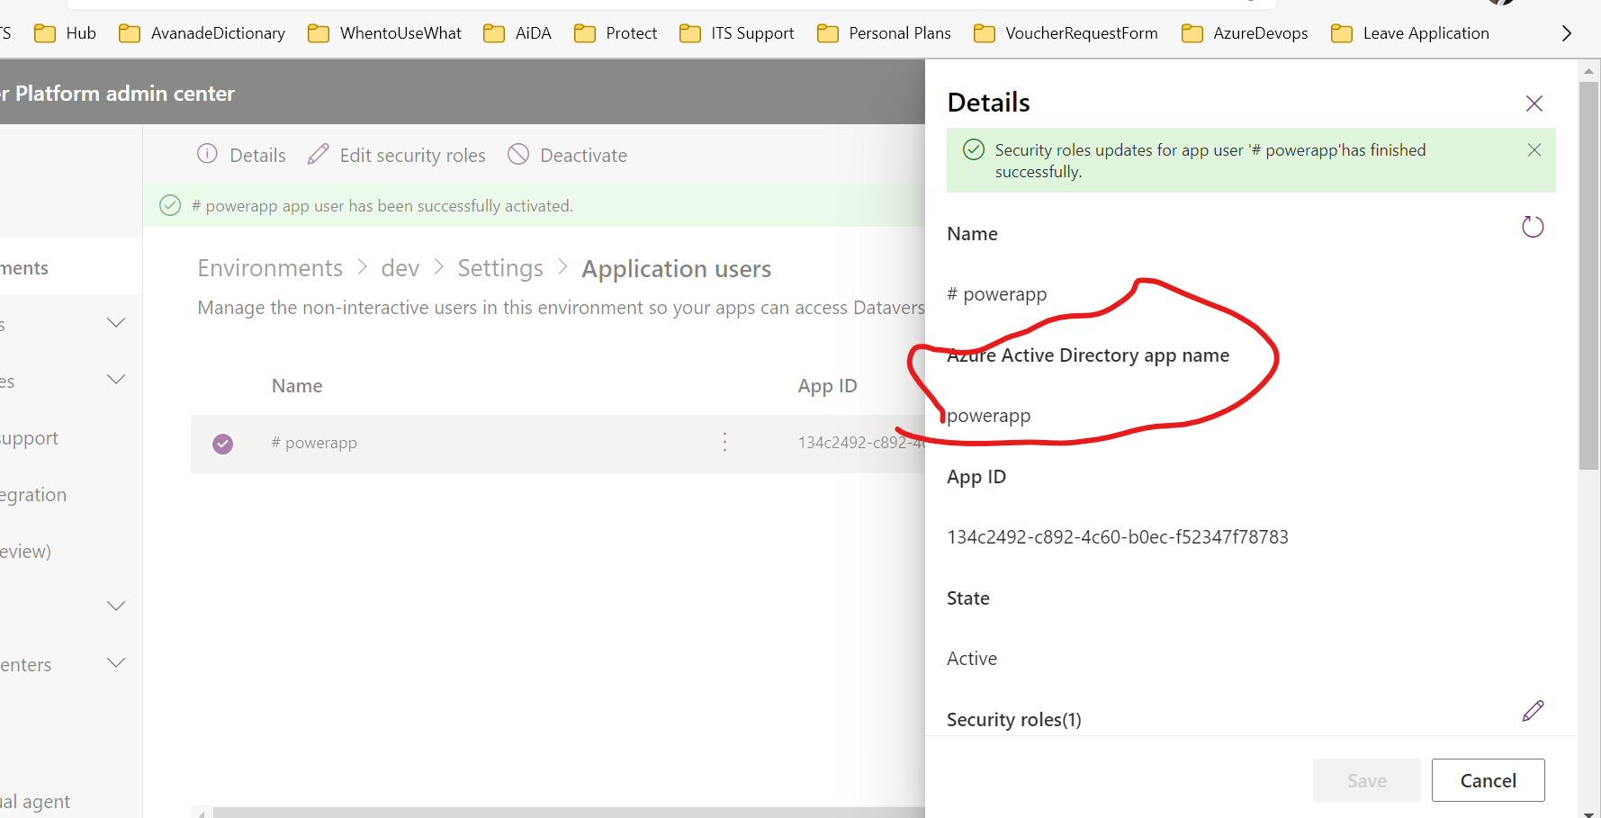

Check with Avanade managed Team (Ac/Kai/Eugenio for above steps)

1. Create service principal in service connection in the azure pipeline

[(573) Power Platform Environment ALM DevOps, Using PowerShell & CLI - Part 3 - YouTube](https://www.youtube.com/watch?v=3TVukPC6xMU&list=PL6Z-b1l5x5d_dq04pgAQb8BNcYsaUux9O&index=4)

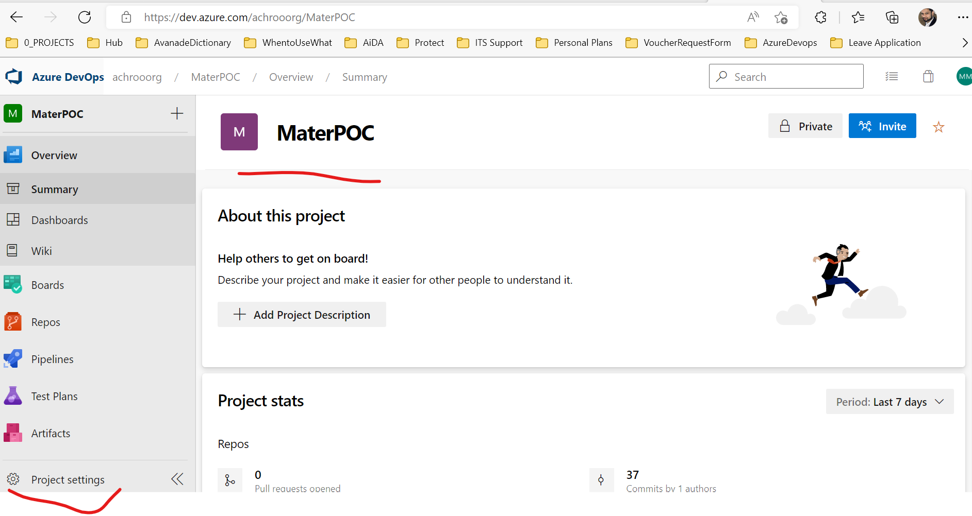

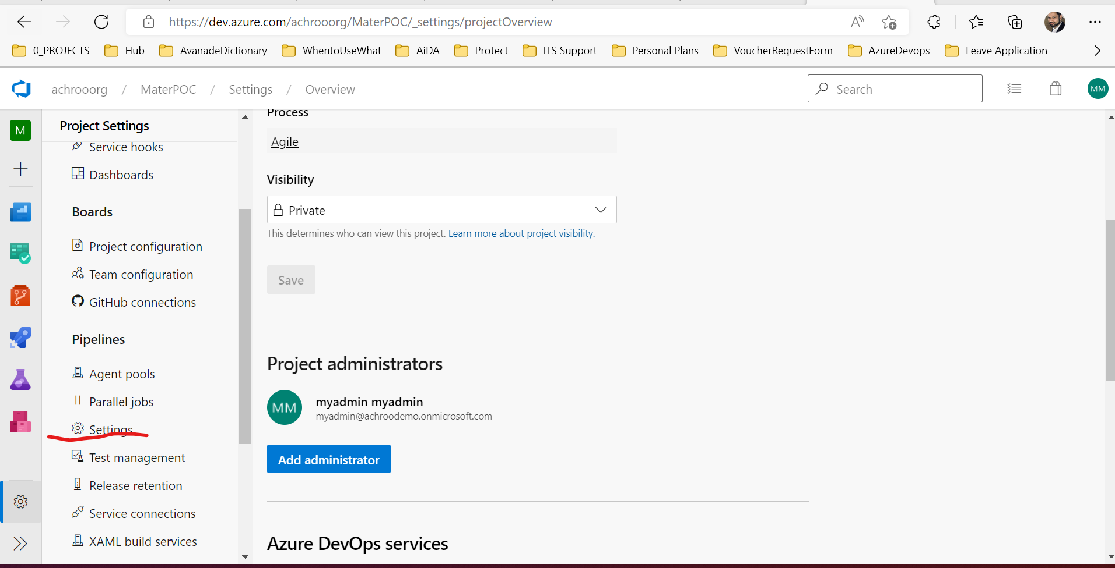

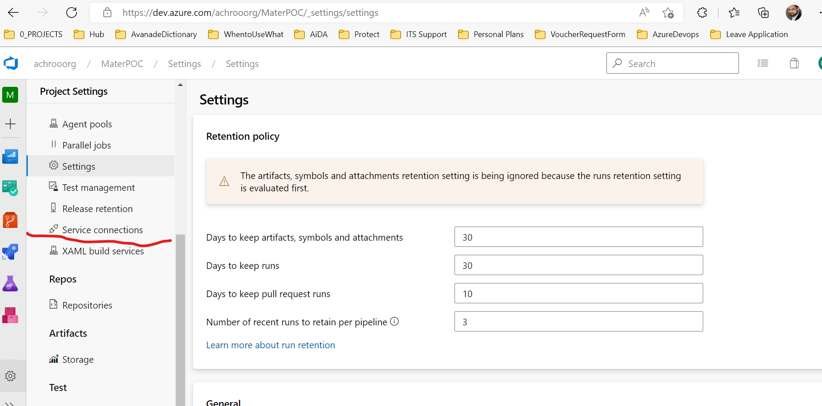

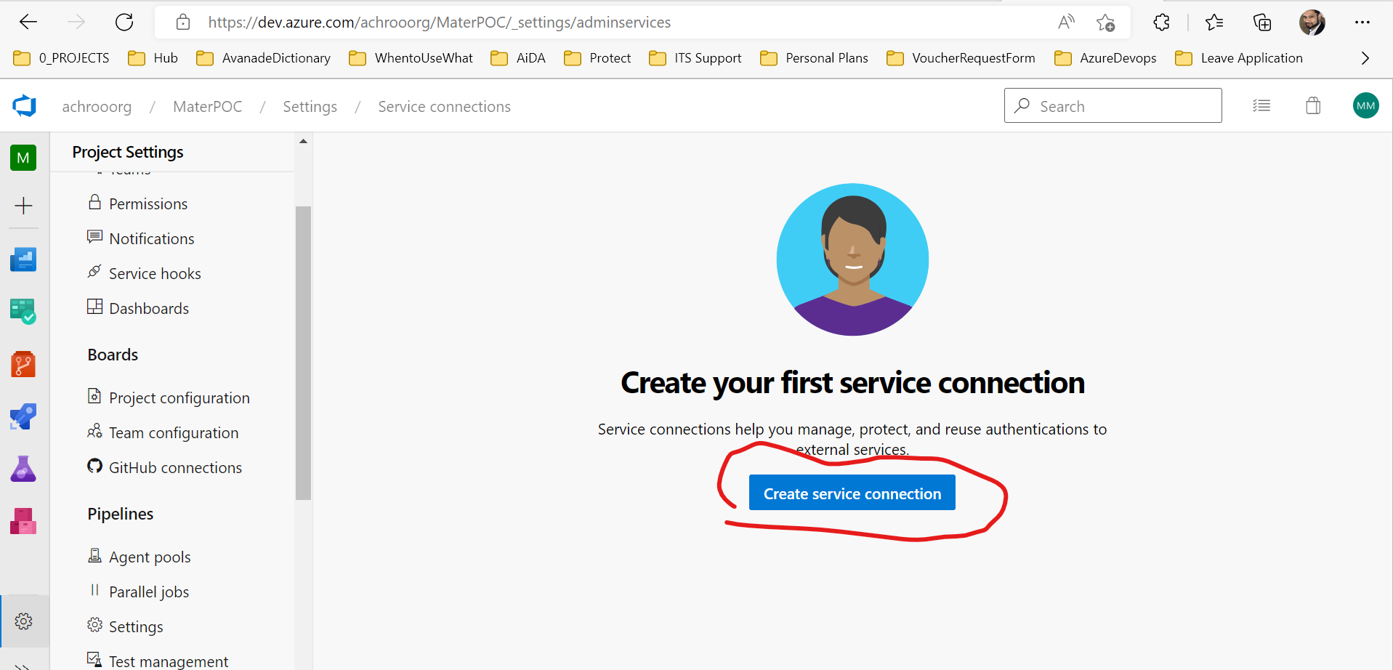

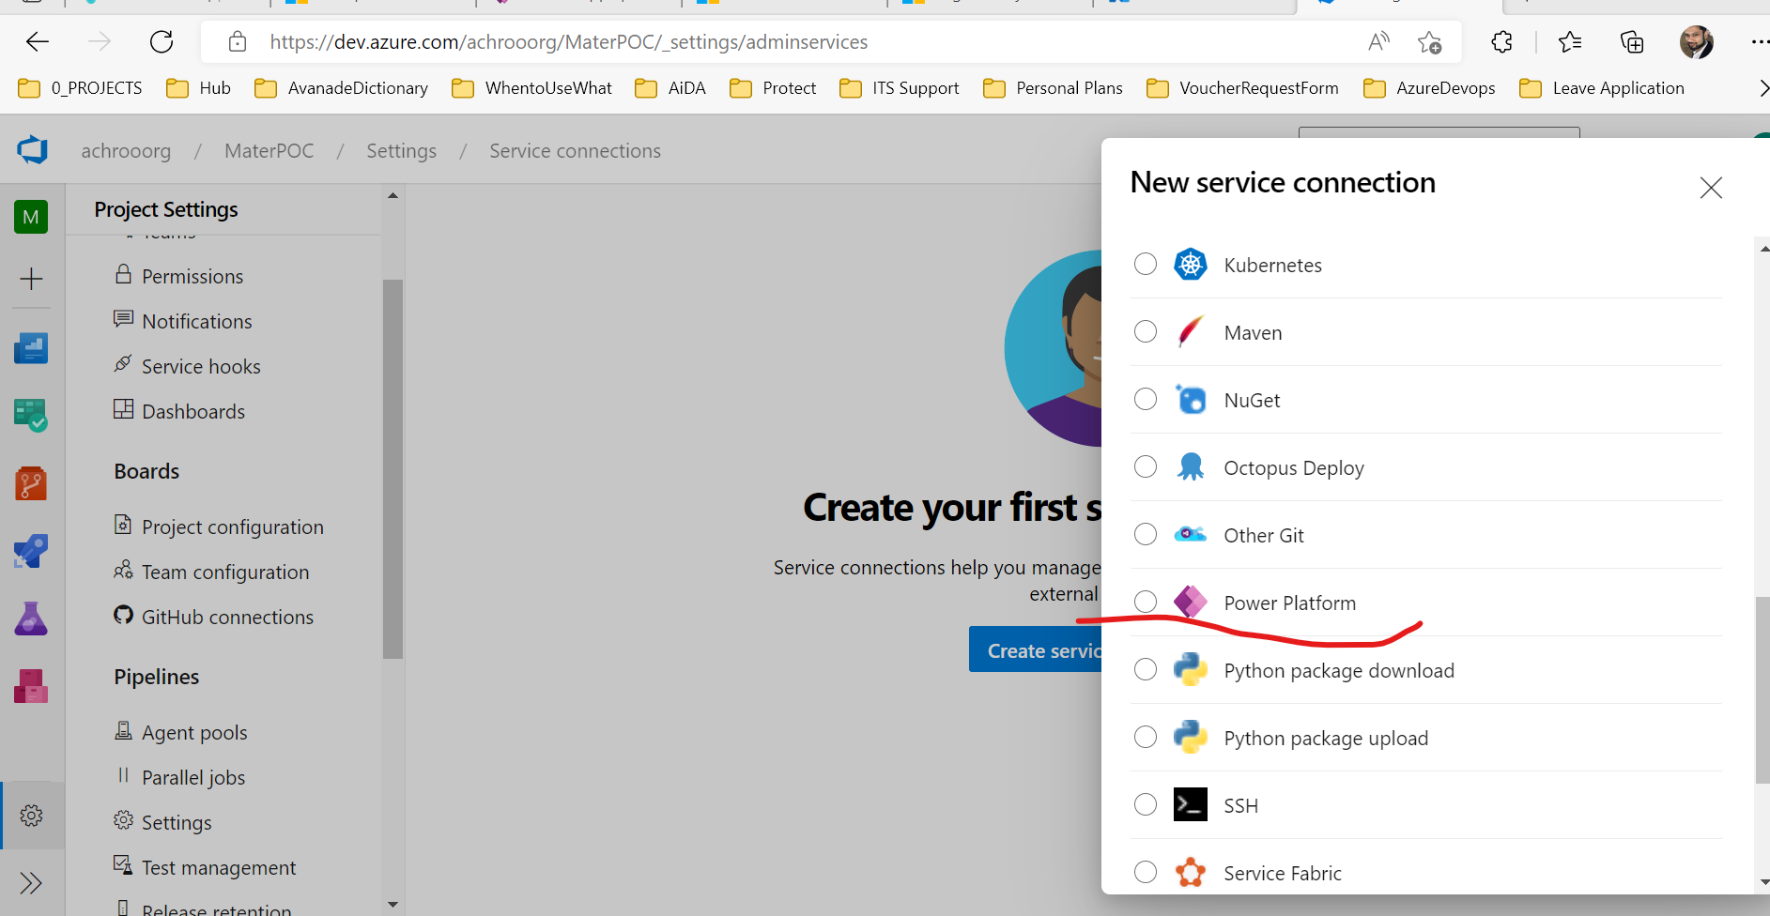

1. Clone MAH10webresources into your machine from github.
2. Link remote origin to Azure Repo and push code

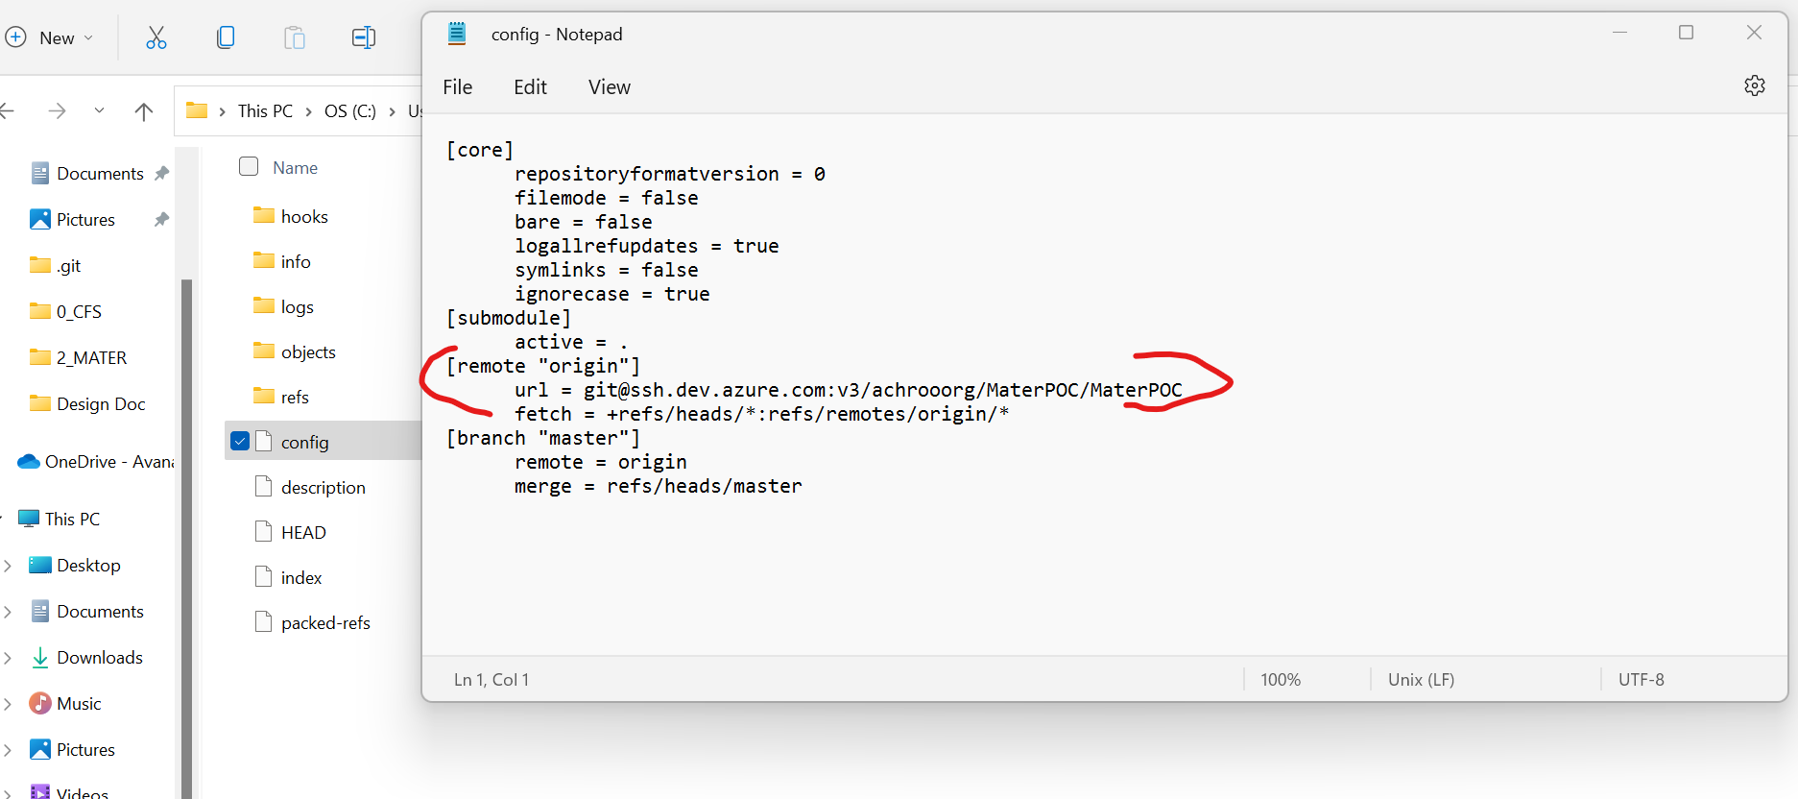

1. Build a sol 10 (deployment frontend) using azure devops (unmanaged) and (managed) store it azure artifacts. Also, copy

/src/Dynamics/Web/src/webresources/Mater

/src/Dynamics/Deployment/ManagedSolutions

Refer Link: [Deploying Web resources or Plugins with Azure DevOps Pipeline » Benedikt's Power Platform Blog (benediktbergmann.eu)](https://benediktbergmann.eu/2020/07/14/deploying-web-resources-or-plugins-with-azure-devops-pipeline/)

/src/Dynamics/Web/src/webresources/Mater

/src/Dynamics/Deployment/ManagedSolutions

- ${{ if eq(parameters.deploy_frontend, true) }}:

        - job: buildFrontend

          displayName: "Build Frontend"

          steps:

          - template: ../steps/build/dynamics-build-frontend.yaml

          - upload: "$(base_path)/Web/dist"

            artifact: Web

            displayName: "Publish Web Artifact"

1. Build sol for 20 components (managed) store it to azure artifacts
2. Transport managed sol for 10 and 20 from azure artifacts to poctest using release pipeline

Refer:

<https://youtube.com/playlist?list=PLd4QV6bvfaDn32wa-TJESnwZEDjP5_-UQ>

[PowerApps-Samples/build-tools at master · microsoft/PowerApps-Samples (github.com)](https://github.com/microsoft/PowerApps-Samples/tree/master/build-tools)

1. Avanade Managed team will help to validate the deployed sol for pocdev and poctest.

**Low-Level Design Document and Implementation Process**

1. This document should show name and no. of build/release pipeline/yaml file.
2. This document should aklso contain Azure artifacts and Azure Repos, Azure service connection names (User prefix MH_ for MaterAtHome project and MF_ for MaterAtFoundation project to distinguish)
3. It should also contain screenshot of extensions used to build solution
4. It should show instructions on how to use the pipelines
5. It should show implementation instruction on how to create new pipeline. You can refer above mentioned steps and screenshots. Feel free to add new/missing screenshots

**Phase 2: -**

DevOPS person will build pipelines for all solutions in POC Dev and POC Test Environment for MaterAtHome and MaterFoundation. Also need to integrate teams in the pipelines.

Refer: [Microsoft Teams with Azure DevOps Services (Collaborate, Communicate and Celebrate) | Azure DevOps Hands-on-Labs (azuredevopslabs.com)](https://www.azuredevopslabs.com/labs/vstsextend/teams/)

[Create a service hook Microsoft Teams - Azure DevOps Server | Microsoft Learn](https://learn.microsoft.com/en-us/azure/devops/service-hooks/services/teams?view=azure-devops)

Put code for UAT and Production environment (which will not be tested in POC Environment)

Avanade managed team will create Test Plan Document will contain test scenarios and test cases. They will also conduct validation of pipeline in POC dev and POC test. They will verify if correct artifacts are created, and unmanaged sol deployed in POC Dev and managed sol will deploy in POC Test

**Phase 3: -**

Point the environment from POC Dev and POC Test in yaml file to DEV and TEST for both the projects.

Archive Old pipelines.

Avanade managed team will monitor/test the project in prod environment using new pipelines.