Colonial First State

DevOps UserManual -

AVD

Apr 2023

Document title

|  |  |
| --- | --- |
| **Project Title** | CFS Core IT |
| **Author** | Avanade:  Achroo Batta |
| **Reviewer** | <Insert> |
| **Approver** | <Insert> |
| **Current Version** | 1.0 |
| **File Name** | DevOps UserManual-AVD |
| **Publication Date** |  |

Revision history

|  |  |  |  |
| --- | --- | --- | --- |
| Version | Date | Author | Changes |
| 1.0 | 15/4/2023 | Achroo Batta | Initial Version |
| 1.1 | 17/4/2023 | Abaigail Artagame | Added Details for VM Deployment Scripts |
|  |  |  |  |
|  |  |  |  |
|  |  |  |  |
|  |  |  |  |

Table of Contents

1 Introduction 1

1.1 Purpose 1

1.2 Project Description 1

2 GitHub Action – CI Job 2

3 AVD Pipeline 3

4 AVDVM Pipeline 5

# Introduction

## Purpose

The purpose of this document is to provide information about various pipelines being used to automate AVD through IAC

## Project Description

AVD Automation involves use of PowerShell Scripts, Azure Bicep, Github, Github Actions and Azure DevOps pipelines.

1. GitHub action CI job – GitHub CI job lint Bicep and PowerShell code, creates NuGet package and pushes to Azure Artifactory on completion.
2. AVD Pipeline – This pipeline deploys AVD components such as Host Pool, Application group, Workspaces, and Scaling plan. This pipeline register hostpools and workspaces with Diagnostic settings on numerous log metrics. Also, this associate new shared hostpool with Scaling plan.
3. AVDVM Pipeline – This pipeline has two set of stages fuzzy logic or normal deployment of VMs. If user enables fuzzy logic, then machine deployment and distribution happen automatically based on current count in edc/sdc blue/green. This kind of replicates human intelligence. However, if you don’t choose fuzzy logic, then you need to supply some additional parameters, which will deploy n number of virtual machines in that host pools.
4. Bicep Code/Params: - bicep code to deploy Persona (Hostpool, Workspace, appgroup and diagnostic settings), Scaling Plan, VM and VM fuzzy logic. Also, it contains corresponding parameters to supply static information such as persona, scalingPlan, avdvm and {projectPfx}, where projectPfx can be default for existing, dmt and anything based on new projects.
5. Scripts – AVDScalingPlan scripts association of (new + existing) shared host pool with scaling plan. AVDDeployment -Fuzzy Logic or AVDDeployment – enables fuzzy deployment of VMs or provides starting point and hostpool for VM deployments in specific lane.

# GitHub Action – CI Job

This job lints the bicep and powershell scripts and scans the code for vulnerabilities. On successful completion, it creates a nuget package and pushes this package under the name of CFS.Core.OPERAVD to Azure Artifactory. As soon as, code is pushed to develop or main branch, CI jobs will be triggered automatically.

**CIjob** - cfs-core-oper-avd/.github/**workflows**/

**Screenshots**

# AVD Pipeline

This pipeline is responsible for deployment of Persona components such as Host Pool, Application group, Workspaces, Scaling Plan, and association of shared host pools with scaling plan and association with diagnostic settings.

**Bicep** –

* cfs-core-oper-avd/CFS.Core.OPERAVD/bicep-templates/ deployment/**deployment-templates**/ deploy-AvdPersona.bicep
* cfs-core-oper-avd/CFS.Core.OPERAVD/bicep-templates/ deployment/**deployment-templates**/ deploy-AvdScalingPlan.bicep
* cfs-core-oper-avd/CFS.Core.OPERAVD/bicep-templates/modules/**Microsoft.Avd/**deployAvdPersona.bicep
* cfs-core-oper-avd/CFS.Core.OPERAVD/bicep-templates/modules/**Microsoft.Avd**/ deployAvdScalingPlan.bicep

**Pipeline** - [cfs-core-oper-avd](https://github.com/CFSCo/cfs-data-migration)/[CFS.Core.OPERAVD](https://github.com/CFSCo/cfs-data-migration/tree/main/CFS.Core.BKOF)/[azure-pipelines](https://github.com/CFSCo/cfs-data-migration/tree/main/CFS.Core.BKOF/azure-pipelines)/AVDPipeline.yml

**Templates** –

* cfs-core-oper-avd/CFS.Core.OPERAVD/deploy-AvdPersona.yml
* cfs-core-oper-avd/CFS.Core.OPERAVD/deploy-AvdScalingPlan.yml

**Parameters** –

* cfs-core-oper-avd/CFS.Core.OPERAVD/bicep-templates/deployment**/00-AVD/** persona.param.np.json
* cfs-core-oper-avd/CFS.Core.OPERAVD/bicep-templates/deployment/**00-AVD/** persona.param.prd.json
* cfs-core-oper-avd/CFS.Core.OPERAVD/bicep-templates/deployment**/00-AVD/** scalingPlan.param.np.json
* cfs-core-oper-avd/CFS.Core.OPERAVD/bicep-templates/deployment/**00-AVD**/ scalingPlan.param.prd.json

**Scripts –**

cfs-core-oper-avd/CFS.Core.OPERAVD/**scripts**/ AVDScalingPlan.ps1

**Screenshots**

# AVDVM Pipeline

This pipeline is responsible for deployment of VM.

**Bicep** –

* cfs-core-oper-avd/CFS.Core.OPERAVD/bicep-templates/ deployment/**deployment-templates**/ deploy-AvdVm-FuzzyLogic.bicep
* cfs-core-oper-avd/CFS.Core.OPERAVD/bicep-templates/ deployment/**deployment-templates**/ deploy-AvdVm.bicep
* cfs-core-oper-avd/CFS.Core.OPERAVD/bicep-templates/ deployment/**deployment-templates**/ deployAvdVm.bicep

**Pipeline** - [cfs-core-oper-avd](https://github.com/CFSCo/cfs-data-migration)/[CFS.Core.OPERAVD](https://github.com/CFSCo/cfs-data-migration/tree/main/CFS.Core.BKOF)/[azure-pipelines](https://github.com/CFSCo/cfs-data-migration/tree/main/CFS.Core.BKOF/azure-pipelines)/ AVDVMPipeline.yml

**Templates** –

cfs-core-oper-avd/CFS.Core.OPERAVD/ deploy-AvdVM-FuzzyLogic.yml

cfs-core-oper-avd/CFS.Core.OPERAVD/ deploy-AvdVM.yml

**Parameters** –

* cfs-core-oper-avd/CFS.Core.OPERAVD/bicep-templates/deployment**/00-AVD/** avdvm.param.np.json
* cfs-core-oper-avd/CFS.Core.OPERAVD/bicep-templates/deployment/**00-AVD/** avdvm.param.prd.json
* cfs-core-oper-avd/CFS.Core.OPERAVD/bicep-templates/deployment**/00-AVD/** defaultvm.param.np.json
* cfs-core-oper-avd/CFS.Core.OPERAVD/bicep-templates/deployment/**00-AVD**/ defaultvm.param.prd.json
* cfs-core-oper-avd/CFS.Core.OPERAVD/bicep-templates/deployment**/00-AVD/** dmtvm.param.np.json
* cfs-core-oper-avd/CFS.Core.OPERAVD/bicep-templates/deployment/**00-AVD**/ dmtvm.param.prd.json

**Scripts –**

cfs-core-oper-avd/CFS.Core.OPERAVD/**scripts**/ AVDDeployment-FuzzyLogic.ps1

**Screenshots**

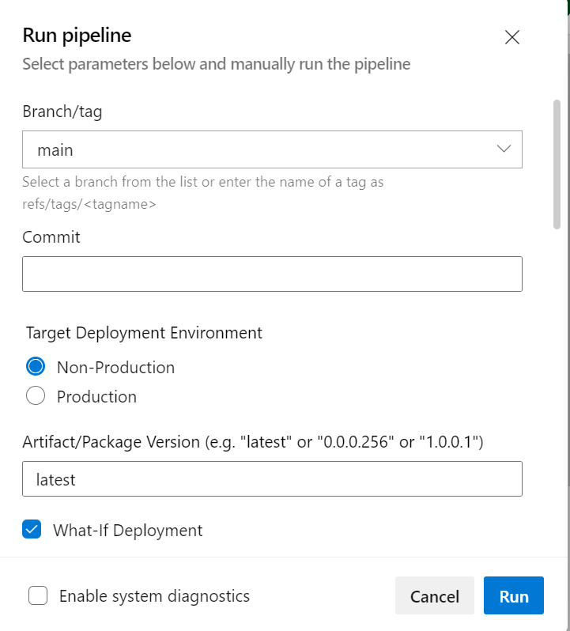

## AVD Scaling Plan Script

This script's purpose is to fetch existing shared hostPools associated with existing Scaling Plan and append new shared hostPools in the list. If we are deploying new scaling plan, it will only attach new shared host pools. This will be decided based on following parameters:

* AzureEnvironmentPrefix
* projectPrefix
* subId

### Script Parameters

|  |  |  |  |
| --- | --- | --- | --- |
| Parameter Name | Parameter Type | Parameter Description | Sample Value |
| AzureEnvironmentPrefix | string | Prefix for deployment environment | np or prd |
| projectPrefix | string | Project Prefix | dmt or {new project Pfx} |
| subId | String | subscriptionID | Operation subscriptionId provided by pipeline |

## AVD VM Script

This script's purpose is to determine the following dependent on the parameters provided:

* Host Pool Name
* Host Pool Resource Group Name
* Registration Key
* Starting point which is needed for the VM Name(s)

***Note that this script will be executed if Enable Fuzzy Logic has been set to false when running the Azure DevOps Pipeline.***

### Script Parameters

|  |  |  |  |
| --- | --- | --- | --- |
| Parameter Name | Parameter Type | Parameter Description | Sample Value |
| hostPoolType | string | Refers to the type of virtual machines (VMs) that are used to host the user desktops and applications in the host pool | Personal or Shared |
| AzureEnvironmentPrefix | string | Prefix for deployment environment | np or prd |
| locationPfx | string | Location Prefix | edc or sdc |
| projectPrefix | string | Project Prefix | dmt or {new project Pfx} |
| parameterFilePath | string | Path of the parameter file |  |
| vmLane | string | VM Lane | B or G |

## AVD VM Fuzzy Logic Script

This script's purpose is to determine the following dependent on the parameters provided:

* Host Pool Names for both EDC and SDC
* Host Pool Resource Group Names for both EDC and SDC
* Registration Keys for both EDC and SDC
* Determine number of VMs and the starting point (which is needed for the VM Name) for the following cases:
  + EDC – Blue Lane
  + EDC – Green Lane
  + SDC – Blue Lane
  + SDC – Green Lane

***Note that this script will be executed if Enable Fuzzy Logic has been set to true when running the Azure DevOps Pipeline.***

### Script Parameters

|  |  |  |  |
| --- | --- | --- | --- |
| Parameter Name | Parameter Type | Parameter Description | Sample Value |
| hostPoolType | string | Refers to the type of virtual machines (VMs) that are used to host the user desktops and applications in the host pool | Personal or Shared |
| AzureEnvironmentPrefix | string | Prefix for deployment environment | np or prd |
| numberOfInstance | integer | Number of virtual machines needs to be deployed | 5 |
| projectPrefix | string | Project Prefix | dmt or {new project Pfx} |
| parameterFilePath | String | Path of the parameter file |  |