DATABASE CONNECTIVITY PROGRAMS
SAMPLE PROGRM FOR DATABASE CONNECTIVITY WITHOUT GUI
import cx_Oracle

def add():
try:
usern=input("enter user name")
passw=input("enter pass")
con=cx_Oracle.connect("manju/manju@127.0.0.1/XE")
cur=con.cursor()
try:
cur.execute("create table Login(un varchar(20),pw varchar(20))")
cur.execute("insert into Login values('%s','%s')"%(usern,passw))
print("inserted")
except:
cur.execute("insert into Login values('%s','%s')"%(usern,passw))
con.commit()
con.close()
except Exception as e:
print(str(e))
def disp():
try:
con=cx_Oracle.connect("manju/manju@127.0.0.1/XE")
cur=con.cursor()
try:
cur.execute("select * from Login")
li=cur.fetchall()
for i in li:
print(i)
except:
print("sorry")
except Exception as e:
print(e)
def delete():
try:
con=cx_Oracle.connect("manju/manju@127.0.0.1/XE")
cur=con.cursor()
try:
x=input("enter un")
cur.execute("delete from Login where un='%s'"%(x))
con.commit()
con.close()
except Exception as e:
print("sorry",e)
except Exception as e:
print(e)
def Update():
try:
con=cx_Oracle.connect("manju/manju@127.0.0.1/XE")
cur=con.cursor()
try:
x=input("enter un")
y=input("enter pw to change")
cur.execute("update Login set pw='%s' where un='%s'"%(y,x))
con.commit()
con.close()
except Exception as e:
print("sorry",e)
except Exception as e:
print(e)
while True:
print("1.ADD 2.VIEW 3.DELETE 4.UPDATE")
ch=int(input("enter choice"))
if ch==1:
add()
if ch==2:
disp()
if ch==3:
delete()
if ch==4:
Update()
if ch==5:
break

OUTPUT:

1.ADD 2.VIEW 3.DELETE 4.UPDATE
enter choice1
enter user nameabi abi
enter passabi
1.ADD 2.VIEW 3.DELETE 4.UPDATE
enter choice2
('abi abi', 'abi')
('saran', 'saran123')
('revu', 'revu')
1.ADD 2.VIEW 3.DELETE 4.UPDATE
enter choice3
enter unrevu
1.ADD 2.VIEW 3.DELETE 4.UPDATE
enter choice2
('abi abi', 'abi')
('saran', 'saran123')
1.ADD 2.VIEW 3.DELETE 4.UPDATE
enter choice4
enter unsaran
enter pw to changesara@@
1.ADD 2.VIEW 3.DELETE 4.UPDATE
enter choice2
('abi abi', 'abi')
('saran', 'sara@@')
1.ADD 2.VIEW 3.DELETE 4.UPDATE
enter choice

SAMPLE PROGRM FOR DATABASE CONNECTIVITY WITH GUI
import cx_Oracle
from tkinter import *
from tkinter import messagebox
win1=Tk()
win1.configure(background="pink")
L1=Label(win1,text="UN")
L1.grid(row=1,column=1)
L2=Label(win1,text="Gender")
L2.grid(row=2,column=1)
L3=Label(win1,text="Hobbies")
L3.grid(row=4,column=1)
L4=Label(win1,text="AreaOfInterest")
L4.grid(row=13,column=1)
L5=Label(win1,text="Comments")
L5.grid(row=14,column=1)
T1=Entry(win1)
T1.grid(row=1,column=2)
v1=StringVar()
v1.set("male")
R1=Radiobutton(win1,text="male",variable=v1,value="male")
R1.grid(row=2,column=2)
R2=Radiobutton(win1,text="female",variable=v1,value="female")
R2.grid(row=3,column=2)
c1=StringVar()
c2=StringVar()
c3=StringVar()
ch1=Checkbutton(win1,text="singing",onvalue="singing",offvalue="n",variable=c1)
ch1.grid(row=5,column=2)
ch1.deselect()
ch2=Checkbutton(win1,text="dancing",onvalue="dancing",offvalue="n",variable=c2)
ch2.grid(row=6,column=2)
ch2.deselect()
ch3=Checkbutton(win1,text="reading",onvalue="reading",offvalue="n",variable=c3)
ch3.grid(row=7,column=2)
ch3.deselect()
l1=Listbox(win1)
l1.grid(row=13,column=2)
#Sc1=Scrollbar(l1,command=l1.yview,width=40,height=5)
#Sc1.pack(side=RIGHT,fill=Y)
lang=['c','c++','java']
for i in lang:
l1.insert(0,i)
T2=Text(win1,width=40,height=5)
T2.grid(row=14,column=2)
def Add():
lang=""
un=T1.get()
gen=v1.get()
aof=l1.get(ACTIVE)
com=T2.get("1.0","end-1c")

for c in (c1,c2,c3):
lang=lang+c.get()
messagebox.showwarning("hai",un+gen+aof+com+lang)

try:
con=cx_Oracle.connect("manju/manju@127.0.0.1/XE")
cur=con.cursor()
try:
cur.execute("create table cu_re(unmae varchar(20),gen varchar(20),hobby varchar(20),aof varchar(20),comments varchar(20))")
cur.execute("insert into cu_re values('%s','%s','%s','%s','%s')"%(un,gen,lang,aof,com))
messagebox.showinfo("Inserted")
except:
cur.execute("insert into cu_re values('%s','%s','%s','%s','%s')"%(un,gen,lang,aof,com))
con.commit()
con.close()
except Exception as e:
print(str(e))
def retrive():
try:
con=cx_Oracle.connect('manju/manju@127.0.0.1/XE')
cur=con.cursor()
cur.execute("Select * from cu_re")
x=cur.fetchall()
for i in x:
for j in i:
print(j,end=" ")
print()
print(x)
messagebox.showinfo("Retrived")
con.close()
except Exception as e:
print(e)
def delete():
con=cx_Oracle.connect("manju/manju@127.0.0.1/XE")
cur=con.cursor()
cur.execute("delete from cu_re where unmae='%s'"%(T1.get()))
con.commit()
con.close()
def Update():
con=cx_Oracle.connect("manju/manju@127.0.0.1/XE")
cur=con.cursor()
cur.execute("update cu_re set comments='%s' where unmae='%s'"%(T2.get("1.0","end-1c"),T1.get()))
con.commit()
con.close()

B1=Button(win1,text="submit",command=Add)
B1.grid(row=15,column=1)
B2=Button(win1,text="retrive",command=retrive)
B2.grid(row=15,column=2)
B3=Button(win1,text="delete",command=delete)
B3.grid(row=15,column=3)
B4=Button(win1,text="update",command=Update)
B4.grid(row=15,column=4)
win1.mainloop()

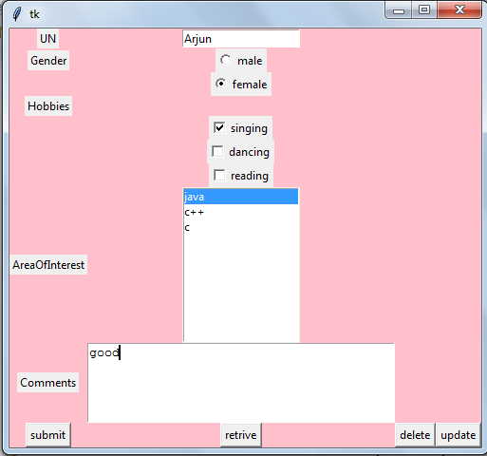

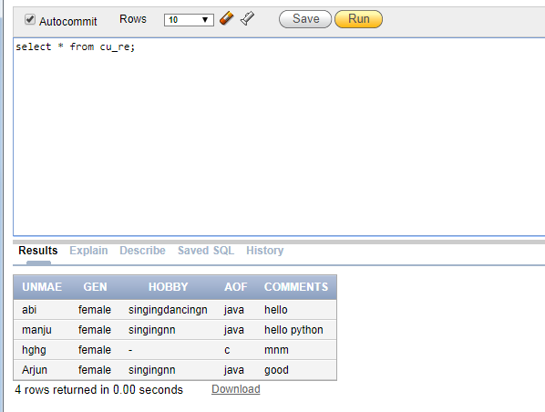
When retrieve button is clicked,
abi female singingdancingn java hello
manju female singingnn java hello python
hghg female None c mnm
Arjun female singingnn java good
[('abi', 'female', 'singingdancingn', 'java', 'hello'), ('manju', 'female', 'singingnn', 'java', 'hello python'), ('hghg', 'female', None, 'c', 'mnm'), ('Arjun', 'female', 'singingnn', 'java', 'good')]

When delete button is clicked,
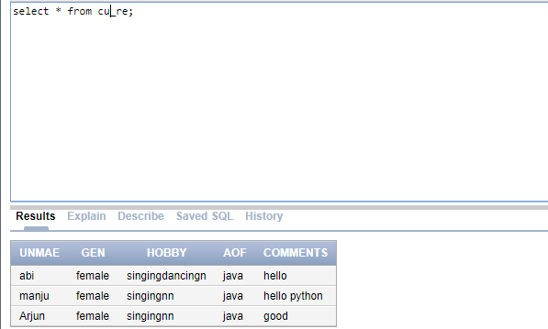

import cx_Oracle
try:
un=input("enter un")
pw=input("enter pw")
con=cx_Oracle.connect("manju/manju@127.0.0.1/XE")
cur=con.cursor()
try:

cur.execute('create table ece(un varchar(20),password varchar(20))')
cur.execute("insert into ece values('%s','%s')"%(un,pw))
except:
cur.execute("insert into ece values('%s','%s')"%(un,pw))
con.commit()
con.close()
except Exception as e:
print(e)

