FITBUDDY – AI FITNESS PLAN GENERATOR USING GEMINI MODELS

Documentation
Definition
FitBuddy is an AI-powered fitness planning application that uses Google Gemini models to generate personalized fitness plans from user-provided information such as fitness goals, activity level, available time, preferred activities, and basic preferences. The system uses Generative AI to create easy-to-follow workout recommendations and fitness guidance in natural language. It is designed to provide structured and personalized suggestions while keeping the user experience simple and interactive.

Team Members Name & Roles
1. Name: RAMDA SHEGA A (Team Leader)
Role: Coding, Voice Over

2. Name: POOVIZHI J (Team Member)
Role: API Testing Video

3. Name: SHOBANA P (Team Member)
Role: Documentation

4. Name: BHAVADHARANI (Team Member)
Role: Demo Video

1.0 Executive Summary&Platform Purpose
Figure 1. FitBuddy combines user preferences with Gemini AI to generate a personalized plan.
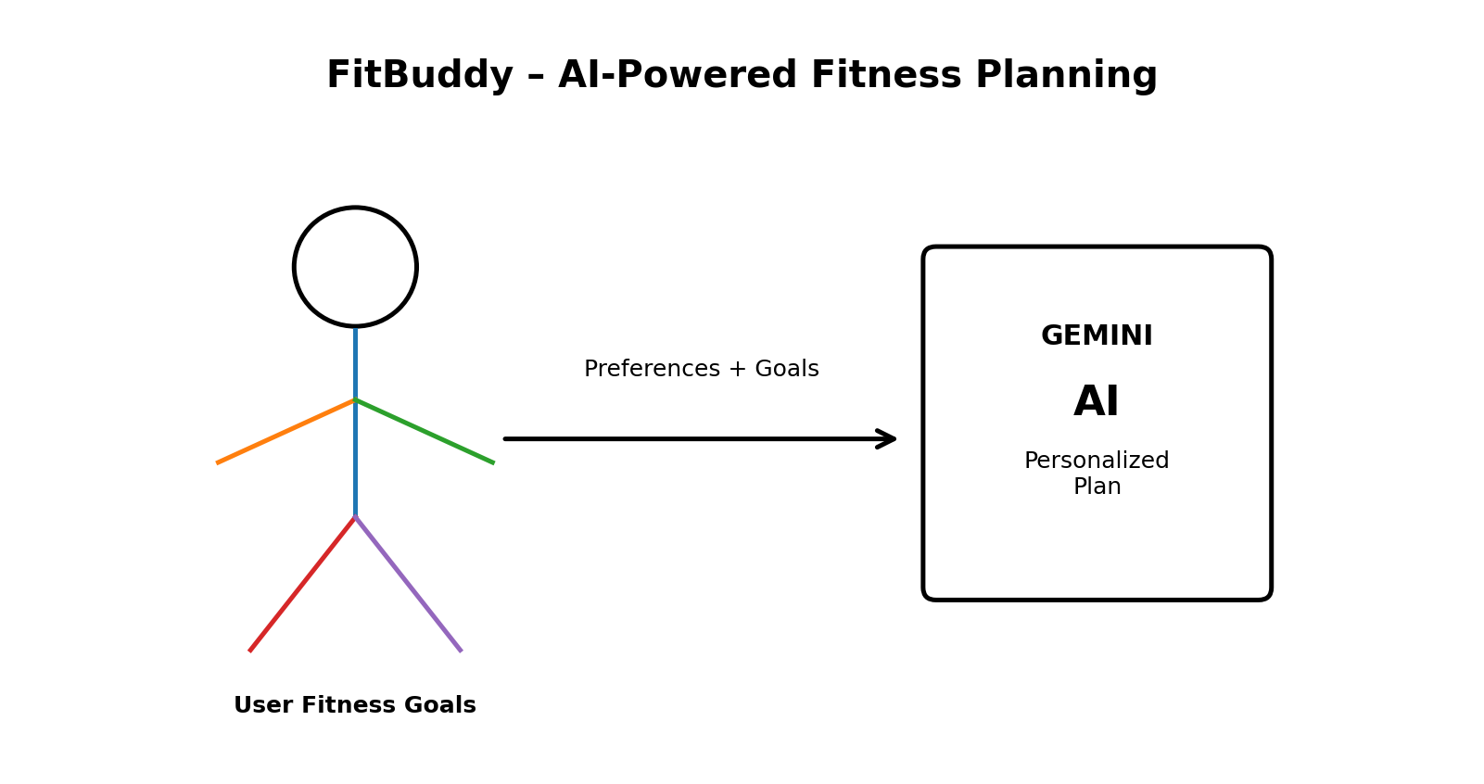

FitBuddy is a Generative AI-based fitness planning platform designed to convert basic user fitness information into personalized and understandable workout plans. The application uses Google Gemini models to generate natural-language fitness recommendations based on the user's selected goals, activity level, schedule, and preferences.

1.1 Core Objectives
- Personalized Fitness Plans: Generate plans according to user goals and preferences.
- Generative AI Integration: Use Google Gemini models to create natural-language recommendations.
- Simple User Interaction: Accept user details through an easy request-based interface.
- Structured Recommendations: Present workouts in an organized and readable format.
- Secure Processing: Validate user inputs and protect application requests.

1.2 High-Level Platform Capabilities
- Gemini AI Integration: Sends suitable prompts to the Google Gemini model and receives generated fitness guidance.
- User Input Processing: Collects goals, activity level, available time, and preferences.
- Plan Generation: Produces a customized fitness routine from the processed inputs.
- API-Based Design: Provides endpoints for submitting requests and receiving generated plans.
- Error Handling: Handles invalid inputs and unavailable AI responses.

2.0 Scenario-Based Case Study&Requirements
2.1 Background Story
Alex is a college student who wants a simple fitness routine but does not know how to organize workouts according to personal goals and available time. FitBuddy allows Alex to enter basic fitness preferences and receive a structured AI-generated plan without manually creating a routine.

2.2 Problem Formulation
Many users find it difficult to create a consistent fitness routine that matches their goals, time, and activity level. FitBuddy addresses this problem by using Generative AI to transform user requirements into a personalized and easy-to-understand fitness plan.

2.3 Software&Hardware Environment Requirements
- Operating System: Windows 10/11, macOS, or Linux.
- Runtime Environment: Node.js.
- Package Manager: npm.
- Database: MongoDB.
- AI Service: Google Gemini API / Gemini models.
- Development Tools: Visual Studio Code and Postman or Thunder Client.
3.0 System Architecture&Design Patterns
FitBuddy follows a modular layered architecture in which the client sends user fitness information to the backend. The backend validates the request, prepares a suitable prompt, communicates with the Google Gemini model, and returns the generated fitness plan to the client.

3.1 Architecture Blueprint
Figure 2. End-to-end request and response flow.
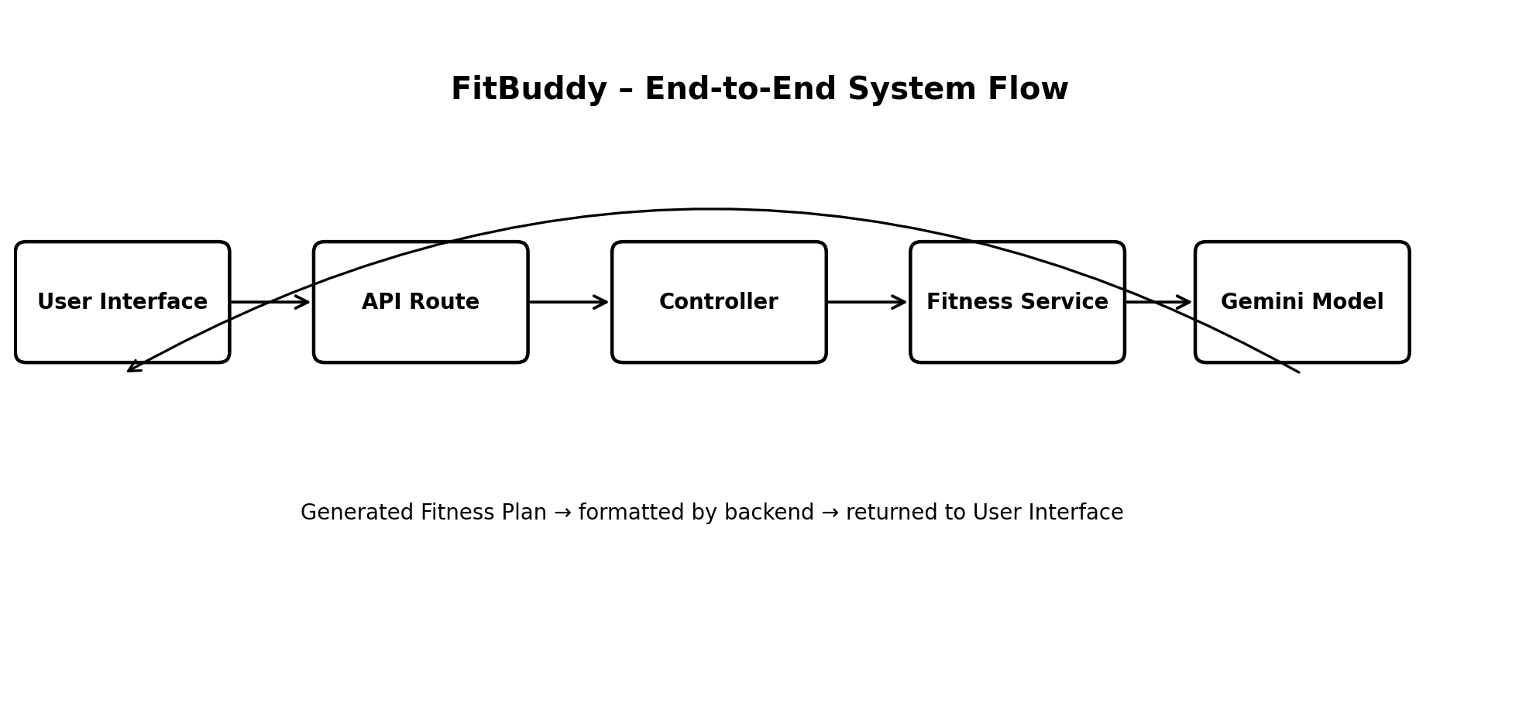

User Interface → API Route → Controller → Fitness Service → Gemini Model → Generated Fitness Plan → User Interface

3.2 Architectural Flow
1. User enters fitness goals and basic preferences.
2. The client sends the information to a protected API endpoint.
3. The controller validates and processes the request.
4. The fitness service prepares a structured prompt for the Gemini model.
5. Google Gemini generates the personalized fitness plan.
6. The backend formats the response and sends it back to the client.

4.0 Data Architecture&ER Modeling
The data architecture stores user profile information and generated fitness-plan details. MongoDB can be used to store flexible user and plan documents while maintaining references between users and their generated plans.

4.1 Entity Relationship Diagram Structure
- USERS Collection: Stores user identity and basic fitness preferences.
- FITNESS_PLANS Collection: Stores generated plans associated with a user.
- WORKOUTS Collection: Stores individual workout details when the plan is divided into workout records.
- AI_RESPONSES Collection: Stores generated recommendations when response history is required.

4.2 Entity Mapping Matrix
The Entity Mapping Matrix defines the relationships between the main entities in the FitBuddy AI Fitness Plan Generator system. One user can have multiple generated fitness plans, while each fitness plan belongs to a single user. A fitness plan can contain multiple workout entries and exercises, allowing users to follow different workout routines based on their requirements. Each workout entry is associated with a particular fitness plan. The system can also maintain multiple progress records for each user to track their fitness activities over time. In addition, users can provide feedback about their generated fitness plans and workouts. These relationships help the system organize user information, fitness plans, workouts, exercises, progress, and feedback in a structured manner.
5.0 Executive Summary&System Vision
FitBuddy aims to make personalized fitness planning easier by combining user requirements with Generative AI. The system uses Google Gemini models to create readable and structured recommendations instead of requiring users to manually design every part of a routine.
5.1 Key System Attributes
- Personalization: Plans are generated from individual user inputs.
- AI-Powered Generation: Gemini models produce natural-language recommendations.
- Scalable API Design: The backend can support multiple client requests.
- Input Validation: User information is checked before processing.
- Maintainable Architecture: Separate modules simplify development and testing.
6.0 End-to-End System Architecture Blueprint
Figure 3. Layered architecture of the FitBuddy platform.
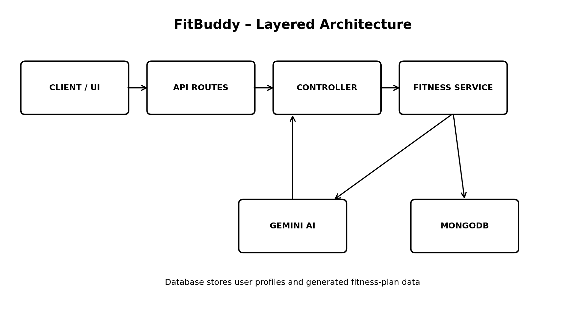

The platform follows a clean layered structure consisting of the client, API routes, controllers, fitness service, Gemini integration, and database layer.
6.1 Data Modeling&User Domain Architecture
The main data relationship connects a user with the fitness plans generated for that user.
6.2 User Account Profile
- Identity: Stores the user's basic account information.
- Fitness Goal: Stores the selected objective such as general fitness or strength improvement.
- Activity Level: Stores the user's selected activity level.
- Preferences: Stores available workout time and preferred activities.
6.3 Fitness Plan Preferences
- Goal and activity level are used as inputs for plan generation.
- Available time helps the system create a practical routine.
- Preferred activities help make recommendations more relevant.
Entity-Relationship (ER) Diagram Description
Figure 4. Entity relationships for users, fitness plans, workouts, and AI responses.
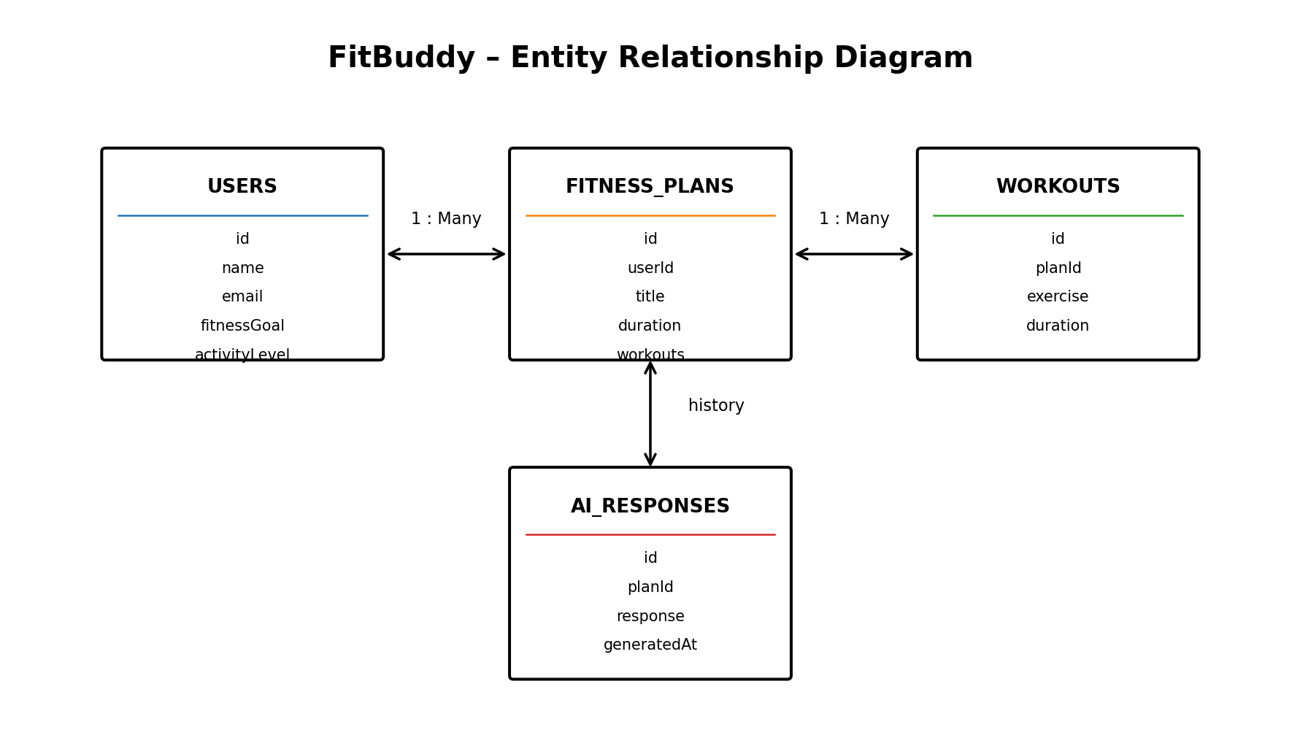

1. User Entity: id, name, email, fitnessGoal, activityLevel, createdAt
2. Fitness Plan Entity: id, userId, title, duration, workouts, generatedAt
Key Structural Mappings
- User to Fitness Plan (One-to-Many): A user can generate multiple fitness plans.
- Fitness Plan to Workout (One-to-Many): A plan can contain multiple workout entries.
- AI Service Integration: Fitness-plan generation is handled through the Gemini model.
Roles and Responsibilities
- Team Leader: Coordinates the project and handles coding and voice-over work.
- API Testing Member: Tests API requests and prepares the API testing video.
- Documentation Member: Prepares project documentation and technical descriptions.
- Demo Video Member: Demonstrates the working application and prepares the demo video.
Core System Script Implementations
Application Entry Point
The application entry point initializes the backend server, loads environment variables, configures middleware, connects to MongoDB, registers API routes, and starts the server.
Gemini AI Integration
The fitness service prepares a prompt using the user's fitness requirements and sends it to the Google Gemini model. The generated response is then formatted as a fitness plan and returned to the client.
API Testing Demo
- Start the backend server.
- Open Postman or Thunder Client.
- Send the required fitness information to the plan-generation endpoint.
- Verify the generated Gemini response.
- Check the response status and generated fitness-plan structure.
Epic 4: Database Configuration
- Install and configure MongoDB.
- Install the required Mongoose dependency.
- Create User and Fitness Plan schemas.
- Connect the application to MongoDB.
- Verify database connectivity before processing requests.
Epic 5: Project Executions
The FitBuddy backend can be executed locally using Node.js. After configuring the Gemini API key, MongoDB connection, and required dependencies, the application can be started and its APIs tested using Postman or Thunder Client.
Running the Backend Server
- Install all required dependencies using npm.
- Configure environment variables such as the Gemini API key and MongoDB connection.
- Start the development server.
- Test the fitness-plan generation API.
API Testing
Generate Fitness Plan API
The user sends fitness preferences such as goal, activity level, available time, and preferred activities. The API processes the request and returns a Gemini-generated fitness plan.
Sample Request
POST /api/fitness/generate
Example input: {"goal":"general fitness","activityLevel":"beginner","time":"30 minutes","preference":"home workout"}
Sample Response
The API returns a structured response containing a generated fitness-plan title, workout suggestions, duration, and basic guidance.

7.0 Functional Requirements
FitBuddy should collect the user's fitness goal, activity level, available time, and preferred activities. The application should validate these inputs, prepare a structured request, send it to the Gemini model, and return an understandable fitness plan.

Key Points
- Personalized fitness-plan generation based on user preferences.
- Validation of required input before AI processing.
- Structured presentation of generated workout recommendations.
- Clear handling of invalid requests and unavailable AI responses.
- API-based communication between the client and backend.

8.0 User Interface and User Experience
The FitBuddy interface should remain simple because the project is intended to help users create a routine without manually designing every workout.

Key Points
- Provide clear fields for fitness goal, activity level, available time, and preferred activity.
- Use simple labels and readable instructions.
- Show a loading state while the AI plan is being generated.
- Display the generated plan in an organized format.
- Show meaningful validation messages when required information is missing.

9.0 API Design
The project uses an API-based design. The documented plan-generation operation is POST /api/fitness/generate. The endpoint receives fitness preferences and returns a Gemini-generated plan.

Key Points
- Validate the request before calling the fitness service.
- Accept goal, activityLevel, time, and preference values.
- Prepare the Gemini prompt through the fitness service.
- Return a structured fitness-plan response.
- Handle invalid input and service failures with controlled responses.

10.0 Gemini AI Integration
Gemini models provide the Generative AI capability of FitBuddy. The fitness service uses the user's requirements to construct a suitable prompt and sends it to the Gemini model.

Key Points
- Include the user's fitness goal in the prompt.
- Include activity level and available workout time.
- Include preferred activities so recommendations are relevant.
- Request an organized and easy-to-understand fitness plan.
- Format the generated response before returning it to the client.

11.0 Database Design
MongoDB is identified as the database for storing flexible user and fitness-plan documents. The project describes relationships between users, plans, workouts, and optional AI responses.

Key Points
- USERS stores identity and basic fitness preferences.
- FITNESS_PLANS stores generated plan information.
- WORKOUTS can store individual workout details.
- AI_RESPONSES can store generated recommendations when response history is required.
- One user can have multiple fitness plans, and one plan can contain multiple workouts.

12.0 Testing, Security and Error Handling
Testing should verify both normal and failure scenarios. The project uses Postman or Thunder Client for API testing, while secure configuration and controlled error handling are important for reliable operation.

Key Points
- Test valid plan-generation requests.
- Test missing or invalid input fields.
- Verify the Gemini response and returned plan structure.
- Keep Gemini API keys and MongoDB credentials in environment variables.
- Do not expose internal errors or secret configuration values to clients.
- Handle database and AI-service failures safely.

13.0 Deployment, Future Scope and Conclusion
FitBuddy can be executed locally using Node.js, MongoDB, the Gemini API, and the required npm dependencies. After configuration, the backend can be started and tested through the documented API.

Key Points
- Configure the Gemini API key and MongoDB connection.
- Install project dependencies and start the backend server.
- Test the generation endpoint using Postman or Thunder Client.
- Future versions can add authentication, plan history, progress tracking, reminders, and richer preferences.
- The modular architecture provides a foundation for extending the application while keeping the main AI, API, and database responsibilities separated.

