Questions

Thursday, July 4, 2024

9:03 PM

Orchestrator: <https://docs.uipath.com/orchestrator/automation-cloud/latest/user-guide/introduction>

Studio: <https://docs.uipath.com/studio/standalone/2024.10/user-guide/introduction>

Releases: <https://forum.uipath.com/t/uipath-community-2022-4-stable-release/412711>

<https://www.examtopics.com/discussions/uipath/view/105045-exam-uiard-topic-6-question-65-discussion/>

**BROADRIDGE**

* 1. What are the pre-requisites for SAP automation? - (a) RZ11 for writing parameter sapgui/user_scripting & set TRUE (b) checkbox in SAP logon pad->Accessibility->options->scripting->Enable scripting
  2. What is the use of click text activity? - It identifies the given text & click on it
  3. How can a single asset with multiple value provide values to multiple robots. - Value per robot
  4. Different ways of inputting assets.
  5. There are two buttons on the screen with same Selectors. How to indicate the second button? - aaname will be different so find the aaname & use click text activity
  6. Different input methods. - Default, Simulate, Send window Chromium API (only in modern design)
  7. Different screen scraping methods. - Full text, native, OCR
  8. Explain wait for ready property. - None (waits only for UI ), Interactive (Waits for the UI & its dependent scripts), Complete (waits for the complete screen to be loaded)
  9. How to run background automation using Excel application scope? - uncheck "visible" property
  10. What is the output of Should stop signal activity? - Boolean
  11. If our process has only one activity THROW, what will be the job status? - Faulted because it is unhandled error
  12. When does the job goes faulted? - When unhandled exception occurs or when job doesn't start
  13. In case of business exception, will the queue status be retried? - NO
  14. Explain Cron expression. - seconds * minutes * hours * date * month * day of month * year
  15. Types of triggers. - Time, queue, event, api
  16. Input: ARCHANA IS GOOD. Output should be: Archana Is Good.

Split this string based on space splitArray = Input.Split(" "c).ToArray

For each item in splitArray, write line -> item.Substring(0,1).ToUpper+ item.Substring(1).ToLower

Assign this result in a variable & concatenate it each time or join it each time

* 1. Array of Integers as input, print the numbers one by one in process state. DO not add any additional variables to the RE-Framework
  2. Convert the TransactionData variable (of type data table) to String[] in whole workflow
  3. Convert the transaction item to integer data type
  4. Commentout all queue item activities & sequences
  5. TransactionItem is Nothing (in the transition) will give error as it is integer & cannot be compared with "Nothing" which is string, so add .ToString for TransactionItem like: TransactionItem .ToString Is Nothing & TransactionItem .ToString IsNot Nothing
  6. In get transaction status, condition should be in_transactionNumber<TransactionData.Count (which is array count)

Then assign out_TransactionItem=Array(in_transactionNumber)

* 1. Print the TransactionItem in process state
  2. Version of uipath studio I'm using & the difference between previous versions
  3. Modern design experience

When we use click activity from modern design,

Place it inside Use Application/Browser

Try clicking UI element - Auto, Active accessibility, UI automation are the frameworks, we can enable computer vision (f8) or image region selector (f3)

* 1. Difference between Full & partial selectors
  2. Get all 300 items from queue. How to do it? - Using API request

<https://forum.uipath.com/t/processing-items-in-orchestrator-queue/54121/2>

* 1. What is the maximum number of items we can get from queue? - using get queue items activity, it is 100.
  2. Maximum ret count can be set between? 1-50
  3. Modern & classic activities difference

Modern activities like Click & Type into requires to be placed inside Use/Attach Browser activity to indicate the element.

* 1. Which tags & attributes must not be selected in the selector? Css selector & idx value

**KOCH**

* 1. When do we need multi bot architecture? - To divide the work among multiple bots to finish asap, to reduce load on 1 machine. In this case 2 robots will be created in the same orchestrator tenant, same folder, same environment & run on different machines using same queue. Queue with NEW status will be picked by available bot & immediately the status turns to In-progress & then successful/failed so this queue item will not be touched by the other bot. Bot takes only NEW items.
  2. How to get machine & robot details from studio activity? - Environment.MachineName & Environment.Username
  3. Difference between on-prem & cloud orchestrator

The difference is on-prem Orchestrator needs to be deployed on your own server which you will need to configure and prepare from scratch. Cloud one is already deployed and you just need to set it up to your company and allow the traffic go through it so robots can work like they should.

<https://docs.uipath.com/overview/other/latest/overview/orchestrator-differences> and <https://docs.uipath.com/overview/other/latest/overview/product-differences>

* 1. Best practices used

<https://docs.uipath.com/studio/standalone/2023.4/user-guide/design-best-practices> and <https://docs.uipath.com/orchestrator/standalone/2023.4/user-guide/automation-best-practices>

* 1. How to handle null value exception in catch section
  2. Difference between classic & modern folder

In dad's laptop

* 1. Explain modern design

<https://docs.uipath.com/studio/standalone/2023.10/user-guide/modern-design-experience>

* 1. Widgets of activities looks different & easy to access
  2. App/Web & computer vision recorders are present
  3. Few activities like click, type into has to be placed inside Use Application/Browser activity
  4. Check app state activity has element/image exist, on element vanish/appear & few more activities integrated in 1 activity as a container giving us option to choose the sub activity & time to wait & provides then & else section.
  5. Object repository
  6. Table extraction wizard is available for data scraping.

* 1. Modern & classic activities difference

<https://docs.uipath.com/activities/other/latest/productivity/classic-vs-modern-activities>

* 1. If bot didn't start process & stuck for 30 minutes, how to stop the bot?
  2. Stop through orchestrator
  3. open CMD to location of where UiRobot.exe is present. Execute command .\UiRobot.exe -file “.nupkg”
  4. you can stop the robot from the UiPath Assistance

But what is the logic behind to identify that job hasn't started or completed or stuck?

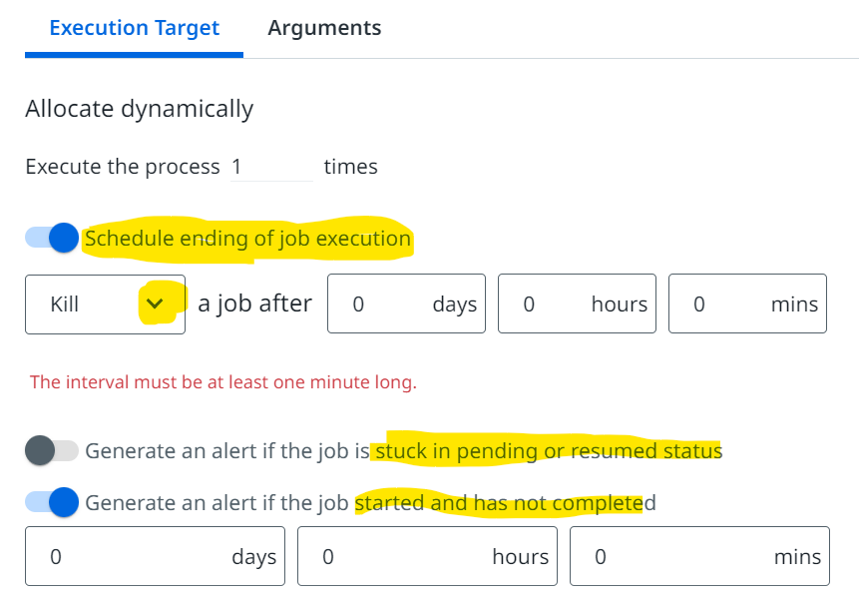

Actual JOB start snap

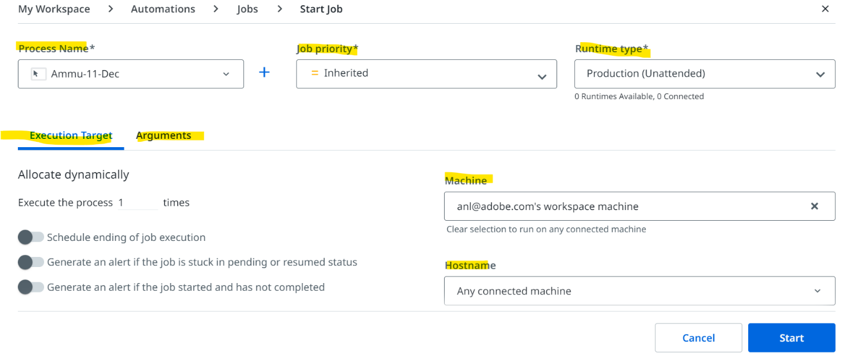

* 1. Can you delete queue item when it is in In-progress state? - NO
  2. Version of studio you are using
  3. How to add queue items manually?
  4. Unable to retrieve asset from orchestrator. What are the alternative ways?
  5. How to duplicate failed queue item? - View the transactions, select the failed & click on Clone
  6. Can we enable fuzzy selector & strict selector at the same time in 1 activity? - Yes
  7. Difference between fuzzy & strict selectors

<https://docs.uipath.com/activities/other/latest/ui-automation/advanced-descriptor-configuration#configuring-the-descriptor>

These are the targeting methods:

Strict, fuzzy, computer vision & image, any 1 or 1+ selector type can be selected.

The order is:

* 1. The primary targeting method is represented by selectors: Strict selector or Fuzzy selector.
  2. The secondary targeting method is Computer Vision.
  3. The tertiary targeting method is Image (disabled by default).

|  |  |
| --- | --- |
| Fuzzy selectors can be more tolerant of slight changes in the user interface, making them more robust in certain scenarios. | Strict selectors, on the other hand, rely on exact attribute values to identify elements on the screen |
| Fuzzy selector can output multiple elements | Strict selector which outputs a single element at a time. |

Compatibility:

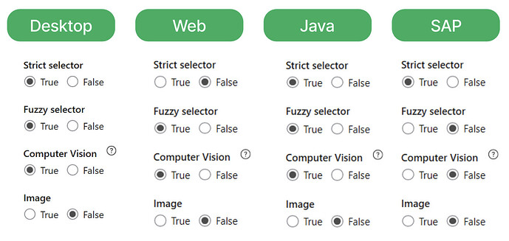

* 1. How to read the data from excel without changing its format? - check "Preserve Format" property while reading excel/workbook
  2. Splunk, Kibana, GitHub experience
  3. Queue statuses:

In-progress item:

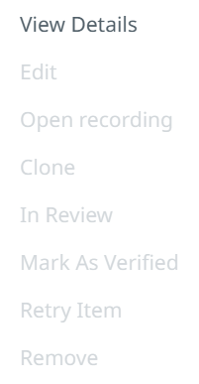

Successful item:

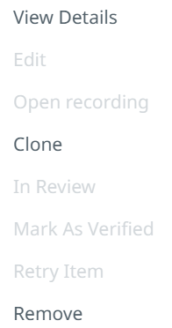

Failed item

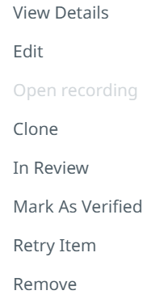

For failed items, when cloned, revision status will be NONE but when failed items & retried manually, revision status will be retried 7 in both cases, NEW item will be created.

**IOPEX**

* 1. UiPath Data service
  2. UiPath Insights
  3. Remove duplicates & arrange in descending order - Create array of integers. ArrayVar.Distinct().ToArray will remove duplicates. Use Invoke methos activity & target type will be system.Array & pass the ArrayVar in parameters & methos is Sort which will make in ascending order & use the Invoke method again & say Reverse to arrange in descending

**CROWDSTRIKE**

* 1. Implicit explicit conversion:

Explicit type conversion in programming is done manually by the programmer, while implicit conversion is handled automatically by the compiler

Change Type Into activity so that it accepts any data type for the input parameter (System.Object instead of System.String) and implicitly convert to a string.

Now we have to explicitly convert to a string via the “ToString” method whenever we want to type a number, DataTable Item, etc and I think this is redundant and could be avoided.

* 1. How do we get array of objects from json output?
  2. Deserialize json -> jsonObjects
  3. Loop through each item in: jsonAsObjects("result")("policy")("documents")("currentTermDocuments")
  4. Print: item("name").ToString

{

"result": {

"policy": {

"documents": {

"currentTermDocuments": [

{

"name": "Test Data123",

"effectiveDate": "2021-09-27T04:01:00Z",

"amt": "$10/$200",

"premium": {

"amount": 0,

"currency": "usd"

},

"code": "sfdsfdf"

},

{

"name": "Test Data123",

"effectiveDate": "2021-09-27T04:01:00Z",

"amt": "$50",

"premium": {

"amount": 0,

"currency": "usd"

},

"code": "ewr",

}

]

}

}

}

}

**ACCENTURE**

<https://forum.uipath.com/t/re-framework-retry-scope-orchestrator-queue-retry-or-config-retry/555672>

* 1. What exceptions can get transaction state throw?
  2. If conditions are included to extract data row or array object & index is not set within limits.
  3. If queue item activity is used but transactionItem data type is not queueItem anymore
  4. If queue name is wrongly mentioned in config, what happens? Where is the exception thrown?

Exception is thrown in Init state itself, while reading Config dictionary, the built-in mechanism checks for queue & assigns value accordingly

* 1. Difference between Delay activity & delay before/after property
  2. Format of passing delay value is different. In activity it is Time span & in property it is milli seconds.
  3. Delay activity is used to delay the execution of workflow, delay property is used to delay the activity it is incorporated in.
  4. Queue retry & config retry. Explain the difference & use of each
  5. Difference between Throw & Rethrow activity
  6. Explain wait for ready property

=====================================================================

* 1. How do you deal with business exceptions at Init state?
  2. What if you have defined queue name in congif but queue is not created in orchestrator. Where will the error be thrown?
  3. What if you have duplicates in config file?
  4. Explain config file - settings, constants, assets

Managerial Round

Wednesday, July 17, 2024

9:36 PM

<https://targetjobs.co.uk/careers-advice/interviews-and-assessment-centres/what-can-you-bring-company-tricky-graduate-interview-question>

* 1. What would you bring to the company?

I understand that this role will involve

* 1. achieving targets
  2. implementing end - end automations with best practices & great code quality
  3. team collaboration
  4. taking ownership of the assigned task & drive till completion with aggressive timelines.

‘I’d bring all of my skills, abilities and passion here to my job to achieve the team's objectives.

Skills: Strong RPA background combined with soft skills (analytics & problem solving skill, clear communication, prioritizing & managing multiple tasks, time management) will help me translate complex solutions to easy & actionable items & help clients in meeting their requirements & providing outstanding services.

Abilities: my ability in achieving the targets (saving time, extra work & operational cost & also building good customer relation) so far & taking ownership of the tasks & my

Passion: That is desire to excel in the role & learn new skillsets within my technology or outside my primary skill & an ambition to actively contribute to the team's objective.

So basically as a RPA developer, I will bring all this together to reduce operational cost, resource optimisation, design rpa solutions, supervise rpa development.

I believe having all this & using my experience in this role will enable me to bring positivity & growth to the team.

* 1. How will you adapt to a new environment?

Adapting to the new environment can be challenging at times in the initial days nut it is important to remember that we are not alone.

In my 6 years of experience I have been exposed to multiple business teams & initially it would get difficult for me but having gone through all thus from years , now I am doing good by:

Listen actively amap for better understanding of the scenario.

Communicate effectively & clearly as it the key to build trust & rapport with our colleagues

Embrace diversity: A new work environment will expose you to different perspectives, backgrounds, experiences, and opinions. This is an opportunity to embrace diversity and inclusion, and to learn from others.

Be proactive & positive: take initiatives & show enthusiasm.

Learn & improve: Seeking feedback & guidance is one of the best way to learn & improve in a new work environment. Seek new opportunities & expand our knowledge

How soon?

Every workplace has its own norms, values, and expectations that shape how people communicate, collaborate, and perform. To adapt quickly, you need to observe and learn these norms as soon as possible

* 1. Values that added to your previous organizations/ changes that you suggested & it helped clients a lot/best moments in automation journey

My values like the technical skills I possess, effective communication, client collaboration, presenting technical concepts to a non-technical audience, meeting client's expectations set an impression on me in such a way that it made me work as one among the team. I became dedicated developer for our SAP platform team & was responsible to identify automation use cases & drive it to successful implementation wherein I suggested 4+ automations to the team which effectively saved the QA's man hours, the repetitive tasks they were performing, the validations they were doing on financial documents everything was automated which allowed them to concentrate on other important aspects of their flows.

Extracted 4000+ test data through automation - creating end user & corresponding document numbers for them.

Data extraction & validation -> creating orders for valid data

* 1. What will you do for your own career growth
  2. Set up career goals short term & long term
  3. Check for opportunities that support my goal : workshops, courses & professional certifications.
  4. Learn new technologies or upskill in different areas of same technology
  5. Find opportunities & check how it can benefit my work & implement the same & if it is yielding some positive results then it can be shown to management & ask them to implement it for our team.

* 1. Your strengths & weakness

Strengths:

* 1. Dedicated
  2. Desire to take up new challenges & learn out of it
  3. Flexible
  4. Time management
  5. Prioritising & managing multiple tasks.
  6. Team player
  7. Clear & effective communication

Weakness:

* 1. One weakness i've identified is lack of experience in other technologies like other RPA tools or scripting languages. I would like to turn this weakness into my strength by actively looking for opportunities to enhance my skills through online courses & hands-on practice
  2. Sometimes I'll be overly critical of my work which actually excels me but I've learned that it is important to balance & not to be too harsh on myself.
  3. I'll be overly detailed oriented at times which leads to spending too much time on minor tasks. While attention to detail is important, I'm learning to prioritize effectively & focus on the bigger picture.
  4. Sometimes I get nervous & forget what to speak even though I know exactly what to say. Like in interviews or public speaking. While I'm comfortable communicating one on one or in smaller groups. I've been taking steps to improve by practicing & taking feedbacks.

* 1. Experience with escalation, how do you deal with it?

Use this opportunity to enhance the service quality & customer satisfaction.

Understand the scenario:

* 1. Listen carefully on the problem statement carefully/properly identify the issue that has happened
  2. Ask clarifying questions if needed
  3. Repeat back & confirm the pointers to make sure what I have understood is right.

Explain my approach:

* 1. Explain my approach to resolving the escalation by demonstrating them the solution by effectively communicating with them using the documented actions & outcomes.
  2. Explain them the skills & techniques that will be used to action the escalation

Keep them informed on the updates

Delegate tasks to team members appropriately.

--------------------------------------------------------------------

Prod issue: QA were checking before but then was assigned to me to complete in a week as QA got busy in functional testing.

Requests when raised weren't routing to the assigned approvers as there was mismatch in configurations. This wasn't checked before running the bot because functional team didn't inform our QA team on the changes that happened like approvers no more available in the team & few systems were removed from the application. Also our QA team wasn't capable to taking care of all this as they were not having RPA or the bot knowledge. They had just run the bot & took the results if scenarios are working fine.

Challenge was to understand the process quickly & debug the issue & provide solution

Collaborated with different concerned teams & updated the configurations & passed to the bot.

Then I enhanced the exception handling by doing pre-checks if approvers & required roles are present even before starting the process for that scenario which made the bot run smoothly without breaking down in the middle of the execution & send appropriate reports to the customers.

--------------------------------------------------------------------------------------------------------------------

UI was getting changed often like once in 5 months. Used API automation.

--------------------------------------------------------------------------------------------------------------------

* 1. Challenges you faced in your organization

Recent project which was quite complex

Role switches from developer to QA and vice versa

Explain them how analyzing business exceptions are important

Explain them why proper testing of a project & proper development using best practice should be done which takes quite amount of time but gives great results.

Explain them the automation capabilities by showing POCs

* 1. How will you overcome if you got less rating?
  2. Have you suggested better ideas to your boss & did it go well?
  3. About KOCH
  4. Successful accomplishment: day to day office work what I do is a part of successful accomplishment, the real one is when we learn new things & successfully implement it in our work & it yields some value to the team
  5. Why should we hire you:

It's an honor and a privilege to work for an established company like yours. As I researched the job opening you have, I realized that my abilities align with your requirements. Through this job, I can showcase my technical skills to help the company's development.

* 1. Unexpected enhancement by you - excel as database
  2. Best practices or Testing the automations

Use annotations wherever necessary

Proper naming conventions for variables & arguments

Exception handlings - try catch scenarios

Log every exception

Retry mechanism

Read data from configs & no hard coded data

Explain the critical logic by describing in annotations

Keep the code clean by removing dead variables

Load balancing - divide the process & implement dispatcher performer - regeneron

Follow best architectire so that the solution will be easily understood by other developers

For testing, create test cases & test with enough data & check test explorer to view the test results & activity coverage

* 1. Properly document the requirements
  2. Create test case documents



Doubts on Documentation

Tuesday, July 16, 2024

1:21 PM

BEST PRACTICES: <https://docs.uipath.com/orchestrator/automation-cloud/latest/user-guide/organization-modeling-in-orchestrator>

* 1. Add logs fields activity
  2. Optimizing Unattended Infrastructure Using Machine Templates
  3. Unattended automation

TENANT: <https://docs.uipath.com/orchestrator/automation-cloud/latest/user-guide/about-the-tenant-context>

* 1. Robots
  2. Monitoring
  3. Managing Access and Automation Capabilities
  4. Machines
  5. Packages
  6. Credential stores
  7. Webhooks
  8. Licensing
  9. Alerts
  10. Settings

LOGS: <https://docs.uipath.com/orchestrator/automation-cloud/latest/user-guide/logging-levels>

Monitoring: <https://docs.uipath.com/orchestrator/automation-cloud/latest/user-guide/monitoring-queue-sla>

QUEUES: <https://docs.uipath.com/orchestrator/automation-cloud/latest/user-guide/managing-queues-in-studio#adding-a-custom-progress>

Assets

JOBS: <https://docs.uipath.com/orchestrator/automation-cloud/latest/user-guide/about-jobs>

* 1. Account machine pair
  2. Machine template
  3. Runtime types - Production (Unattended), Testing & Non-Production
  4. Job execution priority
  5. High density robots
  6. Recording
  7. Job Types - Service Unattended, Personal remote, Attended, Development
  8. Configure execution target using valid account-machine mapping
  9. Job Details : - Job Information (Process, package, package version, state, raw msg <in case of success> or reasons for job state <in case of pending>) & Runtime details (Start time, end time, machine template, robot, account, hostname, input values, output values, has recording)
  10. Job state - suspended & resumed ? Learn more. There are total 9 states.
  11. Working with long-running workflows
  12. Process Data Retention Policy

Can we discuss now

Workday portal

Sent email

Exit formalities to follow ?

Timesheet leaves

RFB

Tax declaration

Reason

Utilization - Certification

1 more month time for certification

GSK, Kore.ai, learning programs, any certifications, power BI,

Staying back ?

Talk to Hari

available options

Your support

Adobe feedback

Prove in same place

Anurag

6 months - clearing certifications, Chandini

Package - move to a different company

Mock exam

Sunday, July 7, 2024

6:48 PM

A developer has defined a variable named "CurrentDate" of type **DateTime**. Which of the following expressions can be used to show the name of the day that was 3 days prior to the date from the variable?

CurrentDate.AddDays(-3).DayOfWeek

CurrentDate.AddDays(-3).Name

CurrentDate.SubtractDays(3).NameDay

CurrentDate.SubtractDays(3).DayOfWeek

Which **Log Levels** will be displayed if a user of **UiPath Orchestrator** filters the severity to **Error** for **UiPath Robots**' logs?

Review Later

Error and Fatal.

Info, Warn, and Error.

Warn and Error.

Error only.

What is the effect of using a UiPath.UIAutomation.Activities package version that does not match the deployed driver version of the UiPath Remote Runtime?

Review Later

The automation process will automatically be downgraded to use the supported UiPath.UIAutomation.Activities package version.

Selectors are not generated and an exception is thrown, as the package is incompatible with the UiPath Remote Runtime on the server.

The mismatched package version would be automatically updated to match the deployed driver version on the server.

The automation process will continue to execute, but only OCR and image recognition activities will function correctly.

In which workflow(s) is the **Queue Item** status updated in a regular **REFramework Performer** process?

Review Later

SetTransactionStatus.xaml only.

Process.xaml and SetTransactionStatus.xaml.

GetTransactionData.xaml and SetTransactionStatus.xaml.

GetTransactionData.xaml and Process.xaml.

In which **REFramework** workflow are the custom fields "logF_TransactionStatus", "logF_TransactionNumber" and "logF_TransactionID" being added to logs?

Review Later

Process.xaml

InitAllSettings.xaml

SetTransactionStatus.xaml

GetTransactionData.xaml

Which of the following examples represent best practices of the correct usage regarding **Invoke Method** and **Invoke Code** activities in a UiPath project?

Review Later

Utilizing Invoke Code to call a method or property of a .NET object by specifying the target object, method name, and input parameters.

Using Invoke Method to call the "Substring" method on a string variable, specifying the startIndex and length as input parameters, to extract a portion of the string.

Employing Invoke Code to trigger an HTTP request to an external API and storing the response in a variable.

Using Invoke Method activity to execute a block of VB.NET code and assign its output to a specified variable.

When is it necessary to use the **Invoke Method** activity?

Review Later

When invoking the VB.NET or Java code.

When it is necessary to create custom code for specific steps within the process.

When invoking the VB.NET or C# code.

When the method doesn't produce an output and thus cannot be used in an Assign activity.

A developer uses **Background Process Automation** on a single attended robot. Which of the following is a characteristic of the background process?

Review Later

A robot can transition interactive UI automation activities from the foreground to the background.

A robot can execute a maximum of two background processes at a time.

A background process can be transitioned to the foreground with the help of the Use Foreground activity.

A robot can run simultaneous background processes that use Click and Type Into activities.

What is one of the key benefits of using **Monitoring** in **UiPath Orchestrator** for an organization?

Review Later

Improving decision-making and optimizing resource usage based on data insights.

Automating the process of scheduling and deploying Robots.

Eliminating the need for external monitoring tools and applications.

Reducing the need for human intervention in monitoring activities.

In **UiPath Orchestrator**, considering the allocation of runtimes to machine objects and their impact on concurrent execution capacity, which of the following choices describes the maximum number of automation that can simultaneously run on an associated host machine that has been assigned 3 runtimes?

Review Later

1

3

6

9

After installing UiPath Remote Runtime, what automatically happens at every user login on the remote server?

Review Later

The UiPathRemoteRuntime.exe process verifies the compatibility of installed extensions on the remote server and updates them if necessary.

The UiPathRemoteRuntime.exe process launches a dedicated UiPath Studio instance for each user.

A task in the Task Scheduler starts the UiPathRemoteRuntime.exe process for every user logged in.

The UiPathRemoteRuntime.exe process automatically configures the remote server for optimal automation performance.

What LINQ query can be used to filter a list of **DataTables** based on a specific column's value in C#?

Review Later

myDataTables.Select(dt => dt.AsEnumerable().Where(row => row["ColumnName"].ToString() == "Value"))

myDataTables.OrderBy(dt => dt.AsEnumerable().Any(row => row["ColumnName"].ToString() == "Value"))

myDataTables.GroupBy(dt => dt.AsEnumerable().All(row => row["ColumnName"].ToString() == "Value"))

myDataTables.Where(dt => dt.AsEnumerable().Any(row => row["ColumnName"].ToString() == "Value"))

A developer needs to use the **REFramework** in order to implement a linear process. Which value should be set to "out_TransactionItem" the second time it enters the **Get Transaction Data** state?

Review Later

It should be set to the next queue item.

It should be set to Nothing.

It should be set to a static value and, in order to respect the UiPath best practices, this value should be taken from "Config.xlsx".

The process will not enter twice in the Get Transaction Data state.

What is the correct way to define an **Input Element**?

Review Later

new UiElement("")

new UiElement(new Descriptor(""))

new UiElement(''))

new UiElement(new Selector(""))

How can you use the Delayed Screen Refresh button in the Computer Vision wizard?

Review Later

To pause the Computer Vision analysis for a specified period of time before resuming.

To synchronize multiple screens refresh simultaneously with a 3-second delay.

To delay the execution of the current action until the user manually allows it.

To perform a refresh of the target app with a 3-second delay.

In **UiPath Orchestrator Monitoring**, which feature allows you to centrally analyze the performance and efficiency of your automation processes across multiple components, such as **Robots, Machines, Queues, and Jobs**?

Review Later

Execution Logs

Asset Management

Version Control

Insights Dashboard

A developer used the **REFramework** with **Orchestrator** queues. The value of the **Max # of retries** on the queue is "2" and the **MaxRetryNumber** value in the config file is "1". In the case of repeating **System Exceptions**, what is the maximum number of times a **Queue Item** will be retried?

Review Later

1

2

3

4

Which of the following is a characteristic of the **Final State** in a **State Machine**?

Review Later

A State must be connected to a Final State.

A Final State can only transition to another Final State activity.

Must have at least one Transition configured from the Final State.

A Final State contains the Transitions and the Exit sections.

What type of information is primarily available in the **Logs monitoring** feature in **UiPath Orchestrator**?

Review Later

Detailed record of actions and activities performed within the system.

Detailed history of user actions and activities.

Notifications about potential issues with infrastructure or Robots.

Execution details, errors, warnings, and messages generated by Robots.

Which of the following examples correctly demonstrates the appropriate usage of **Remote Runtime** for automating virtual environments in a UiPath project?

Review Later

Applying Remote Runtime to encrypt and protect sensitive data being transferred between a local machine and a remote virtual environment.

Using Remote Runtime to seamlessly interact with UI elements on a virtual machine, where traditional selectors may not be reliable.

Utilizing Remote Runtime to execute a UiPath script on a virtual machine while running the main UiPath Studio application on a local machine.

Employing Remote Runtime to run and debug a UiPath project on a local machine while simultaneously monitoring its execution on a remote virtual machine.

===================================================================================

According to best practices, where in the **REFramework** should credentials be retrieved?

Review Later

Credentials should be retrieved in it's own workflow for security reasons, and passed to other flows as needed.

Credentials should be retrieved in Main.xaml, so that they will be easily accessed and passed to other workflows.

Credentials should be retrieved in InitAllSettings.xaml, where all the settings and assets are retrieved as well.

Credentials should be retrieved in the workflow that uses them and should be defined in the smallest possible scope.

*From <*[*https://uipath.onlinetests.app/Assess.aspx?guid=2423C74FB3C04263A304D022E5DC666E&a=Q1*](https://uipath.onlinetests.app/Assess.aspx?guid=2423C74FB3C04263A304D022E5DC666E&a=Q1)*>*

Explanation

Topic: Describe the mechanisms of the REFramework template.

Loading Third-Party Plugins

1. Navigate to the \Orchestrator\Plugins folder in your Orchestrator installation directory.
2. Save the .dll files of your plugin in this folder.
3. Update the UiPath.Orchestrator.dll.config file with this plugin as detailed [here](https://docs.uipath.com/orchestrator/standalone/2022.10/installation-guide/uipath-orchestrator-dll-config#pluginssecurestores).
4. Restart your Orchestrator instance and check the logs to confirm that the plugin was loaded successfully.
5. Your new credential store should now be available when [creating a new credential store](https://docs.uipath.com/orchestrator/standalone/2022.4/user-guide/managing-credential-stores).

Which **Log Levels** will be displayed if a user of **UiPath Orchestrator** filters the severity to **Error** for **UiPath Robots**' logs?

*From <*[*https://uipath.onlinetests.app/Assess.aspx?guid=2423C74FB3C04263A304D022E5DC666E&a=R1*](https://uipath.onlinetests.app/Assess.aspx?guid=2423C74FB3C04263A304D022E5DC666E&a=R1)*>*

=================================================================================

Webhooks allow external systems to subscribe and listen to different types of Orchestrator events

What is the primary purpose of using custom log fields in **REFramework** projects?

Review Later

To store sensitive information about transactions for auditing purposes.

To automatically retry failed transactions based on the additional data provided in the custom log fields.

To include extra information about transactions that might be helpful.

To replace the default log fields with customized fields for better readability.

What is a major benefit of a **REFramework Performer** process with **Orchestrator** queues?

Review Later

Prepare the data in a unitary format in queues.

The same robot processes all Queue Items concurrently.

Retrieve data from various sources and directly adds them to the queue.

Several robots simultaneously execute the same process from a single queue.

A developer creates a new **REFramework** project in **UiPath Studio** and sets the value of **MaxConsecutiveSystemExceptions** to "2" in the "Config.xlsx" file. How many transaction items can have **Status** = "Failed" and **ErrorType** = "Application" before the process is ended?

Review Later

0

1

2

3

What is the name of the state(s) where the **TransactionItem** variable is used, in the context of a **Performer** process that uses the **Robotic Enterprise Framework** template and **Orchestrator** queues?

Review Later

Process Transaction.

Process Transaction and End Process.

Get Transaction Data and Process Transaction.

Initialization and End Process.

Initialization and Get Transaction Data.

Initialization and Process Transaction.

A developer is debugging a workflow and the **Executor** is pointing to the **Log Message** activity as shown in the following exhibit:

Currently, the value of "rowIndex" variable is "15". There are 285 more rows left in the data table.

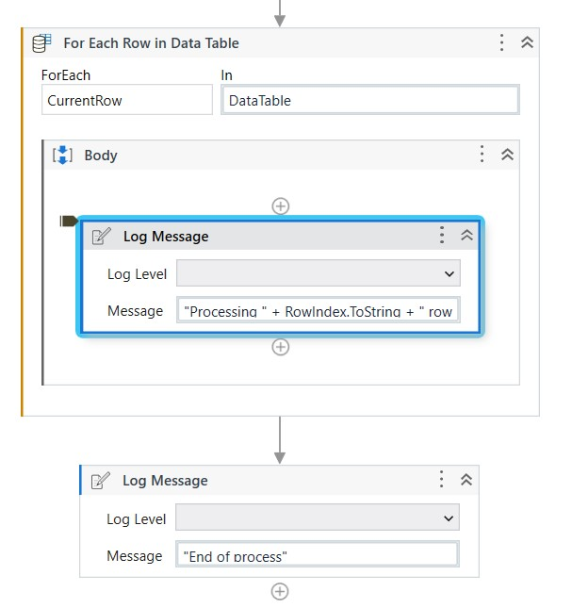

Which button should be clicked in order to quickly execute the **Log Message** activity for the remaining rows and make the **Debugger** immediately finish the **For Each Row in Data Table** activity?

Review Later

Step Into

Break

Step Over

Step Out

Continue

When iterating through multiple digital PDF invoice files with the same structure, what action should be taken to retrieve the "Total Value" based on best practices?

Review Later

Use OCR activities to extract the "Total Value" from all invoices.

Use the Find Image and Get Text activities.

Validate selectors for all invoices.

Copy the total values using Hotkeys.

How can the **Invoke Code** activity be used to execute vb.net code with an input argument and an output argument in a UiPath project?

Review Later

Create a sequence, add an Invoke Code activity, add the vb.net code in the Arguments property of the activity, and use the Edit Arguments button to define input and output arguments.

Create a sequence, add an Invoke Code activity, add an Assign activity to define input and output arguments, and use the Edit Code button to edit the vb.net code.

Create a sequence, add an Invoke Code activity, add the vb.net code using the Edit Code button, and use the Edit Arguments button to define input and output arguments.

Create a sequence, add an Invoke Code activity, use the Edit Code button to define input and output arguments, and add the vb.net code using an Assign activity.

What is a major benefit of a **REFramework Dispatcher** process using **Orchestrator** queues?

Review Later

Enhanced ease of use, as the REFramework automatically generates the queue.

The same robot that will process a Queue Item is responsible for adding each Queue Item to the queue.

Improved error handling when extracting data from multiple sources and directly adding it to queues.

Guarantees that all data follows a consistent format and fetches information from an Orchestrator queue.

Which feature in **UiPath Orchestrator** allows diagnosing potential issues and optimizing resources for better efficiency of unattended automations?

Review Later

Monitoring

Storage Buckets

Job prioritization

Triggers

Which LINQ query will return the quantity of pears from the following table?

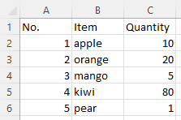

eview Later

dt.AsEnumerable.

SkipWhile(Function(x) x("Item").ToString.Equals("pear"))(0)("Quantity").ToString

dt.AsEnumerable.

Skip(5).First.Item("Quantity").ToString

dt.AsEnumerable.

Where(Function(x) x("Item").ToString.Equals("pear"))("Quantity").ToString

dt.AsEnumerable.

First(Function(x) x("Item").ToString.Equals("pear"))("Quantity").ToString

How do you properly configure UiPath Remote Runtime for use with Citrix Virtual Apps and Desktops?

Review Later

Install the Remote Runtime component only on the client machine

Install the Remote Runtime component on both the Citrix Application servers and the client machine

Install the Remote Runtime component on Citrix Application servers and the corresponding UiPath extension on the client machine

Install the Remote Runtime component on the Citrix Application server and configure a direct connection to the UiPath Studio

A developer designed two automation projects to work with an **Orchestrator** queue. One is a **Dispatcher** and the other is a **Performer**. Which activity is required to be used in the **Performer** project?

Review Later

Add Transaction Item

Wait Queue Item

Delete Queue Items

Get Transaction Item

Add Queue Item

How does the Screen Refresh button function in the Computer Vision wizard?

Review Later

It refreshes the target app by closing and reopening it during runtime.

It restarts the Computer Vision neural network server in case of errors or disconnects.

It updates the UI elements of the target app with new positions and properties.

It sends a new picture to the Computer Vision server to be analyzed again if something changes in the target app.

What actions should be taken by a developer to transform a **REFramework** process into a linear process?

Review Later

In the configuration file (Config.xlsx) establish the MaxRetryNumber variable to 0.

Assign a value to the out_TransactionItem variable in the GetTransactionData workflow only when the in_TransactionNumber is 1.

In the configuration file (Config.xlsx) establish the MaxRetryNumber variable to 1.

Within the scope of the GetTransactionData workflow, set the value of the out_TransactionItem variable to Nothing, indicating the absence of any assigned transaction item.

When using **UiPath Orchestrator**, how can the unattended robot user's actions and access to certain data be limited?

Review Later

By assigning specific roles and permissions to the robot user.

By setting up user groups with predefined limitations.

By hardcoding restrictions into the automation workflow.

By defining rules within the Classic Folder settings.

A developer has followed UiPath best practices while automating a process using the **REFramework**. A large number of **Orchestrator** assets of type **Integer** are needed for the process.

Where in the "Config.xlsx" file should the names of the **Integer** assets be referenced?

Review Later

A new sheet

Settings sheet

Assets sheet

Constants sheet

When using **REFramework** without **Orchestrator** access, what is the best practice to ensure that a transaction will be retried in case a **System Exception** occurs during its processing?

Review Later

Create a queue in Orchestrator with the "Max # of retries" greater than 0.

Use a Retry Scope activity within the Process Transaction state.

Use a Try Catch activity with a Retry Scope activity in the Catch block defined for System Exceptions.

Set the MaxRetryNumber in the Config.xlsx file to a number greater than 0.

A developer automated a process in the **REFramework** using **Orchestrator** queues. In which state(s) is the status updated to **Successful** for each **Transaction Item** from the queue?

Review Later

Initialization and Process Transaction.

Process Transaction only.

Initialization and Get Transaction Data.

Get Transaction Data only.

What is a major benefit of a **REFramework Dispatcher** process using **Orchestrator** queues?

Review Later

Improved error handling when extracting data from multiple sources and directly adding it to queues.

Guarantees that all data follows a consistent format and fetches information from an Orchestrator queue.

Enhanced ease of use, as the REFramework automatically generates the queue.

The same robot that will process a Queue Item is responsible for adding each Queue Item to the queue.

*==========================================================================================================*

In which situation is an anchor NOT automatically created?

Review Later

When the anchors are disabled from Project Settings.

When the strict selector is considered reliable.

When the fuzzy selector is considered reliable.

When an anchor is not found with 100% certainty or duplicates are found.

A developer wants to move an automation into production. A **Click** activity contains the below automatically-generated selector. Which attribute in the selector is stable?

'="" idx="34" tag="1">

Review Later

css-selector

tag

idx

app

title

A user needs to download a report for a variable number of months of the year and extract the needed months from multiple emails. The user decides to loop over the months using a For Each activity. Which data type is best suited to store the values of the names of the months?

Review Later

Dictionary<Object,String>

DateTime

String[]

List<String>

**Comments**

In UiPath Studio, after a developer has published a library to a folder on their machine and opened a new process, which option should be configured through the "Manage Packages" window to load the library into the process?

Review Later

Modify the Default Package Location

Configure the Library Settings

Add a new User-Defined Package Source

Update the preinstalled packages

Create a new library from the existing process

Adjust the Project Dependencies

What is the component of the UiPath Ecosystem that gives a user access to ready-to-use automations?

Review Later

UiPath Marketplace

UiPath Community

UiPath Studio

UiPath Forum

What capabilities can a developer achieve by using GIT version control in UiPath Studio?

Review Later

Upgrade or downgrade UiPath Activities.

Determine the last person who modified a project.

View the differences between two releases of a UiPath Activity.

Prevent local edits to a project.

Which filter option should be used for the **For Each File in Folder** activity to iterate between all the Microsoft Word documents in a local folder?

Review Later

"*.doc*"

"*.doc, *docx"

"*.doc"

Microsoft Word

Which of the following statements accurately describes the purpose of the **Read Range** in UiPath Studio's Excel activities?

Review Later

It allows you to read and apply formatting options to the values in an Excel range.

It saves the contents of an Excel range as a DataTable for later use in the automation.

It allows you to read only the visible rows of an Excel range, ignoring filtered and hidden values.

It reads the formatting of the values in an Excel range and applies it to the resulting DataTable.

What is the correct approach using the Microsoft 365 activities to retrieve all the emails with a specific keyword in the subject?

Review Later

Use the Get Newest Email activity.

Use the Move Email activity.

Use the Get Email List activity and configure the filter.

Used the Download Email activity.

What activity retrieves the size in KB (kilobyte) of a specific folder?

Review Later

Get Folder Info

Get Info

Retrieve Folder Info

Get Folder Size

Where can a published Template Project be found?

Review Later

Official

Built-in

Marketplace

Orchestrator

What are the main components of a digital business process?

Review Later

Inputs, Source applications, Assignees.

Inputs, Process flows, Outputs.

Inputs, Process flows, Source applications, Outputs.

Inputs, Process flows, Assignees, Outputs.

A developer needs to ensure that a string represents a valid email format. How can this verification be performed?

Review Later

Using Regular Expressions.

Using a Send SMTP Mail Message activity.

Using the Contains method with '@.com'.

Using the Format Value activity.

The developer is building a workflow using **Type Into** activity to interact with minimized apps on an employee's workstation without causing disruptions to the user.

What **Input mode** should be enabled on the activity?

Review Later

Chromium API

Hardware Events

Simulate

EmptyField

In the UiPath implementation model, at which stage is the **Statement of Work (SOW)** reviewed?

Review Later

Solution Document Review

Process Analysis

Kickoff

User Acceptance Testing

Given a string containing an email address, which of the following is the correct approach to check if the email format is correct?

Review Later

Using an Is Match activity.

Using the Contains method with '@.com'.

Using the Format Value activity.

Using a Send SMTP Mail Message activity.

A developer has a project which includes a **Global Exception Handler**. Based on best practice, all exceptions must be handled as defined by the business requirements. To ensure the defined exceptions do not reach the **Global Exception Handler**, which activity is used?

Review Later

Try Catch

Retry Scope

Rethrow

GlobalExceptionHandler

Given there are two lists in a workflow:

1. "FranceCities" which contains city names in France

2. "IndiaCities" which contains city names in India

Which expression should be used as the input to a **MessageBox** in order to show all city names from both lists?

Review Later

String.Join(",", Enumerable.Concat(FranceCities, IndiaCities).ToList)

String.Join(",", FranceCities.ToString + IndiaCities.ToString)

Enumerable.Concat(FranceCities, IndiaCities).ToString

FranceCities.Concat(IndiaCities).ToList.ToString

What property should be configured to ensure that the **Read Range Workbook** activity returns all rows when reading a .xlsx file with headers and 300 rows of data?

Review Later

SheetName

Range

PreserveFormat

AddHeaders

What is the status of a queue item before it is changed to "Abandoned"?

Review Later

Postponed

Failed

In Progress

Retried

Successful

A developer automated a business process using three automation projects. Each project file has several invoked workflow files. Before publishing, the developer wants to ensure all unexpected exceptions are caught.

How many **Global Exception Handlers** can be set?

Review Later

Only one per business process.

Only one for each invoked file.

Only one per automation project.

One for each invoked file.

A developer has stored a UiPath Studio project in a remote GIT repository. Which feature enables the developer to access and view the project on their local computer?

Review Later

GIT Init

Clone Repository

Disconnect

Copy to GIT

Which of the following C# data structures in a UiPath workflow allow dynamic resizing, making it suitable for scenarios where the number of elements is not predetermined?

Review Later

Tuple

Array

List

Integer

The project manager examined the Orchestrator logs for any pertinent error information related to a process after the process owner informed them about missing expected outputs.

To view all alerts/errors, which Level should the project manager filter the logs by?

Review Later

Error

Trace

Fatal

Warn

Info

When automating Excel tasks using **UiPath Modern activities**, which activity would be used to write data to a specific cell in an Excel worksheet?

Review Later

Format Cell activity

Fill Range activity

Append Range activity

Write Cell activity

Which of the following variable names respects the UiPath best practices?

Review Later

ExtractedPhoneNumber

MyVariable

MyTestVariableBool

in_FirstName

Which UiPath product combines collaboration with people, UI and API automation, and native integrated AI capabilities?

Review Later

Orchestrator

UiPath Forum

UiPath Marketplace

Studio Family & Apps

A developer uses GIT for version control in UiPath Studio. After changing the local file and executing the Push action, Studio identifies a discrepancy between the local file and the remote repository file.

Which window appears on the developer's screen to address this issue?

Review Later

Solve Conflicts

Manage Remotes

History

Clone a remote GIT repository

A developer is creating a process that uploads data to an **Orchestrator** queue. The data originates from emails in one inbox. The **Queue Item** needs to be processed first if the email was sent by the process owner.

To ensure the **Queue Items** are processed in the correct order, which property of the **Add Queue Item** activity should be used?

Review Later

Reference

ItemInformation

Priority

Postpone

When a developer is examining a suspended state upon reaching a breakpoint, which activity will the Executor be directed to if Step Out is selected from the Debug section in UiPath Studio's ribbon interface?

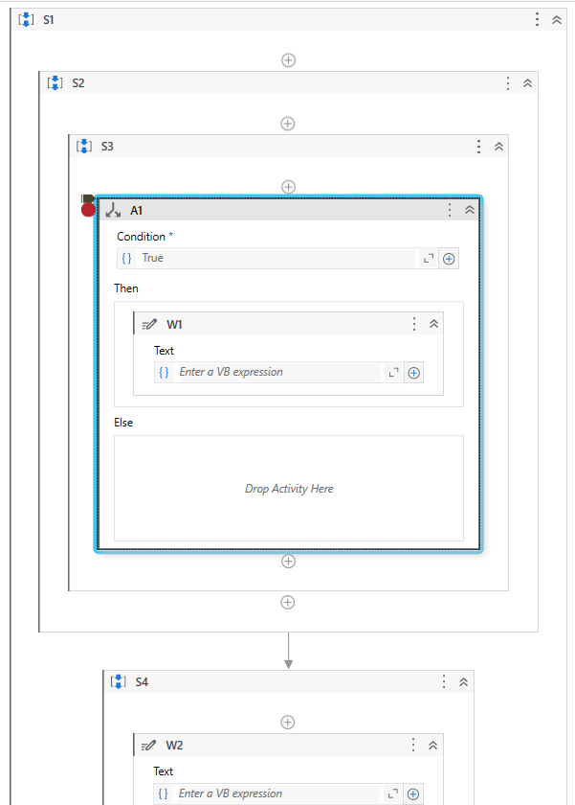

Review Later

S2

S3

W1

A1

S4

What is the best practice rule regarding nested IF clauses?

Review Later

There is no rule regarding nested IF clauses.

A maximum of 2 nested IF clauses.

A maximum of 4 nested IF clauses.

A maximum of 3 nested IF clauses.

*From <*[*https://uipath.onlinetests.app/Assess.aspx?guid=AD3F1D0CE8424EFDAE538EE7254C55D0&a=Q1*](https://uipath.onlinetests.app/Assess.aspx?guid=AD3F1D0CE8424EFDAE538EE7254C55D0&a=Q1)*>*

Exam failed questions

Monday, July 8, 2024

2:45 PM

Deadline priority

Invalid operator exception - application exception occurs

OrderByDescending or max method? - get maximum value from column

Personal workspace: <https://docs.uipath.com/orchestrator/standalone/2023.4/user-guide/managing-personal-workspaces>

Alerts

Extract pdf page range - password protected

Data service filter - add test data

Test explorer - percentage shows coverage or test data used

Update test data - add 2 numbers, next add 3 numbers & print sum

Subtract some time span from today using datetime

Verbose

Use Custom Log Fields in REFramework projects.

When custom log fields stop working

Use Tenant Entities (Webhooks, Alerts) and Folder Entities (Triggers, Credential Stores).

Use features for unattended automations (use of folders and job priorities, separation between background and foreground processes, license allocation per machine).

Use Orchestrator monitoring features.

Use LINQ for Lists and DataTables.

Perform DateTime manipulation to parse dates, add or subtract time and convert to and from string type.

Use Invoke Method and Invoke Code in projects.

Notepad - closed, try system exce business ex

App/web recorder - what actions can be performed

What status can we set for queue item in studio to retry it? Abandoned, failed, retried, postpone

Add transaction log field

Remove transaction log field

Difference between assets & settings sheet? Where credentials are stored & where it is hard coded?

If credential asset is present in 2 sheets of config, what happens? Error thrown in init settimgs or empty value assigned or what?

Ui descriptor - ? Screens ? Applications ? Libraries

If library has object repository & this library is installed in a process, what happen sto ui descriptors in object repository

How to bring ui element to foreground?

Captre all elements in cv activity, what it captures?

userList is array of strings, declared empty. Then this argument is passed inside invoke code, below this activity we will print the list count. Inside the invoke code we add userList.Add("User1") and user 2.

======================================================================================