# movie booking ticket system

INTRODUCTION

Launched in 2022, CINEPLEX ENTERTAINMENTS, owned and operated by CIE Pvt Ltd (founded in 2021), is India's leading entertainment destination and the one-stop-shop for every out-of-home entertainment need. The firm is present in over 650 towns and cities in India and works with partners across the industry to provide unmatched entertainment experiences to millions of customers. Over the years, the company has evolved from a purely online ticketing platform for movies across 6,000 screens to end-to-end management all accomplished at par with global standards. CINEPLEX ENTERTAINMENTS has also built India’s largest organic reviews and ratings engine for movies and has driven technology innovations, such as the m-ticket and Movie Mode, impacting tens of millions of users and the industry at large. Demonstrating category leadership, BookMyShow has grown beyond India with operations in Dubai, Indonesia, Sri Lanka, and Singapore amongst others. The Bangalore-headquartered company counts Ticket Green, Eventifier, Masti Tickets, Townscript, and Burrp amongst its key investments in the sector. CINEPLEX ENTERTAINMENTS is also committed to society at large, by way of its charity initiative SignASmile, which provides entertainment experiences to the underprivileged.

# implementation

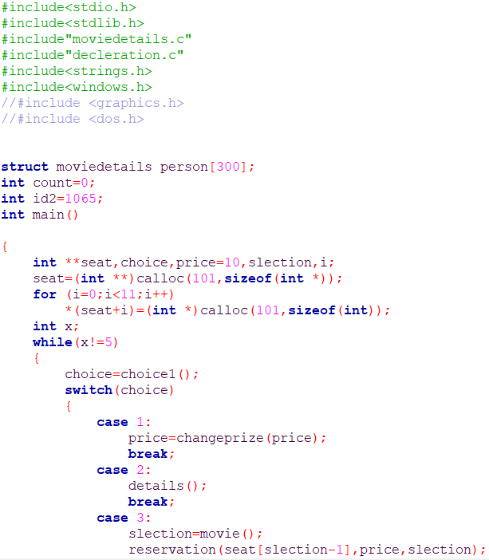

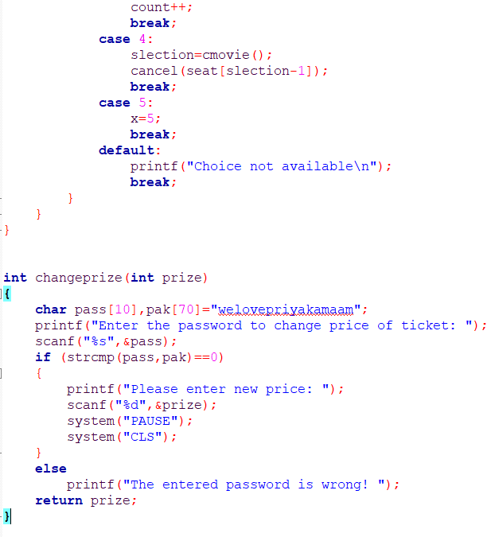

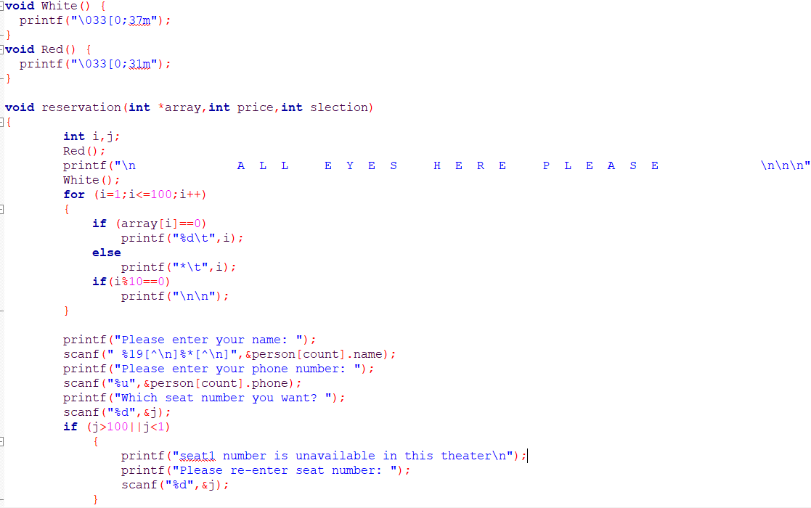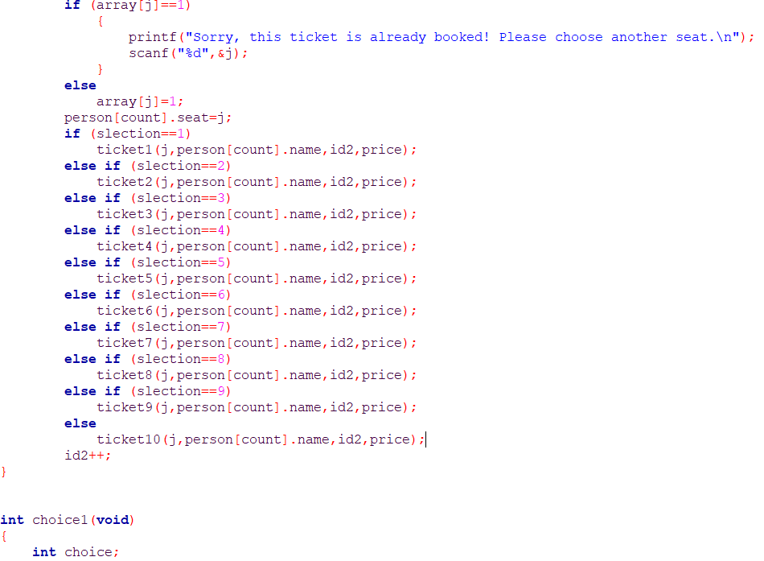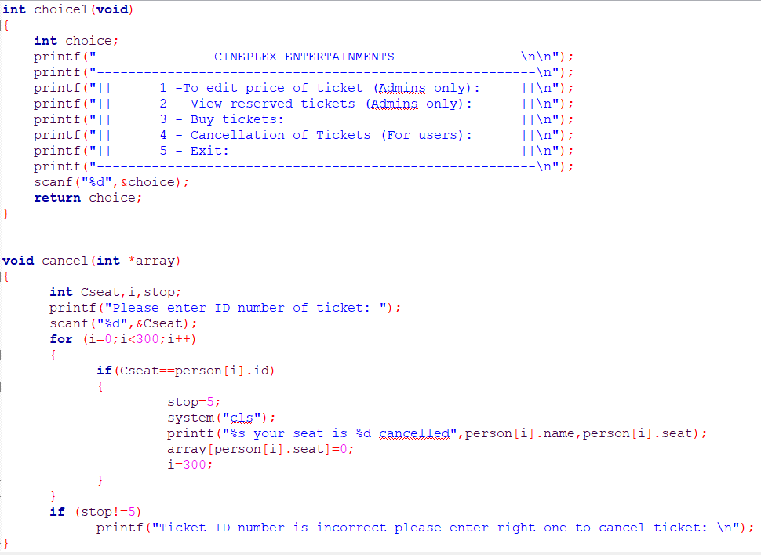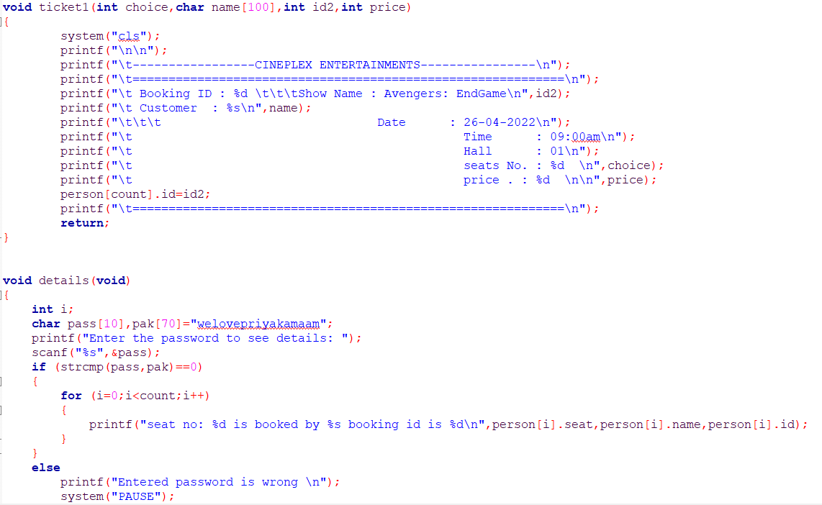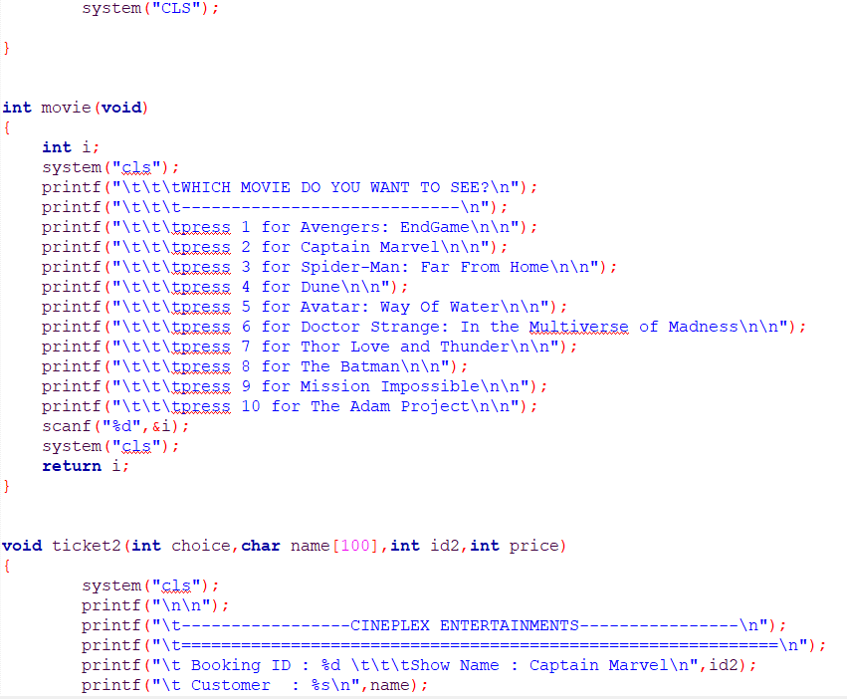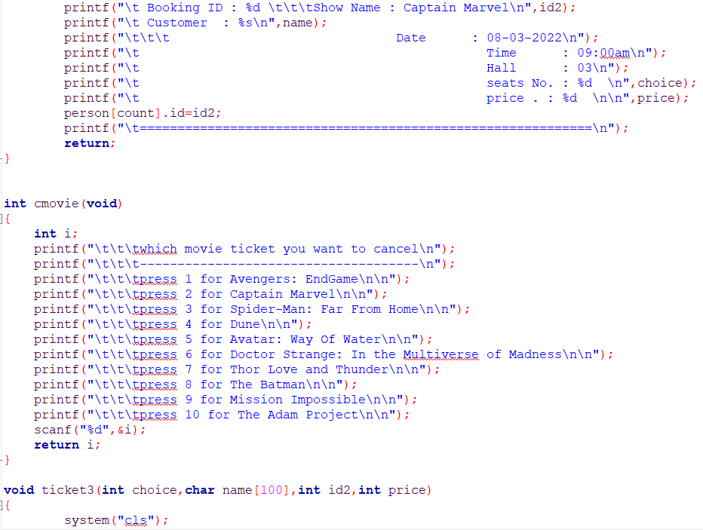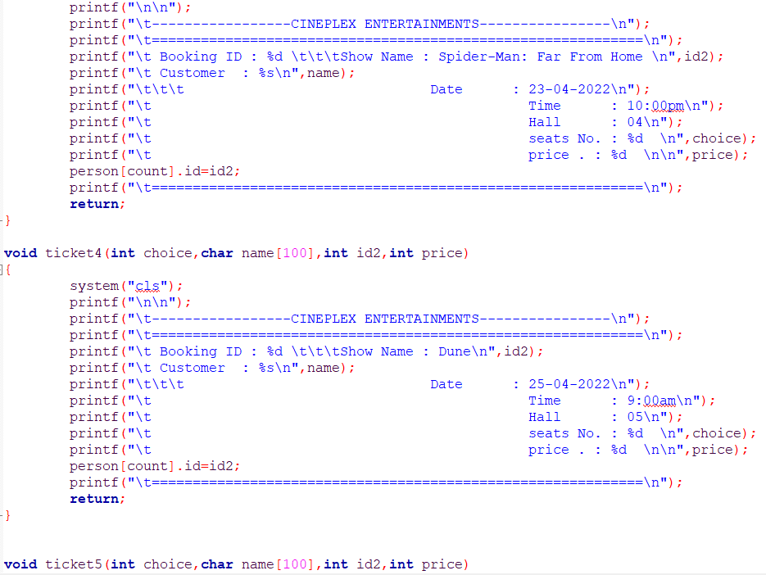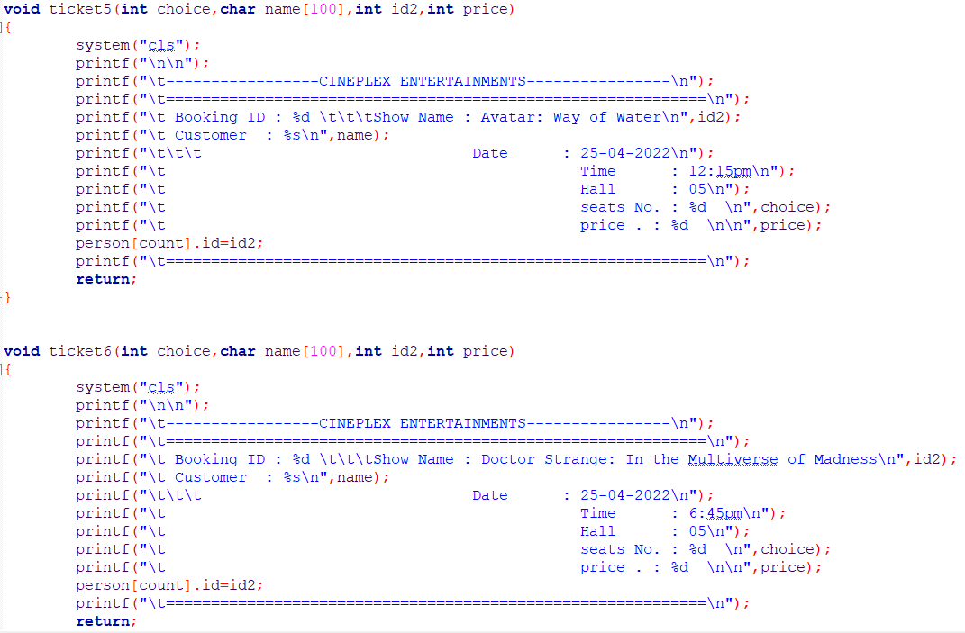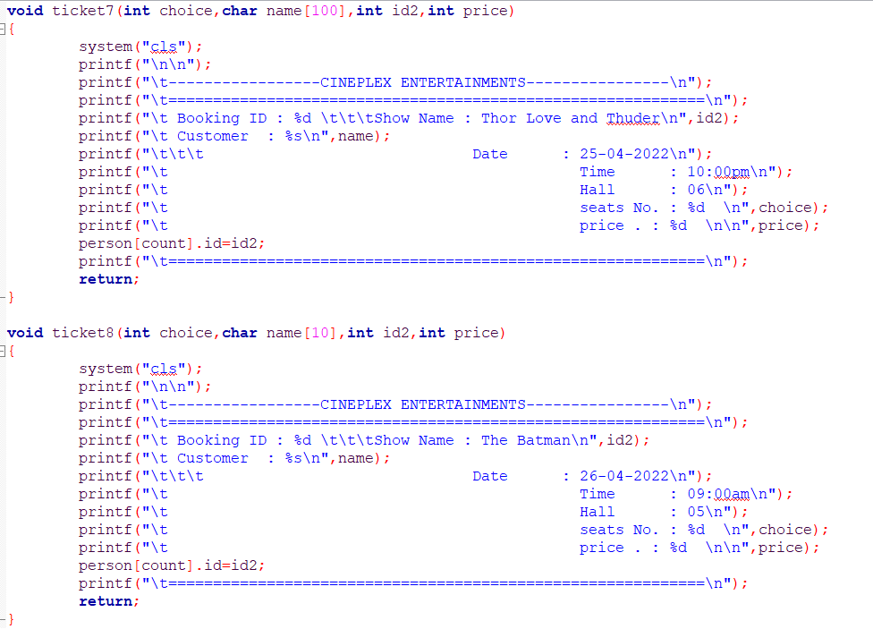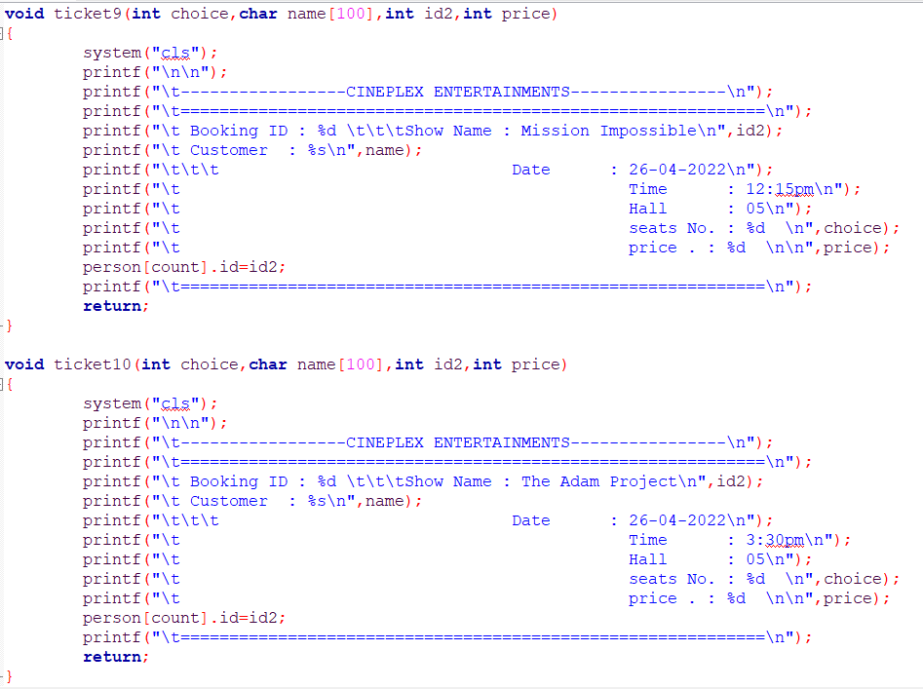

# OUTPUTS

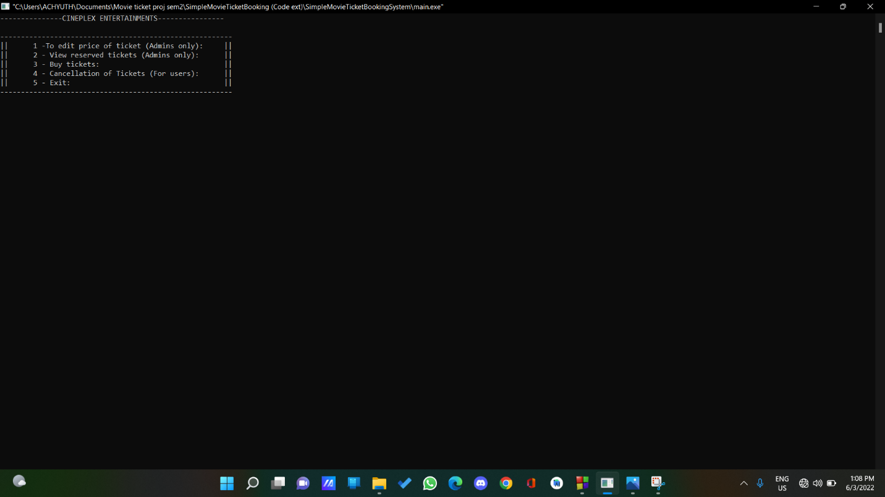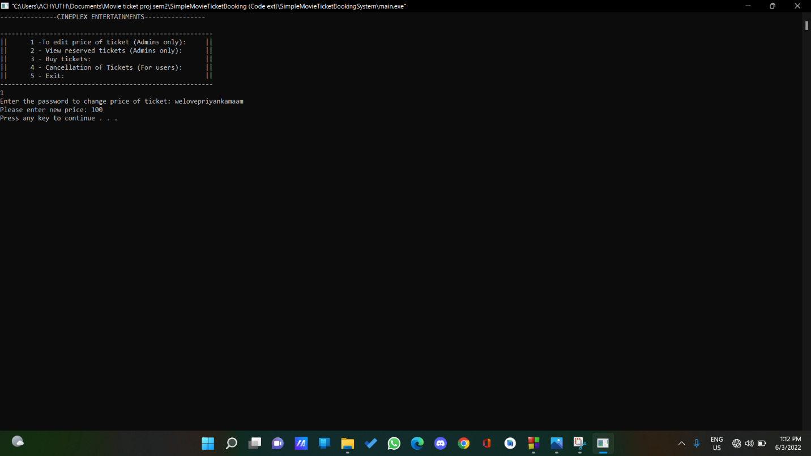

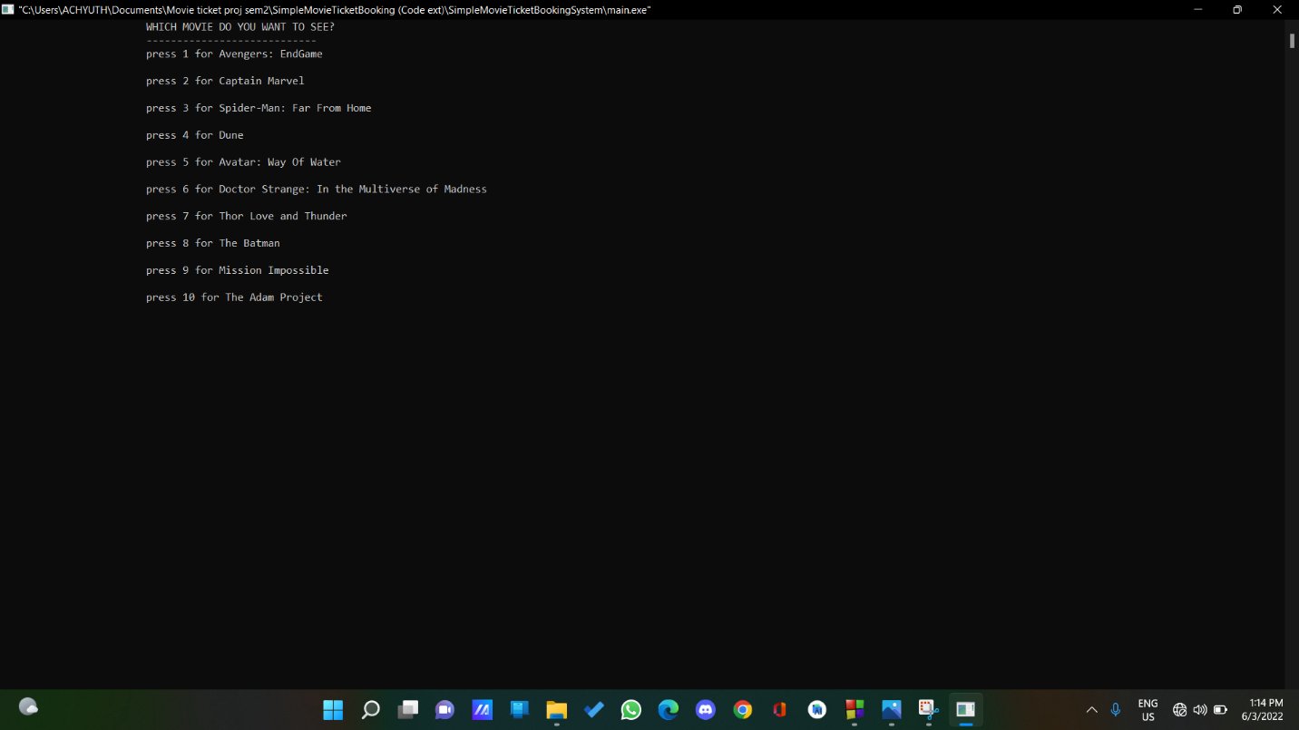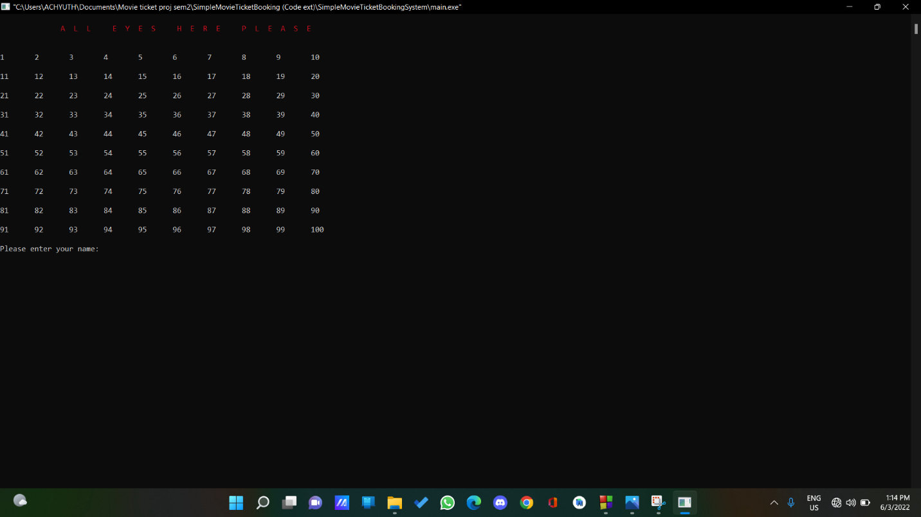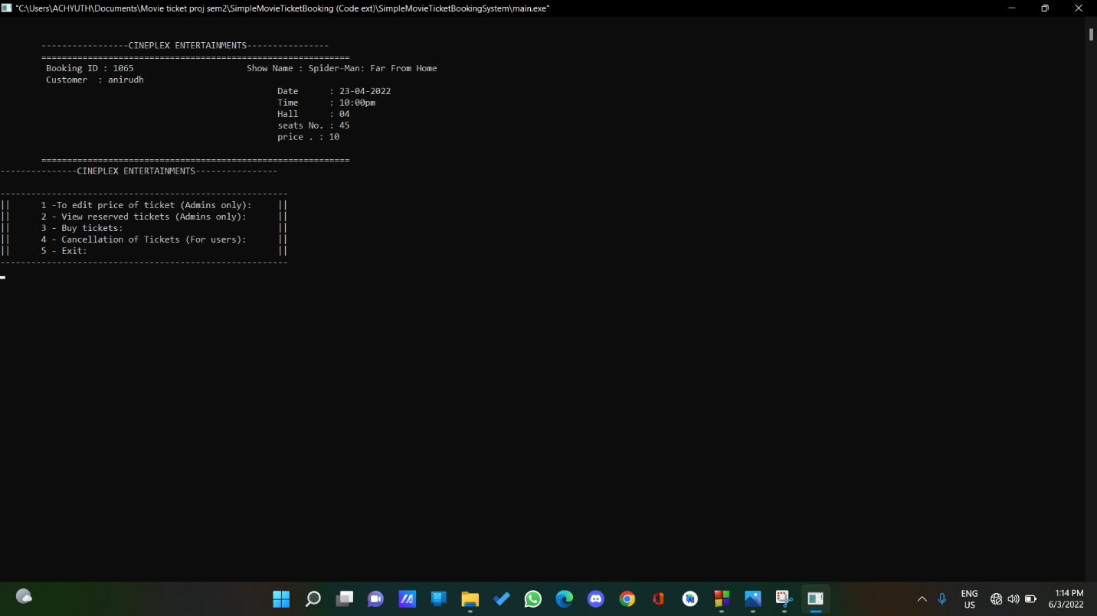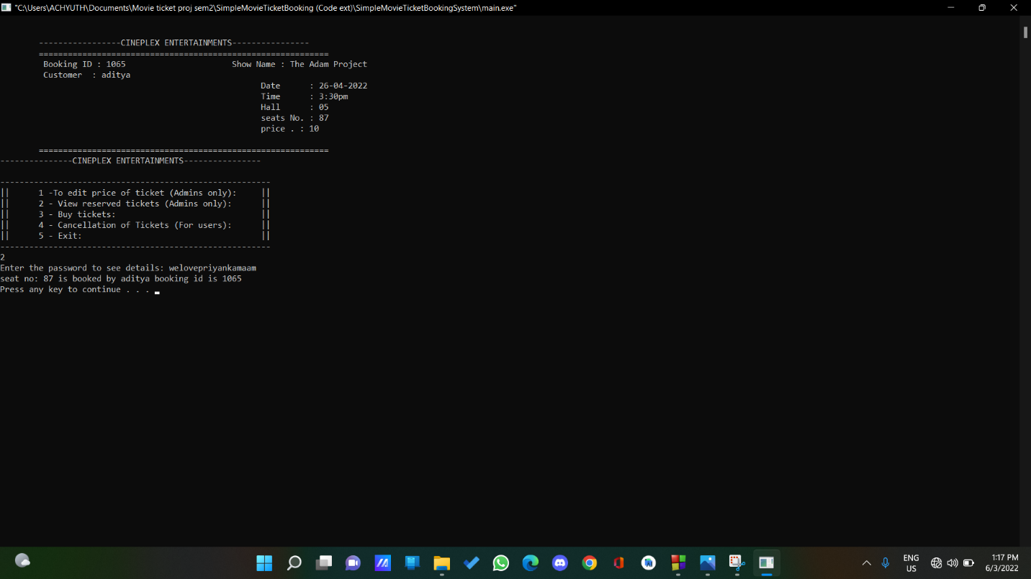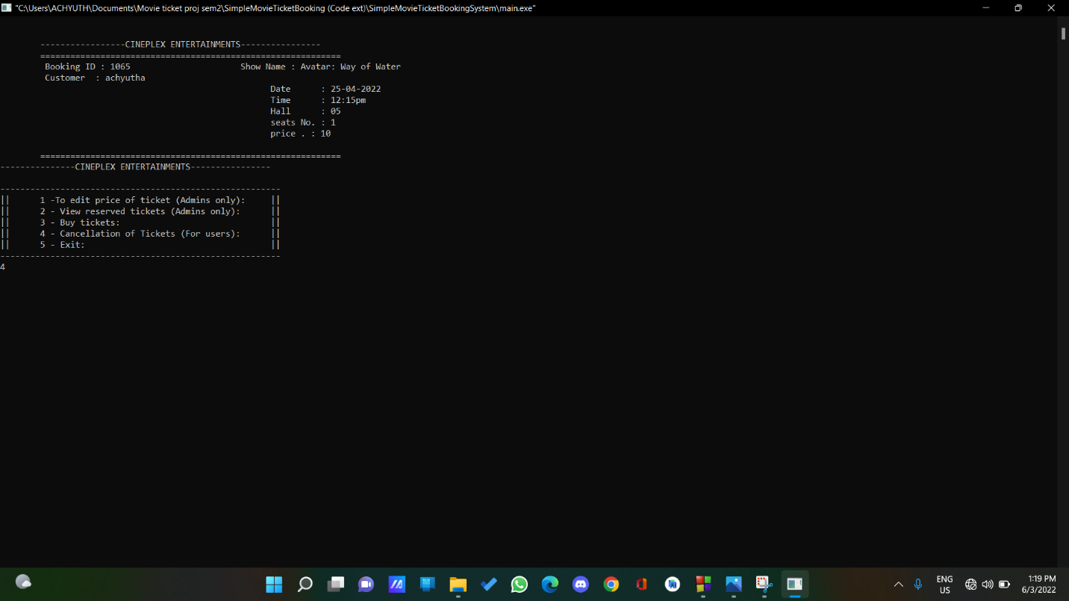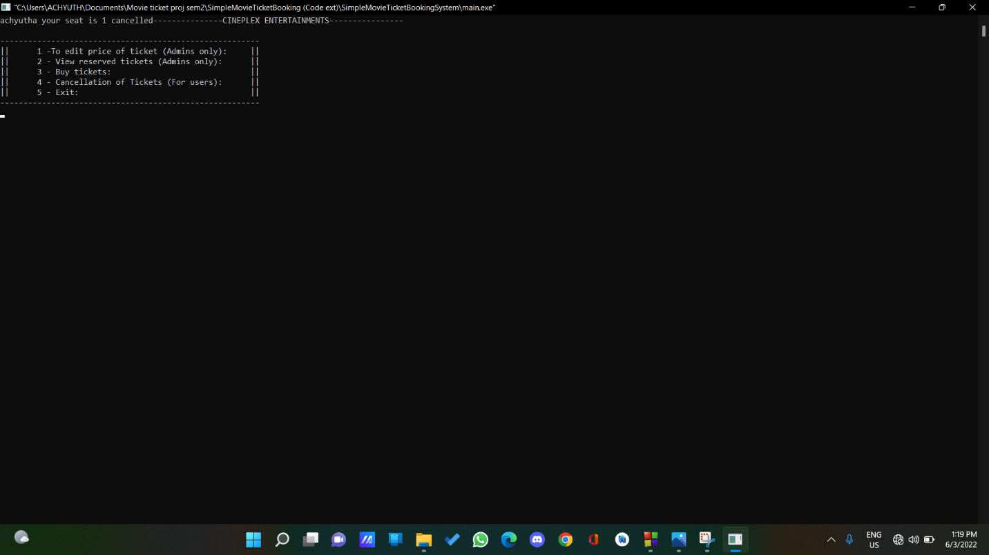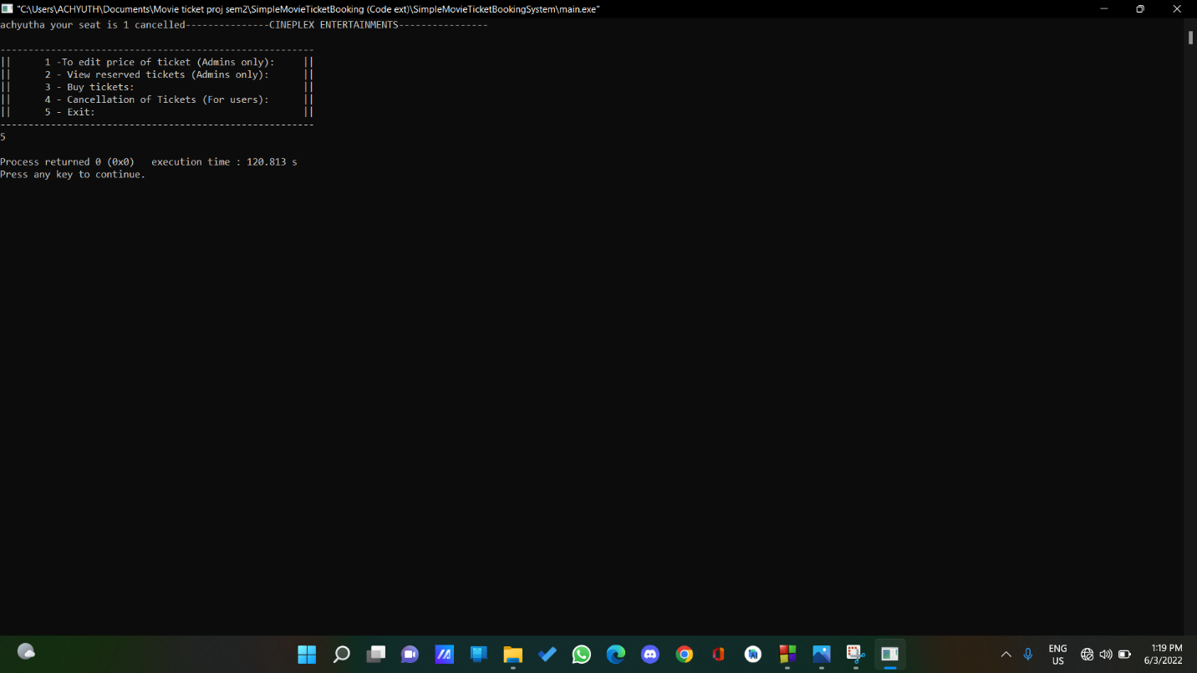

# CONCULSION