Tourism Experience Analytics: Classification, Prediction, and Recommendation System
Author: Akash Jalapati
Date: February 25, 2026

1. Executive Summary

🔹 Problem
Tourism platforms collect large amounts of data about users, attractions, and travel patterns, but this data is often not fully utilized to improve user experience. Travelers have different preferences, travel purposes, and satisfaction levels, making it difficult for agencies to predict what a user will enjoy. This project aims to solve this challenge by using data to understand traveler behavior, predict user satisfaction, identify visit types, and provide personalized attraction recommendations.

🔹 Approach
The project follows a structured data analytics pipeline. First, multiple datasets containing transaction records, user demographics, and attraction information were cleaned and merged into a single usable dataset. Exploratory Data Analysis was performed to understand patterns such as popular attractions, rating trends, and regional travel behavior. Based on these insights, machine learning models were developed to perform prediction and recommendation tasks, and the final solution was integrated into an interactive application.

🔹 Techniques Used
Various data science and machine learning techniques were applied. Data preprocessing included handling missing values, encoding categorical variables, feature engineering, and normalization. For modeling, regression algorithms were used to predict attraction ratings, classification algorithms were used to predict the mode of visit, and recommendation techniques such as collaborative filtering and content-based filtering were used to suggest attractions. Model performance was evaluated using standard metrics like accuracy, precision, recall, F1-score, R², and Mean Squared Error.

🔹 Key Results
The analysis revealed clear patterns in travel behavior based on demographics, visit timing, and attraction types. The classification model can reasonably predict whether a user is likely traveling for business, family, couples, or other purposes. The regression model estimates expected attraction ratings, helping identify experiences that may satisfy users more. The recommendation system successfully generates personalized attraction suggestions by analyzing user preferences and similarities between travelers.

🔹 Application
To make the solution practical, a Streamlit application was developed where users can enter their travel details and receive predicted visit modes along with recommended attractions. This system can help tourism companies personalize marketing strategies, improve service planning, enhance customer satisfaction, and increase retention. It demonstrates how data-driven decision-making can significantly improve tourism experiences for both businesses and travelers.

2. Introduction

🔹 Overview of Tourism Analytics
Tourism analytics involves analyzing travel data such as user demographics, visit history, ratings, and attraction details to understand traveler behavior and trends. It helps tourism organizations identify popular destinations, seasonal patterns, and customer preferences, enabling them to make better decisions and improve services.

🔹 Need for Personalization in Travel
Every traveler has different needs, interests, and travel purposes. Some travel for business, while others travel with family, friends, or as couples. Providing the same recommendations to all users may not satisfy everyone. Personalized suggestions based on user preferences and past behavior help improve user experience, increase engagement, and build customer loyalty.

🔹 Role of Machine Learning
Machine learning enables systems to learn from historical data and make intelligent predictions. In tourism, it can be used to predict user satisfaction, identify travel patterns, classify visit types, and recommend suitable attractions. These data-driven insights help platforms provide relevant suggestions automatically and efficiently.

🔹 Problem Motivation
Although large amounts of tourism data are available, it is often not fully utilized to improve decision-making. Predicting what a traveler will enjoy and understanding their travel purpose remains challenging. This project aims to use analytics and machine learning to predict attraction ratings, classify visit modes, and provide personalized recommendations, ultimately enhancing both traveler experience and business outcomes.

3. Problem Statement

🔹 Predict Attraction Ratings
Travel platforms need to understand how satisfied users are likely to be with a particular attraction. However, user satisfaction depends on many factors such as demographics, travel purpose, and attraction characteristics. This project aims to predict the rating a user may give to an attraction, helping businesses identify experiences that may delight or disappoint travelers.

🔹 Predict Visit Mode
Travelers visit destinations for different purposes, such as business trips, family vacations, or trips with friends or partners. Knowing the likely visit mode helps tourism providers offer suitable services and packages. This project develops a model to predict a user’s visit mode based on their profile and travel data.

🔹 Recommend Attractions
With thousands of attractions available, travelers often struggle to choose places that match their interests. Generic recommendations may not be effective. This project builds a personalized recommendation system that suggests attractions based on user preferences, past behavior, and similarities with other travelers.

🔹 Business Value
By predicting satisfaction levels, understanding travel purposes, and offering personalized recommendations, tourism businesses can improve customer experience, design targeted marketing strategies, optimize resources, and increase customer retention. The system helps transform raw tourism data into actionable insights that support better decision-making.

4. Objectives

🔹 Primary Objectives
1. Predict Attraction Ratings (Regression)
Develop a model that estimates the rating a user is likely to give to a tourist attraction based on their profile, travel details, and attraction characteristics. This helps identify experiences that are expected to satisfy users.
2. Predict Visit Mode (Classification)
Build a classification model to determine the likely purpose of travel, such as business, family, couples, or friends, using user demographics and historical travel data. This enables better planning of services and targeted offerings.
3. Provide Personalized Recommendations
Create a recommendation system that suggests attractions tailored to individual users based on their preferences, past visits, and similarities with other travelers. The goal is to help users discover places they are most likely to enjoy.

🔹 Secondary Objectives
1. Customer Segmentation
Group users into meaningful segments based on their travel behavior, preferences, and visit patterns. This allows tourism providers to design targeted promotions and customized experiences for different traveler types.
2. Tourism Trend Analysis
Analyze patterns such as popular destinations, seasonal travel behavior, and attraction preferences across regions. These insights help stakeholders understand demand and adjust their offerings accordingly.
3. Improve User Satisfaction
By predicting preferences and delivering relevant recommendations, the system aims to enhance the overall travel experience, increase engagement, and encourage repeat usage of tourism platforms.

5. Dataset Description
The project uses multiple related datasets containing information about users, their visits, attractions, and geographic details. These tables were merged using common identifiers to create a comprehensive dataset for analysis and modeling.

🔹 Transaction Data
Purpose:
Contains records of user visits to attractions along with ratings and visit details. It captures actual travel behavior.
Key Columns:
- TransactionId — Unique visit record
- UserId — Identifies the traveler
- VisitYear, VisitMonth — Time of visit
- VisitMode — Purpose of travel (Business, Family, etc.)
- AttractionId — Visited attraction
- Rating — User’s rating of the attraction
How Used in Modeling:
This dataset is the core source for predicting ratings, classifying visit modes, and understanding user preferences.
Sample (Illustrative):
TransactionId | UserId | VisitMode | AttractionId | Rating
1001 | U12 | Family | A45 | 4
1002 | U07 | Business | A18 | 3

🔹 User Data
Purpose:
Provides demographic information about users, mainly their geographic location.
Key Columns:
- UserId — Unique user identifier
- ContinentId, RegionId
- CountryId
- CityId
How Used in Modeling:
Helps analyze travel behavior across regions and is used as input features for prediction models.

🔹 City Data
Purpose:
Links CityId values to actual city names and countries.
Key Columns:
- CityId — Unique city identifier
- CityName — Name of the city
- CountryId — Associated country
How Used in Modeling:
Enables meaningful geographic analysis and mapping of users and attractions to real locations.

🔹 Attraction Data (Item Data)
Purpose:
Contains details about tourist attractions.
Key Columns:
- AttractionId — Unique attraction identifier
- Attraction — Name of the attraction
- AttractionCityId — Location
- AttractionTypeId — Category (Beach, Museum, Park, etc.)
- AttractionAddress — Physical address
How Used in Modeling:
Used for recommendation systems and to understand which types of attractions users prefer.

🔹 Visit Mode Data
Purpose:
Describes different travel purposes.
Key Columns:
- VisitModeId — Unique identifier
- VisitMode — Type of visit (Business, Family, Couples, Friends, etc.)
How Used in Modeling:
Serves as the target variable for classification models predicting travel purpose.

🔹 Geographic Data
Includes Continent, Region, and Country tables that describe the hierarchical location of users and attractions.
Purpose:
Provides broader geographic context for analysis.
Key Columns:
- ContinentId → Continent name
- RegionId → Region name
- CountryId → Country name
How Used in Modeling:
Helps identify regional travel patterns and preferences, improving prediction accuracy and insights.

🔹 Data Integration
All datasets were joined using common identifiers such as UserId, AttractionId, CityId, CountryId, and VisitModeId. The integrated dataset provides a complete view of user behavior, location, attraction characteristics, and travel patterns, enabling effective machine learning modeling and analysis.

6. Data Preparation
Before building machine learning models, the raw datasets were carefully cleaned and transformed to ensure accuracy, consistency, and reliability. Proper data preparation is essential to improve model performance and avoid misleading results.

🔹 Data Cleaning
• Missing Value Handling
Missing values in columns such as ratings, visit mode, or location details were identified and handled appropriately. Depending on the situation, missing entries were either removed or replaced using suitable techniques to maintain data consistency.
• Duplicate Removal
Duplicate transaction records and repeated user entries were checked and removed to prevent bias in analysis and modeling.
• Outlier Treatment
Unusual or incorrect values, such as invalid ratings outside the expected range, were detected and corrected or removed to ensure accurate predictions.
• Standardization
Categorical values such as visit modes, city names, and attraction types were standardized to maintain uniform formatting across datasets. Date formats were also aligned to ensure consistency.

🔹 Preprocessing
• Encoding Categorical Variables
Since machine learning models require numerical input, categorical variables such as VisitMode, Continent, Country, and AttractionType were converted into numerical form using encoding techniques.
• Feature Engineering
New meaningful features were created, such as user-level average ratings, attraction popularity scores, and time-based features (month/year trends). These enhanced the model’s ability to capture patterns.
• Data Merging (Joins)
Multiple datasets including transaction, user, city, and attraction data were merged using common identifiers like UserId and AttractionId to create a consolidated dataset for modeling.
• Normalization / Scaling
Numerical features such as ratings and aggregated scores were scaled to ensure uniform value ranges. This helps improve model convergence and performance.

7. Exploratory Data Analysis (EDA)
Exploratory Data Analysis was performed to understand travel behavior, user distribution, attraction popularity, and rating patterns before building machine learning models.

🔹 User Distribution by Continent/Country
Graph Suggested:
- Bar chart showing number of users per continent
- Bar chart or map showing users by country
Purpose:
To understand where most users are located and identify major user bases.
Insights:
- A large proportion of users belong to a few dominant continents, indicating key markets for tourism platforms.
- Certain countries show higher user engagement, suggesting strong travel activity from those regions.

🔹 Popular Attraction Types
Graph Suggested:
- Bar chart showing number of visits per attraction type (Beach, Museum, Park, etc.)
Purpose:
To identify which types of attractions are most preferred by travelers.
Insights:
- Some attraction types receive significantly more visits, showing general traveler preferences.
- Family-oriented attractions and recreational spots appear more frequently in user visits compared to niche categories.

🔹 Rating Distribution
Graph Suggested:
- Histogram of ratings (1–5 scale)
- Boxplot for rating spread
Purpose:
To analyze overall user satisfaction levels.
Insights:
- Most ratings are concentrated between higher values, indicating generally positive travel experiences.
- A small portion of low ratings highlights areas where improvements may be needed.

🔹 Visit Mode Patterns
Graph Suggested:
- Pie chart or bar chart showing distribution of VisitMode (Business, Family, Couples, Friends)
- Grouped bar chart comparing VisitMode across regions
Purpose:
To understand travel purposes and behavioral trends.
Insights:
- Family and couples trips represent a major share of visits, indicating leisure tourism dominance.
- Business travel is more common in specific regions, suggesting targeted service opportunities.

🔹 Correlation Analysis
Graph Suggested:
- Correlation heatmap of numerical features
Purpose:
To identify relationships between variables such as ratings, visit frequency, and time features.
Insights:
- Certain features show moderate correlation with ratings, making them important predictors.
- Weak correlations between some variables indicate independence, helping avoid redundancy in modeling.

🔹 Overall EDA Findings
- Travel behavior varies based on region and visit purpose.
- Attraction type plays a significant role in user satisfaction.
- Ratings are generally positive but influenced by user demographics and visit mode.
- The patterns observed support the feasibility of building regression, classification, and recommendation models.

8. Model Development
The project includes three modeling tasks: regression for rating prediction, classification for visit mode prediction, and a recommendation system for personalized attraction suggestions.

🔹 Regression — Rating Prediction
Models Tried:
Multiple regression algorithms were evaluated, including Linear Regression, Random Forest Regressor.
Training Method:
The dataset was split into training and testing sets. Models were trained using historical user, attraction, and visit data to learn patterns influencing ratings.
Evaluation Metrics:
Performance was assessed using standard regression metrics:
- R² Score — Measures how well the model explains variance in ratings
- Mean Squared Error (MSE) — Measures average prediction error
- Root Mean Squared Error (RMSE) — Provides error magnitude in rating units
Best Model Selection:
The model with the highest R² score and lowest error values was selected as the final regression model, as it provided the most accurate rating predictions.

🔹 Classification — Visit Mode Prediction
Models Used:
Several classification algorithms were tested, such as gradient boosting XG-Boost , Random Forest models. These models aim to predict whether a trip is for business, family, couples, friends, or other purposes.
Feature Importance:
Feature importance analysis helped identify which variables most influenced predictions. Factors such as user location, attraction type, and travel timing showed strong impact on visit mode.
Evaluation Metrics:
Model performance was evaluated using classification metrics:
- Accuracy — Overall correctness of predictions
- Precision — Correctness of positive predictions
- Recall — Ability to identify actual cases
- F1-Score — Balance between precision and recall
The best-performing classifier was chosen based on these metrics.

🔹 Recommendation System
The recommendation component suggests attractions tailored to each user using multiple approaches.
Collaborative Filtering:
This method recommends attractions based on the preferences of similar users. A user–item matrix was created using user ratings for attractions, and similarity between users was computed.
Content-Based Filtering:
This approach recommends attractions similar to those a user has previously liked, based on features such as attraction type, location, and popularity.
User–Item Matrix:
Rows represent users and columns represent attractions, with ratings indicating user preferences.
Similarity Method:
Cosine similarity was used to measure how similar users or attractions are based on their rating patterns.
Recommendation Logic:
The system generates a ranked list of attractions by identifying similar users or similar attractions and selecting those with the highest predicted relevance for the target user.

9. Streamlit Application
The project includes an interactive Streamlit web application that allows users to explore predictions and personalized recommendations in real time. The application is divided into two main pages for better usability and structured navigation.

🔹 Application Overview
The application provides a user-friendly interface where travelers can input their preferences and receive:
- Predicted visit mode (e.g., Family, Business, Couples)
- Expected attraction rating
- Personalized attraction recommendations
The app is built using Python, Machine Learning models, and Streamlit for interactive visualization.

🔹 Page 1: Business Analytics
This page focuses on analytical insights and visualizations derived from the tourism dataset.

Purpose
To help stakeholders understand trends, user behavior, and attraction performance.

Key Features
- Visual representation of user distribution
- Popular attraction types
- Rating trends
- Visit mode patterns
- Data-driven insights for decision-making

Business Value
This page helps tourism companies:
- Identify high-demand regions
- Understand seasonal travel behavior
- Detect popular attraction categories
- Make strategic marketing and operational decisions

This Graph Shows the most visited Attractions in the chosen Season

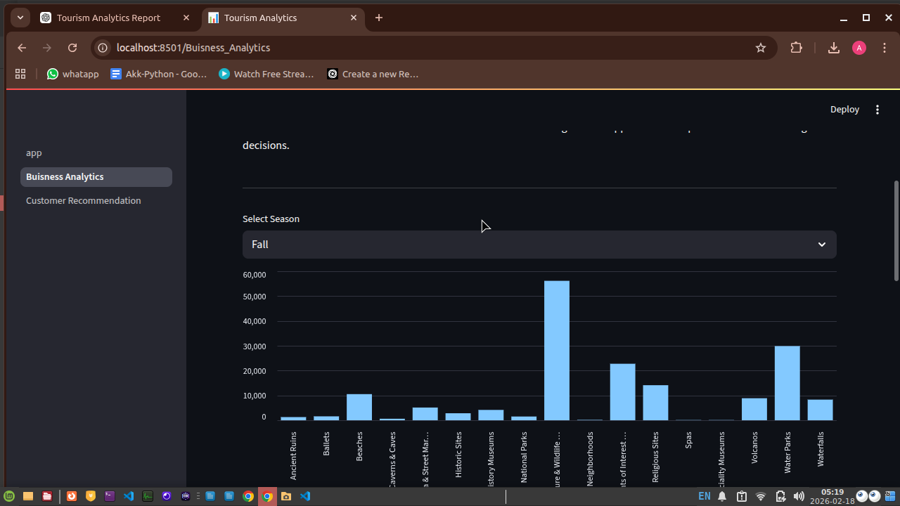

The Graph shows the distributions of the visit mode
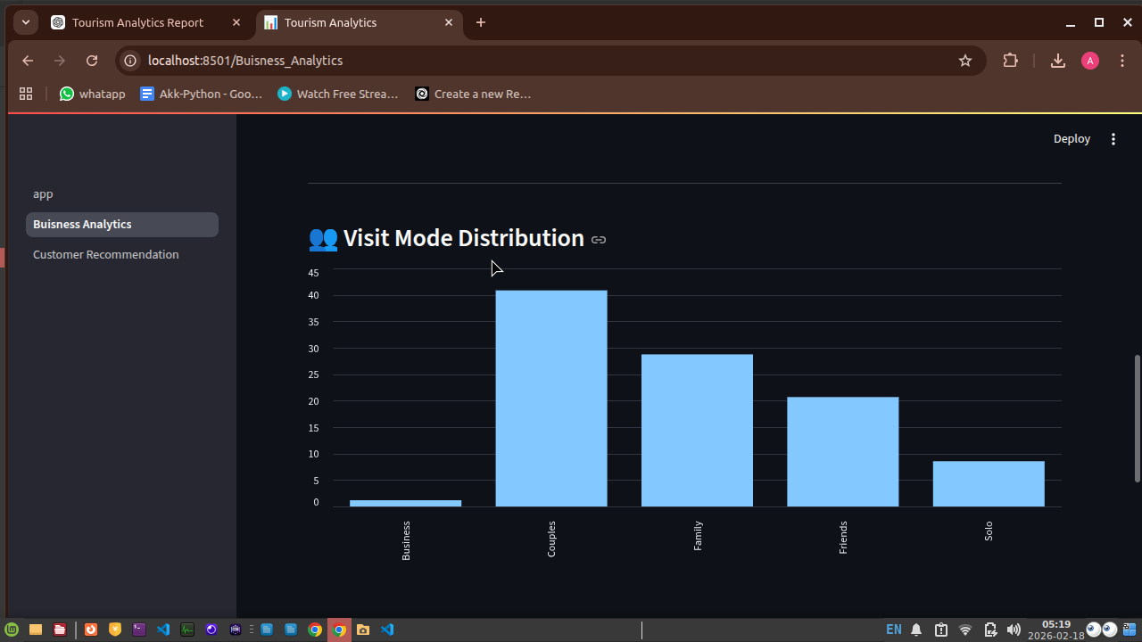

This Graph shows the Average Predicted Rating per Attraction Type and Depicts the Attraction with the Highest Rating
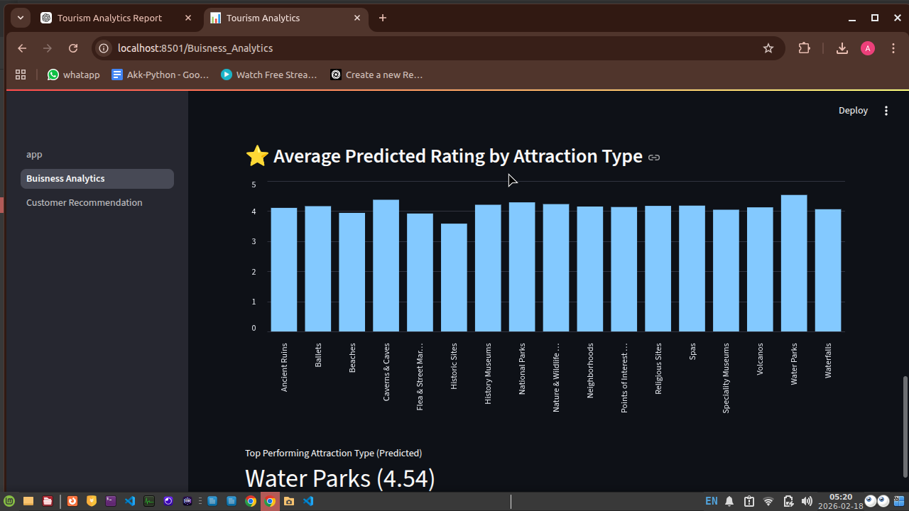

🔹 Page 2: Customer Recommendation
This page is focused on personalized prediction and recommendation for users.

🔸 User Input Section
Users can provide:
- 🌍 Select Country – Choose travel destination country
- 🎯 Select Attraction Type – Choose preferred attraction category
- 🧠 Trip Details – Provide expected rating and travel season
These inputs are used as features for the trained machine learning models.

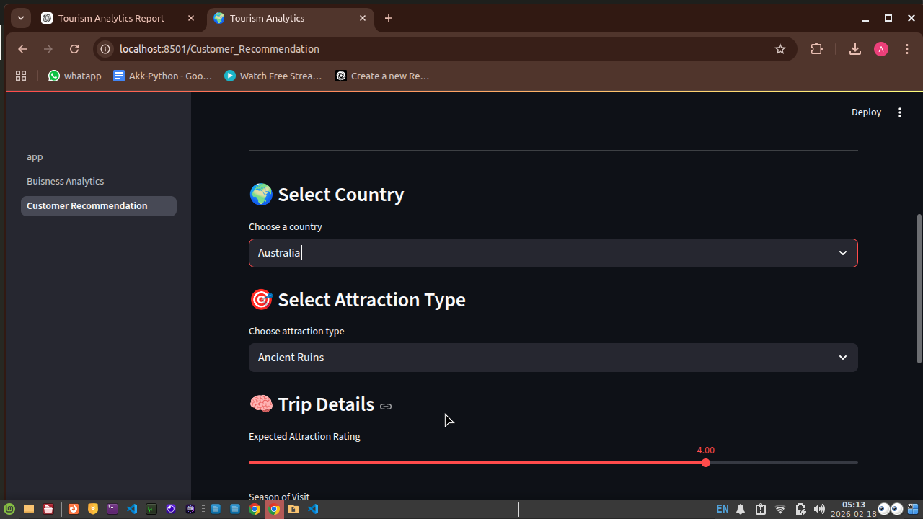

🔸 Predicted Visit Mode
After input submission, the classification model predicts the likely visit type.
Example from your app:
Predicted Visit Mode: Family
This helps tourism platforms understand the traveler’s purpose and tailor services accordingly.

🔸 Recommended Attractions
The recommendation system generates a ranked list of attractions.
Displayed information includes:
- Attraction Name
- Predicted Rating
- Similarity Score
- Final Recommendation Score
Example shown:
- Sewu Temple
- Predicted Rating: 4.1592
- Final Score: 2.9708
The system uses similarity calculations and predicted ratings to determine the most relevant attraction for the user.

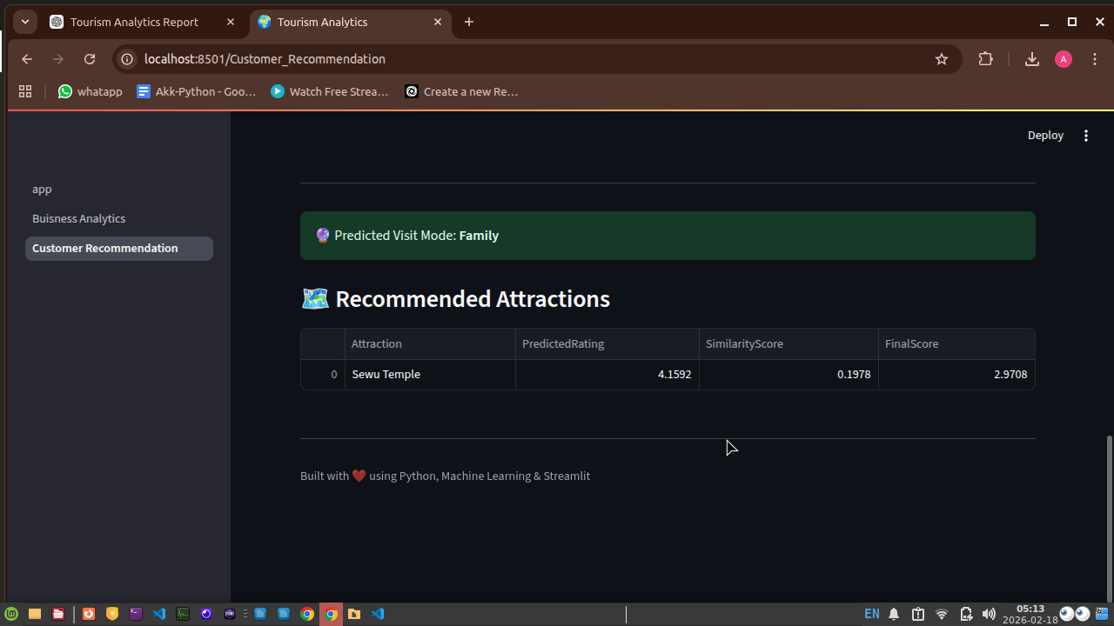

🔸 Recommendation Logic (Behind the Scenes)
- Uses a user-item matrix
- Applies cosine similarity to find similar users or attractions
- Combines similarity score with predicted rating
- Generates ranked recommendations

🔹 Technical Implementation
- Backend: Python
- Machine Learning: Regression + Classification + Recommendation algorithms
- Frontend: Streamlit
- Real-time predictions using trained models

🔹 Overall Impact
The Streamlit application demonstrates how raw tourism data can be transformed into:
- Intelligent predictions
- Personalized recommendations
- Actionable business insights
It provides a practical, user-friendly solution that enhances both traveler experience and tourism business strategy.

10. Results and Insights

🔹 User Distribution Across Regions
The platform’s user base is heavily concentrated in Asia and Australia & Oceania, making these regions the primary contributors to overall activity. Europe shows moderate participation, while the Americas have relatively fewer users. Africa has the lowest representation, indicating limited engagement and a potential opportunity for future expansion into under served markets.

🔹 Regional Travel Activity
Travel visits are strongly concentrated in Northern America, South East Asia, and Australia, suggesting these regions dominate tourism demand. Western Europe and South Asia show steady but secondary travel activity. Several regions, particularly in Africa, exhibit very low visit counts, highlighting uneven regional engagement and possible data sparsity.

🔹 Popular Attractions and Destinations
A small number of attractions account for a large share of total visits, indicating highly concentrated tourist interest. The Sacred Monkey Forest Sanctuary emerges as the most visited attraction by a significant margin. Many top-ranked attractions are located in Bali, reinforcing its position as a major tourism hotspot within the dataset.

🔹 Popular Attraction Types
Nature-oriented attractions such as water parks, spas, and caves receive the highest average ratings, reflecting strong visitor satisfaction. Cultural and historical sites—including museums, religious locations, and ancient ruins—also perform well but slightly below nature-based experiences. Historic sites and street markets tend to have comparatively lower ratings, suggesting areas where visitor experience could be improved.

🔹 Travel Behavior by Visit Mode
Leisure travel clearly dominates tourism activity. Visits by Couples and Families form the largest share across most regions, indicating a strong focus on vacation-oriented travel. Friends’ trips also contribute significantly, while Solo and Business travel remain relatively limited. This pattern suggests that tourism offerings should prioritize group and family-friendly experiences.

🔹 Seasonal Travel Trends
Travel demand peaks during Spring and Fall, particularly for couples and family trips. Seasonal factors appear to influence travel behavior more strongly than travel purpose. Mid-year and early fall months show especially high activity levels, while business travel remains low and stable throughout the year.

🔹 Customer Segments
Distinct traveler segments emerge from the data:
- Couples and Families — dominant segment with high travel frequency
- Friends groups — strong participation during vacation periods
- Solo travelers — smaller but consistent segment
- Business travelers — minimal representation
Understanding these segments enables tourism providers to design targeted packages and marketing strategies.

🔹 Rating Patterns and Customer Satisfaction
Ratings are strongly skewed toward the higher end of the scale, with most values between 3.5 and 5.0. Low ratings are rare, indicating generally positive travel experiences. The highest concentration occurs around the 4.0–4.5 range, suggesting good overall satisfaction without extreme ratings.

🔹 Regional Rating Differences
Average ratings are relatively consistent across regions, typically ranging from approximately 3.9 to 4.6. Some regions, such as Central Asia and areas labeled “Unknown,” show slightly higher averages, while certain African regions exhibit marginally lower scores. This suggests broadly uniform service quality with minor regional variations.

11. Business Use Cases

🔹 Personalized Marketing
The system enables targeted marketing by understanding user preferences, travel behavior, and attraction interests. Tourism companies can recommend destinations, packages, and activities tailored to specific customer segments such as families, couples, or friends, increasing conversion rates and customer satisfaction.

🔹 Resource Planning
Insights into seasonal trends and regional demand help businesses allocate resources efficiently. Hotels, transport services, and attractions can prepare for peak seasons (Spring and Fall) by optimizing staffing, inventory, and pricing strategies, while avoiding under utilization during low-demand periods.

🔹 Customer Retention
By recommending relevant attractions and predicting satisfaction levels, the platform enhances the overall travel experience. Personalized recommendations encourage repeat usage, build customer loyalty, and reduce churn by consistently delivering value to users.

🔹 Tourism Strategy and Market Expansion
Regional insights reveal under served markets, particularly in Africa and low-engagement regions. Tourism boards and businesses can use this information to design promotional campaigns, develop infrastructure, and attract visitors to emerging destinations, supporting long-term growth.

12. Conclusion
This project developed an end-to-end tourism analytics system capable of predicting attraction ratings, identifying visit modes, and generating personalized attraction recommendations. Through comprehensive exploratory data analysis, meaningful travel patterns, customer segments, and seasonal trends were identified.
Machine learning models demonstrated strong effectiveness in both regression and classification tasks, enabling accurate predictions of user satisfaction and travel behavior. The recommendation system further enhanced the platform by suggesting attractions aligned with user preferences.
Overall, the system provides significant value for tourism businesses by supporting data-driven decision-making, improving customer experience, and enabling targeted marketing strategies. It demonstrates how analytics and machine learning can transform raw travel data into actionable insights.

13. Future Work
Several enhancements can further improve the system’s capabilities:
- Real-Time Recommendation Engine: Incorporating live user interactions and current trends for dynamic recommendations
- Integration with Booking Platforms: Connecting with hotel, flight, and activity booking systems for end-to-end travel planning
- Advanced Deep Learning Models: Using neural networks to capture complex patterns in user behavior
- Larger and More Diverse Datasets: Improving model accuracy and generalizability across regions
- Mobile Application Version: Providing on-the-go recommendations and personalized travel assistance
- User Feedback Loop: Continuously refining recommendations based on user ratings and interactions
These improvements would transform the prototype into a scalable, production-ready tourism intelligence platform.

14. References

🔹 Libraries and Tools Used
- Python
- Pandas
- NumPy
- Scikit-learn
- Matplotlib
- Seaborn
- Streamlit
- XGBoost (if used)

🔹 Dataset Source
- Tourism / Travel Review Dataset (provided dataset used for analysis)

🔹 Documentation and Learning Resources
- Scikit-learn Official Documentation
- Pandas Documentation
- Streamlit Documentation
- Machine Learning tutorials and academic resources

