1.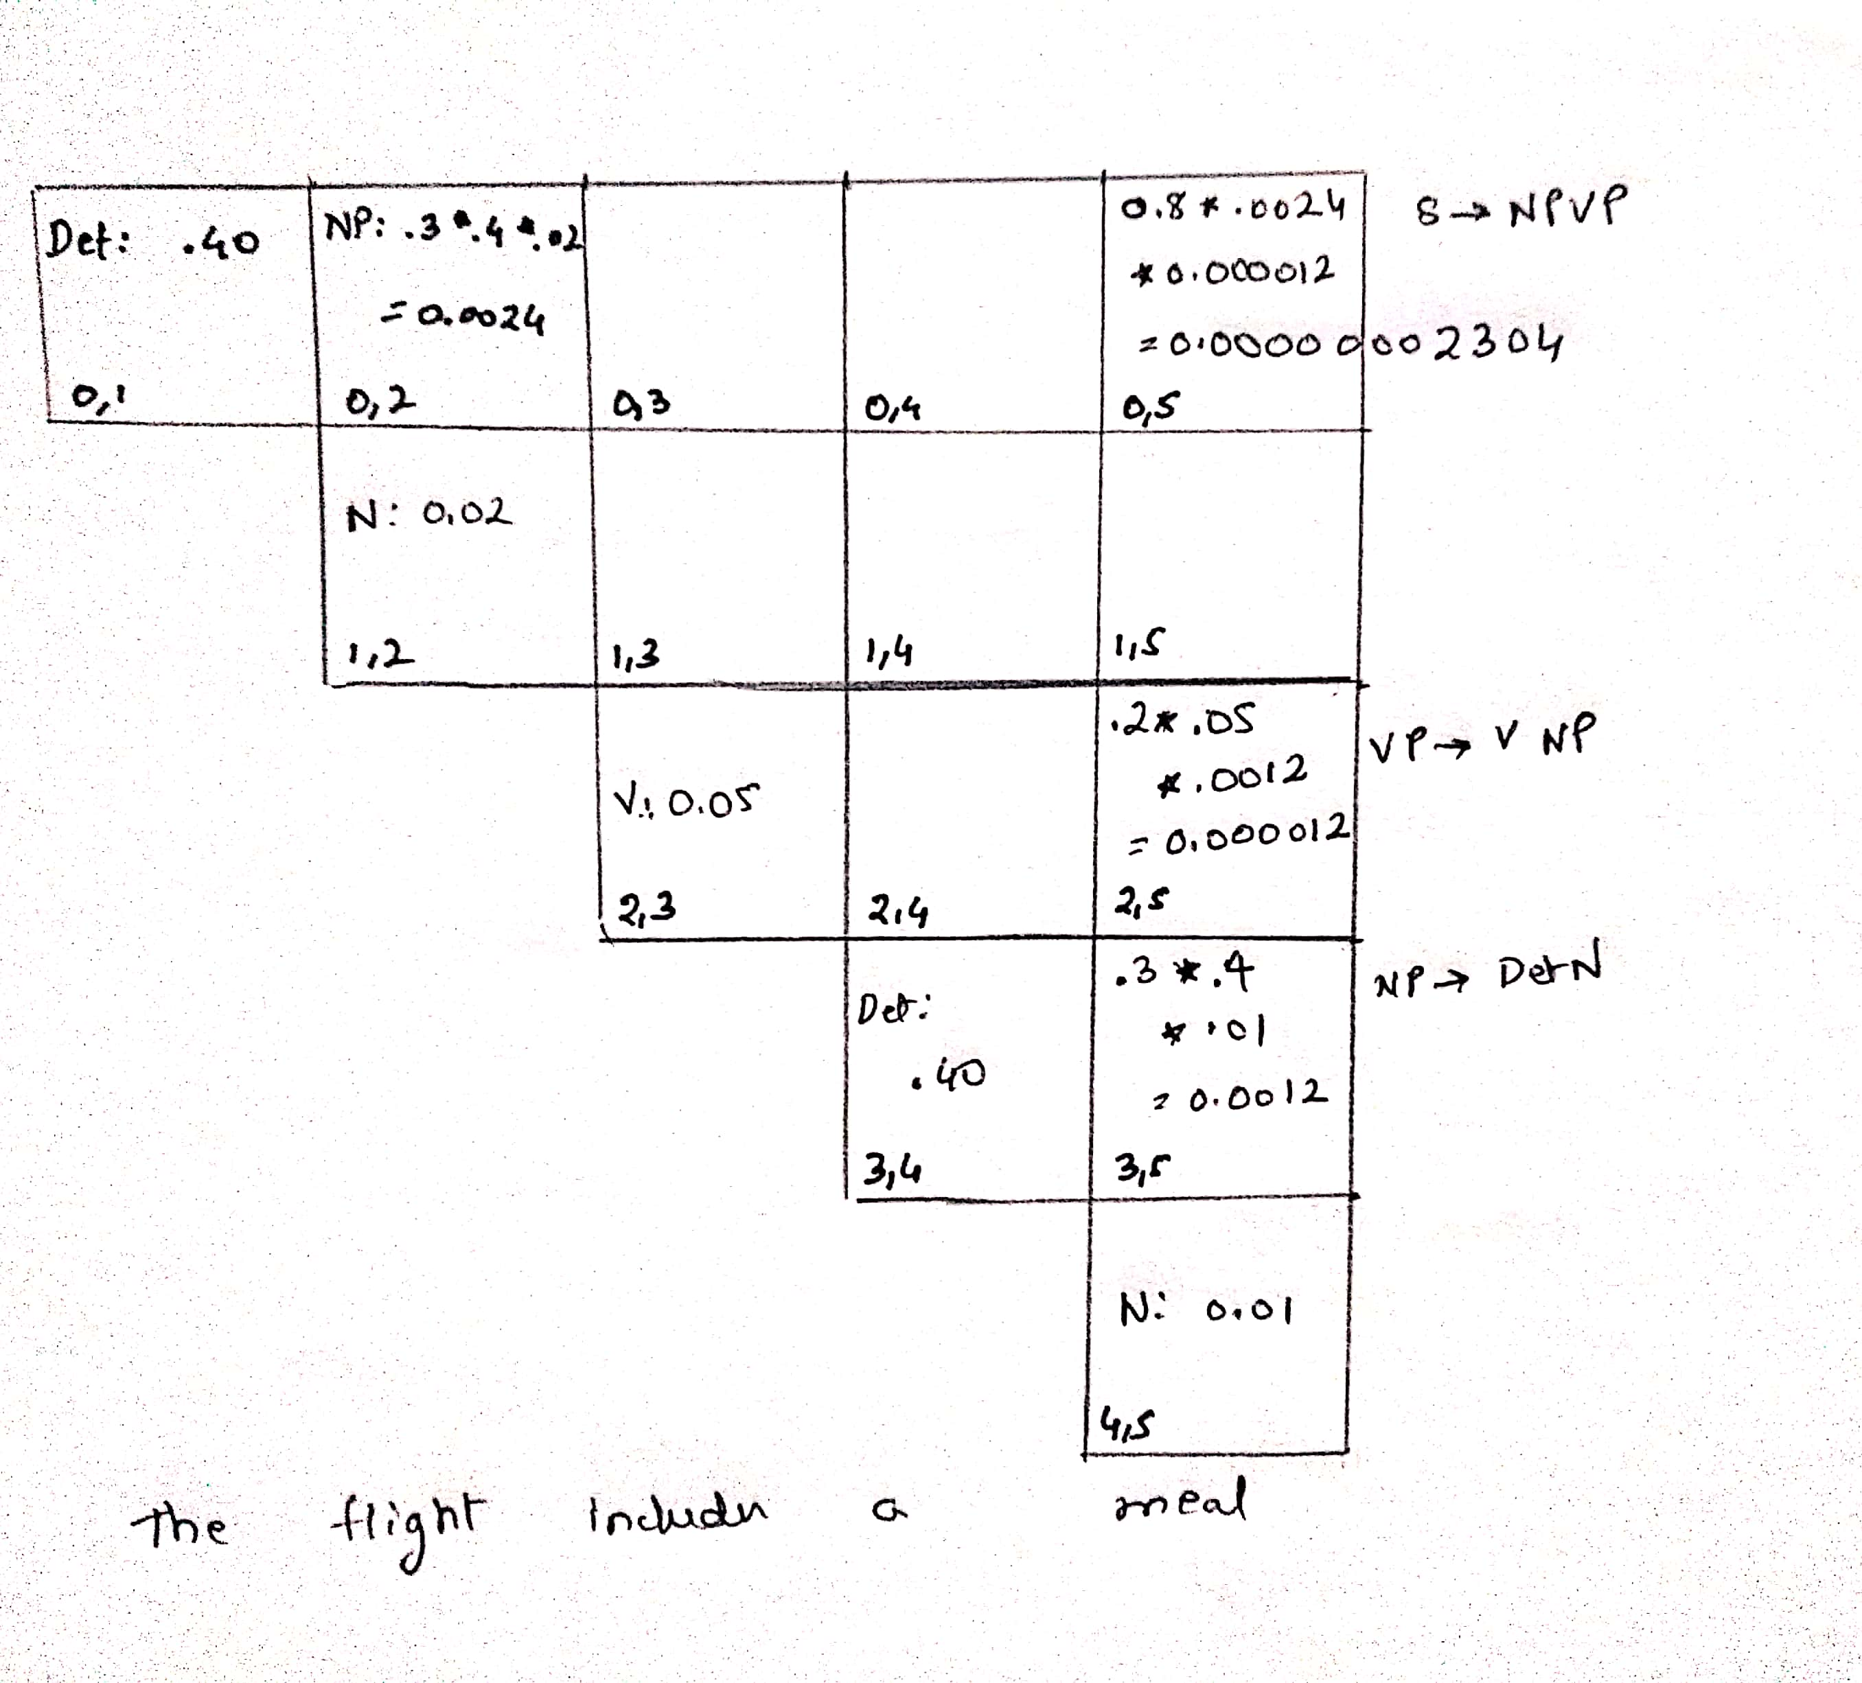

2.

1. The intense heat buckled the highway about three feet.

The intense heat – **Force**

the highway – **Theme**

about three feet - **Result**

1. He melted her reserve with a husky-voiced paean to her eyes.

He – **Agent**

Her Reserve- **Theme**

with a husky-voiced paean to her eyes – **instrument**

1. But Mingo, a major Union Pacific shipping center in the 1890s, has melted away to little more than the grain elevator now.

Mingo, a major Union Pacific shipping center in the 1890s – **Experiencer**

To little more than the grain elevator - **Result**