**SDC087 – MERN Stack Powered by Mongo DB**

**Naan Mudhalvan Scheme**

**Date:** 15 - 11 - 2024 **Team Members:**

Achyut Prasad D C (2021503002)

Ragul N (2021503542)

Dhanush E (2021503708)

Logith V L (2021503710)

**Title:** ShopEZ: E-Commerce Application

**Objectives:**

* To create an online platform for users to browse, search, and filter products based on categories, price range, and user preferences.
* To Provide a user-friendly checkout process, allowing customers to add products to the cart, apply discounts, and make payments securely.
* To allow vendors to manage their product listings, view sales analytics, update inventory, and handle customer inquiries.
* To enable notifications for order updates, special offers, and customer queries to enhance communication between buyers and sellers.
* To utilize MongoDB to store product details, user profiles, orders, and payment information, ensuring data persistence and quick retrieval.
* To implement secure user authentication and authorization for customers, vendors, and administrators to protect sensitive data.
* To design a responsive user interface with React.js to ensure a seamless shopping experience across all devices.

**Project Description:**

* **Platform Overview:** ShopEZ is a robust eCommerce web application built using the MERN stack (MongoDB, Express.js, React.js, Node.js) designed to streamline online shopping for customers and vendors.
* **Product Listings:** Vendors can create and manage product listings with detailed descriptions, high-quality images, pricing, and stock availability, making it easy for customers to explore and purchase products.
* **Shopping Cart and Checkout:** Customers can add products to the cart, apply discount codes, choose delivery options, and securely complete purchases using integrated payment gateways.
* **User Roles and Permissions:** ShopEZ offers distinct roles for customers, vendors, and administrators, each with specific features and permissions for a secure and tailored experience.
* **Vendor Dashboard:** Vendors have a dedicated dashboard to manage product inventory, view order details, track sales trends, and respond to customer inquiries.
* **Customer Interaction:** Customers can leave reviews, communicate with vendors, track order statuses, and receive updates on their orders, enhancing their shopping experience.
* **Admin Management:** Administrators oversee platform operations, manage user accounts, approve vendor registrations, and monitor product listings to ensure compliance with platform policies.
* **Real-Time Analytics:** ShopEZ provides insightful analytics for vendors and administrators, including sales reports, customer behavior trends, and product performance.

**ER Diagram:**

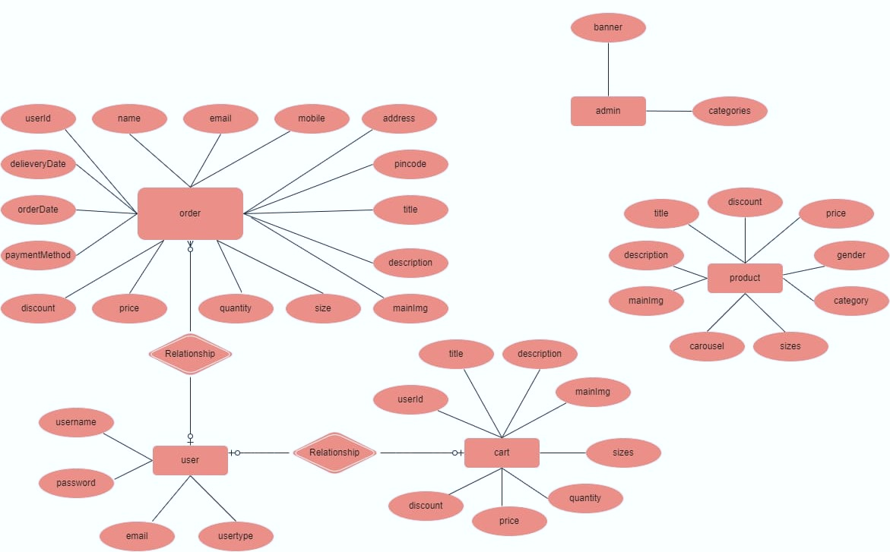

**Stack Overview:**

**Frontend (Client-Side) Technologies:**

* **React.js:**
* Serves as the core framework for building a responsive, dynamic, and interactive user interface.
* Utilizes a single-page application (SPA) design, allowing seamless navigation without page reloads.
* Provides modular, reusable components for various features such as property listings, application forms, and user dashboards.
* **Redux:**
* Manages complex application state, useful for handling user authentication and maintaining consistent data across components.
* Helps streamline state management, particularly in a multi-user application like Rentify where different roles (tenants, owners) have unique data needs.
* **CSS Frameworks:**
* Used to style the UI and ensure a responsive, mobile-friendly experience.
* Enhances the design for visual appeal and usability across various screen sizes and devices.
* Frontend Routing (React Router):
* Manages navigation within the application, creating a smooth user experience without page reloads.
* Allows users to move between pages like property listings, user profile, and application status with ease.

**Backend (Server-Side) Technologies:**

* **Node.js:**
* Provides a runtime environment for server-side logic, ensuring high performance and scalability.
* Allows real-time communication for dynamic features, such as application status updates and notifications.
* **Express.js:**
* Acts as the backend framework, structuring the server-side code and managing API endpoints.
* Handles RESTful API requests for CRUD (Create, Read, Update, Delete) operations on user data, properties, and applications.
* Facilitates efficient data exchange between the frontend (React) and the MongoDB database.
* **MongoDB:**
* Functions as the primary database, storing data on properties, users, and applications.
* Offers a flexible schema-less structure, ideal for scaling the application as user and property data grows.
* Provides a secure, persistent data store for rental application details and property listings.
* **Mongoose:**
* An ODM (Object Data Modeling) library used with MongoDB to add schema and validation to the database.
* Simplifies database interactions by providing structured models for properties, users, and applications.
* **JSON Web Tokens (JWT):**
* Manages user authentication and authorization, ensuring secure access to user-specific features and protecting sensitive data.
* Helps create a secure, session less authentication system for users, allowing login and secure access to restricted content.

**Features:**

* User registration and authentication (sign up, login, logout) for customers, vendors, and administrators.
* Browse and search products with advanced filter options (e.g., category, price, brand).
* Add products to a shopping cart or save them in a Wishlist for future purchases.
* Place orders and track their status in real-time (e.g., pending, shipped, delivered).
* Vendors can add, edit, delete product listings, manage inventory, and view sales data.
* Customers can leave reviews and ratings for purchased products.
* Administrators can manage user accounts, approve vendor registrations, and monitor platform policies.
* Interactive and responsive interface for seamless navigation across devices.

**Conclusion:**

ShopEZ leverages the MERN stack to streamline eCommerce operations, providing a unified platform for customers, vendors, and administrators. With a responsive React.js frontend, a scalable Node.js and Express.js backend, and secure MongoDB data storage, it ensures a seamless and efficient shopping experience. By simplifying the shopping process and offering comprehensive management tools, Shop Easy stands as a robust solution for modern online retail with potential for future enhancements.

**References:**

GitHub Link: <https://github.com/achyutdc/ShopEZ-E-Commerce-Application-using-MERN-Stack--NM-Project>

Video Link: included within Github Repo.