Midterm Project
Global Terrorism Dataset.
-achyutganti

The main aim of this project was to visualize those various variables in the Global terrorism dataset onto the US map. I was given four dataset – GTD dataset, Population dataset, County_city dataset and Poverty dataset.

GTD dataset – It gives the information of various attacks, venue of those attacks, groups that controlled those attacks, weapons used, number of people killed etc.

Population Dataset – This dataset has information about the city, state, population in those cities in particular years (2013,2014, 2015,2016).

County_City dataset - gives you information about cities , counties and states respectively.

Poverty Dataset – This dataset gives me the poverty percentages in those areas and the median income for the year 2015.

The first challenge was to merge those four datasets together so that we can use the poverty and population information along with the GTD information to make informative visualizations.

The way I tackled was as follows :

My main aim was to merge the remaining three datasets with the GTD dataset. I did not want to mess with the GTD dataset’s observations nor its variables.

So Here is what I did.

Dealing with the Population dataset

I tired to merge the population dataset with the GTD dataset. For that I needed unique keys that would identify each observations uniquely. So my keys were Year, State and City. But to do that I had to do a bit of cleaning in the Population dataset. The problems I faced were

- I had to gather the column names of the population dataset (POPESTIMATE2014,POPESTIMATE2015,POPESTIMATE2016) into a column named year and the respective values into another columns and name them as cases.
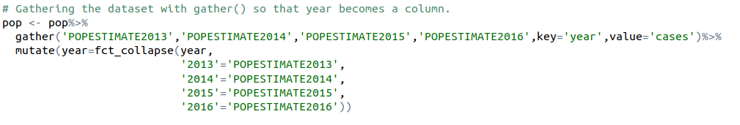

Now the dataset looks pretty much like this

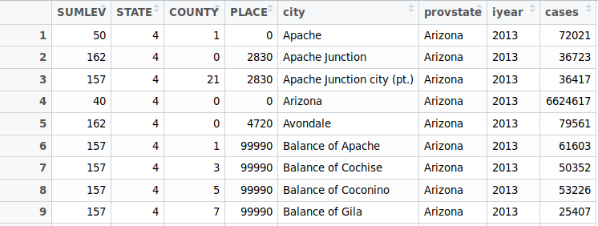

- The population dataset had all the states in it while the GTD dataset had only 35 or 36. So, I filtered out the required states from the population dataset so that I would not have to deal with the big dataset.
- The next problem was at the time of merging. The city names in the population dataset and the GTD dataset differ. For example: Population dataset had Abbeville city in it while the GTD dataset had he same city listed as Abbeville. So had to remove the ‘city’ words in the end. Not only that, there are some other ctites where this problem existed. Those are the cities that had County, Town, Village, Township, Borough in the end of their names.
- But that was not it. Removing ‘city’ from the city name in the end would work for all the cities expect for one. New York City. So, this had to be taken care of first. So, I have changed all the New York city names to New York City. After doing that change the column names so that they are same in both the datasets and then merge them .
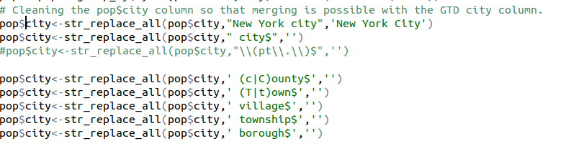
- Finally after merging the two datasets I found that there are some cities like ‘Ingelwood’ that were misspelled in the datasets. So, had to change the names individually so that they don’t clash and give me NA values.

Merging the County_city dataset.

County city dataset had abbreviated state names but the GTD dataset had full state names. So the first task was to add a column to the GTD dataset that contained abbreviated state names.

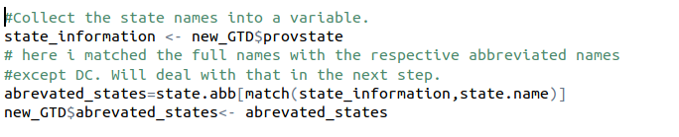
But the list did not have DC in it and when I added that column to the GTD dataset I had NA values in place of all the DC entries. But it was not a huge task. I just manually added DC to the list in the next step.
Some city names in the county_city dataset misspelled and I had to deal with them. You can find that information in the snippet given below.

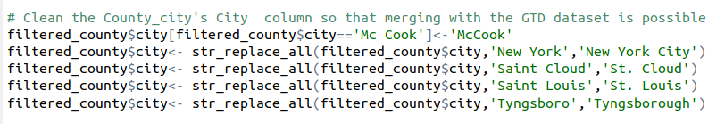
Variables used as Keys for merging:
Finally the GTD dataset and the County_city dataset were joined by abbreviated state column and the City column.

I still had a problem. Some of the Cities had were absent in the County_city dataset and I had no County information merged into the GTD dataset. Those were.

Overland Park – KS
Blooming Groove – PA
Corinth – TX
Colerain – PA
Lake Los Angeles – CA

Luckily these were only a few in number. So a simple Google search gave me the required county information and a small piece of R code completed my merging.

Dealing with the Poverty dataset

As always I filtered out the states that I wanted and simplified the dataset. Just like the population dataset, the poverty dataset too had county names with County, Parish etc in the end. I had to deal with them because Poverty dataset had to be merged with the now GTD dataset (that had population and county_city merged with it) with County and State as keys.
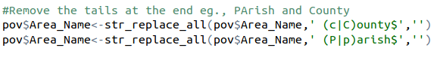

Apart from that the two datasets had some county names different. They had some upper case and lower case problems. So I had to deal with them individually. Those were as follows.

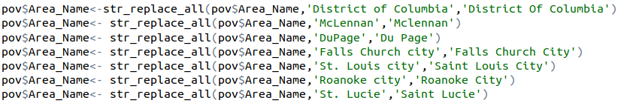
After that merging the two datasets was possible. And the final dataset was almost a success.

The next task was to create a column called Date which had dates in yyyy-mm-dd format.
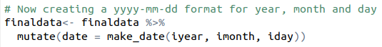
The above code allowed me to create a new variable called date which had year,month,date in the yyyy-mm-dd format.

Finally I have recoded the missing values as -99.
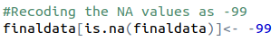

Univariate summaries

For attack types1_txt, I have made a tabular representation of the different categories in the variable and the count with which they occurred.

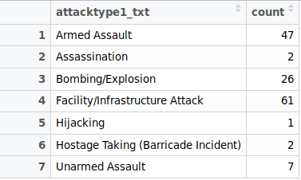

Summary for Population (cases)
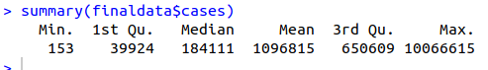

From this, we can see that the Min of the data is 153, the maximum value is 10066615. We can also see the median and the mode of the data as well.

Summary for the weaptype_txt variable

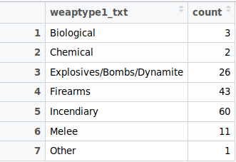

Golden words to the reader:

The project was fun to do and I’ve made a lot of mistakes and learned a lot along the way. Few things that I felt mentioning are:
- Always save your progress. I had to write the same code thrice because I did not save my work.
- As the elders say, always write good comments. My work would have been twice as difficult if I did not write comments that were not meaningful.
- Assign variable names that makes sense. Or else, you’ll have hard time figuring out what is what.
- This is what I found most useful. ** Always create a copy of your original dataset whenever you feel like exploring it more. Or, when you want to change some variables, assign the resultant dataset to a new variable. ** If you know what you are doing, then fine. If not this is my advice.

HAPPY CODING.!!!..

