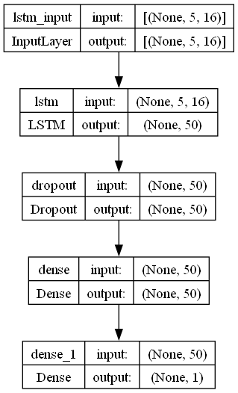

1. **Input Layer (InputLayer)**:
   * Input Shape: **[None, 5, 16]**
   * The input layer accepts data with a shape that is not fixed in the first dimension (allowing for variable batch sizes), and expects sequences of length 5 with 16 features each.
2. **LSTM Layer (lstm)**:
   * Input Shape: **[None, 5, 16]**
   * Output Shape: **[None, 50]**
   * This LSTM layer processes the sequential input and outputs a transformed sequence with a length of 50 features. LSTM units are designed to remember long-term dependencies and are particularly useful in avoiding the vanishing gradient problem common in traditional RNNs.
3. **Dropout Layer (dropout)**:
   * Input Shape: **[None, 50]**
   * Output Shape: **[None, 50]**
   * Dropout is a regularization technique used to prevent overfitting. It randomly sets a fraction of the input units to 0 at each update during training time, which helps prevent complex co-adaptations on training data.
4. **Dense Layer (dense)**:
   * Input Shape: **[None, 50]**
   * Output Shape: **[None, 50]**
   * A dense layer is a fully connected layer that applies a linear operation (**output = activation(dot(input, kernel) + bias)**) on the input and then follows it with an activation function. This layer outputs 50 features, and it’s likely that an activation function is applied (though not explicitly mentioned).
5. **Dense Layer (dense_1)**:
   * Input Shape: **[None, 50]**
   * Output Shape: **[None, 1]**
   * This is another fully connected layer that likely serves as the output layer. It reduces the 50 features from the previous layer down to a single output feature. This configuration suggests that the model might be used for regression tasks (predicting a continuous value) or binary classification (predicting one of two classes).

The arrows indicate the flow of data from one layer to the next, and the **input** and **output** labels indicate the shapes of the data as it moves through the network. The shapes are defined as **[batch_size, sequence_length, number_of_features]** for the input and **[batch_size, number_of_features]** for the output at each layer. The **None** in the shape represents a variable size that can be dynamically changed, allowing the network to process batches of different sizes