

***Dissertation on***

**Twitter Sentiment Analysis for Bitcoin Price Prediction**

*Submitted in partial fulfilment of the requirements for the award of degree of*

**Bachelor of Technology**

**in**

**Computer Science & Engineering**

**UE19CS390A – Capstone Project Phase - 1**

***Submitted by:***

|  |  |
| --- | --- |
| **Achyut Jagini**  **Kaushal Mahajan**  **Namita Aluvithangal**  **Vedanth Mohan** | **PES2UG19CS013**  **PES2UG19CS178**  **PES2UG19CS245**  **PES2UG19CS449** |

*Under the guidance of*

|  |
| --- |
| **Prof. Prajwala**  Assistant Professor  PES University |

**January - May 2022**

**DEPARTMENT OF COMPUTER SCIENCE AND ENGINEERING**

FACULTY OF ENGINEERING

**PES UNIVERSITY**

(Established under Karnataka Act No. 16 of 2013)

Electronic City, Hosur Road, Bengaluru – 560 100, Karnataka, India



**PES UNIVERSITY**

(Established under Karnataka Act No. 16 of 2013)

Electronic City, Hosur Road, Bengaluru – 560 100, Karnataka, India

**FACULTY OF ENGINEERING**

**CERTIFICATE**

*This is to certify that the dissertation entitled*

**Twitter Sentiment Analysis for Bitcoin Price Prediction**

*is a bonafide work carried out by*

|  |  |
| --- | --- |
| **Achyut Jagini**  **Kaushal Mahajan**  **Namita Aluvithangal**  **Vedanth Mohan** | **PES2UG19CS013**  **PES2UG19CS178**  **PES2UG19CS245**  **PES2UG19CS449** |

In partial fulfilment for the completion of sixth semester Capstone Project Phase - 1 (UE19CS390A) in the Program of Study -Bachelor of Technology in Computer Science and Engineering under rules and regulations of PES University, Bengaluru during the period Jan. 2022 – May. 2022. It is certified that all corrections / suggestions indicated for internal assessment have been incorporated in the report. The dissertation has been approved as it satisfies the 6th semester academic requirements in respect of project work.

|  |  |  |
| --- | --- | --- |
| Signature  Prajwala TR  Assistant Professor | Signature  Dr. Sandesh B J  Chairperson | Signature  Dr. B K Keshavan  Dean of Faculty |

**External Viva**

|  |  |
| --- | --- |
| **Name of the Examiners**  **1.** __________________________  **2. ___**_______________________  **_______________________** | **Signature with Date**  __________________________  **__________________________** |

**DECLARATION**

We hereby declare that the Capstone Project Phase - 1 entitled **“Twitter Sentiment Analysis for Bitcoin Price Prediction”** has been carried out by us under the guidance of Prof. Prajwala, Assistant Professor and submitted in partial fulfilment of the course requirements for the award of degree of **Bachelor of Technology** in **Computer Science and Engineering** of **PES University, Bengaluru** during the academic semester January – May 2022. The matter embodied in this report has not been submitted to any other university or institution for the award of any degree.

|  |  |  |
| --- | --- | --- |
| **PES2UG19CS013**  **PES2UG19CS178**  **PES2UG19CS245**  **PES2UG19CS449** | **Achyut Jagini**  **Kaushal Mahajan**  **Namita Aluvathingal**  **Vedanth Mohan** | **Achyut Jagini**  **Kaushal Mahajan**  **Namita Aluvathingal**  **Vedanth Mohan** |
|  |  |  |
|  |  |  |
|  |  |  |

**ACKNOWLEDGEMENT**

I would like to express my gratitude to Prof. Prajwala, Department of Computer Science and Engineering, PES University, for her continuous guidance, assistance, and encouragement throughout the development of this UE19CS390A - Capstone Project Phase – 1.

I am grateful to the Capstone Project Coordinators, Dr.Sarasvathi V, Associate Professor and Dr. Sudeepa Roy Dey, Assistant Professor, for organizing, managing, and helping with the entire process.

I take this opportunity to thank Dr. Sandesh B J, Chairperson, Professor, Department of Computer Science and Engineering, PES University, for all the knowledge and support I have received from the department. I would like to thank Dr. B.K. Keshavan, Dean of Faculty, PES University for his help.

I am deeply grateful to Dr. M. R. Doreswamy, Chancellor, PES University, Prof. Jawahar Doreswamy, Pro Chancellor – PES University, Dr. Suryaprasad J, Vice-Chancellor, PES University for providing to me various opportunities and enlightenment every step of the way. Finally, this Capstone Project could not have been completed without the continual support and encouragement I have received from my family and friends.

**ABSTRACT**

Sentiment analysis is a research area of Natural Language Processing. It is used to determine whether a body of text is positive, negative, or neutral. Twitter tweets are technically more challenging to analyse when compared to other forms of text, due to the presence of irregular grammar, emoticons and sarcasm. In this project we aim to analyse various factors that might affect the stock price of Bitcoin, one such factor being tweets related to the popular cryptocurrency, ascertain their sentiment and try to predict the way in which the price will fluctuate.

**TABLE OF CONTENTS**

|  |  |  |
| --- | --- | --- |
| **Chapter No.** | **Title** | **Page**  **No.** |
| **1.** | **INTRODUCTION** | **01** |
| **2.** | **PROBLEM DEFINITION** | **03** |
| **3.** | **LITERATURE SURVEY** | **04** |
|  | 3.1 Forecasting Bitcoin Price Fluctuation by Twitter Sentiment Analysis | 04 |
|  | 3.2 Recurrent Neural Network Based Bitcoin Price Prediction by Twitter dddddSentiment Analysis | 06 |
|  | 3.3 Twitter Sentiment Analysis for Bitcoin Price Prediction | 08 |
|  | 3.4 Cryptocurrency Price Prediction using Sentiment Analysis | 11 |
|  | 3.5 Tweet Sentiment Analysis for Cryptocurrencies | 13 |
|  | 3.6 Summary | 14 |
| **4.** | **PROJECT REQUIREMENTS SPECIFICATION**  4.1 Project Scope  4.2 Product Perspective  4.2.1 Product Features  4.2.2 User Classes and Characteristics  4.2.3 Operating Environment System  4.2.4 General Constraints, Assumptions and Dependencies  4.2.5 Risks  4.3 Functional Requirements  4.4 External Interface Requirements  4.4.1 User Interfaces  4.4.2 Hardware Requirements  4.4.3 Software Requirements | **16**  16  16  16  16  17  17  17  17  18  18  18  18 |
| **5.** | **DATA** | **19** |
| **6.** | **SYSTEM REQUIREMENTS SPECIFICATION**  6.1 Hardware Requirements  6.2 Software Requirements  6.3 Functional Requirements  6.4 Non functional requirements  6.5 Advantages of system | **21**  21  21  21  21  22 |
| **7.** | **SYSTEM DESIGN**  7.1 Data Collection  7.2 Data Preprocessing  7.3 Sentiment Analysis  7.4 Prediction Model  7.5 Comparison and Accuracy  7.6 Architecture Diagram  7.7 Use case diagram  7.8 Activity Diagram | **23**  23  23  23  23  24  24  25  26 |
| **8.** | **CONCLUSION OF CAPSTONE PROJECT PHASE – 1** | **27** |
| **9.** | **PLAN OF WORK FOR CAPSTONE PROJECT PHASE - 2** | **28** |

|  |  |
| --- | --- |
| **REFERENCES/BIBLIOGRAPHY** | **29** |
| **APPENDIX A DEFINITIONS, ACRONYMS AND ABBREVIATIONS** | **31** |

**LIST OF TABLES**

|  |  |  |
| --- | --- | --- |
| **Table No** | **Title** | **Page No** |
| **1** | **Literature Survey** | **14** |
| **2** | **Dataset variables** | **19** |

**LIST OF FIGURES**

|  |  |  |
| --- | --- | --- |
| **Figure No** | **Title** | **Page No** |
| 1 | **Architecture Diagram** | 24 |
| 2 | **Use Case Diagram** | 25 |
| 3 | **Activity Diagram** | 26 |
| 4 | **Project timeline phase-2** | 28 |

CHAPTER 1

**INTRODUCTION**

* Twitter is a social network site on which users interact through tweets and replies.
* Bitcoin is an electronic currency system developed by Satoshi Nakamoto.
* Bitcoin has a decentralized existence and is not regulated by any government. The Bitcoin price constantly fluctuates in real time.
* Common out-of-box sentiment analysis is challenged to produce good results on tweets.
* Fluctuations regarding crypto prices are mostly addressed on social media and are talked about by influencers and commoners alike.
* Various influencers predict the fluctuations for numerous crypto currencies.
* A person wishing to sell or buy bitcoin searches for ‘bitcoin’ in Twitter search bar and look for tweets in favour of or against bitcoin which may assist in predicting the price in the future.
* We perform sentiment Analysis of Bitcoin tweets to predict the Bitcoin price fluctuations.
* Bitcoin is a type of electronic currency with no administering authority and is controlled by the common public. Therefore it is unpredictable and its cost is impacted by socially developed opinions.

**1.1 Purpose of the project**

This project aims to develop a model that can predict the price of bitcoin at a reasonable level of accuracy using the sentiment of bitcoin related tweets and the historical bitcoin price data.

**1.2 Scope**

* This is beneficial to those interested in investing as it gives them an idea of how their crypto will do. Opinions are gathered from a social media site -Twitter- because it has established itself as one of the largest sites in the micro-blogging sphere and along with this also supports data collection.
* We chose to restrict our model to only bitcoin currently as it is the most established in both market share and age.

CHAPTER 2

**PROBLEM DEFINITION**

Bitcoin is a [cryptocurrency](https://www.investopedia.com/terms/c/cryptocurrency.asp), not the control of any specific person, organisation, or entity, and thus removes the need for any external involvement during transactions. It is rewarded to blockchain miners for the work done to verify transactions and can be purchased on several exchanges.

Bitcoin tweets have an effect on the price of bitcoin.

Our project aims to accurately find the fluctuation in the bitcoin price using the sentiment of tweets and the historical bitcoin price data. This will help to serve the needs of investors.

Our project is done by:

1)Collecting bitcoin related tweets and bitcoin historical price data for a certain time period.

2)Creating a model that can accurately find the fluctuation in the price of bitcoin with a reasonable degree of precision using the sentiment of bitcoin related tweets and using the historical bitcoin price data.

3)Finding accuracy of prediction.

CHAPTER 3

**LITERATURE SURVEY**

# 3.1 “Forecasting Bitcoin Price Fluctuation by Twitter Sentiment Analysis”

**Otabek Sattarov**

# Collected tweets from Twitter, Reddit, and Bitcointalk.org for a period of 60 days starting from 12th March - 12th May 2018.

Sentiment analysis was performed, using VADER. Before utilizing the typical results of sentiment analysis to figure out the heading of cost of Bitcoin, the connection between Tweet sentiment and price was determined. Random Forest was used with various features as inputs and outputs were analysed.

The error was measured by the difference (γ) (between each models prediction result(α) with the closing Bitcoin cost(β) and taking an absolute value: γ **= |**α-β|

Module’s average accuracy was 62.48%.

Module’s average accuracy error was 37.52 with the extremes being 43.83% and 21.84%.

**Advantages**

A new model is used and findings of previous research and papers was used to decide on the models and approach.

**Limitations**

In the prediction stage, the model had lost beyond 10000 datapoints which could have provided better performance.

A sentiment lexicon developed specifically for Bitcoin would improve the correlation of the results of sentiment analysis on tweets and the Bitcoin’s variation in price, along with other variables such as hashtags, users, tweet volume, and emojis.

**Result**

It is seen that there is a strong correlation of the Bitcoin price shift and Twitter sentiment.

## 

# 3.2 “Recurrent Neural Network Based Bitcoin Price Prediction by Twitter Sentiment Analysis”

**R Pant**

The opinions on Twitter in regards to Bitcoin have an immediate or indirect influence on the general change in costs of Bitcoin. Research is concerned about forecasting the fluctuating cost of Bitcoin by investigating the opinion on Twitter to track down the connection between them.

* Tweets regarding Bitcoin are collected from various sources are categorised as positive or negative.
* The acquired level of positive and negative tweets is fed to an RNN model alongside historical prices to foresee the new cost for the next time frame.
* New methodology of consolidating the sentiment scores along with historical cost to anticipate cost is applied.

1. Dataset: The gathered tweets are named physically as 'p' - positive, 'n' - negative and 'I' - unbiased or neutral. Absolute of 2585 ‘p’, 1669 ‘n’ and 3200 ‘I’ tweets are categorised manually.
2. Repeating and Irrelevant tweets were removed.
3. Regex and Weighted Search

For text categorization the two models used were Word2Vector and Bag-of-Words are utilized.

**Sentiment Analysis**

The elements extracted from the two techniques for the 4,254 physically named tweets are then processed with five distinct models: Multinomial Naïve Bayes, Naïve Bayes, Linear Support Vector Classifier, Bernoulli Naïve Bayes and Random Forest.

A classifier, which takes output from each of the five models as it’s input and then categorises the new tweet to the class with maximum vote, is made.

Correlation of Sentiment with Price

Pearson Correlation test used.

The tweets from 01-01-2018 to 30-05-2018 were collected and the cumulative sentiment for each day was found.

**Advantages**

The accuracy of prediction for sentiment categorization of tweets in two classes (p and n) is 81.39 % and the overall precision using the RNN model is 77.62%.

**Result**

Word2Vector had an accuracy of 69.82% while Bag-of-words had one of 78.50%.

Bag-of-words is a better choice asWord2Vector does not perform well over a small dataset or at sentence level classification.

The cumulative accuracy of prediction by classifier with a split in validation at 1:3 is found to be 81.4%.

# 3.3 Twitter Sentiment Analysis for Bitcoin Price Prediction

## Sara Abdali and Ben Hoskins

**Objective, Techniques/Methods**

* Measure the sentiment of the average investor could, be useful in making projections about the future movements of asset prices. Since the average sentiment of investors is not possible to measure, test whether the average sentiment of tweets about a specific asset could be used as a substitute.
* To improve the usefulness, focus on Bitcoin and its price movements. Take tweets mentioning Bitcoin and aggregate into one-minute "buckets" to use as an input. Use Naive Bayes and SVM (two separate models) to display a prediction whether the cost would go higher or lower over a day.
* Compared these models to a logistic regression model that used features generated by feeding twitter data into a language model called BERT.

Combine the tweets already downloaded with a dataset from Kaggle. All tweets in this combined dataset mentioned Bitcoin in either a hashtag or in the main text of the tweet and published between January and May of 2021. Total 272,304 tweets.

Sort these tweets into "buckets" based upon the time they were published, segmenting the entire dataset into one-minute intervals. We were left with 34,294 buckets, each with a unique starting time.

To extract features from these buckets, bundled all the tweets in each bucket together. Tokenized the aggregated and removed punctuation, emojis, urls, and stopwords.

Used one hot encoding and BERT to extract features.

Bitcoin historical price data from Binance public dataset. each entry in the dataset contained 12 data points, only used "Open time" and "Close" in the model.

"Open time" is a UTC timestamp denoting the time at the beginning of each one-minute interval. Use these timestamps to align our labels with their corresponding tweet buckets. "Close" was the price of Bitcoin in US dollars at the end of that interval, which we could then use to find the ensuing change in price.

Used these changes in price to assign labels to each of the sets of tweets. Performed experiments using two different label methods. The first assumed sets of tweets had either a “bullish”

(positive) sentiment or a "bearish" (negative). Set the label to 1 if the price increased in the day following the tweets and -1 if the price decreased.

**Naive Bayes**

splitting data into train, val, and test sets, used the sklearn implementation of the Naive Bayes model for training. We tuned the hyper- parameter alpha (Laplace smoothing parameter) for the model. This model had a training accuracy of 77% and a peak accuracy of 58% on the test set when alpha = 0.01.

**Support Vector Machines**

use sklearn implementation of linear support vector classifiers for training. Fitting our data to support vector machines with radial and sigmoid kernels but they did not seem to work any better than a random classifier. As expected, the training accuracy keeps going up with increasing C, since the optimizer penalizes wrong classifications more strictly and over-fits to the training set more heavily.

**BERT +logistic regression**

Used the vector representation of the CLS token as the feature for our model. We then fed these features into a logistic regression model, returning an accuracy of 58% with 2 labels and 50% with 3 labels on our test set.

**Advantages**

After tuning regularization parameter, C training accuracy of 78% was achieved and a peak accuracy of 63%. No on the test set when C = 0.01.

**Result**

The result from experiments shows that in training using both 2 or 3 labels, SVM outperforms our baseline algorithm, Naive Bayes. Surprisingly, SVM also outperforms BERT. A possible reason behind this could be that a pretrained BERT model is not familiar with financial terms and online slang used by cryptocurrency investors.

Project has demonstrated that it is possible to predict Bitcoin price movements with relatively little data sourced solely from social media.

**3.4 “Cryptocurrency Price Prediction using Sentiment Analysis”**

**AR Khurshid**

This paper investigates the impact of social media and other sources of information to anticipate cost changes for two cryptographic forms of money: Bitcoin and Cardano.

Inputs to the model are sentiment analysis of collected Bitcoin and Cardino along with Google Trends data and tweet volume.

By utilizing Google trends, the prevalence of digital currency throughout recent years could be extracted, this information is utilized for the prediction.

A sentimental analysis was performed and the information was dissected to decide whether it would be an important contribution to the final model.

VADER was used and it determined tweets to be more neutral. Both volume of tweets and Google Trends were correlated with cost. Linear regression was applied to calculate daily closing price of Bitcoin. Twitter’s sentiment on cryptocurrencies gravitates towards being positive irrespective of fluctuations in the cost.

Social media sentiment and News were utilized to anticipate cryptographic prices. Bernoulli Naive Bayes, vector grouping, multinomial Naive Bayes were attempted.

Model created by utilizing Neural networks (NN), SVM, random forest (RF) used for a selected few cryptocurrencies and it showed that predicting prices is feasible through analysis of sentiment and machine learning tools.

LSTM model was also used. The required data was taken from a Sina-Weibo, a chinese social media platform. LSTM coupled with the historical cryptocurrency prices was used to predict future price. The model had an accuracy of 87 percent accuracy rate.

**Advantages**

Multiple models have been used to figure out the superiority.

All the models had a very high accuracy and provided useful insights.

LSTM had a very high accuracy at 87%.

## 3.5 Tweet Sentiment Analysis for Cryptocurrencies

**E. Şaşmaz**

**Objective and Technique**

Examined the applicability of sentiment analysis for cryptos. NEO altcoin was targeted and its data for the last 5 years was collected. All data containing “NEO” in their hashtag was collected and filtered. This data was then labelled/classified manually followed by feeding it as input for a random forest model.

The second phase of the project included investigating if the results of the daily sentiment did have a relation with the fluctuation in NEO’s price. There was a positive correlation between the two.

It is assumed that BTC and Ethereum affect the prices of all the cryptocurrencies and there even Bitcoin and Ethereum tweets are collected along with NEO tweets.

The daily prices in Dollars and transaction volume of BTC and Ethereum was collected from Yahoo Finance.

NEO tweets were scraped from Twitter.

Python Scikit Learn library and The GridSearchCv are used to train the sentiment analyser and the CountVectorized method was used to change tweets to token counts having parameters. The results obtained were then compared with BERT Model.

**Advantages**

Details regarding crypto are widely spread across the internet, specifically on social media. Various social media personalities spread their thoughts and mindset on crypto and often use hashtags so it is very easy to gather data.

**Result**

1)Verified that the sentiment and price of NEO are correlated.  
2) The daily price of Bitcoin and ETH have an impact on the price of NEO.

## 3.6 Summary

|  |  |  |  |
| --- | --- | --- | --- |
| Paper Title | Author and year | Models used | Metrics |
| “Tweet Sentiment Analysis for Cryptocurrencies” | “E. Şaşmaz and F. B. Tek  2021” | Random Forest Classifier,BERT | 77%accuracy,45%accuracy |
| “Twitter Sentiment Analysis for Bitcoin Price Prediction” | “Sara Abdali,Ben Hoskins  2021” | * Naive Bayes and SVM * BERT | training accuracy of 78% and a peak accuracy of 63%. No on the test set when C = 0.01. |
| “Recurrent Neural Network Based Bitcoin Price Prediction by Twitter Sentiment Analysis” | “D. R. Pant, P. Neupane, A. Poudel, A. K. Pokhrel and B. K. Lama - 2018” | Text classification:  Word2Vector and Bag of-Words  Sentiment analysis:  Naïve Bayes, Bernouli Naïve Bayes, Multinomial Naïve Bayes, Linear Support Vector Classifier and Random Forest | Word2Vector has an accuracy of 69.8% and Bag-of-words is at 78.49%.  The tweet sentiment classification is 81.4% accurate and the RNN price prediction model is at 77.6%. |
| “Forecasting Bitcoin Price Fluctuation by Twitter Sentiment Analysis” | “Otabek Sattarov, Heung Seok Jeon, Ryumduck Oh, Jun Dong Lee-2020” | VADER,Random Forest Regression | 62.48%avg acc.  37.52 avg acc error with the extremes being 43.83% and 21.84% . |
| “Cryptocurrency Price Prediction using Sentiment Analysis” | “Abdul Rehman Khurshid  -2021” | VADER, Bernoulli Naive Bayes, multinomial Naive Bayes, and Linear support vector classification (classify news and social media sentiment)  NN, SVM and random forest for selected few cryptos, Averaged sentimental score of tweets over a period from 5min.- 4hours.  LSTM, historical cryptocurrency prices and data from Sina-Weibo | Logistic regression produced the best results.  LSTM 87 percent accuracy rate  aggregated method gave 83 % |

## 

CHAPTER 4

**Project Requirement Specification**

# 4.1 Project Scope

Our project is meant to predict price fluctuations in Bitcoin price. This is beneficial to those interested in investing as it gives them an idea of how their crypto will do. Sentiments collected from a social networking site Twitter. We decided to limit the cryptocurrency to Bitcoin as it is the most used cryptocurrency and has largest share.We do not, however, predict the actual price of Bitcoin overtime.

# 4.2 Product Perspective

Investing carries a certain degree of risk. While an investor might believe an asset's value will increase over time, when they purchase an asset, it is almost impossible to know whether they will gain or lose money on that investment. Being able to predict the future price movement of an asset is an extremely powerful tool for any investor.

## 4.2.1 Product Features

* Collects tweets using relevant hashtags and prices of bitcoin over a particular period of time
* Format this information and extract the important parts to perform sentiment analysis to obtain the emotion and classify them as positive or negative.
* Correlate this with the current price of bitcoin and predict the fluctuation in price.

## 4.2.2 User Classes and Characteristics

* **Investors**: Those interested in purchasing bitcoin as an investment. They would like to understand if the purchase is worth it by checking if it’s predicted to do well.
* **Analysts**: People interested in studying and understanding the trend in bitcoin price fluctuation. This also includes people using it in their projects and papers.
* **Media**: Newspapers, journals, etc, referring to the price fluctuation prediction to spread the word and further confirm what they think.

## 4.2.3 Operating Environment System

The Operating environment system will operate in Windows, Mac and Ubuntu operating systems using google colab.

## 4.2.4 General Constraints, Assumptions and Dependencies

* **Constraints and Dependencies**

1. Requires the tweets to have a hashtag to denote it’s about bitcoin/cryptocurrency. Some users may not tag their tweets.
2. Prediction is based solely off of tweets hence relies heavily on twitter.
3. Data repository and distribution requirements <https://www.kaggle.com/datasets/kaushiksuresh147/bitcoin-tweets> <https://in.investing.com/crypto/bitcoin/historical-data>

* **Assumptions**

1. We assume that there is some correlation between tweets and price fluctuations.
2. Most tweets are tagged appropriately

## 4.2.5 Risks

* Sentimental analysis of tweets that include hashtags, emoticons or are sarcastic.
* Fewer tweets on particular days/weeks

# 4.3 Functional Requirements

* Predicting correlation of sentiment of tweets with bitcoin prices
* Predict the fluctuation in the price of bitcoin based on sentiments of tweets
* Make a graph of these fluctuations to better visually depict the changes

# 

# 4.4 External Interface Requirements

## 4.4.1 User Interfaces

Google Colab

## 4.4.2 Hardware Requirements

* Processor: 64-bit
* RAM: 4GB

## 4.4.3 Software Requirements

* Twitter API
* Python 3.7
* Libraries: Scikit-learn, Pandas, NumPy, Matplotlib and a few ML model libraries.
* Data on the prices of bitcoin for a certain time range. Sources: Kaggle, Google
* Tweets related to bitcoin during the same time range. Source: Twitter

CHAPTER 5

**DATA**

**Dataset**

For tweets, the dataset used is downloaded from kaggle

It is available on “https://www.kaggle.com/datasets/kaushiksuresh147/bitcoin-tweets”. The tweets have #Bitcoin and #btc hashtag. The dataset consists of 13 columns.

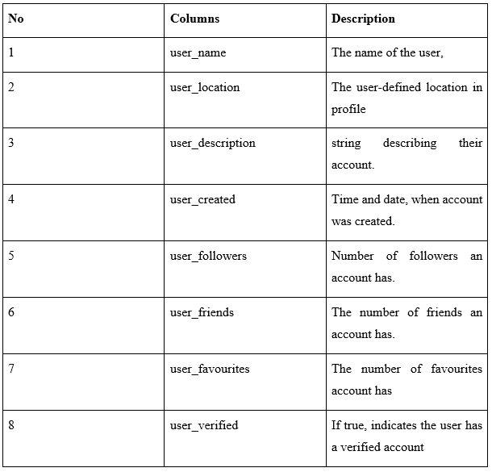

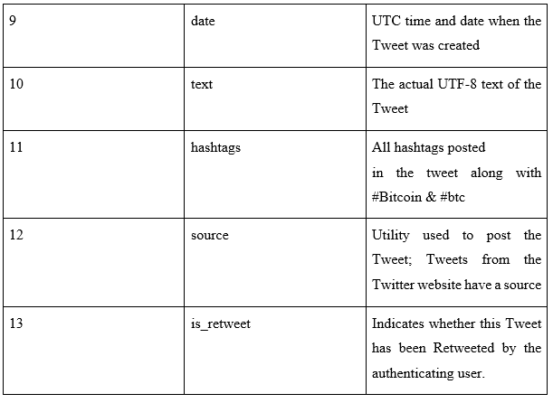”

The bitcoin historical data is downloaded from <https://in.investing.com/crypto/bitcoin/historical-data>.

The data has columns Date, Price, Open, High, Low, Volume.

CHAPTER 6

**SYSTEM REQUIREMENTS SPECIFICATION**

# 

# 6.1 Hardware Requirements

* Processor-64 bit
* Hard disk-80 GB
* RAM-4 GB

# 6.2 Software Requirements

* Operating System-Linux, Windows or MAC OS.
* Google colab
* Twitter API
* Python 3.7
* Libraries: Scikitlearn, Pandas, NumPy, Matplotlib and a few ML model libraries.

# 6.3 Functional Requirements

Functions to be performed by the system.

* Classify the tweets into positive, negative and neutral.
* Predict price of bitcoin

# 6.4 Non-functional requirements

* **Innovation**:Using a combination of historical prices and tweets to predict the fluctuation in price.
* **Performance**:System will try to provide results fast.
* **Security:** System is designed to be secure
* **Reliability:** The application has few chances of failure
* **Maintainability:** A well maintained code is possible with our project.
* **Portability:** Highly portable as it is being run on Google Colab, a cloud based service.
* **Legacy to modernisation:** Code developed using latest python libraries
* **Reusability:** Code follows good principles and is reusable
* **Compatibility:** Code is compatible on Linux, Windows and MAC OS.

# 6.5 Advantages of system

* High performance and gives results easily
* Ease of use

CHAPTER 7

**SYSTEM DESIGN**

# 7.1 Data Collection

* Collecting Tweets, Bitcoin historical data
* Tweets collected have #Bitcoin, #btc hashtags.
* Tweets collected were posted almost every minute

# 7.2 Data Pre-processing

* Conversion of the tweets to lower case.
* Remove all the URL, excess spaces and mentions(@user_name).
* Remove quotes and brackets tweets.
* Stripping hashtags off words.

# 7.3 Sentiment Analysis

VADER (Valence Aware Dictionary for sentiment Reasoning) sentiment. VADER analysis provides several benefits including the fact that it not only classifies text as positive, negative, or neutral (polarity) but also measures the intensity of words used.

The sentiment analysis method of VADER is well suited to the sentiment of social media. The sentiment feature of VADER returns a polarity score for a compound.

The polarity score for VADER is between -1 and 1, where from -1 to 0 is negative, 0 is neutral and 0 to 1 is positive.

# 7.4 Prediction Model

* Use sentiment score and historical price of Bitcoin as input data and implement LTSM model and forest among others.
* These models effective for price prediction

# 7.5 Comparison and Accuracy

Compare prediction model’s output data with actual Bitcoin price movements and find prediction accuracy by checking the output of model and make calculations appraising the model’s performance.

# 7.6 Architecture Diagram

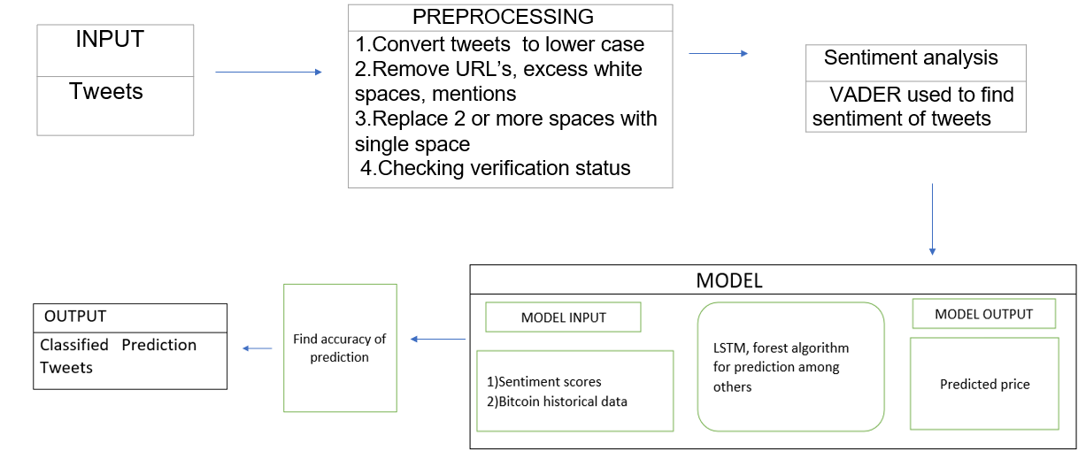

# 7.7 Use case diagram

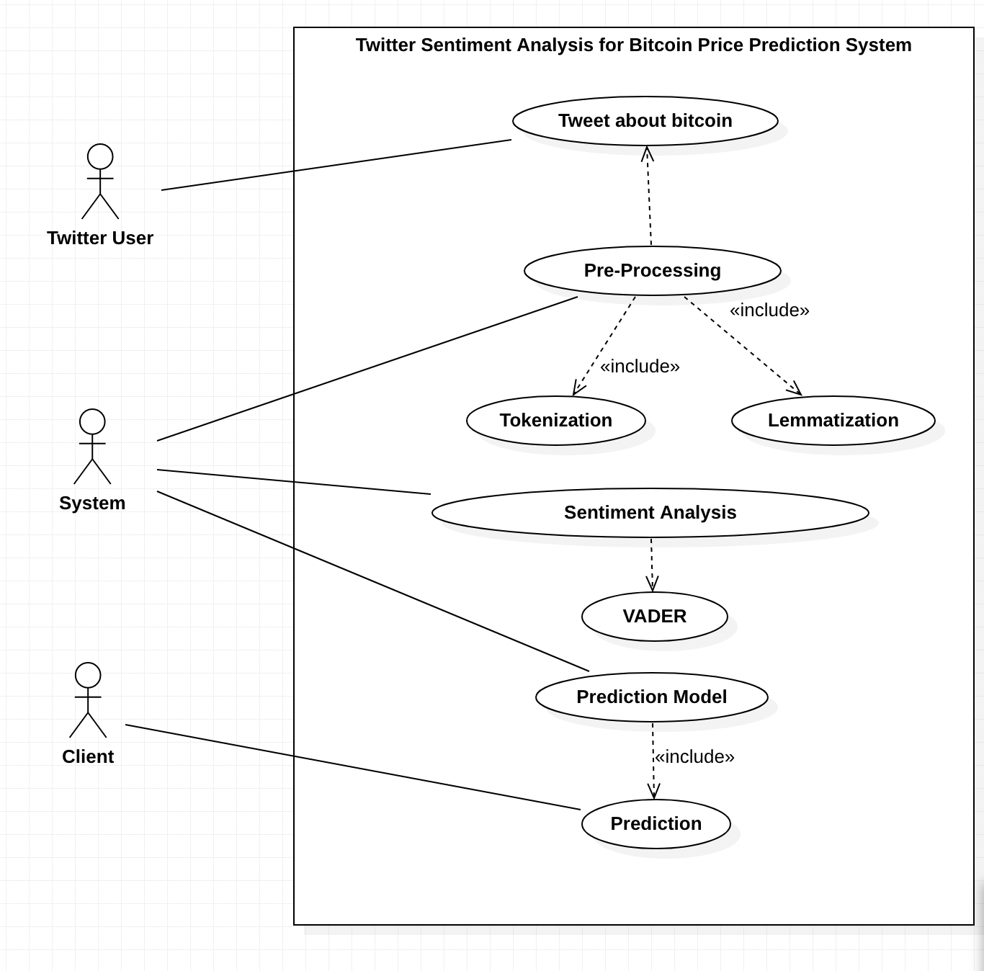

# 7.8 Activity Diagram

CHAPTER 8

**CONCLUSION OF CAPSTONE PROJECT PHASE-1**

●In the first phase of the project, the problem statement and scope of the project has been defined.

●By reading more about our project and the papers published on it, we understood the model we can use, their advantages and limitations, gained better insight into the scope of the project, and validated our hypothesis.

●The architecture and dataset to be used was identified.

CHAPTER 9

**PLAN OF WORK FOR CAPSTONE PROJECT PHASE2**

The implementation of our project in Google Colab will be carried out during phase 2 in accordance to the following Gantt chart.

Project Timeline Phase 2

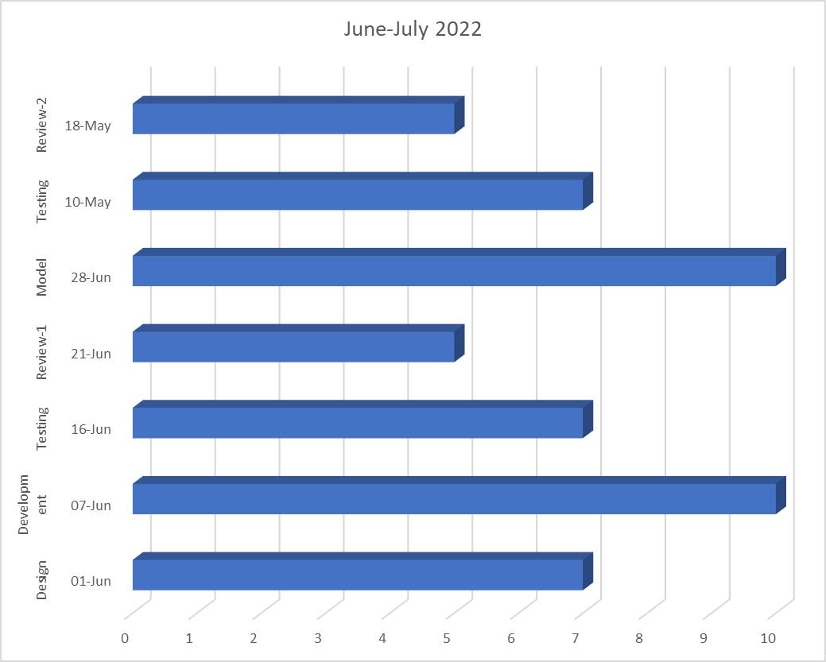

Fig 4 Project timeline phase-

**REFERENCES/BIBLIOGRAPHY**

[1]Abraham, Jethin; Higdon, Daniel; Nelson, John; and Ibarra, Juan (2018) "Cryptocurrency Price Prediction Using Tweet Volumes and

Sentiment Analysis," SMU Data Science Review: Vol. 1 : No. 3 , Article 1

[2]D. R. Pant, P. Neupane, A. Poudel, A. K. Pokhrel and B. K. Lama, "Recurrent Neural Network Based Bitcoin Price Prediction by Twitter Sentiment Analysis," 2018 IEEE 3rd International Conference on Computing, Communication and Security (ICCCS), 2018, pp. 128-132, doi: 10.1109/CCCS.2018.8586824.

[3]O. Sattarov, H. S. Jeon, R. Oh and J. D. Lee, "Forecasting Bitcoin Price Fluctuation by Twitter Sentiment Analysis," 2020 International Conference on Information Science and Communications Technologies (ICISCT), 2020, pp. 1-4, doi: 10.1109/ICISCT50599.2020.9351527.

[4]E. Şaşmaz and F. B. Tek, "Tweet Sentiment Analysis for Cryptocurrencies," 2021 6th International Conference on Computer Science and Engineering (UBMK), 2021, pp. 613-618, doi: 10.1109/UBMK52708.2021.955891

[5]Twitter Sentiment Analysis for Bitcoin Price Prediction - Sara Abdali Ben Hoskins 2021

[6]<https://in.investing.com/crypto/bitcoin/historical-data>.4

[7]<https://www.kaggle.com/datasets/kaushiksuresh147/bitcoin-tweets>

[8]<https://online.visual-paradigm.com/>

[9]<https://keep.lib.asu.edu/items/133184>

[10]http://www.diva-portal.org/smash/get/diva2:1110776/FULLTEXT01.pdf

**APPENDIX**

**APPENDIX A: Definitions, Acronyms and Abbreviations**

**Definitions**

Tokenization -chunking down sensitive data to unique identifiers in such a way that they retain their original meaning.

Lemmatization - remove only inflectional endings and return the base form of a word

**Acronyms**

BTC -Bitcoin

ETH -Ethereum

RNN -Recurrent neural networks, a type neural network class used to model sequential data.

VADER – “Valence Aware Dictionary and Sentiment Reasoner”, a sentiment analysing tool that provides a sentiment score as well.

BERT – “Bidirectional Encoder Representations from Transformers”.

SVM- “Support Vector Machine” is a classification-based Machine Learning algorithm.