Achyut Jagini

PES2UG19CS013

Assignment-4 Zookeeper

1a



2a



2b



2c

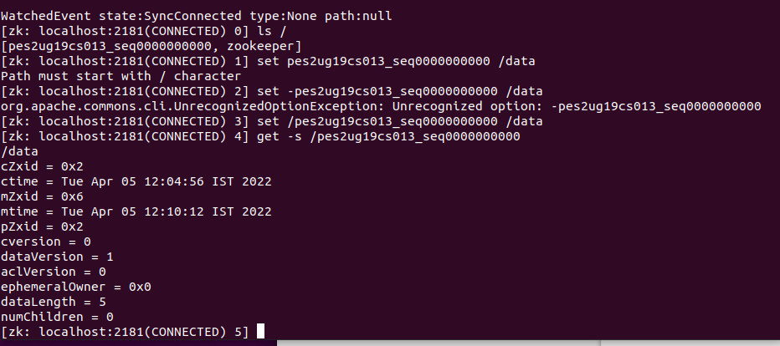

2d

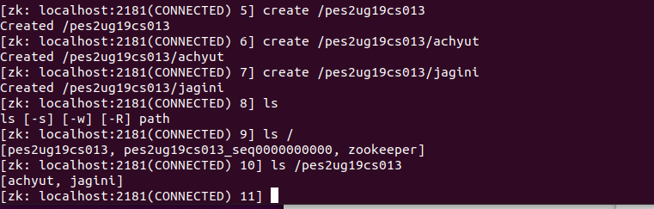

3a

