Consensus Algorithms: Raft Lab Experiment 4

Achyut Jagini

PES2UG19CS013

1-a

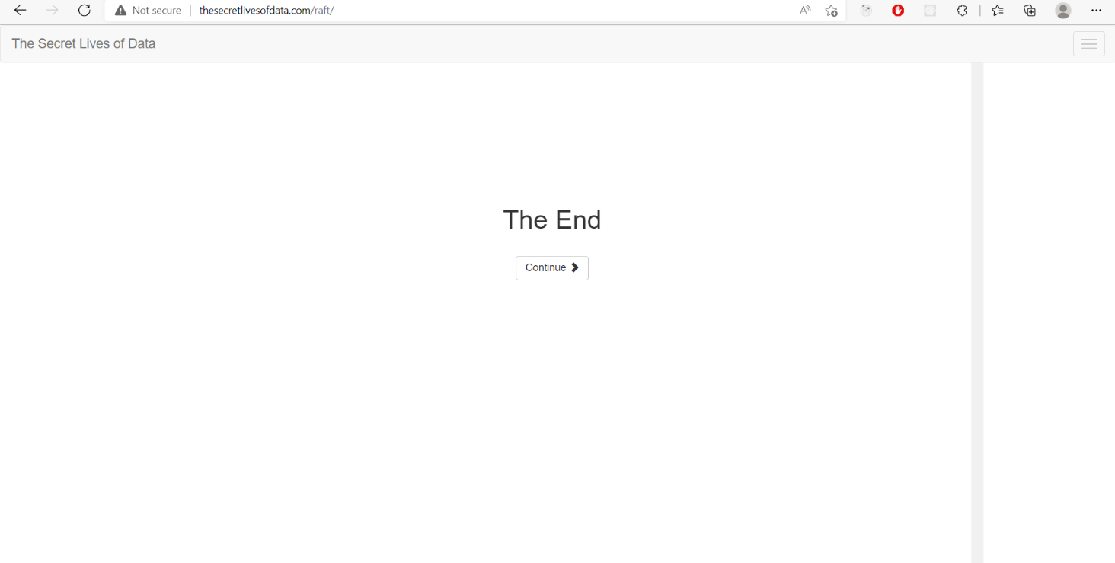

1-b

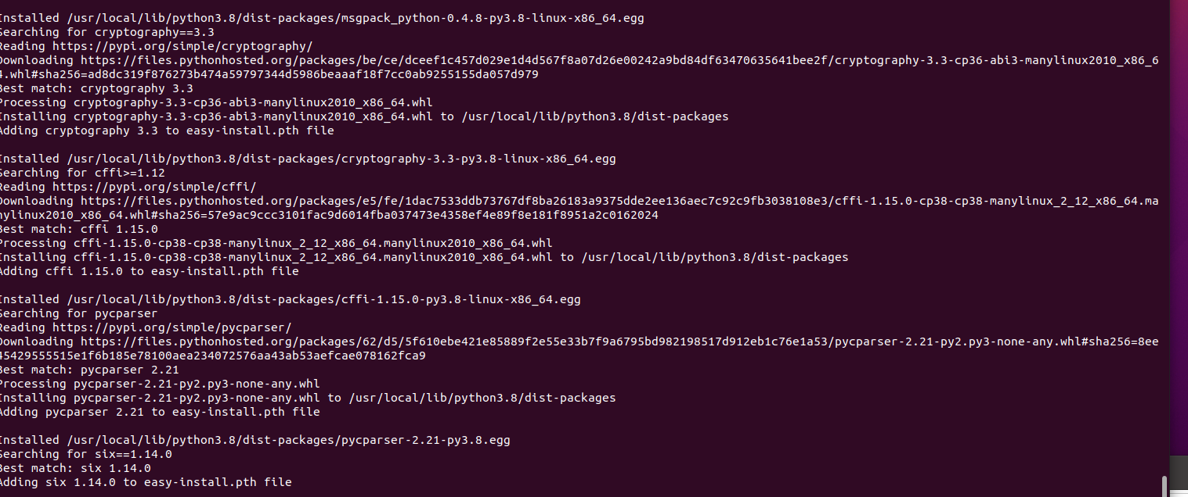

2-a

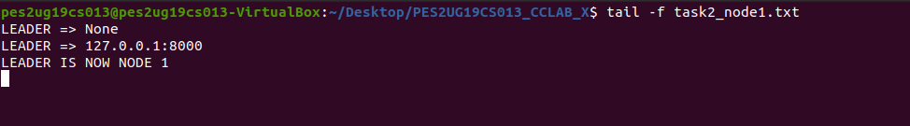

2-b

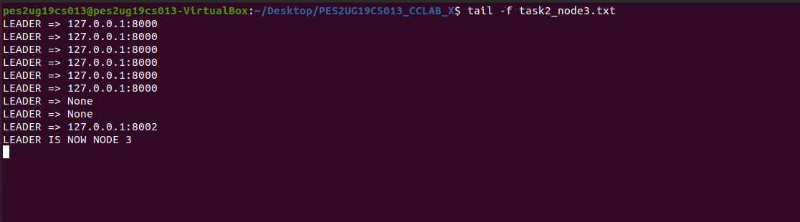

2-c

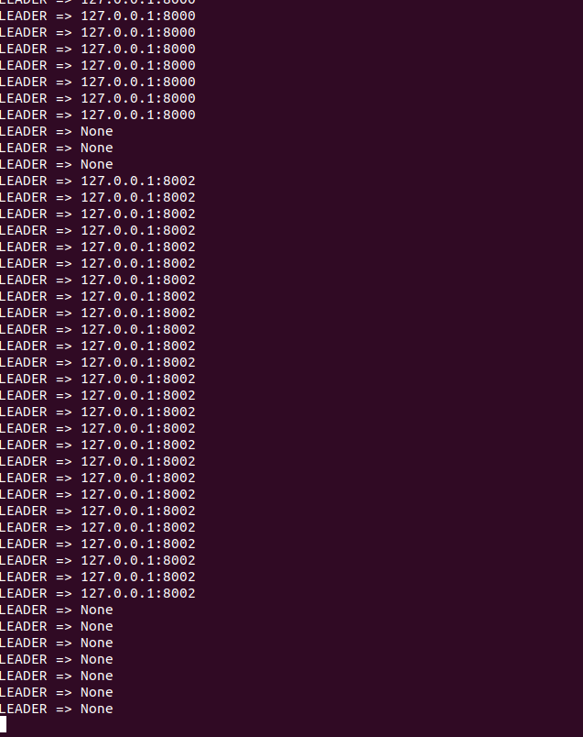

3a



3b



3c

