**DATABASE MANAEMENT SYSTEM**

**Project On**

**LG STORE MANAGEMENT SYSTEM**

**Achyut Jagini – PES2UG19CS013**

**Ajith Vivekanandan – PES2UG19CS021**

**Akif Iqbal – PES2UG19CS027**

**Problem statement**

To create LG store management system.

**Introduction**

Our LG Store Management System aims at conveniently managing and manipulating the data corresponding to the various events taking place. This will make it easier to maintain the record of employees, customers as well as the details of every commodity present in their store.

**Objectives**

1. Facilitates the administration of the employees to retrieve,  
   update, and report the information of their employees as well as of their customers efficiently
2. ease the needs of the Department of Sales and Purchase.
3. In case, the store decides to make changes in their services, it becomes easy for them as all the data can be manipulated easily without mixing and loss of data.

**Entities and Attributes**

Employee

* eId (Primary Key)
* eEmail
* eAccNo
* eSalary
* eHiredate
* ePhone
* eName
* eDOB
* eBank

Customer

* cEmail
* cGender
* cDOB
* cId (Primary Key)
* cName
* cPhone
* cLastPurchase

Sale

* sBillingID (Primary Key)
* sTotalCost

Payment

* pAmountDue
* pModeOfPayment

LGProduct

* lgID (Primary Key)
* lgName

LGTV

* tvID (Primary Key)
* tvName
* tvPrice
* tvModel
* tvScreen (LED, LCD, 4K, 8K)
* tvWeight
* tvType (Android TV, Normal TV)
* tvElectricityInput
* tvWarranty

LGAC

* acID (Primary Key)
* acName
* acPrice
* acModel
* acWeight
* acMinTemp
* acMaxTemp
* acElectricityInput
* acWarranty

LGWashingMachine

* wmID (Primary Key)
* wmName
* wmPrice
* wmModel
* wmWeight
* wmLoad (Front Load, Top Load)
* wmMotorType
* wmLoadVolume
* wmElectricityInput
* wmWarranty

LGRefrigerator

* rID (Primary Key)
* rName
* rPrice
* rModel
* rWeight
* rFreezer (No Freezer, Top, Bottom)
* rMinTemp
* rMaxTemp
* rLoadVolume
* rElectricityInput
* rWarranty

**Relationships**

* **Buys(customer buys product)**

Many customers can buy any device and a lot of device can be bought by one customer so cardinality is, M:N

* **Handles (employee handles customer)**

One employee can handle many customers but one customer can be handled by one employee only, so cardinality is, 1:N.

* **Manages (employee manages sale)**

One employee manages many sales, cardinality is, 1:N

* **Done for(payments done for sales)**

One payment can be made for one sale only. So, cardinality is 1:1.

**ER Diagram (Hand Drawn)**

**ER Tool Used**

The tool used was YED Graph Editor. It is a free to use software used to easily create high quality diagrams. Using this software, it is easy to modify, export or import diagrams. It has an extremely user-friendly GUI.

We chose this tool because it is easy to create ER diagrams. The tool is unfortunately not open-source and hence cannot be modified.

Reference links: https://www.yworks.com/products/yed

Installation process: When you go to the official website and choose yed graph editor in the products section. After downloading the required file open the setup file and follow the instructions.

**ER Diagram**

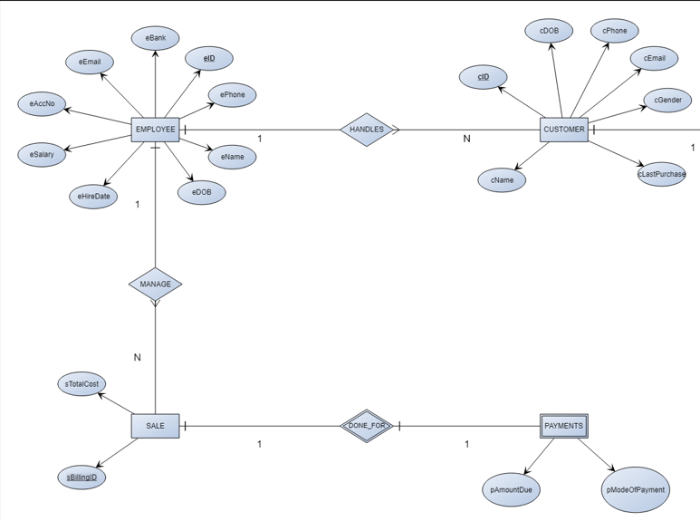

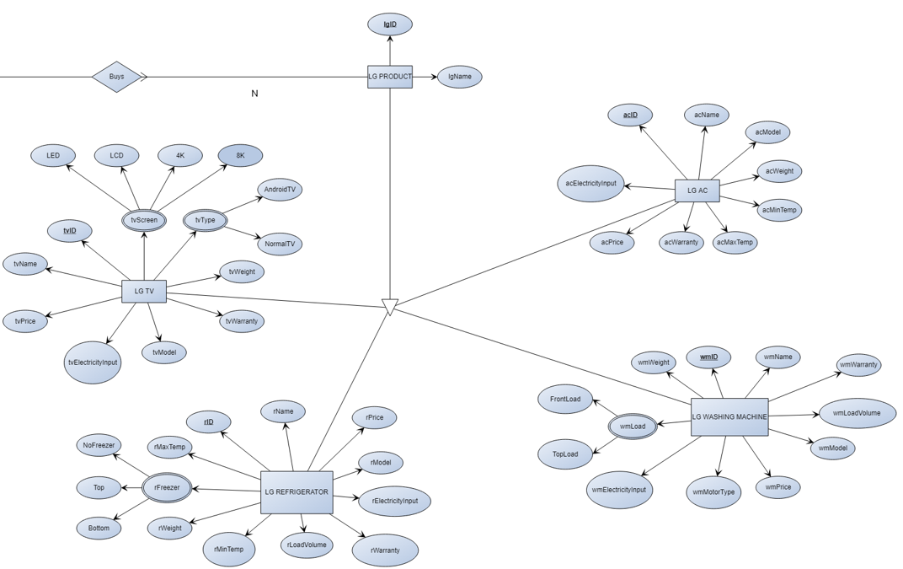

**Contributions and Time Spent**

Achyut Jagini – All stages of ER diagram (hand-drawn) – 2 hrs

Ajith Vivekanandan – Using tool to create final ER diagram – 2 hrs

Akif Iqbal – Creating of Problem statement, Entities, Attributes & Relationship – 2 hrs