**Digital Design and Computer Organization Laboratory**

**UE19CS206**

**3rd Semester, Academic Year 2020-21**

Date: 18-11-20

|  |  |  |
| --- | --- | --- |
| Name : Achyut Jagini | SRN : PES2UG19CS013 | Section : A |

Experiment Number: 8 Week #: 8

**Title of the Program:**

Microprocessor Control Logic – 2(Load and Jump Instructions )

**Aim of the Program:**

To enhance the microprocessor control logic to implement a load and a jump instruction.

**Code (mproc.v)**

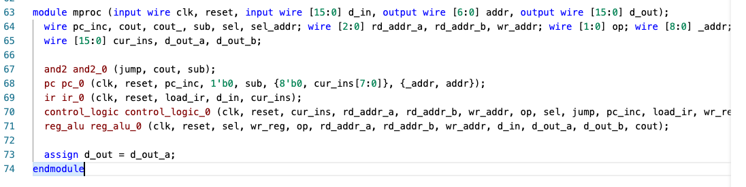

**TABLE**

|  |  |  |  |  |  |  |  |
| --- | --- | --- | --- | --- | --- | --- | --- |
|  |  |  | **In HEX** |  |  |  | **In HEX** |
|  |  |  |  | **Fibonacci Number 11** | **233** | **89+144=233** | **00E9 H** |
| **Fibonacci Number 1** | **2** | **1+1 =2** | **0002 H** | **Fibonacci Number 12** | **377** | **144+233=377** | **0179 H** |
| **Fibonacci Number 2** | **3** | **1+2=3** | **0003 H** | **Fibonacci Number 13** | **610** | **233+377=610** | **0262 H** |
| **Fibonacci Number 3** | **5** | **2+3=5** | **0005 H** | **Fibonacci Number 14** | **987** | **377+610=987** | **03DB H** |
| **Fibonacci Number 4** | **8** | **3+5=8** | **0008 H** | **Fibonacci Number 15** | **1597** | **610+987=1597** | **063D H** |
| **Fibonacci Number 5** | **13** | **5+8=13** | **000D H** | **Fibonacci Number 16** | **2584** | **987+1597**  **=2584** | **0A18 H** |
| **Fibonacci Number 6** | **21** | **8+13=21** | **0015 H** | **Fibonacci Number 17** | **4181** | **1597+2584**  **=4181** | **1055 H** |
| **Fibonacci Number 7** | **34** | **13+21=34** | **0022 H** | **Fibonacci Number 18** | **6765** | **2584+4181**  **=6765** | **1A6D H** |
| **Fibonacci Number 8** | **55** | **21+34=55** | **0037 H** | **Fibonacci Number 19** | **10946** | **4181+6765**  **=10946** | **2AC2 H** |
| **Fibonacci Number 9** | **89** | **34+55=89** | **0059 H** | **Fibonacci Number 20** | **17711** | **6765+10946**  **=17711** | **452F H** |
| **Fibonacci Number 10** | **144** | **55+89=144** | **0090 H** | **Fibonacci Number 21** | **28657** | **10946+17711**  **=28657** | **6FF1 H** |

**Output waveform**

(1 screenshot showing the Fibonacci sequence)

