Authentication – creating relation between something in real world and the system.

Other things in real world that have a representation in the system.

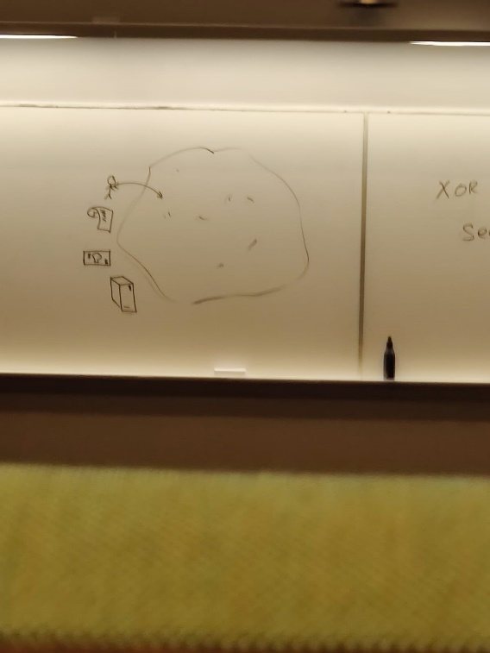

Person,camera binded to system

Give an interesting example of an IT related authentication method that could clearly be classified as something the entity has

Office ID card to enter an office– correct answer

Biometric scanner – wrong answer

Dsv access card - correct answer

Bank ID – correct answer ,you will need the correct phone

Biometric authentication – wrong.

Something the entity knows

Something the entity has

Something the entity is(and can do?)

Someplace the entity is.

There are European regulations that talk about multifactor authentication

We can create new authentication methods.

Don’t see these are separate classes. Tricky ones can be there where we don’t know where to put them.

Biometric phone,pin code are mixing up.

Give an interesting example of an IT related authentication method that could clearly be classified as something the entity is(and can do?)

IRIS scanning

Voice capture

Fingerprint

Palm print

Face ID

Could have printed picture and shown

3D scans changed this

Facial recognition or iris scanner

Mythbusters could falsify thumb prints

Biometric – must specify

Footprint – is not used today.

Gait – good method to identify how people walk from a distance.

Something the entity knows

Password

Pin code

Personal number

Captcha – which of following are traffic lights

Sometimes just have to authenticate yourself as being human