Recursion : Function calling itself:

There are many problems for which the solution can be expressed in terms of the problem itself. There are some classical examples from Mathematics. Successive differentiation of trigonometric functions like sine or cosine yields the same function itself. There are special functions like Legendre polynomial and Bessel’s function which express the relationships using recursion.
In programming, we require two steps.
- express solution for a problem in terms of the problem itself, but of a smallest size
- express solution to a simple or base case without recursion
We may express factorial of n as n times factorial of (n – 1) if n > 0 and we can express factorial of 0 as 1.
Here is such a program.

# name : 1_recursion.py
# recursion
# factorial :
# n! = n x (n-1)! for n > 0
# = 1 for n = 0

def fact(n):
if n == 0 :
res = 1
else:
res = n * fact(n - 1)
return res

print(fact(5)) # 120
print(fact(0)) # 1

Each time the function is called a new activation record is created. Please check how this function works using the tool python tutor.

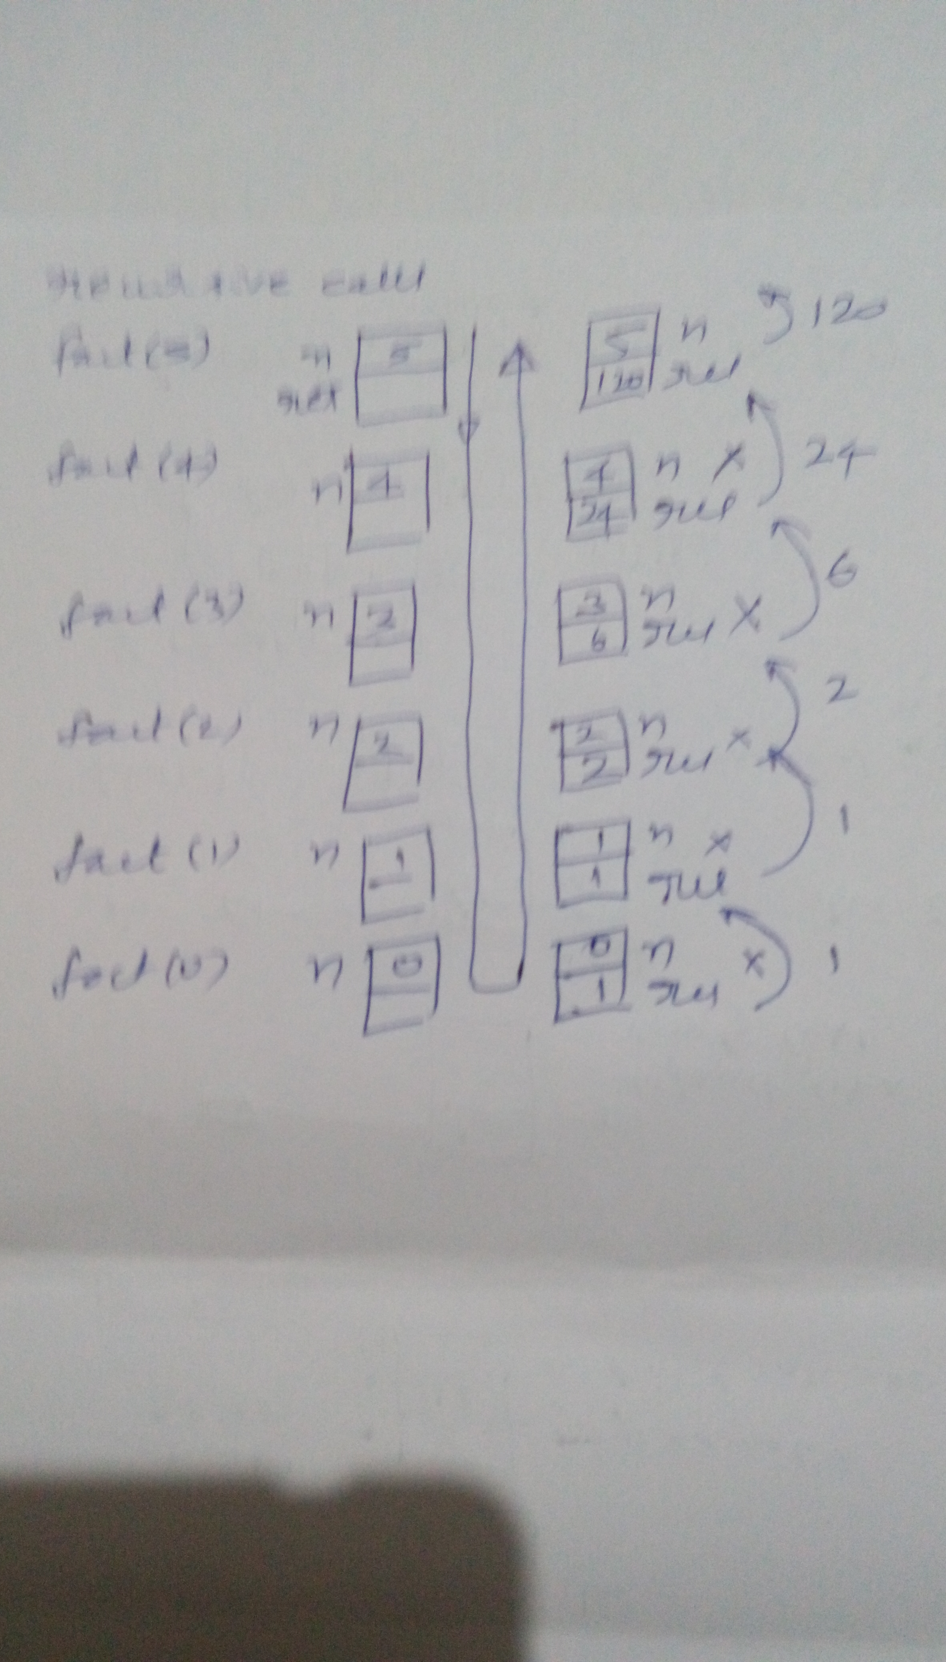

Let us look at another example of recursion – the greatest common divisor. This is supposed to be the oldest algorithm ever known – traced to 300 BC. This is called Euclid’s algorithm.
It states as follows.
Algorithm gcd(a, b)
if two numbers a and b are equal then
that itself is the gcd
else if a > b then
subtract b from a and find gcd of (a – b, b)
else
subtract a from b and find gcd of (a, b – a)

Here is the equivalent Python code.
Observe that the recursive calls are made two different limbs of the if statement. At runtime, the activation record will remember to which part of the code it should return once the function terminates.

# name: 2_recursion.py
# Euclid's algorithm to find the greatest common divisor
def gcd(m, n):
if m == n :
res = m
elif m > n :
res = gcd(m -n, n)
# 3
# 4
else:
res = gcd(m, n - m)
# 2
# 5
return res
print("gcd : ", gcd(65, 91))
# 1
# 1. gcd(65, 91)
# 2. gcd(65, 26)
# 3. gcd(39, 26)
# 4, gcd(13, 26)
# 5. gcd(13, 13)

Try this in the Python tutor and observe they the activation records get created and get destroyed. Observe how the res variable of the function gets populated. Also observe how the cursor jumps back to different recursive calls once the earlier call is terminated.

The following diagram illustrates
- call sequence
- activation record creation, population and destruction
- return value propagation
- return control

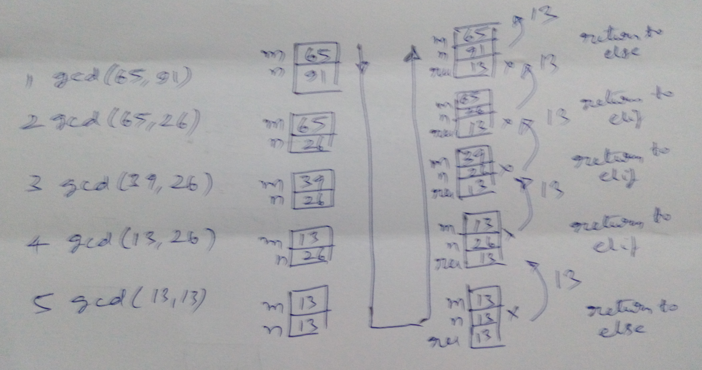

Let us discuss one very interesting puzzle – called tower of Hanoi. It is also known as Brahma’s riddle. Check this link : https://en.wikipedia.org/wiki/Tower_of_Hanoi


There are three pegs. There are a number of disks in the first peg. The task is to move the disks from the first to the third using second if necessary. There are two rules in the game. We can move only one disk at a time. We cannot place a biggest disk over a smaller disk.
It seems Brahma created 3 diamond sticks and put 64 golden disks in the decreasing order of size at Varanasi. It seems he asked the priests of Varanasi to move the disks from the first to the third using second if necessary. It seems that priests can move one disk per second. It seems that Brahma has said that the world will perish if all the disks are moved. How come the world has not perished so far? How do we solve the problem?
The solution is extremely simple. If there is no disk(say n = 0), then nothing to move. This is the base case or the escape hatch.
If there are number of disks(say n), then somehow move the (n – 1) disks from the first peg to the second peg using third peg if necessary, then move the bottom disk from the first peg to the third peg. Then move (n – 1) disks from the second peg to the third peg using first if necessary.
So, the number of moves for varying values of n shall be:
n = 1 => moves = 1
n = 2 => moves = 3
n = 3 => moves = 7
…
moves for n disks = 2 ** n - 1
If you calculate the time required, it will turn out to be a huge number.
18446744073709551615 seconds = 584942417355 years.

Our priests are very slow. Can we do this task on our computers for n = 64? Our computers at a speed of about 5 GHz – can do so many operations in one second. How much time will our computers take to solve this assuming that a move can be made in one clock cycle?

It turns out to be : 117 years !!
These problems require time proportion to the power of n. There are many such problems which can be solved only for a small value of n in a reasonable type.

So, our computers are not really powerful. Are they?

# name: 3_tower_of_hanoi.py

# tower of hanoi
# if there are disks(say n) then
# move n-1 disks from f to u using t
# move one disk from f to t
# move n-1 disks from u to t using f
def move(n, f, t, u) :
if n > 0 :
move(n - 1, f, u, t)
print(f, "=>", t)
move(n - 1, u, t, f)

move(5, 1, 3, 2)

Here is the output for n = 5.
1 => 3
1 => 2
3 => 2
1 => 3
2 => 1
2 => 3
1 => 3
1 => 2
3 => 2
3 => 1
2 => 1
3 => 2
1 => 3
1 => 2
3 => 2
1 => 3
2 => 1
2 => 3
1 => 3
2 => 1
3 => 2
3 => 1
2 => 1
2 => 3
1 => 3
1 => 2
3 => 2
1 => 3
2 => 1
2 => 3
1 => 3

Some more examples:
There are three different implementations of a recursive function in this program. You may want to closely observe all of them.
The first one find mimics the in operator.
Given a list and an element, it returns True or False.
So, what is the logic?
If the list is empty, then return False
else if the zeroth element matches the given element, then return true
otherwise try find again on the slice of the list starting from position 1.
This is not a very efficient program as slicing of lists will cause copying the elements.

The second version of find uses two techniques.
a) wrapper function: The client calls a function with two arguments as in the earlier case. It in turns calls another function with an extra argument.
b) Function tracks the state: In each call, the function indicates the position in the list which should be used to compare. The value is builtup over each call.

The third version uses a default parameter – so that the wrapper function is avoided. This tip came from one of my students during my lecture.

#name : 4_recursion.py

"""
def find(mylist, x) :
if not mylist:
return False
elif mylist[0] == x :
return True
else:
return find(mylist[1:], x)

x = [11, 33, 22, 44]
print(find(x, 22))
print(find(x, 5))
"""

"""

def find_(mylist, x, i) :
if i == len(mylist):
return -1
elif mylist[i] == x :
return i
else:
return find_(mylist, x, i + 1)

def find(mylist, x) :
return find_(mylist, x, 0)

x = [11, 33, 22, 44]
print(find(x, 22))
print(find(x, 5))
"""
def find(mylist, x, i = 0) :
if i == len(mylist):
return -1
elif mylist[i] == x :
return i
else:
return find(mylist, x, i + 1)

x = [11, 33, 22, 44]
print(find(x, 22))
print(find(x, 5))

Functional Programming:
In this example, we shall try three different tasks. Then we shall retry them using a totally different technique.

Observe the function what1. Given a list of strings, it creates a list of lengths of the corresponding strings and returns the list.
Observe the following steps.
- There is some initialization
- There is a traversal through all the elements of the iterable – in this case, a list.
- There is an application of some operation on each of these elements
- The result is collected in an iterable – in this case a list.
- The list is returned.

Now let us observe the function what2. This function receives a list of strings as argument. This walks through the list. Converts each string to its uppercase equivalent. Puts them into a list. Then returns the list.

Please observe both what1 and what2 do similar tasks – but the operation performed on the element of the iterable is different,

How about the function what3? It is very similar to the earlier two examples. Here the input is a list of numbers. Each number is squared – the operation is different.

# name: 5_map.py

# given a list of strings, find their corresponding lengths

def what1(x):
res = []
for w in x:
res.append(len(w))
return res

a = [ 'apple', 'pineapple', 'fig', 'mangoes' ]
b = what1(a)
print(b) # 5 9 3 7

# given a list of strings, convert to uppercase

def what2(x):
res = []
for w in x:
res.append(str.upper(w))
return res

a = [ 'apple', 'pineapple', 'fig', 'mangoes' ]
b = what2(a)
print(b) # APPLE PINEAPPLE FIG MANGOES

# given a list of numbers, square each number
def what3(x):
res = []
for w in x:
res.append(w * w)
return res

a = [11, 33, 22, 44]
b = what3(a)
print(b)

# map : allows us to walk thro an iterable
# apply some function
# collect the result

a = [ 'apple', 'pineapple', 'fig', 'mangoes' ]
# map(<callable>, <iterable>)
b = list(map(len, a))
print(b)

b = list(map(str.upper, a))
print(b)

a = [11, 33, 22, 44]
b = list(map(lambda x : x * x, a))
print(b)

We observe this requirement at number of places in programming. We walk through an iterable, do some operation, collect the result in an iterable, The number of elements in the output will be same as the number of elements in the input. There is a builtin function called map to do this.
The function map takes two arguments - a callable and an iterable.
The implementation of map is similar to our what functions.
The map function causes iteration through the iterable, applies the callable on each element of the iterable and creates a map object which is also an iterable.
All these happen only conceptually as the map function is lazy.
Unless the map object is iterated, none of these operations happen!
We can force an iteration of the map object by passing the map object as an argument for the list constructor.
The first argument for the map function in our case should be a callable which takes one argument – could be a free function, could be a function of a type, could be user defined function, could be a lambda function as well.

Let us understand a few more examples using map.
The iterable is a range object standing for the sequence 1, 2, … 10.
The callable is a user defined function which returns a string.
The map object is a lazy iterable which contains the multiplication of a given number.
The for loop of the client iterates through the map object and displays the elements.

# name : 6_map.py
# given a number, generate its multiples with numbers from 1 to n
# generate multiplication table for a given number
n = int(input("enter a number : "))
#print(list(range(n, n * 10 + 1, n)))

def foo(i) :
# n : global variable
prod = n * i # prod : local variable
#print(n, " X ", i, " = ", prod)
return str(n) + " X " + str(i) + " = " + str(prod) + "\n"

for i in range(1, 11):
#foo(i)
print(foo(i), end = "")

#print(list(map(foo, range(1, 11))))
for line in map(foo, range(1, 11)):
print(line, end = "")

This is another useful program to list the filenames and their sizes in the current directory.
We are using the os module which supports a few useful functions.
- os.listdir(“.”) gives the names in the current directory.
- os.path.getsize(filename) gives the size of the file in bytes
In this case, the map object produces an iterable of tuples, each having the filename and the corresponding size. As there is no such callable available directly, we are using our own function get_name_size as the callable.

# name: 7_map.py
# use the os module
# os.listdir("path") gives the output of ls command
# path = "." ; list in the current directory

# os.path.getsize(filename) => size of file in bytes

import os
# make an iterable of all files
for size in map(os.path.getsize , os.listdir(".")) :
print(size)

def get_name_size(name):
return (name, os.path.getsize(name))
for pair in map(get_name_size , os.listdir(".")) :
print(pair[0], "=>", pair[1])

filter:
The map function has the following characteristics.
- input : an iterable of some # of elements (say n)
- output: a lazy iterable of same number of elements(also n)
- elements in the output: obtained by applying the callback on the elements of the input.

There are cases where we want to remove a few elements of the input iterable. Then we use the function filter.
The filter function has the following characteristics.
- input : an iterable of some # of elements (say n)
- output: a lazy iterable of 0 to n elements(between 0 and n)
- elements in the output: apply the callback on each element of the iterable – if the function returns True, select the input element and otherwise do not select the input element.

There are many cases where we may want to do some mapping and filtering. It is always a good habit filter first and then map. Otherwise map will have to do processing of some elements which eventually be filtered out.

# name: 8_map_filter_reduce.py

print(list(map(lambda x : x % 2, range(5)))) #[0, 1, 0, 1, 0]
print(list(filter(lambda x : x % 2, range(5)))) #[]
# map:
# returns an iterable
# input : n elements
# output : n elements

# output : not the input, result of the fn call on the input

# filter:
# returns an iterable
# input : n elements
# output : anything between 0 and n elements

# output : has elements given in the input itself
# not the result of the function call

# gives the output only when the function returns a true value

a = [ 'rama', 'krishna', 'balarama', 'lakshmana', 'dasharatha', 'sita' ]
# pickup all words which have r
print(list(filter(lambda s : 'r' in s , a)))
# pickup all words whose length exceeds 4
print(list(filter(lambda s : len(s) > 4 , a)))

# convert all strings to uppercase and find all strings whose length exceeds 4
# terrible code
print(list(filter(lambda s : len(s) > 4 , map(str.upper , a))))

# good code
print(list(map(str.upper, filter(lambda s : len(s) > 4, a))))

reduce:
This is another useful function which is present in a module called functools.
The characteristics are as follows.
- input : an iterable of some # of elements (say n)
- output : a single element
- processing : requires a callback which takes two elements. Will apply the function repeatedly and reduce the output to a single element.

In this example, the following shall be the calls on the callable within the function reduce.

print(functools.reduce(foo, [11, 22, 33, 44]))
res = foo(11, 22)
res = foo(res, 33)
res = foo(res, 44)
There will be n – 1 calls where n is the number of elements in the input iterable.

The function reduce may take a third argument which will indicate the initial value for the first call. In that case, the reduce will call the callable n times.

The following code is interesting. This is a single liner to find the factorial of a given number. The range function produces a lazy iterable of numbers from 1 to n. The callable multiples all of them resulting in the factorial.
n = 5
print(functools.reduce(int.__mul__ , range(1, n + 1)))

import functools

print(functools.reduce(int.__add__, range(10)))
# reduce:
# input : n elements
# output : 1 element

# callable : takes two arguments
# called n - 1 times
def foo(x, y):
print("foo : ", x, y)
return x + y
print(functools.reduce(foo, [11, 22, 33, 44]))

# n calls
# 100 is the initial value
print(functools.reduce(foo, [11, 22, 33, 44], 100))

names = [ 'nagabhushana', 'satya', 'kumar' ]
#names = [ 'amar', 'bharatha', 'chandra', 'deepa', 'eshwara']
# output : nsk
print(functools.reduce(lambda x, y : x + y[0], names, ""))

# output a single string
words = ['raja', 'ram ', 'mohan ', 'roy']
print(functools.reduce(lambda x, y : x + y, words))

# find factorial of n in a single statement
n = 5
print(functools.reduce(int.__mul__ , range(1, n + 1)))

zip:
zip does not stand for data compression. The function zip is used to associate the corresponding elements of two or more iterables into a single lazy iterable of tuples. It does not have any callback function.

# name: 9_zip.py

# zip :
# combining two iterables
a = [1, 2, 3, 4, 5]
b = list(map(lambda x : x * x * x, a))
print(a)
print(b)
# zip : takes # of iterables and returns a single iterable of tuples
# obtained by mapping the corresponding elements
print(list(zip(a, b)))

# filenames
import os
names = os.listdir(".")
sizes = list(map(os.path.getsize, names))
#print(list(zip(names, sizes)))
for pair in sorted(zip(names, sizes), key = lambda x : x[1]):
print(pair[0], "=>", pair[1])

# find the biggest element in an array
a = [33, 11, 55, 44, 22]
import functools
def big(a, b) :
if a > b :
return a
else:
return b
print(functools.reduce(big , a))

# find sum of digits using reduce
n = '1729'
print(functools.reduce(int.__add__ , map(int, n)))

The last line of this code is interesting. The variable n being a string is an iterable. The function map returns an iterable where each element is the int equivalent of the corresponding character in the string n. The function will now add all these digits and returns a single sum.

