The three parts of the exam cover the following areas: Part 1 (Theory and modeling): Everything about semi-structured data, XML, DTD, XML Schema, JSON, JSON Schema, XML-based languages, usages of semi-structured data and XML, representations of XML Part 2 (Query languages for SSD and XML): Path expressions, Lorel, XPath, XQuery, XSLT Part 3 (XML and relational databases): SQL/XML and product-specific solutions by Microsoft, Oracle and IBM

3 parts of exam cover following areas:

Part 1 -theory and modelling

Everything about semi structured data ,XML,DTD,XML schema ,JSON ,JSON schema, XML based languages , usages of semi-structured data and XML, representations of XML.

part 2 -query languages for SSD and XML

part 3 – xml and relational databases

first database is XML file with information about movies and actors.

2nd database – 2 XML files with information about books and publishers.

3rd database – relational database about people, their employments and their cars.

4th database -db about courses

XML – defines set of rules for adding markup to data.

Markup adds structure to data ,and gives us a way to talk about meaning of data.

Family of XML technologies ,provides way to standardize representation of data.

Movies example

Data describing many of our favourite movies.

DTD’s don’t include data type information about fields

DTD’s not like XML documents

XML schema defines where elements may occur in a document and in what order ,in formal standard way.

XML schema also defines data type of an element

Each element described by xs:element

<xs:element name=”title” type=”xs:string”>

Metadata – data about data

Definitional data that provides information about or documentation of other data managed within an application or environment.

XML representations

Textual representation

Abstract node structure representation

XML infoset

XPath 1.0 model

Xquery 1.0 model

Xquery 3.0 model

Xquery 3.1 model

Valid XML

Is well formed

Follows rules of associated DTD or XML schema

XML schema defines where elements may occur in a document and in what order in formal standard way.

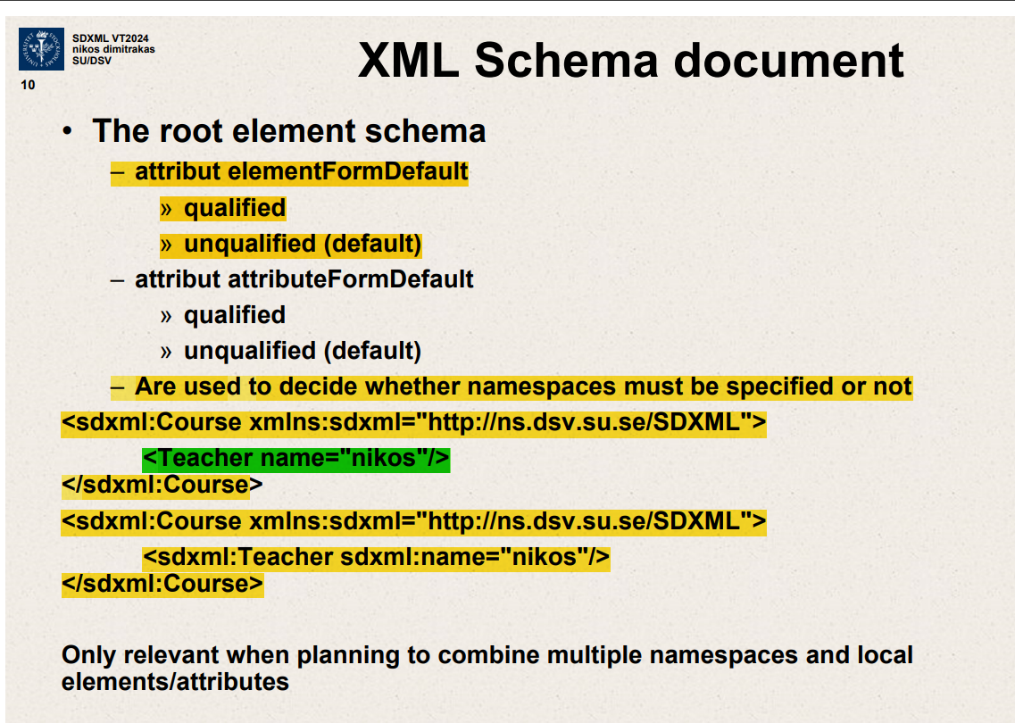

Root element schema

attribut elementFormDefault

Qualified

Unqualified (default)

attribute attributeFormDefault

qualified

unqualified(default)

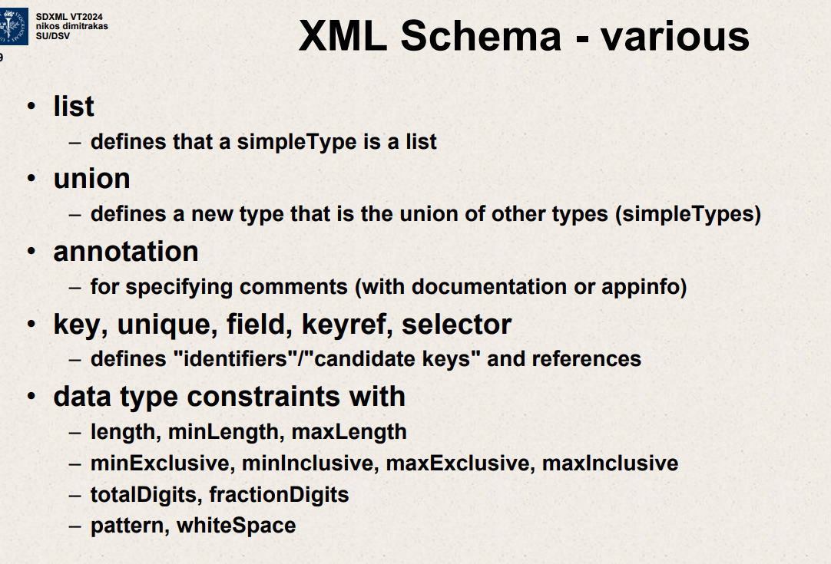

DC – Dublin Core

Catalog metadata for books,articles etc

Close relation to RDF

15 elements

Many more metadata terms