**Determining a strategy for introduction of a chain of restaurants**

Achyut Saxena

May 13, 2020

**Introduction**

Restaurant chains is one of the most popular business model in recent times, but opening a restaurants in a wrong location can leave one in loss rather than profit. Therefore in order to reduce the risk involved, one can use the below described method to determine the locations where the restaurants can be opened to minimize risk in Mumbai.

**Data acquisition and cleaning**

The list of name of all the neighbourhoods in Mumbai along with their area has been taken from the Wikipedia page ‘https://en.wikipedia.org/wiki/List_of_neighbourhoods_in_Mumbai’After getting the address of each neighbourhoods, geolocator is used to get the latitude and longitude of all the neighbourhoods. The neighbourhoods without any result from the geolocator are removed.

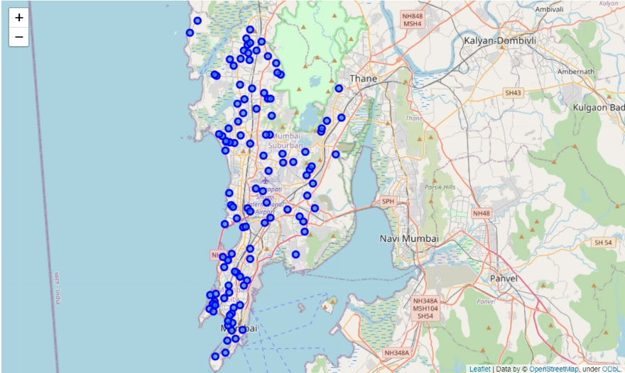

**Analysis and Clustering**

Foursquare api’s explore function was called to find the venues in each neighbourhoods in a radius of 500 m. After getting the venues another dataframe is created to were the frequencies of each category of venues is stored and from that a list of top 10 venue categories with their frequencies is extracted.

For clustering using k-means value of k is taken as 4.

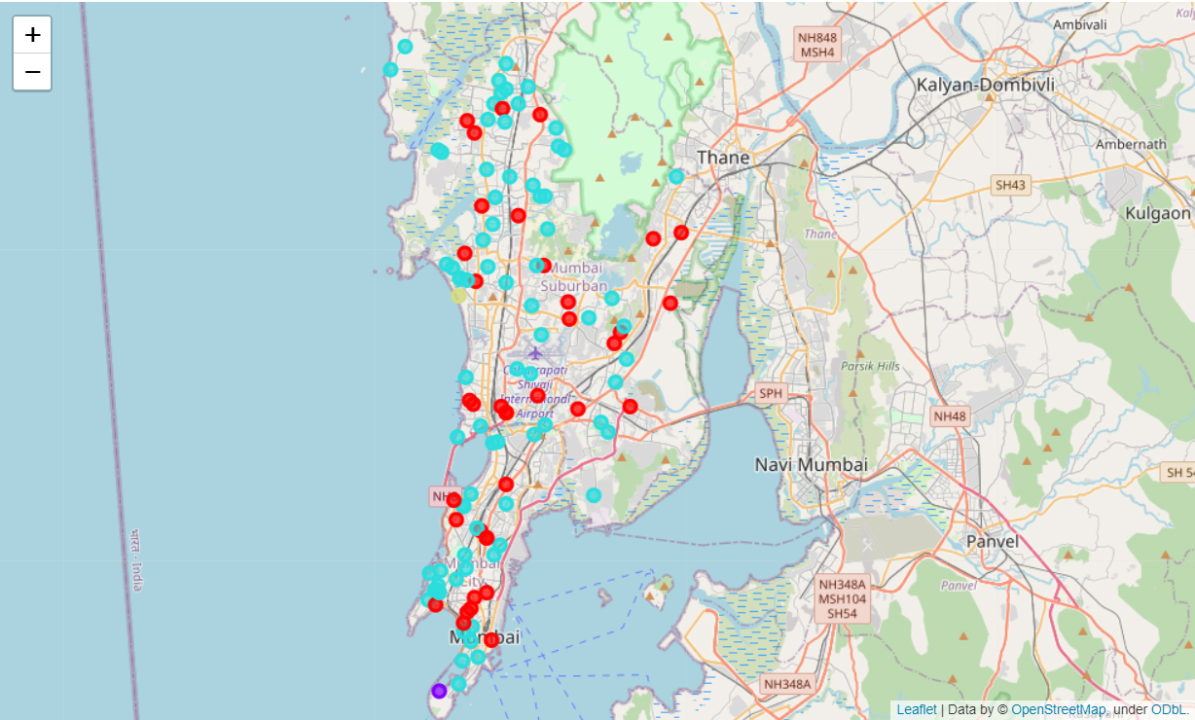

**Observation and Conclusion**

Looking at the different clusters and its venues we can say that

1. Neighbourhoods in cluster 1 and 2 seems to be residential and food trucks can be used for testing before opening a poper restaurant or pop up shops.
2. Neighbourhoods in cluster 3 i.e. Arey Milk colony can benifit from a food truck
3. Neighbourhoods in cluster 4 appear to be a mix of buisness and residential are, hence restaurants can be setup in these areas