How to add a sensor to air compressor monitoring system

This document its aim to describe how to add a new sensor to air compressor monitoring system, this will allow users to visualize new sensors in computer display

Following steps detail on how to add new sensor

**ESP8266 HUZZAH**

1. Open Arduino IDE with code provided
2. Change Sensor name in client.publish and client.suscribe methods

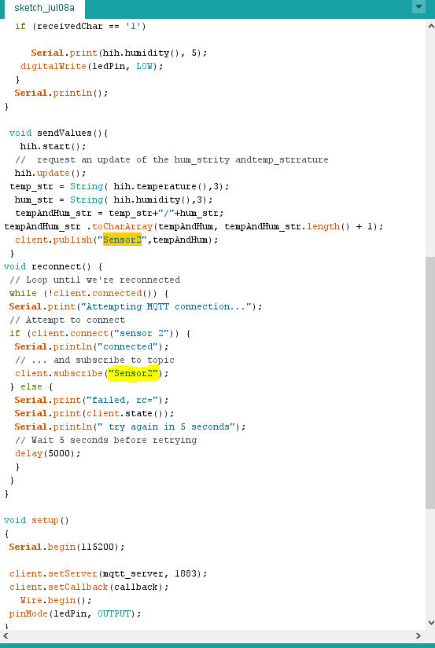

Note: This will be the topic where MQTT will subscribe and publish used in the raspberry pi

**RaspberryPI Python**

1. Open the pi and go to files

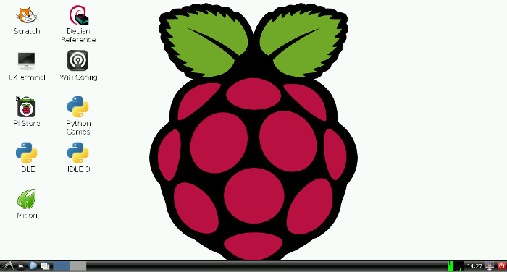

1. Copy HIH logger file into /pi/ with a different name
2. Open copied HIHlogger.py change topic name

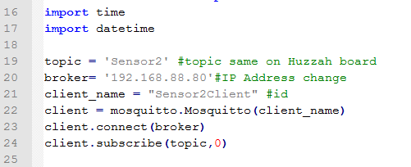

**IMPORTANT: topic should match same as Arduino file on huzza board**

**Config.json**

1. Open config.json file
2. Change backup path to new backup file

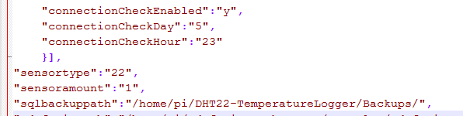

**HTML/PHP File**

1. Go to path **/var/www/html/**
2. **Open Index.html file**
3. **Copy php text from an already existing sensor tab**

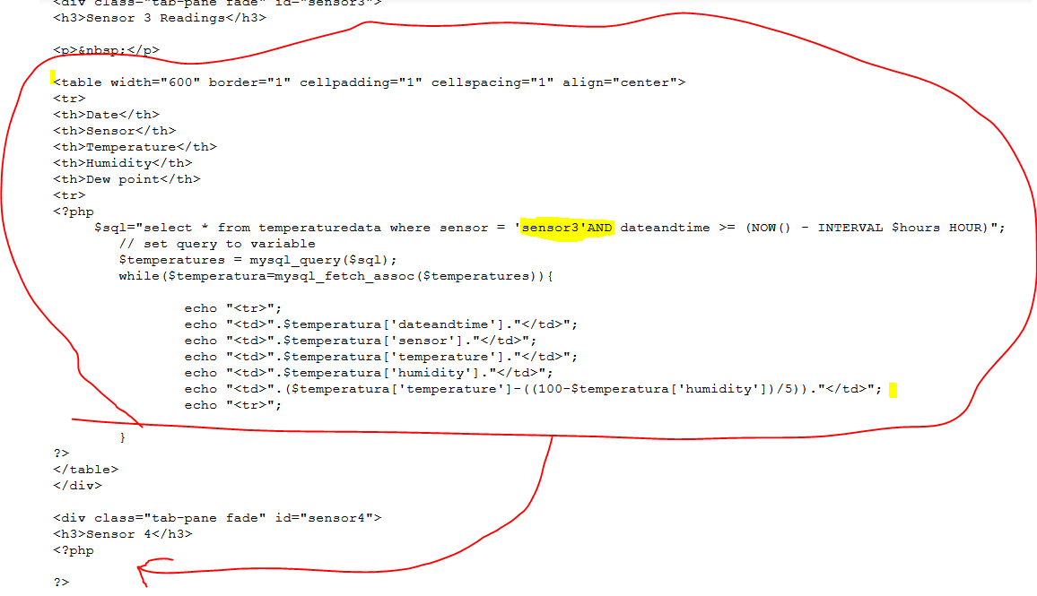Text circled in red should be copied

1. Change topic name to match the topic name in huzzah board and python file

**Sensor readings should now appear on the new tab!**

**Notes**

* root permit is needed to do some of this action password has not been changed from default
* root password to access my SQL database with command (**mysql -u root -p -h localhost) is “claudia” for other users logger2 is password**

**LIBRARIES NEEDED FOR THIS PROGRAM TO WORK!**

* **MySQL: sudo apt-get install mysql-server python-mysqldb**
* **PythonLibrary: sudo apt-get install build-essential python-dev python-openssl**
* **MQTT library: A quick guide on how to install it can be** [found here](http://www.instructables.com/id/Installing-MQTT-BrokerMosquitto-on-Raspberry-Pi/)