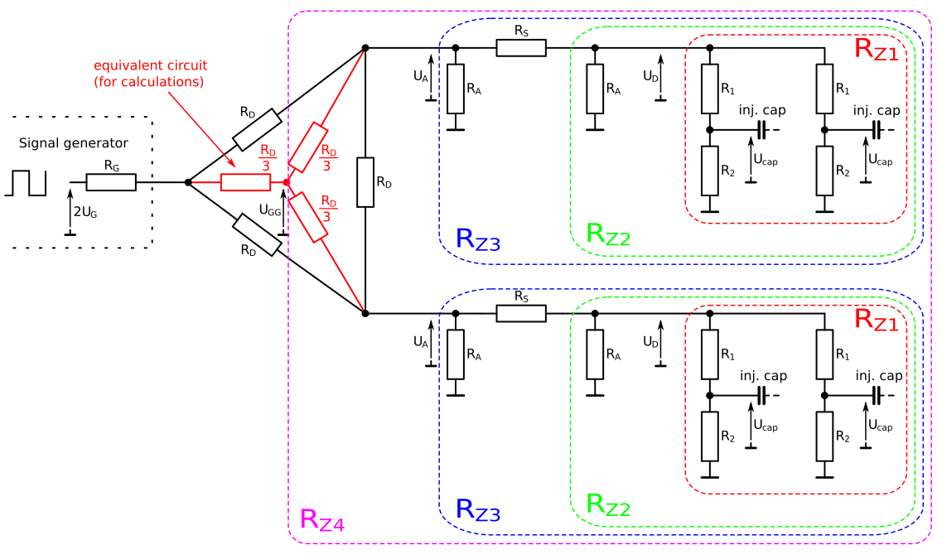
Resistances:

Voltages (U_{G} - generator amplitude, U_{cap} - voltage jump at the injection capacitors):

